AXI4-Lite custom PL peripheral controlled by ARM

1.Document Information
Item | Description
Design Name | axi_ledseg_irq
Protocol | AMBA AXI4-Lite
Design Type | Memory-mapped peripheral
Clock Domain | Single (ACLK)
Reset Type | Active-low asynchronous reset

2. Design Overview
The axi_ledseg_irq module is a memory-mapped AXI4-Lite slave peripheral that provides:
- Control of an 8-bit LED output
- Control of an 8-bit seven-segment display
- An edge-triggered interrupt (IRQ) based on LED state
- Software-accessible status and control registers
The design supports simultaneous read and write transactions using independent read and write finite state machines (FSMs), compliant with AXI4-Lite protocol rules.

3. Functional Features
3.1 Supported Features
- AXI4-Lite compliant read/write interface
- Independent read and write channels
- One outstanding read and one outstanding write supported
- Byte-level write support via WSTRB
- Write-1-to-clear (W1C) interrupt register
- Edge-detected interrupt generation
- Fully synchronous register access
3.2 Unsupported Features
- Burst transfers
- Multiple outstanding reads or writes
- Out-of-order responses
- Unaligned accesses
- AXI IDs

4. Block Design
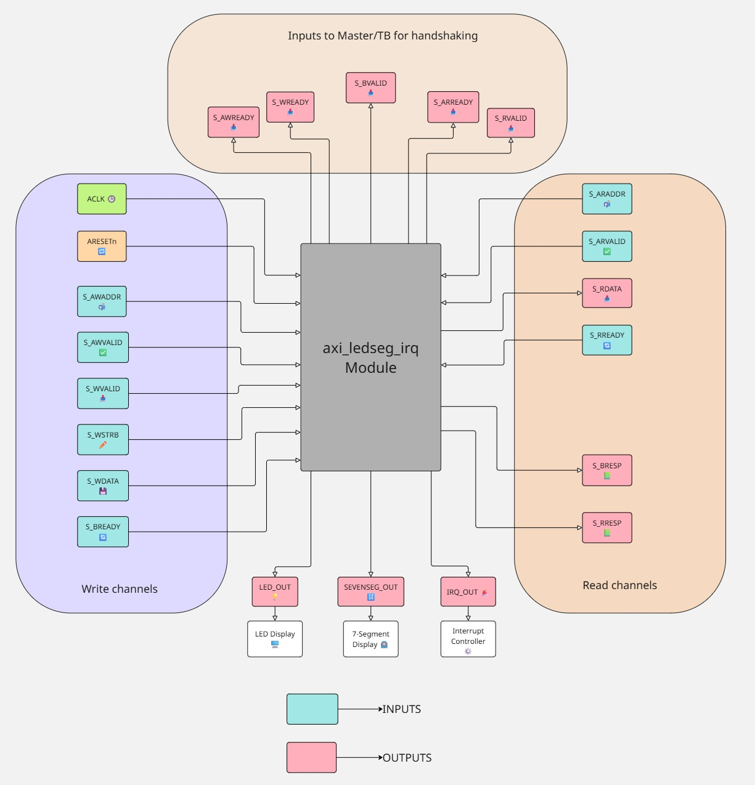

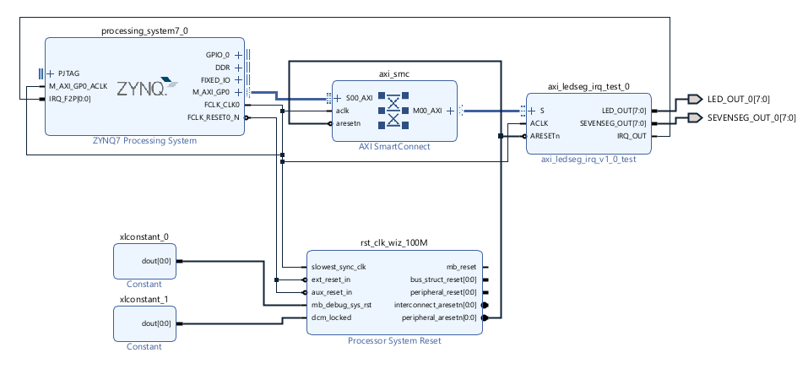

5.Interface Description
5.1 Clock and Reset
Signal | Direction | Description
ACLK | Input | AXI clock
ARESETn | Input | Active-low asynchronous reset
5.2 AXI4-Lite Write Interface
Signal | Direction | Description
S_AWADDR[31:0] | Input | Write address
S_AWVALID | Input | Write address valid
S_AWREADY | Output | Write address ready
S_WDATA[31:0] | Input | Write data
S_WSTRB[3:0] | Input | Byte write strobes
S_WVALID | Input | Write data valid
S_WREADY | Output | Write data ready
S_BRESP[1:0] | Output | Write response (OKAY only)
S_BVALID | Output | Write response valid
S_BREADY | Input | Write response ready

AXI Write Channel – Handshake Signals
Write Address Handshake
Signal | Direction | Used by TB / Master
S_AWREADY | Output | Indicates slave is ready to accept write address
Handshake condition:
S_AWVALID && S_AWREADY
TB waits for S_AWREADY == 1 before deasserting S_AWVALID
Confirms write address acceptance

Write Data Handshake
Signal | Direction | Used by TB / Master
S_WREADY | Output | Indicates slave is ready to accept write data
Handshake condition:
S_WVALID && S_WREADY
TB waits for S_WREADY == 1
Confirms write data transfer

Write Response Handshake
Signal | Direction | Used by TB / Master for
S_BVALID | Output | Indicates write response is available
S_BRESP[1:0] | Output | Indicates write response status

Handshake condition:
S_BVALID && S_BREADY
TB asserts S_BREADY and waits for S_BVALID
Confirms write transaction completion
S_BRESP checked for OKAY (2'b00)

5.3 AXI4-Lite Read Interface
Signal | Direction | Description
S_ARADDR[31:0] | Input | Read address
S_ARVALID | Input | Read address valid
S_ARREADY | Output | Read address ready
S_RDATA[31:0] | Output | Read data
S_RRESP[1:0] | Output | Read response (OKAY only)
S_RVALID | Output | Read data valid
S_RREADY | Input | Read data ready

AXI Read Channel – Handshake Signals
Read Address Handshake
Signal | Direction | Used by TB / Master
S_ARREADY | Output | Indicates slave is ready to accept read address

Handshake condition:
S_ARVALID && S_ARREADY
TB waits for S_ARREADY == 1
Confirms read address acceptance

Read Data Handshake
Signal | Direction | Used by TB / Master
S_RVALID | Output | Indicates read data is valid
S_RDATA[31:0] | Output | Read data returned by slave
S_RRESP[1:0] | Output | Read response status
Handshake condition:
S_RVALID && S_RREADY
TB waits for S_RVALID == 1
Samples S_RDATA
Checks S_RRESP == OKAY

5.4 External Outputs
Signal | Direction | Description
LED_OUT[7:0] | Output | LED drive output
SEVENSEG_OUT[7:0] | Output | Seven-segment drive output
IRQ_OUT | Output | Interrupt request output

6. Register Map
All registers are 32-bit, word-aligned, and byte-addressed.
Address Offset | Name | Access | Description
0x00 | LED Register | R/W | Controls LED output
0x04 | Seven-Segment Register | R/W | Controls seven-segment output
0x08 | IRQ Status Register | R/W1C | Interrupt status

7. Register Descriptions
7.1 LED Register (Offset 0x00)
Bit | Name | Access | Reset | Description
[7:0] | LED_DATA | R/W | 0x00 | Drives LED_OUT
[31:8] | Reserved | — | 0 | Read as zero

- Writing updates LED_OUT
- Supports byte writes via WSTRB

7.2 Seven-Segment Register (Offset 0x04)
Bit | Name | Access | Reset | Description
[7:0] | SEG_DATA | R/W | 0x00 | Drives SEVENSEG_OUT
[31:8] | Reserved | — | 0 | Read as zero

- Raw segment control (no digit decoding)
- Supports byte writes via WSTRB

7.3 IRQ Status Register (Offset 0x08)
Bit | Name | Access | Reset | Description
[0] | IRQ_STATUS | R/W1C | 0 | Interrupt status
[31:1] | Reserved | — | 0 | Read as zero
- Bit[0] = 1 → IRQ asserted
- Write 1 to write bit[0] clears IRQ
- Write 0 has no effect

8. Interrupt Behaviour
8.1 IRQ Generation
- IRQ is generated when:
  - LED_OUT transitions from any value ≠ 0xFF to 0xFF
- Edge detection is performed internally using a delayed LED value
8.2 IRQ Clearing
- IRQ is cleared by writing 1 to IRQ_STATUS[0]
- Writing 0 does not clear IRQ
8.3 IRQ Output
- IRQ_OUT directly reflects IRQ_STATUS[0]

9. AXI Protocol Compliance
9.1 Read Channel
- One outstanding read supported
- Address and data channels are independent
- Read data is returned with RRESP = OKAY
9.2 Write Channel
- One outstanding write supported
- Address and data phases are sequential
- Write response always BRESP = OKAY
9.3 Simultaneous Read & Write
- Read and write FSMs are independent
- Read and write transactions may occur concurrently
- No ordering guarantee between read and write completion

10. Reset Behaviour
- Active-low asynchronous reset (ARESETn)
- On reset:
  - All registers cleared to zero
  - Outputs deasserted
  - FSMs return to idle state

