**Flask-Wallet**

Flask API for a Wallet

This is an API for a wallet. It can be used to create a new wallet, login to an account, check balance in the wallet of the user, credit and debit the wallet and check credit and debit logs.  
Authentication can be done through a POST request with the ID and password sent through a form. Error code 401 indicates that the request can be done only after authentication.  
A UI for Sign up and login is also provided.

To set it up locally, install all the dependencies from requirements.txt  
Run app.py using *python app.py*   
Using postman, requests can be sent to the API to register, login, check balance, deposit, withdraw or check balance in a wallet.  
Each kind of re

**Creating a wallet**

PUT Request for Creating a new Wallet user.  
This PUT request creates a new user for the Wallet. The URL must consist of the ID, which if clashes with an already existing user, aborts the creation of a new wallet. The form along with the PUT request must consist of  
1.Name   
2.Phone Number   
3.Balance (Must be no less than the minimum balance, failing which the account will not be created)   
4.Password for login   
BODY raw  
{ "name":"XYZ",   
"PhNo" : 3010101010,   
"balance": 100,   
"password": "xyzxyz" }

[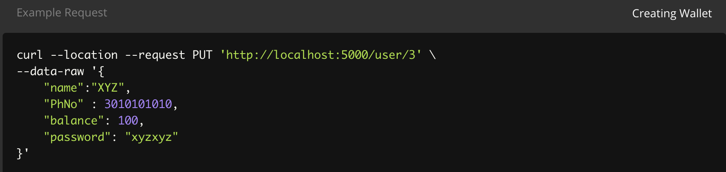](https://user-images.githubusercontent.com/42965936/118037151-1808fb80-b38b-11eb-965f-91de630b8a43.png)

**Logging in to a wallet**

POST Request for Logging into a wallet.  
This POST request is to login to a particular account. The form sent should contain -

1.ID   
2.Password   
3.remember = True   
BODY formdata   
ID 1   
password admin   
remember True

[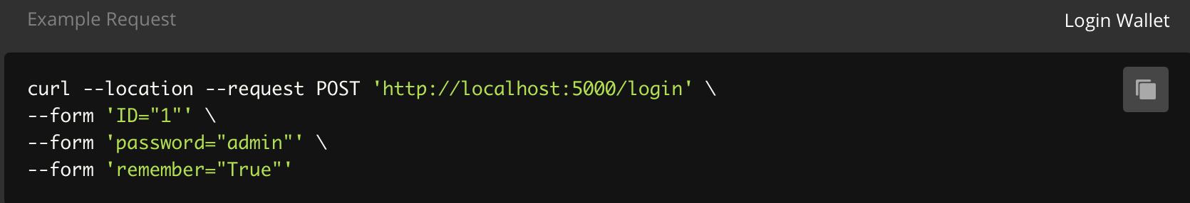](https://user-images.githubusercontent.com/42965936/118037322-50103e80-b38b-11eb-82f9-6b071e1c6eb9.png)

**Check Balance**

GET Request to check Balance   
This GET request requests for the balance of any user The URL must contain the ID of the user whose wallet balance must be checked

[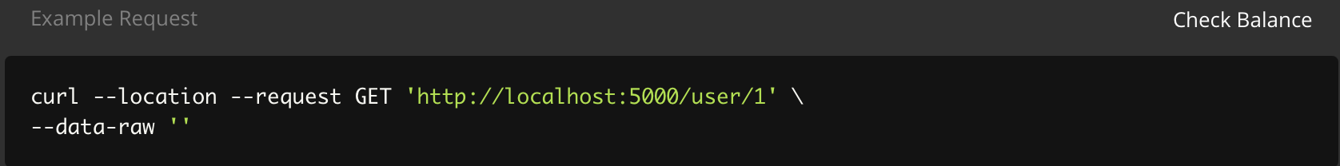](https://user-images.githubusercontent.com/42965936/118037353-5b636a00-b38b-11eb-8237-91bbd6d5c1f9.png)

**Debit Wallet**

PATCH Request for Debiting Wallet   
This PATCH request debits the wallet of the logged in user with a certain amount of money. The form must contain the amount to be debited. If the balance of the user wallet goes below the minimum balance, the amount will not be debited.

BODY raw { "amount":20 }

[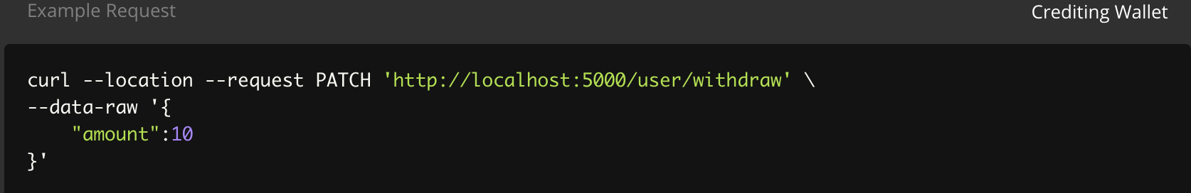](https://user-images.githubusercontent.com/42965936/118037767-eb091880-b38b-11eb-8b0a-76f7eb815111.png)

**Credit Wallet**

PATCH Request for Crediting Wallet.  
This PATCH request credits the wallet of the logged in user with a certain amount of money. The form must contain the amount to be credited.

BODY raw { "amount":10 }

[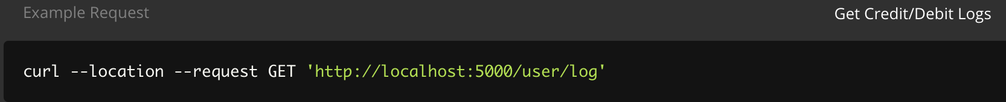](https://user-images.githubusercontent.com/42965936/118037923-17bd3000-b38c-11eb-9b48-385065219a22.png)

**Get credit and Debit Logs**

GET Request to get Credit/Debit Logs .  
This GET request gets all the credit and debit logs made by the logged in user. [](https://user-images.githubusercontent.com/42965936/118037942-1e4ba780-b38c-11eb-8613-15dd2e912af7.png)