 

**INSTITUTE FOR ADVANCED COMPUTING ANDSOFTWARE DEVELOPMENT (IACSD), AKURDI, PUNE**

Documentation On

Roadmate

(Making the trip easy and adventurous)

PG-DAC March 2023

# Submitted By:

Group No: 100

Roll No. Name:

233218 Sourabh Tanaji Deshmukh

233125 Akanksha Parihar

Mrs. Monika Ma’am

# Mrs. Harshal Sir Mr. Rohit Puranik

Project Guide Centre Coordinator

# ABSTRACT

Roadmate is a project to provide necessary functionalities to the customers to find and select their travel companions. This project is basically divided into 3 modules and can be titled as front end, back end and database. Also, Spring Security is used to provide authentication and authorization with the objective to improve data security.

This web project has applied standard ‘SOLID Principles’ by maintaining Separation Of Concern and Interface Segregation concepts. To attract more customers, the proposed application also provides attractive Graphical User Interface (GUI) implemented by ReactJS Libraries. As the project involves structured data and fixed schemas, MySQL is used as the database, which is quite preferred for its efficient queries & access.

# ACKNOWLEDGEMENT

I take this occasion to thank God, almighty for blessing us with his grace and taking our endeavor to a successful culmination. I extend my sincere and heartfelt thanks to our esteemed guide, Mrs. Monika Ma’am and Mrs.Harshal Sir for providing me with the right guidance and advice at the crucial juncture sand for showing me the right way. I extend my sincere thanks to our respected Centre Co-Ordinator Mr. Rohit Puranik, for allowing us to use the facilities available. I would like to thank the other faculty members also, at this occasion. Last but not the least, I would like to thank my friends and family for the support and encouragement they have given me during the course of our work.

#### Sourabh Tanaji Deshmukh (223218)

Akanksha Parihar (223096)

# Table of Contents

ABSTRACT 02

ACKNOWLEDGEMENT 03

INTRODUCTION 06

1 FEATURES 07

* 1. 1.1 PROJECT OBJECTIVE 07
  2. 1.2 PROJECT OVERVIEW 07
  3. 1.3 PROJECT SCOPE 07
  4. 1.4 STUDY OF THE SYSTEM 08
     1. 1.4.1 MODULES 08

1. SYETEM ANALYSIS 09
   1. 2.1 PROPOSED SYSTEM 09
   2. 2.2 SYSTEM REQUIREMENT SPECIFICATION 10
      1. 2.2.1 FUNCTIONAL REQUIREMENTS 10
      2. 2.2.2 NON FUNCTIONAL REQUIREMENTS 13

3 DIAGRAMS

3.1 USE CASE DIAGRAM …16

3.2 ER DIAGRAM …18

3.3 CLASS DIAGRAM …20

3.4 ACTIVITY DIAGRAM …21

3.5 DATA FLOW DIAGRAM …22

3.6 DEPLOYMENT DIAGRAM …23

3.7 SEQUENCE DIAGRAM …23

4 TABLE STRUCTURE 24

5 PROJECT DIAGRAMS 29

6 CONCLUSION 38

7 REFERENCES 39

**LIST OF FIGURES**

#### FIGURE 1: UML USE CASE DIAGRAM 11

FIGURE 2: E-R DIAGRAM 13

#### FIGURE 3: CLASS DIAGRAM 15

FIGURE 4: ACTIVITY DIAGRAM 23

#### FIGURE 5: 0 LEVEL DATA FLOW DIAGRAM 24

FIGURE 6: 1 LEVEL DATA FLOW DIAGRAM 25

#### FIGURE 7: DEPLOYMENT DIAGRAM 26

FIGURE 8: SEQUENCE DIAGRAM 27

# INTRODUCTION

Nowadays, the excitement of the customers for clothes shopping is getting crushed by crowdie malls, the long lines involved in the manual process of payments & what not. This is why many customers are opting to enjoy shopping from home instead of shopping at malls, shops etc.

This document includes Software Requirements Specification which is built to describe the agreement between the customer and the developer regarding the specification of the software requested for ‘Roadmate Website’. Its primary purpose is to provide a clear and descriptive ‘Statement of User Requirements’ that can be used as a reference in further development of the software system. This document is broken into a number of sections used to logically separate the whole content for the ease of reference. This Software Requirements Specification aims to describe the Assumptions, Constraints, Scope of Software to be developed, Functional Requirements, Non-Functional Requirements, various diagrams used while software development related to software described throughout the rest of the document.

This SRS describes, in clear terms, the software’s primary uses and required functionality needed to general customer. This project of developing a hazel –free online portal for finding the travel companion by providing separate portals for both riders & Admins.

## 1 FEATURES

## 1.1 PROJECT OBJECTIVE

Many people find bike riding as their hobby so Roadmate is an application which will help the riders to get along with all other riders on the same route. As travelling alone can be risky and boring so by getting a group of people who are also going for bike ride on the same route can be a good way of communication with strangers and continue to explore new places in an effective manner. By using this application, rider can plan for a trip by mentioning the duration so that he/she can plan accordingly. This application will also help the new riders to get the feedbacks of the experienced riders who had already went through that route in past days. The application also provides facilities like hotels, restaurants available so that the rider can search for the hotels to stay and rest for some time. This application is a one stop solution which will provide a rider all the necessities that he/she may require in his road trip.

## 1.2 PROJECT SCOPE

This application allows riders to search for a company by logging into the website and provides the details regarding the journey. One can also register himself/herself so that anyone who is willing to go for a ride can also join him. The application also provides the riders with some facilities like hotels, restrooms, and restaurants available in the way so that if they want to rest for some time then they can search for the available options.

## .

## 1.3 STUDY OF THE SYSTEM

## 1.3.1 MODULES:

The system after careful analysis has been identified to be presented with the following modules and roles.

The modules involved are:

* + - * Rider:-

The rider can browse through the various services available on the website. The authenticated (valid) Rider can add their planned trip details .Rider can also browse to find another rider available on a particular route.

* + - * Admin :-

The admin have the authority of deleting any rider from the portal. He/she also can delete the reviews given by the riders if needed.

# 

# 2 SYSTEM ANALYSIS

System analysis is the process of gathering and interpreting facts, diagnosing problems, and using the information to recommend improvements on the system. System analysis is a problem-solving activity that requires intensive communication between the system users and system developers.

System analysis or study is an important phase of any system development process. The system is viewed as a whole, the inputs are identified, and the system is subjected to close study to identify the problem areas. The solutions are given as a proposal. The proposal is reviewed on user request and suitable changes are made. This loop ends as soon as the user is satisfied with the proposal.

## 2.1 PROPOSED SYSTEM

The proposed web application provides following functionalities in order to attract more customers for buying clothes online.

* + - The whole web application is hassle-free and provided best GUI.
    - Security of the data is maintained properly by using in built Spring Security.
    - Conditional Rendering is also used in order to achieve selective response generation.
    - As it’s an online web application and available for 24 x 7, customers may enjoy the shopping without any time constraints.

# 2.2 SYSTEM REQUIREMENT SPECIFICATION

### **2.2.1 FUNCTIONAL REQUIREMENTS**

**Registration:**

Users would be able to register by providing their email, username, and password.

**Login Credentials:**

Users would be able to log in using their registered email and password.

**Adding trips:**

After Login the user can add the trip details like source, destination and date of trip.

**Searching Riders:**

The riders can search for any other person using the same route in order to have company.

**Services:**

User who is travelling alone or in group may need assistance during the journey. So in the Roadmate there are several services like hotels, garages, trip planners etc that are available so that the user can take the help of the map or guide to get the distance and approx. time needed to cover the distance. There are also some emergency contact that a person need during the trip.

**Feedbacks:**

The riders who have gone on a road trip can share their experience so that the new rider can access it before planning for the trip.

### **2.2.2 NON - FUNCTIONAL REQUIREMENTS**

Roadmate website will provide the following non – functional requirements:-

* + 1. Interface :-

~ Roadmate must provide user interactive interface in order to attract more users.

~ The application should use best available attractive colour shade

combinations.

### Performance:-

~ Number of Concurrent Users: - The application must handle maximum

number of requests.

### Security:-

~ The Roadmate website must provide maximum level of

security regarding data.

~ The data of the users, product details, valuable feedbacks, login credentials

must be protected in order to maintain high customer satisfaction.

~ The application must provide separation via Authorization &

Authentication.

### Availability:-

~ Roadmate must be available 24 X 7 i.e. throughout the day & night, so that Riders can browse and use the application all the time.

### Reliability:-

~ The specified application must be reliable, especially at the time of

weekend, festival days, year endings etc.

~ The application must be reliable in the perspective of login / payment

failures also.

### Safety:-

~ The online application must be saved against session fixations / SQL

injection etc. malicious attacks.

~ The whole software must use firewall configurations in order to safeguard

the application.

### Maintainability:-

~ The Roadmate website should be able to maintain with as little efforts & changes as possible.

### Portability:-

~ The specified application must provide portability in order to change

components of architecture in case of emergencies.

~ It should hazel – free facility to replace the databases to enhance the

efficiency in needed in future. Like replacement from MYSQL to Oracle or

MYSQL to MongoDB.

### Accessibility:-

~ The online website must be accessible via desktops, laptops, smart devices

including mobile phones, tablets etc.

~ The UI – UX must not hamper in case of above options. It should remain

uniform throughout all the devices.

### Durability:-

~ The overall application should be durable, especially in the terms of data, and uniform performance over time.

### Other Requirements:-

* Hardware: - The application is expected to function on Dell G3 – 15 with 1100 MHz Pre Processor Equivalent Or Above, 4 GB RAM, 512 GB HDD.

### Software: - The Roadmate website shall work on Microsoft Windows operating systems family (MS Windows XP & Above). It configures to work with MYSQL database. This System works on Apache Tomcat server. It uses browser Google Chrome Browser.

# 3 DIAGRAMS

### **3.1 USE CASE DIAGRAM:-**

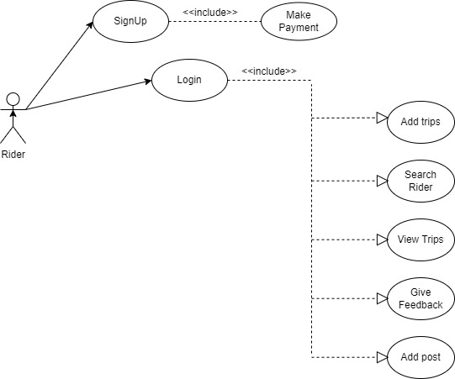

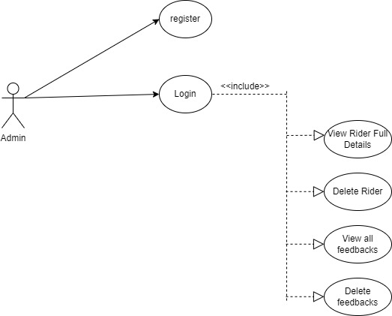

Fig. 1 : UML Use Case Diagram

### **3.2. E-R DIAGRAM:-**

Entity Relationship Diagram is used to define the data elements and relationship for a specified application. It develops a conceptual design for the database. It also develops a very simple and easy to design view of the data.

In Entity Relationship Diagram, the data is represented by using various components including entities, attributes, relationships (One To Many / Many To Many etc.)

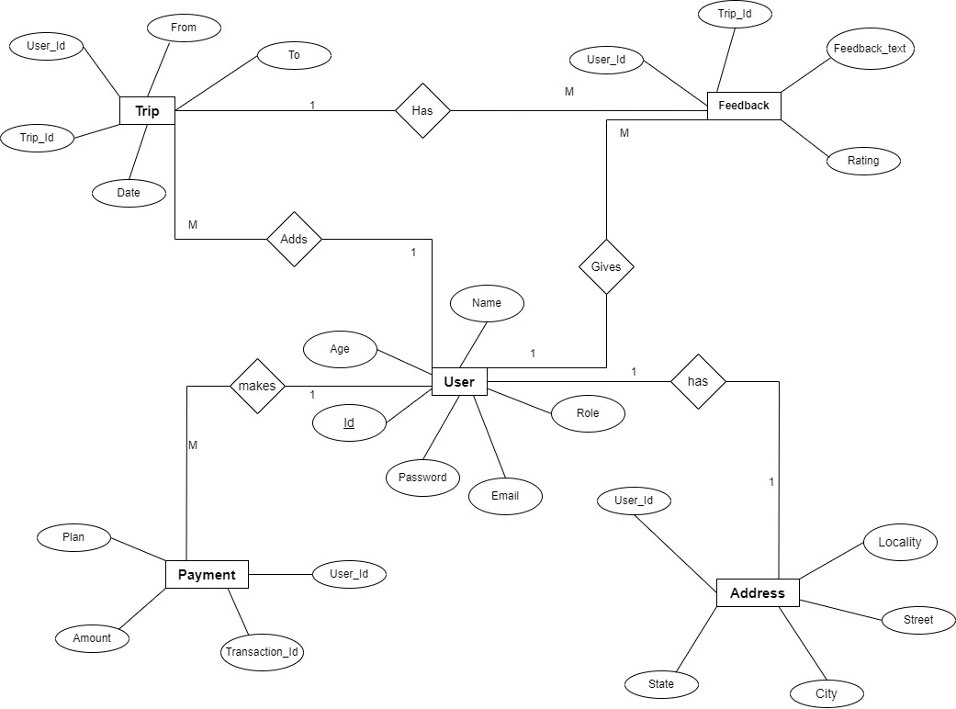

### Fig. 2 : ER Diagram

### **3.3. CLASS DIAGRAM:-**

Class diagram is a static diagram. It represents the static view of an application. Class diagram is not only used for visualizing, describing, and documenting different aspects of a system but also for constructing executable code of the software application. Class diagram describes the attributes and operations of a class and also the constraints imposed on the system. The class diagrams are widely used in the modeling of object oriented systems because they are the only UML diagrams, which can be mapped directly with object-oriented languages.

Class diagram shows a collection of classes, interfaces, associations, collaborations, and constraints. It is also known as a structural diagram. The purpose of the class diagram can be summarized as:-

1. Analysis and design of the static view of an application.
2. Describe responsibilities of a system.
3. Base for component and deployment diagrams.
4. Forward and reverse engineering.

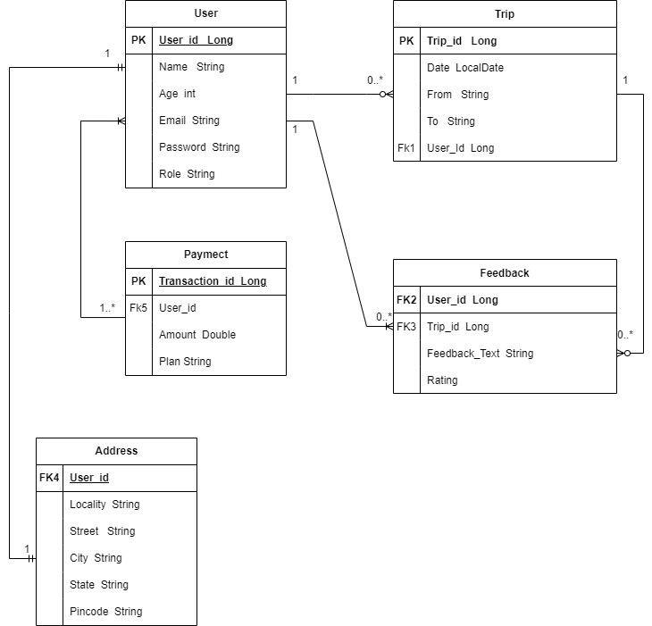

Fig. 3 : Class Diagram

### **3.4. ACTIVITY DIAGRAM:-**

### 

### Fig. 4 : Activity Diagram

### **3.5. DATA FLOW DIAGRAMS:-**

### 

### 

### Fig. 5: Zero Level Data Flow Diagram

### First Level DFD.png

### Fig. 6: First Level Data Flow Diagram

### 

**3.5. SEQUENCE DIAGRAM:**

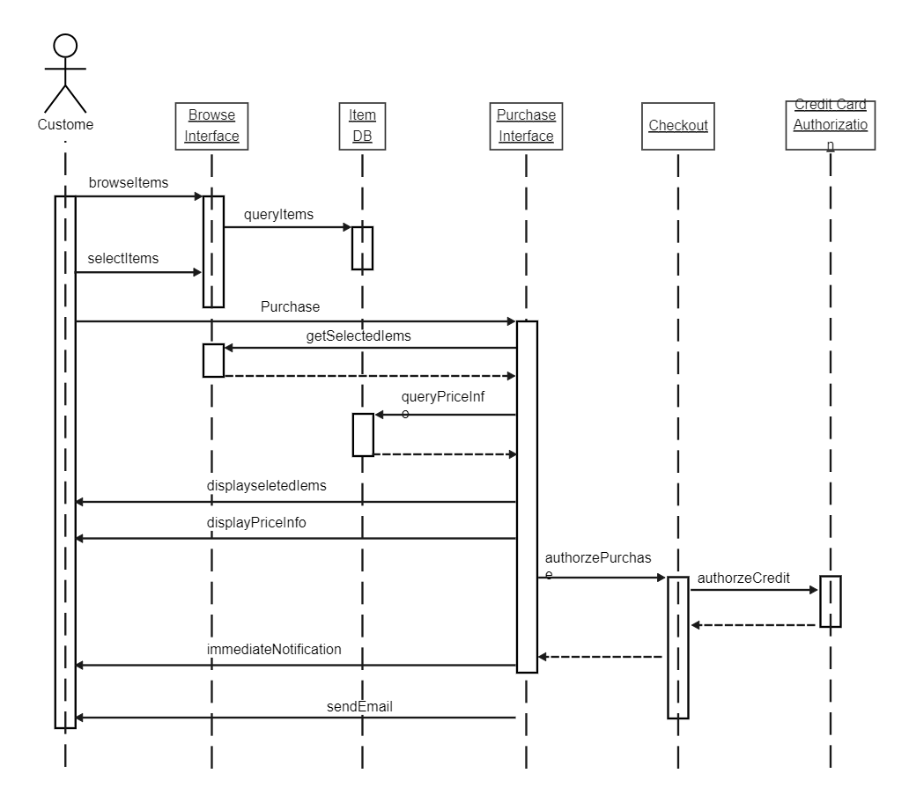

### Fig. 8: Sequence Diagram

# 4 TABLE STRUCTURES

Roadmate Application generate following tables in the database:-

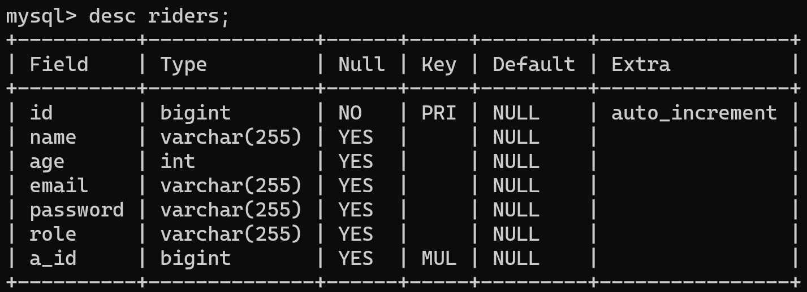

## 

## 

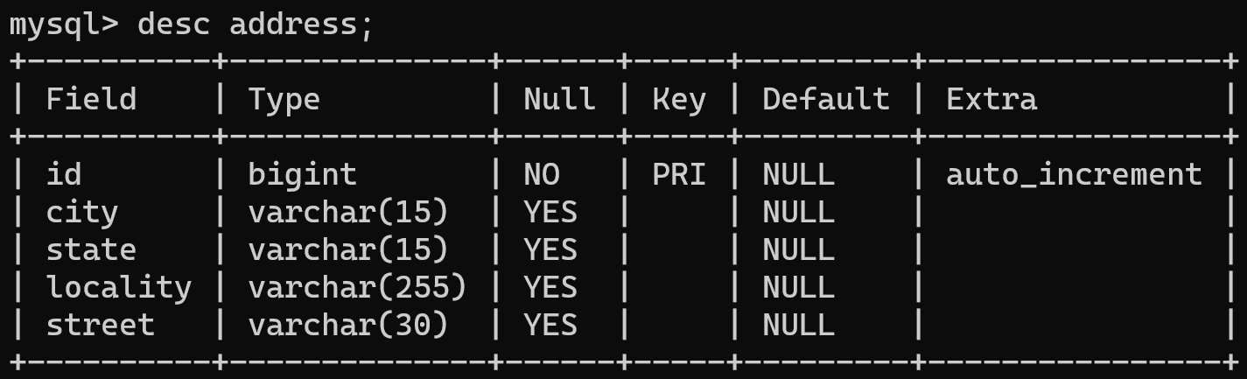

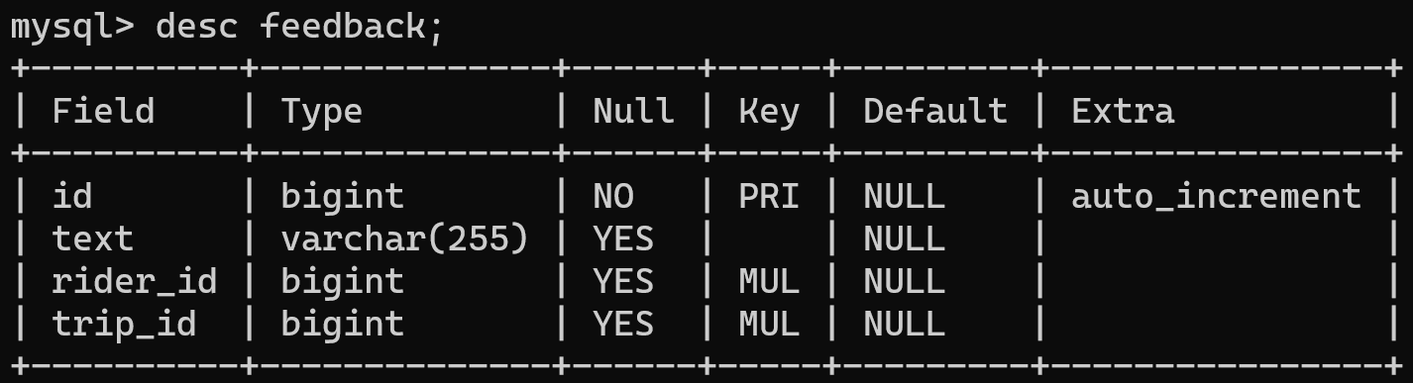

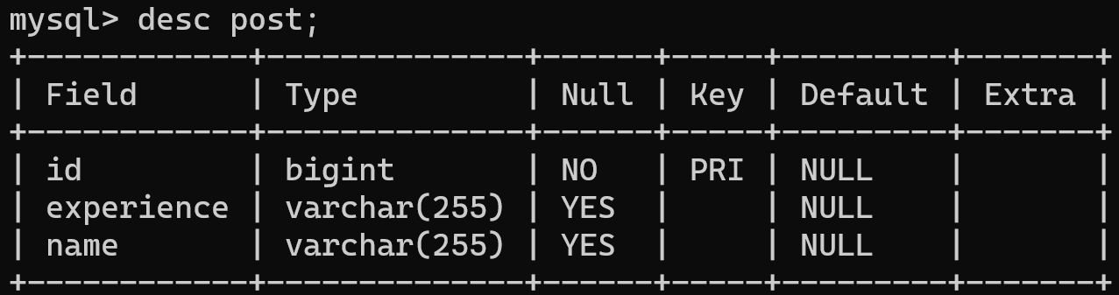

# 5 PROJECT DIAGRAMS

# Home Page

# 

# Sign up:-

# 

# 

# Sign in:-

# 

# After Login:-

# 

# Add trip details:-

# 

# Search riders on your route:-

# 

# Services:-

# 

# Add post :-

# 

# Contact us:-

# 

# 

## REFERENCE

Following references are considered throughout the development of Roadmate Application:-

* + https:/[/www.tutorialspoint.com/java](http://www.tutorialspoint.com/java/)/
  + <http://www.javatpoint.com/java-tutorial>
  + https://docs.oracle.com/javase/tutorial/
  + <http://www.tutorialspoint.com/mysql/>
  + <https://stackoverflow.com/>