Aim: Execute DDL/DML statements which demonstrate the use of views. Update the base table using its corresponding view. Also consider restrictions on updatable views and perform view creation from multiple tables.

Objectives:
- To create view and retrieve data from tables using view.
- To understand restriction on implementation of views.
- To compare between view and table.

Theory:
What is SQL?
SQL stands for Structured Query Language. It is a standardized programming
language used to manage and manipulate relational databases. It enables users to
perform a variety of tasks such as querying data, creating and modifying database
structures, and managing access permissions. SQL is widely used across various
relational database management systems such as MySQL.
SQL commands are essential for managing databases effectively. These commands are
divided into categories such as Data Definition Language (DDL), Data Manipulation
Language (DML), Data Control Language (DCL), Data Query Language (DQL), and
Transaction Control Language (TCL).
SQL Commands are like instructions to a table. It is used to interact with the database
with some operations. It is also used to perform specific tasks, functions, and queries of
data. SQL can perform various tasks like creating a table, adding data to tables,
dropping the table, modifying the table, set permission for users.
Data Definition Language (DDL) in SQL
DDL or Data Definition Language actually consists of the SQL commands that can
be used to defining, altering, and deleting database structures such as tables, indexes,
and schemas. It simply deals with descriptions of the database schema and is used
to create and modify the structure of database objects in the database
Data Manipulation Language (DML) in SQL
The SQL commands that deal with the manipulation of data present in the database
belong to DML or Data Manipulation Language and this includes most of the SQLstatements. It is the component of the SQL statement that controls access to data and
to the database. Basically, DCL statements are grouped with DML statements.
What is View?
In SQL, a view is a virtual table based on the result-set of an SQL statement. A view contains rows and columns, just like a real table. The fields in a view are fields from one or more real tables in the database. You can add SQL functions, WHERE, and JOIN statements to a view and present the data as if the data were coming from one single table.

CREATE VIEW Syntax
CREATE VIEW view_name AS
SELECT column1, column2, ...
FROM table_name
WHERE condition;
In SQL, a table is the foundational structure for persistent data storage. It's where you physically organize your data into rows and columns. When you perform operations like CREATE TABLE, INSERT, UPDATE, or DELETE, you're directly interacting with the stored data within these tables.
A view, however, is a virtual table derived from one or more base tables through a stored SQL query (defined using CREATE VIEW). It doesn't hold any data on its own. Instead, when you query a view using SELECT, the database executes the underlying query on the base tables and presents you with the results as if it were a table. Views are incredibly useful for simplifying complex queries, providing a level of data abstraction, and implementing security by limiting access to specific data without altering the base tables. Think of a view as a pre-packaged, customized way of looking at the data stored in your tables.
Conclusion:
- We have learnt how to create an updatable view and how to update data in the underlying table through the view.
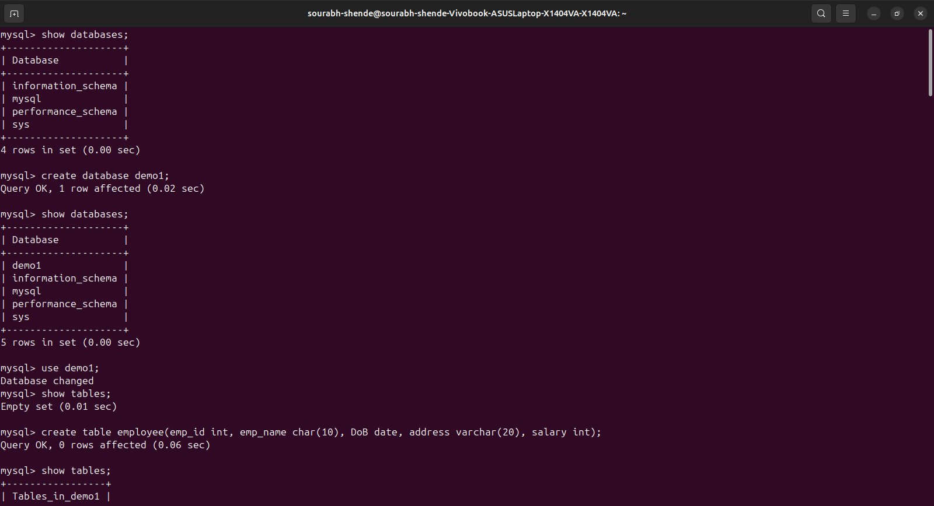
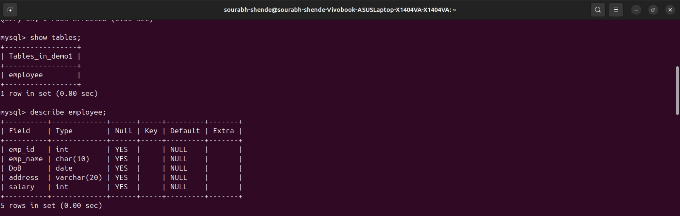
- We have learnt how to manage views in MySQL including displaying, modifying, and removing views.
