ASSIGNMENT NO : 2A

PROGRAM: Name: Sourabh Shende Roll No: 51
#include <stdio.h>
#include <stdlib.h>
#include <unistd.h>
#include <sys/wait.h>

void bubbleSort(int arr[], int n) {
for(int i=0; i<n-1; i++) {
for(int j=0; j<n-1-i; j++) {
if(arr[j] > arr[j+1]) {
int temp = arr[j];
arr[j] = arr[j+1];
arr[j+1] = temp;
}
}
}
}

void selectionSort(int arr[], int n) {
for(int i=0; i<n-1; i++) {
int min_idx = i;
for(int j=i+1; j<n; j++) {
if(arr[j] < arr[min_idx])
min_idx = j;
}
int temp = arr[min_idx];
arr[min_idx] = arr[i];
arr[i] = temp;
}
}

void printArray(int arr[], int n) {
for(int i=0; i<n; i++)
printf("%d ", arr[i]);
printf("\n");
}

int main() {
int n;
printf("Enter number of integers: ");
scanf("%d", &n);

int *arr = malloc(n * sizeof(int));
if(!arr) {
perror("malloc failed");
return 1;
}

printf("Enter %d integers:\n", n);
for(int i=0; i<n; i++)
scanf("%d", &arr[i]);

pid_t pid = fork();

if(pid < 0) {
perror("fork failed");
free(arr);
return 1;
}
else if(pid == 0) {
// Child process
printf("\n[Child] PID: %d, Parent PID: %d\n", getpid(), getppid());

int *childArr = malloc(n * sizeof(int));
for(int i=0; i<n; i++)
childArr[i] = arr[i];

selectionSort(childArr, n);

printf("[Child] Sorted array (Selection Sort): ");
printArray(childArr, n);

free(childArr);

printf("[Child] Exiting now.\n");
exit(0);
}
else {
// Parent process
printf("\n[Parent] PID: %d, Child PID: %d\n", getpid(), pid);

bubbleSort(arr, n);

// Uncomment below wait() to avoid zombie; comment out to see zombie process
int status;
wait(&status);

printf("[Parent] Child terminated. Parent sorting result:\n");
printf("[Parent] Sorted array (Bubble Sort): ");
printArray(arr, n);

// Sleep to observe orphan if child sleeps longer than parent
printf("[Parent] Sleeping for 10 seconds...\n");
sleep(10);

printf("[Parent] Parent exiting.\n");
free(arr);
return 0;
}
}

OUTPUT:
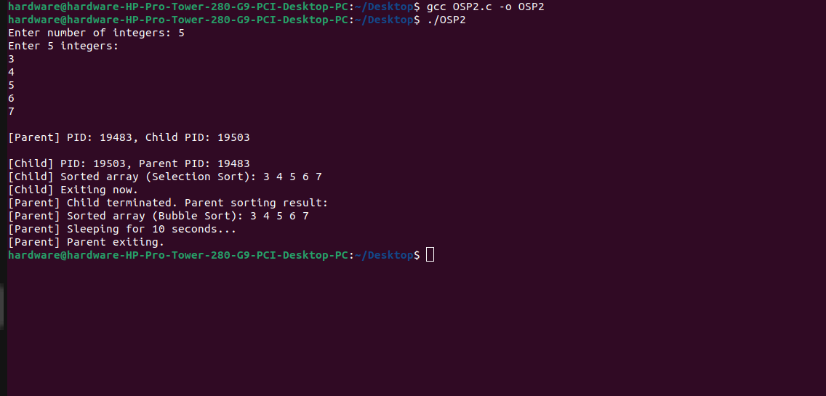
ASSIGNMENT NO : 2B

PROGRAM: Name: Sourabh Shende Roll No: 51
#include <stdio.h>
#include <stdlib.h>
#include <unistd.h>
#include <sys/wait.h>
#include <string.h>

void bubble_sort(int arr[], int n) {
for (int i = 0; i < n - 1; i++) {
for (int j = 0; j < n - i - 1; j++) {
if (arr[j] > arr[j + 1]) {
int temp = arr[j];
arr[j] = arr[j + 1];
arr[j + 1] = temp;
}
}
}
}

int main() {
int n;

printf("Enter array size: ");
scanf("%d", &n);

int arr[n];
printf("Enter %d integers:\n", n);
for (int i = 0; i < n; i++) {
scanf("%d", &arr[i]);
}

bubble_sort(arr, n);

printf("Parent sorted array: ");
for (int i = 0; i < n; i++) {
printf("%d ", arr[i]);
}
printf("\n");

char *args[n + 2];
char str_arr[n][10];

args[0] = "./child";

for (int i = 0; i < n; i++) {
sprintf(str_arr[i], "%d", arr[i]);
args[i + 1] = str_arr[i];
}
args[n + 1] = NULL;

pid_t pid = fork();

if (pid < 0) {
perror("Fork failed");
exit(1);
}
else if (pid == 0) {
if (execve(args[0], args, NULL) == -1) {
perror("Execve failed");
exit(1);
}
}
else {
wait(NULL);
printf("Parent: Child process completed.\n");
}

return 0;
}

OUTPUT:
