ASSIGNMENT NO : 4A

PROGRAM: Name: Sourabh Shende Roll No: 51

#include <pthread.h>
#include <semaphore.h>
#include <stdlib.h>
#include <stdio.h>

#define MaxItems 5
#define BufferSize 5

sem_t empty;
sem_t full;
int in = 0;
int out = 0;
int buffer[BufferSize];
pthread_mutex_t mutex;

void *producer(void *pno) {
int item;
for (int i = 0; i < MaxItems; i++) {
item = rand() % 100;
sem_wait(&empty);
pthread_mutex_lock(&mutex);
buffer[in] = item;
printf("Producer %d: Insert Item %d at position %d\n", *((int *)pno), buffer[in], in);
in = (in + 1) % BufferSize;
pthread_mutex_unlock(&mutex);
sem_post(&full);
}
return NULL;
}

void *consumer(void *cno) {
for (int i = 0; i < MaxItems; i++) {
sem_wait(&full);
pthread_mutex_lock(&mutex);
int item = buffer[out];
printf("Consumer %d: Remove Item %d from position %d\n", *((int *)cno), item, out);
out = (out + 1) % BufferSize;
pthread_mutex_unlock(&mutex);
sem_post(&empty);
}
return NULL;
}

int main() {
pthread_t pro[5], con[5];
pthread_mutex_init(&mutex, NULL);
sem_init(&empty, 0, BufferSize);
sem_init(&full, 0, 0);

int id[5] = {1, 2, 3, 4, 5};

for (int i = 0; i < 5; i++) {
pthread_create(&pro[i], NULL, producer, (void *)&id[i]);
}
for (int i = 0; i < 5; i++) {
pthread_create(&con[i], NULL, consumer, (void *)&id[i]);
}
for (int i = 0; i < 5; i++) {
pthread_join(pro[i], NULL);
}
for (int i = 0; i < 5; i++) {
pthread_join(con[i], NULL);
}
pthread_mutex_destroy(&mutex);
sem_destroy(&empty);
sem_destroy(&full);

return 0;
}

OUTPUT:
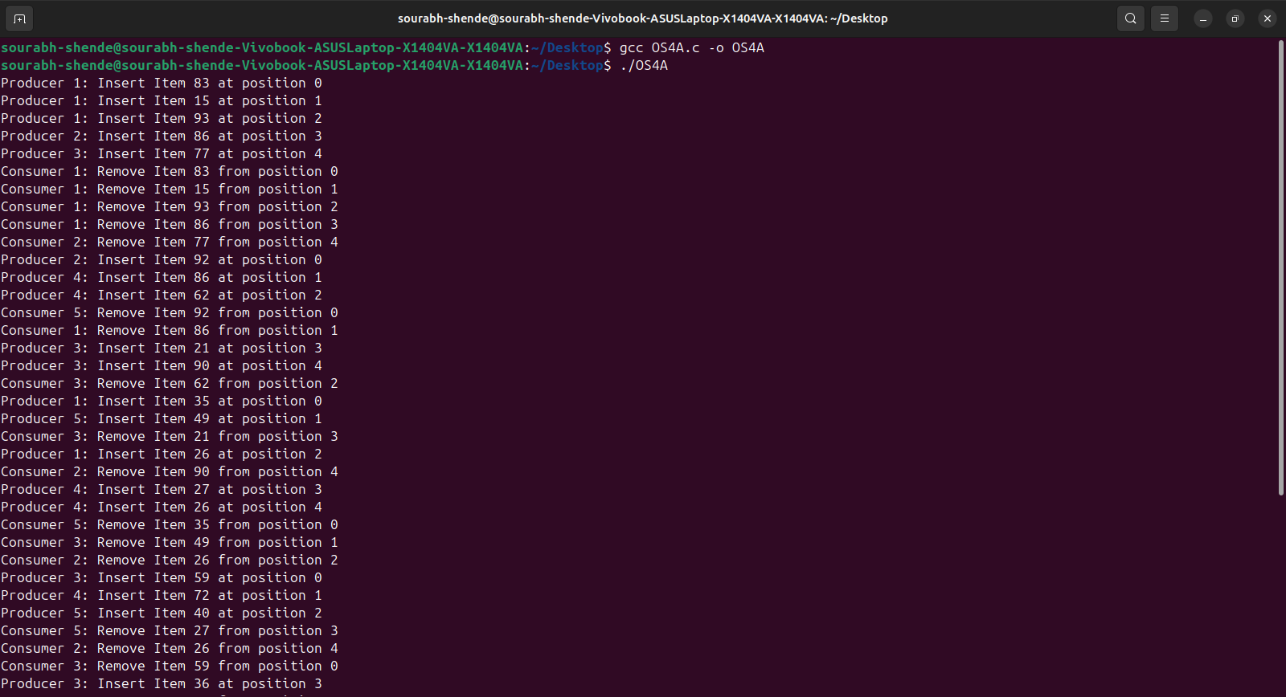
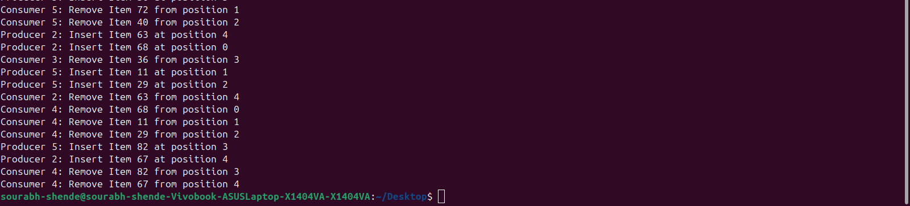
ASSIGNMENT NO : 4B

PROGRAM: Name: Sourabh Shende Roll No: 51

#include <pthread.h>
#include <semaphore.h>
#include <stdio.h>

sem_t wrt;
pthread_mutex_t mutex;
int cnt = 1;
int numreader = 0;

void *writer(void *wno) {
sem_wait(&wrt);
cnt = cnt * 2;
printf("Writer %d modified count to %d\n", *((int *)wno), cnt);
sem_post(&wrt);
return NULL;
}

void *reader(void *rno) {
pthread_mutex_lock(&mutex);
numreader++;
if (numreader == 1) {
sem_wait(&wrt);
}
pthread_mutex_unlock(&mutex);

printf("Reader %d: read count as %d\n", *((int *)rno), cnt);

pthread_mutex_lock(&mutex);
numreader--;
if (numreader == 0) {
sem_post(&wrt);
}
pthread_mutex_unlock(&mutex);
return NULL;
}

int main() {
pthread_t read[10], write[5];
pthread_mutex_init(&mutex, NULL);
sem_init(&wrt, 0, 1);

int a[10] = {1,2,3,4,5,6,7,8,9,10};

for (int i = 0; i < 10; i++) {
pthread_create(&read[i], NULL, reader, (void *)&a[i]);
}
for (int i = 0; i < 5; i++) {
pthread_create(&write[i], NULL, writer, (void *)&a[i]);
}
for (int i = 0; i < 10; i++) {
pthread_join(read[i], NULL);
}
for (int i = 0; i < 5; i++) {
pthread_join(write[i], NULL);
}

pthread_mutex_destroy(&mutex);
sem_destroy(&wrt);

return 0;
}

OUTPUT:
