ASSIGNMENT NO : 5

PROGRAM: Name: Sourabh Shende Roll No: 51

#include<stdio.h>
int main() {
/* array will store at most 5 process with 3 resoures if your process or
resources is greater than 5 and 3 then increase the size of array */
int p, c, count = 0, i, j, alc[5][3], max[5][3], need[5][3], safe[5], available[3], done[5], terminate = 0;
printf("Enter the number of process and resources");
scanf("%d %d", & p, & c);
// p is process and c is diffrent resources
printf("enter allocation of resource of all process %dx%d matrix", p, c);
for (i = 0; i < p; i++) {
for (j = 0; j < c; j++) {
scanf("%d", & alc[i][j]);
}
}
printf("enter the max resource process required %dx%d matrix", p, c);
for (i = 0; i < p; i++) {
for (j = 0; j < c; j++) {
scanf("%d", & max[i][j]);
}
}
printf("enter the available resource");
for (i = 0; i < c; i++)
scanf("%d", & available[i]);

printf("\n need resources matrix are\n");
for (i = 0; i < p; i++) {
for (j = 0; j < c; j++) {
need[i][j] = max[i][j] - alc[i][j];
printf("%d\t", need[i][j]);
}
printf("\n");
}
/* once process execute variable done will stop them for again execution */
for (i = 0; i < p; i++) {
done[i] = 0;
}
while (count < p) {
for (i = 0; i < p; i++) {
if (done[i] == 0) {
for (j = 0; j < c; j++) {
if (need[i][j] > available[j])
break;
}
//when need matrix is not greater then available matrix then if j==c will true
if (j == c) {
safe[count] = i;
done[i] = 1;
/* now process get execute release the resources and add them in available resources */
for (j = 0; j < c; j++) {
available[j] += alc[i][j];
}
count++;
terminate = 0;
} else {
terminate++;
}
}
}
if (terminate == (p - 1)) {
printf("safe sequence does not exist");
break;
}

}
if (terminate != (p - 1)) {
printf("\n available resource after completion\n");
for (i = 0; i < c; i++) {
printf("%d\t", available[i]);
}
printf("\n safe sequence are\n");
for (i = 0; i < p; i++) {
printf("p%d\t", safe[i]);
}
}

return 0;
}

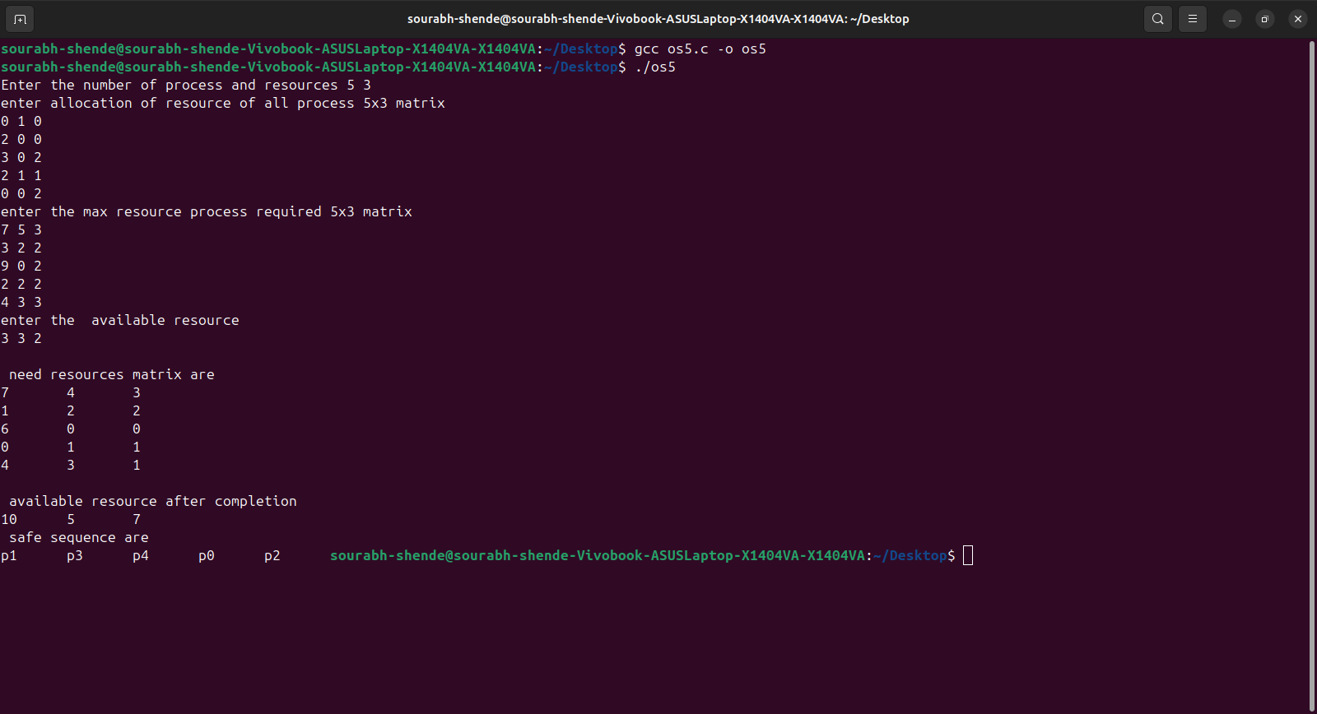
OUTPUT:

