ASSIGNMENT NO : 7A

PROGRAM: Name: Sourabh Shende Roll No: 51
#include <stdio.h>
#include <unistd.h>
#include <sys/stat.h>
#include <fcntl.h>
#include <string.h>
#define Max_Buff 1024

int main() {
int fd1, fd2, c = 0;
char *myfifo1 = "myfifo1";
char *myfifo2 = "myfifo2";
char buff[Max_Buff];
char str;
int res;

// Create both FIFOs if they don't exist
res = mkfifo(myfifo1, 0777);
if (res == -1) {
perror("Pipe 1 not created or already exists");
}
res = mkfifo(myfifo2, 0777);
if (res == -1) {
perror("Pipe 2 not created or already exists");
}

printf("Enter the string (end with #):\n");
while ((str = getchar()) != '#') {
if (c < Max_Buff - 1)
buff[c++] = str;
}
buff[c] = '\0';

// Open FIFO1 for writing
fd1 = open(myfifo1, O_WRONLY);
if (fd1 == -1) {
perror("Error opening fifo1");
return 1;
}
write(fd1, buff, strlen(buff) + 1);
close(fd1);

// Open FIFO2 for reading
fd2 = open(myfifo2, O_RDONLY);
if (fd2 == -1) {
perror("Error opening fifo2");
return 1;
}
read(fd2, buff, Max_Buff);
printf("\nContents read from fifo2:\n%s\n", buff);
close(fd2);

// Remove the FIFOs after use
unlink(myfifo1);
unlink(myfifo2);

return 0;
}

OUTPUT:
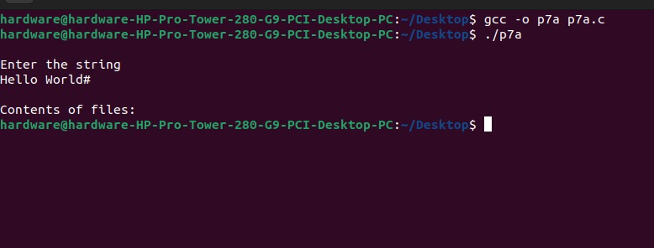
ASSIGNMENT NO : 7B

PROGRAM: Name: Sourabh Shende Roll No: 51

#include <stdio.h>
#include <stdlib.h>
#include <unistd.h>
#include <sys/shm.h>
#include <sys/stat.h>
#include <sys/wait.h>

#define SZ 4096

int main() {
int shm_id;
int *shm_ptr;
int data;
int ret_val;
pid_t pid;

shm_id = shmget(IPC_PRIVATE, SZ, IPC_CREAT | 0666);
if (shm_id < 0) {
perror("shmget error");
exit(EXIT_FAILURE);
}
printf("Shared memory created.\n");
printf("Shared memory id: %d\n", shm_id);

shm_ptr = (int *)shmat(shm_id, NULL, 0);
if (shm_ptr == (void *)-1) {
perror("shmat error");
shmctl(shm_id, IPC_RMID, NULL);
exit(EXIT_FAILURE);
}
printf("Shared memory attached at address: %p\n", (void *)shm_ptr);

printf("Enter the data: ");
scanf("%d", &data);
*shm_ptr = data;

pid = fork();
if (pid < 0) {
perror("fork error");
shmdt(shm_ptr);
shmctl(shm_id, IPC_RMID, NULL);
exit(EXIT_FAILURE);
} else if (pid == 0) {
int *child_shm_ptr = (int *)shmat(shm_id, NULL, 0);
if (child_shm_ptr == (void *)-1) {
perror("Child shmat error");
exit(EXIT_FAILURE);
}
printf("Child: Shared memory attached at address: %p\n", (void *)child_shm_ptr);
printf("Child: Data read from shared memory: %d\n", *child_shm_ptr);

ret_val = shmdt(child_shm_ptr);
if (ret_val == 0) {
printf("Child: Shared memory successfully detached.\n");
} else {
perror("Child shmdt error");
}
exit(EXIT_SUCCESS);
} else {
wait(NULL);

ret_val = shmdt(shm_ptr);
if (ret_val == 0) {
printf("Parent: Shared memory successfully detached.\n");
} else {
perror("Parent shmdt error");
}

ret_val = shmctl(shm_id, IPC_RMID, NULL);
if (ret_val == 0) {
printf("Parent: Shared memory segment removed.\n");
} else {
perror("shmctl IPC_RMID error");
}
}
return 0;
}

OUTPUT:
