PROGRAM: Name: Sourabh Shende
Roll No:

#!/bin/bash

FILENAME="address_book.txt"

# Clear the existing file or create a new empty one
create_address_book() {
> "$FILENAME"
echo "Address book created."
}

# View the address book content
view_address_book() {
if [ ! -f "$FILENAME" ]; then
echo "Address book does not exist!"
return
fi

if [ ! -s "$FILENAME" ]; then
echo "Address book is empty."
return
fi

echo "---- Address Book ----"
cat "$FILENAME"
echo "----------------------"
}

# Insert a new contact record
insert_record() {
echo "Enter the name:"
read name
echo "Enter the address:"
read address
echo "Enter the phone number:"
read phone
echo "Enter the e-mail:"
read email

# Store one record per line, fields separated by '|'
echo "$name|$address|$phone|$email" >> "$FILENAME"
echo "Record inserted successfully."
}

# Delete a contact by name
delete_record() {
echo "Enter the name of the contact to delete:"
read name_to_delete

if [ ! -f "$FILENAME" ]; then
echo "Address book does not exist!"
return
fi

if ! grep -q "^$name_to_delete|" "$FILENAME"; then
echo "Contact not found!"
return
fi

temp_file=$(mktemp)

# Delete the line starting with the name (exact match)
grep -v "^$name_to_delete|" "$FILENAME" > "$temp_file"

mv "$temp_file" "$FILENAME"
echo "Record deleted successfully."
}

# Main menu for testing
while true; do
echo ""
echo "Address Book Menu"
echo "1. Create Address Book"
echo "2. View Address Book"
echo "3. Insert Record"
echo "4. Delete Record"
echo "5. Exit"
echo -n "Enter your choice: "
read choice

case $choice in
1) create_address_book ;;
2) view_address_book ;;
3) insert_record ;;
4) delete_record ;;
5) echo "Goodbye!"; exit 0 ;;
*) echo "Invalid choice. Try again." ;;
esac
done
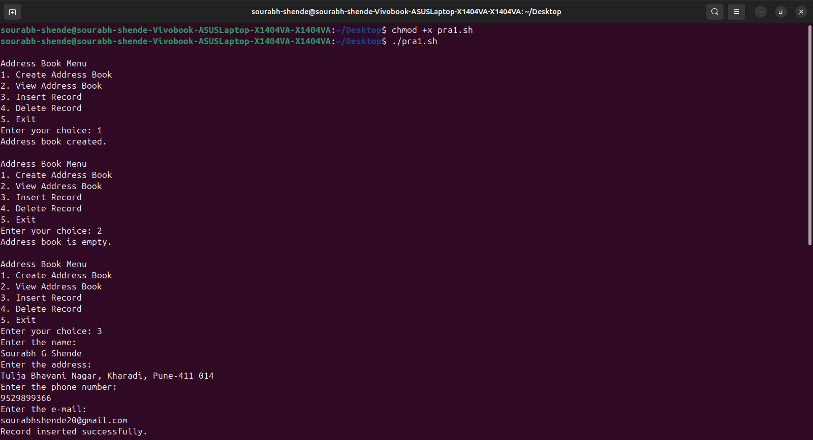
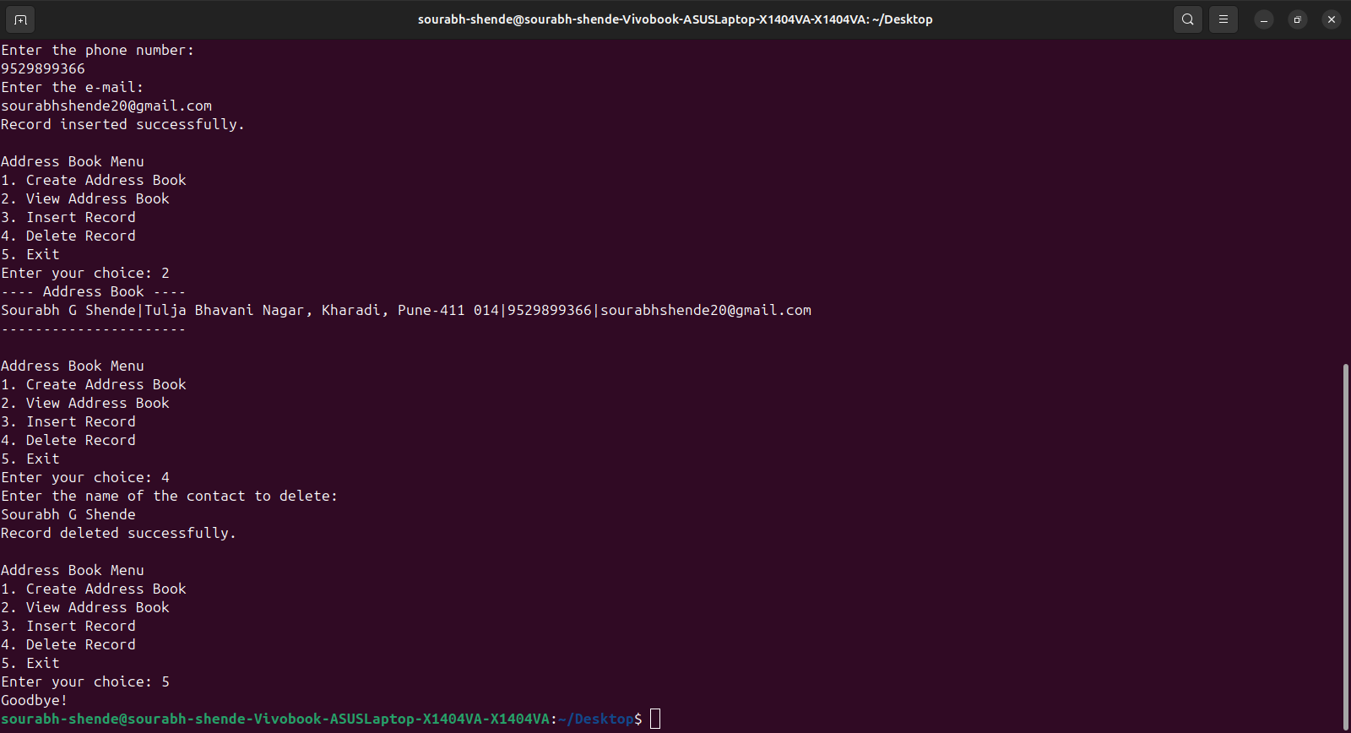
OUTPUT:

