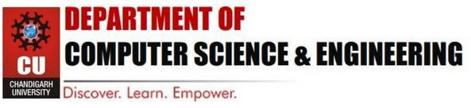

Experiment 1

|  |  |
| --- | --- |
| **Student Name:** Souradeep Banerjee | **UID:** 23BAI70654 |
| **Branch:** BE-AIT-CSE | **Section/Group:** 23AIT-KRG-G2 |
| **Semester:** 5th | **Date of Performance:** 22nd July, 2025 |
| **Subject Name:** ADBMS | **Subject Code:** 23CSP-333 |

# AIM:

To design and manipulate a University Database using SQL that involves creating relational tables for Students, Courses, Enrollments, and Professors, inserting and retrieving data using JOINs, managing access control with GRANT/REVOKE, and handling transaction control using COMMIT and ROLLBACK.

# Tools Used:

SQL Server Management Studio 21 (SSMS) code editor.

# Experiment:

# Easy-Level Problem: Author-Book Relationship Using Joins and Basic SQL Operations.

# Design two tables — one for storing author details and the other for book details.

# Ensure a foreign key relationship from the book to its respective author.

# Insert at least three records in each table.

# Perform an INNER JOIN to link each book with its author using the common author ID.

# Select the book title, author name, and author’s country.

##### **Medium-Level Problem:** Department-Course Subquery and Access Control.

* Design normalized tables for departments and the courses they offer, maintaining a foreign key relationship.
* Insert five departments and at least ten courses across those departments.
* Use a subquery to count the number of courses under each department.
* Filter and retrieve only those departments that offer more than two courses.
* Grant SELECT-only access on the courses table to a specific user.

# Output:

# Easy-Level

# Author Table

# 

# Books Table

# 

# INNER JOIN

# 

# 

# Medium-Level

# Department Table

# 

# 

# 

# Course Table

# 

Subquery to Count

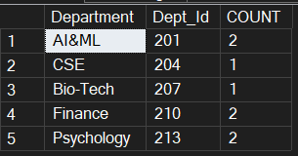

Department with more than 2 courses

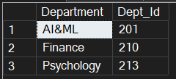

1. **Learning Outcomes:**
   * Learn’t about SQL Basic Operations.
   * Learn’t about various types of JOINS such as FULL JOIN, INNER JOIN, LEFT & RIGHT JOIN.
   * Learn’t about foreign key and its implementation in actual scenario.
   * Learn’t how to perform subquery and implement filter along with subquery.
   * Learn’t about basic TCP command such as GRANT.