UI- As of Now (July Release):

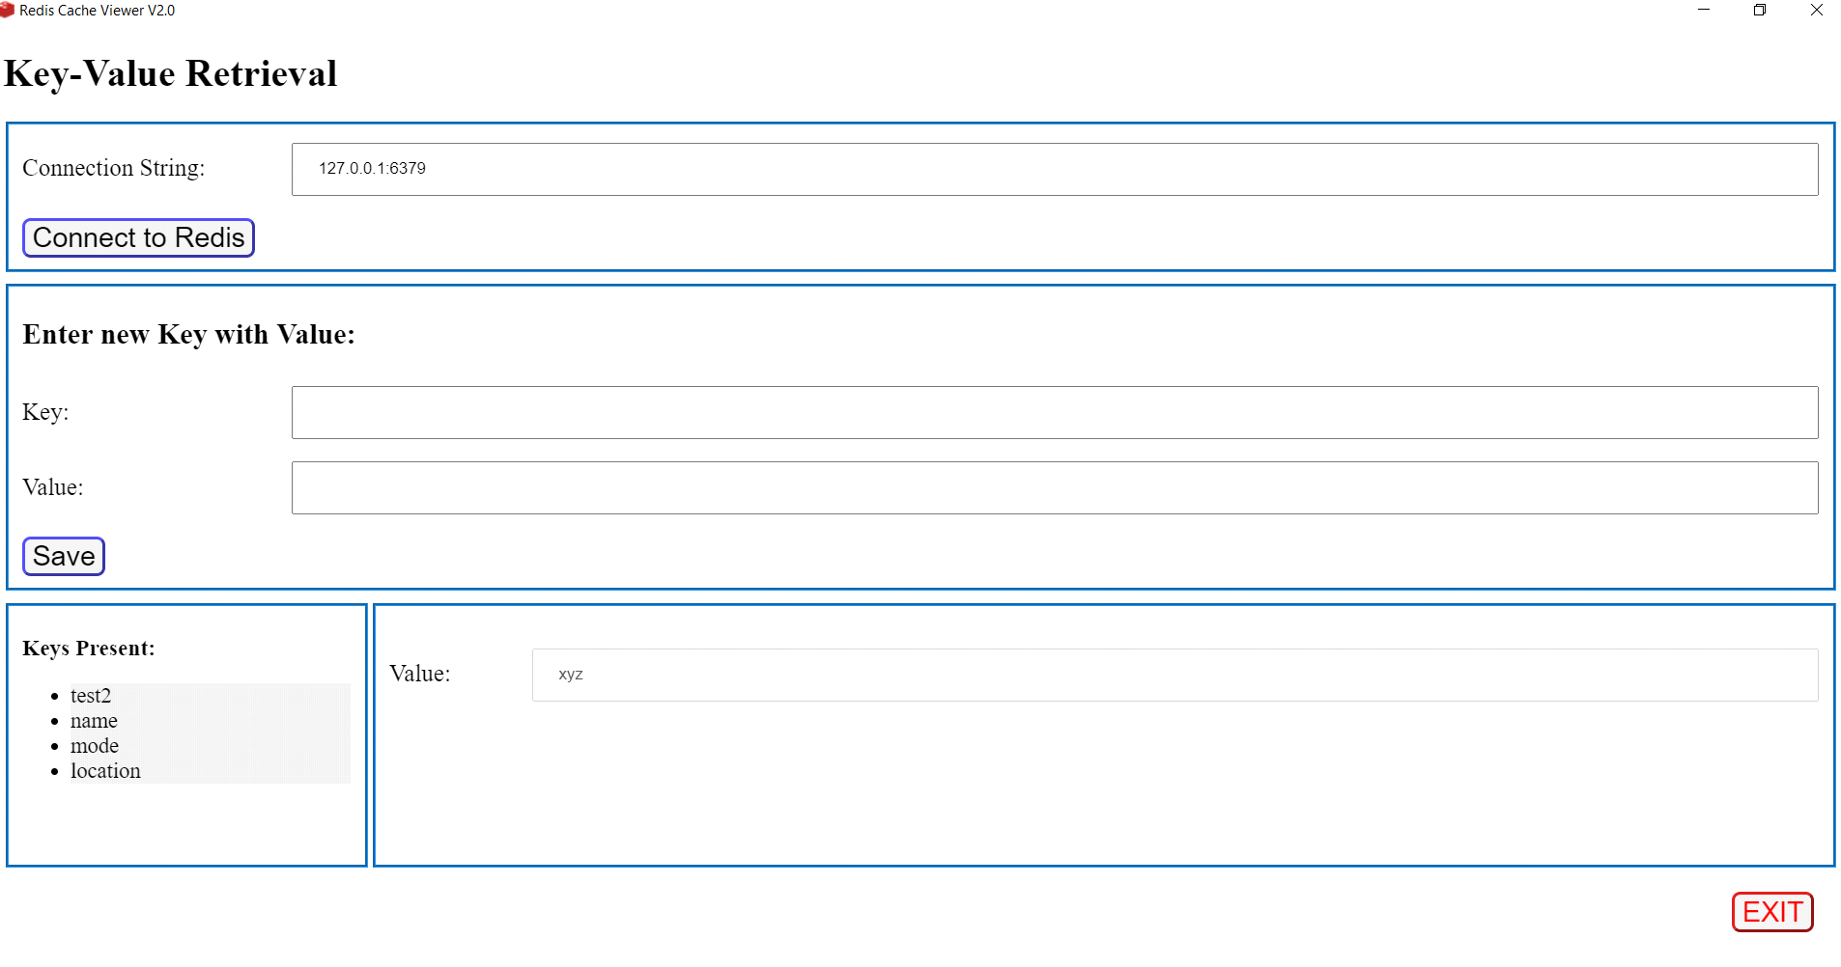

V1-Oct Release

* Change the Splash Screen **Souradeep B**
* File Connect to Redis (Existing Screen, no action item) **Ankur D**
* Create a new Welcome Screen **Ankur D**
* File Exit Menu to close the app. **Ankur D**
* Help Welcome (dialog box with only close button) **Apaar S & Nikhil G**
* Three Panels
* First Panel will give intro to the tool.
* Second Panel will give the briefing about the features of the tool currently available.
* Third Panel should display Known Issues

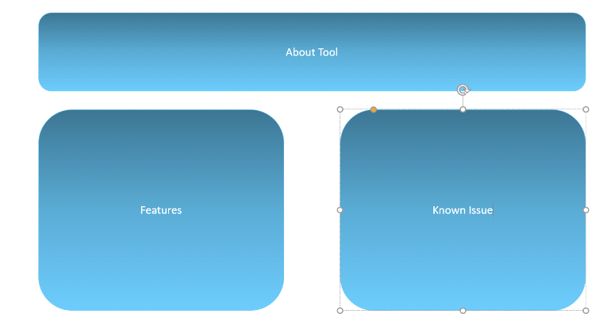

* Help About (dialog box with only close button) **Divyaksh S**

**1. App version**

**2. Node version**

**2. Electron Version**

**3. Os**

**4. Git link**

* Report issues/features link **-Divyaksh S**
* Enhancements to the existing screen.
* Make the connection string block in one line **Devyanshi T & Souradeep B**
* Enter new key and value in one line, include add in place of save **Devyanshi T & Souradeep B**
* Keys Present (with icon) => 70% of main window
* 30% => conn and add key
* Convert the list into tree view
* Icon for database should be diff from each of the key icon
* Border colour for the panel should be light blue
* Border must be rounded.

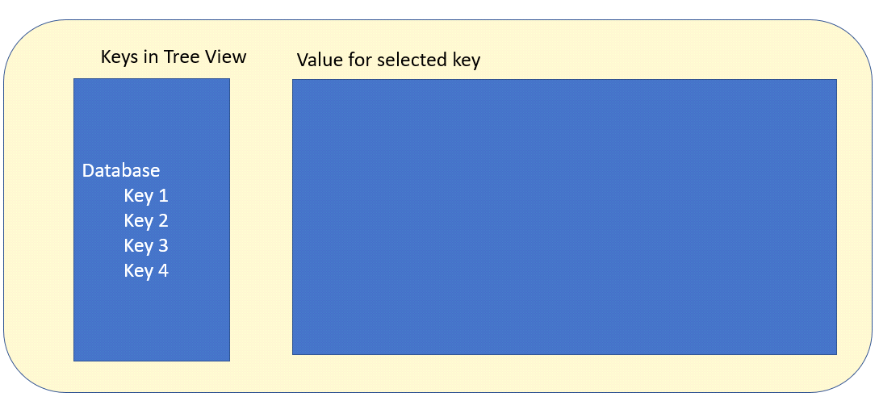

==================================================================================

V2-Nov Release

* The keys should show one tree icon for each db.
* Add Feature Flags.
* Multi Cloud Solution (GCP, AWS, Azure)