PHASE ONE:
OBJECTIVE: To interface a LoRa EBYTE E32 900T30D module with an Arduino Uno, and to send temperature readings of DS18B20 sensor over it.
METHODOLOGY:
Caution: The pins of the E32 except VCC are configured for 3.3V, and the digital pins of Arduino Uno output 5V. This can potentially damage the E32. The only pin which accepts input from Arduino is the RXD pin, thus it is necessary to connect it to Arduino via a potential divider.
The codes given below have memory sizes less than the maximum packet size of E32 LoRa, i.e., 58 bytes. If larger than 58 bytes is sent, the E32 automatically breaks it into multiple 58-byte air packets. The receiver reassembles them transparently. Code does not need to handle splitting manually.
User manual for the EBYTE E32 LoRa Module: https://share.google/uwfjcqdH3uACMZ1pL
E32-900T30D Payload & Packet Behaviour:
Air Packet Size
- Maximum single air packet: 58 bytes
- If payload exceeds 58 bytes, the module automatically fragments into multiple 58-byte air packets.
- Receiver reassembles transparently — application code sees a continuous byte stream.
Buffer:
- Internal UART buffer: 512 bytes
- Maximum data you can write in one burst without overflow: 512 bytes

- Diagnosis Test:
  - Objective and Scope:
The primarily objective of the Diagnostic Sketch is to provide hardware abstraction validation and establish a baseline of operational trust before full system deployment. It isolates the physical and electrical layer connection between the host microcontroller (Arduino) and the EBYTE E32 LoRa transceiver. By executing low-level software verification, the script confirms the integrity of the data lines, clock sync, and device power distribution.
  - Functional Mechanism:
The firmware configures a SoftwareSerial port running at a standardized 9600 bps baud rate, preserving the hardware serial port exclusively for PC debugging and data logging. The microcontroller forces a manual command query down the transmission line while the module's operational state selection pins are held at logic high (M0 = 1, M1 = 1), placing it into Sleep/Configuration mode.
The firmware evaluates core parameters using non-destructive hex sequences:
  - 0xC1 0xC1 0xC1 (Read Registry Parameters): Commands
the module's integrated processing core to read out its current saved configuration profile and echo the bytes back over the interface.
  - 0xC3 0xC3 0xC3 (Firmware Information Query):
Instructs the module to return its internal tracking data, confirming silicon health and internal firmware status.

  - System Validation Criteria:
A successful deployment returns crisp hexadecimal responses matching expected device defaults. Absolute silence or random data indicators highlight specific physical faults:
- Missing Acknowledgment: Pin inversion on the board (TX/RX swapped) or a complete hardware failure across the logic lines.
- Garbage or Stray Data: Faulty voltage divider resistor networks matching 5V to 3.3V thresholds, loose internal terminal connections on the breadboard, or floating pins resulting from a missing common system ground.
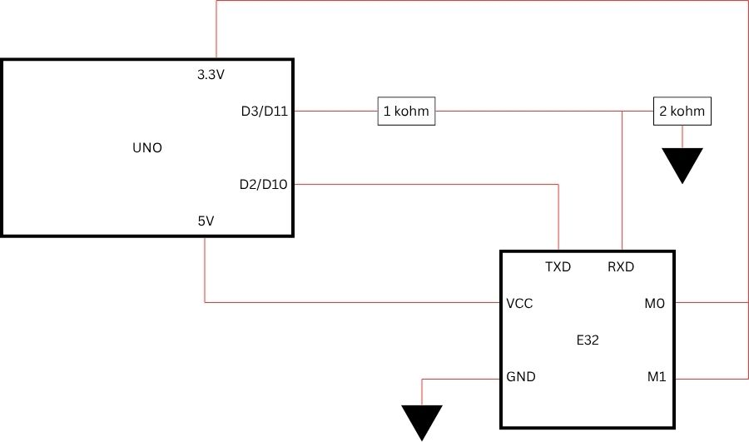
  - Circuit Diagram:
  - C0 C0 C0 hex command- Why C1 C1 C1 command works:
This is a precautionary point to be noted as google will often suggest sending the C0 hex command instead of C1.
  - C1 is an Open Read Command (Always Permitted):
The hex byte 0xC1 is a Read/Query command header. When you transmit C1 C1 C1, you are strictly asking the module: "Read out your current operating parameters from your EEPROM and print them back to me over serial." Because reading parameters is completely non-destructive and safe, the module's internal firmware processes it instantly, regardless of what values are currently stored inside its registries. It simply echoes back its internal configuration profile (e.g., C0 00 02 1A 04 C4).
  - C0 is a Strict Write Command (Requires a Valid Payload):
The hex byte 0xC0 is NOT a query command—it is a Write/Save command header. When you send 0xC0, the module's onboard micro-controller expects a complete, formatted 6-byte configuration packet to overwrite its permanent EEPROM storage; it would attempt to overwrite the module's configuration with invalid values, potentially corrupting it.
The structural format required by the module for a write instruction looks like this:
[Command Header] + [ADDH] + [ADDL] + [Speed] + [Channel] + [Option]
  - What happens when you send C0 C0 C0: You are sending a 3-byte packet consisting of 0xC0, 0xC0, 0xC0.
  - Why it fails: The module's internal command parser reads
the first 0xC0, recognizes it as a permanent save command, and then waits for the remaining 5 bytes of data to specify the address, speed, channel, and option registers. Because your diagnostic loop stops transmitting after only 3 bytes, the module recognizes that the data payload is truncated and malformed. To prevent its internal EEPROM memory from becoming corrupted with incomplete settings, the module silently rejects the command and refuses to reply.
  - Explanation of 6 byte register configuration frame:
    - Command Header - (“Action” Byte): The Command
Header is the first byte sent in any serial communication with the module. It tells the module's internal processor how to treat the data that follows it. It is essentially the "instruction" part of the sentence.
- 0xC0 + 5 bytes - Save & Write: Writes parameters to EEPROM. Settings are permanent and survive a power cut.
- 0xC2 + 5 bytes- Temporary Write: Writes parameters to RAM. Settings work now, but are lost if power is unplugged.
- 0xC1 0xC1 0xC1- Read Query: If sent as a 3-byte sequence, it tells the module: "Don't change anything, just tell me your current settings."
- 0xC3 0xC3 0xC3- Identity Query: Tells the module to report its internal version/firmware number.
- 0xC4 0xC4 0xC4- Reset: Resets the module (triggers self-check; AUX goes low during reset, high when done)
- ADDH & ADDL (Address High and Address Low):
Together, ADDH (Byte 1) and ADDL (Byte 2) form a 16-bit unique hardware address for the module, ranging from 0x0000 to 0xFFFF.
- In Transparent Mode: The modules drop their addresses. As long as they are on the same frequency channel, any data sent is broadcasted to everyone.
- In Fixed Transmission Mode: The transmitting module uses the target's ADDH and ADDL as a prefix before sending data. The receiving module will only open the data packet if the incoming target address matches its own configured address.
- Speed: The SPEED parameter (Byte 3) handles how data
moves both through the wires and through the air. This byte is broken down into three distinct sub-settings controlled by different bits:
  - UART Baud Rate (Bits 7, 6, 5): This configures how fast the module communicates locally with your microcontroller (e.g., Arduino or ESP32) over the TX/RX lines. Options range from 1200 bps up to 115200 bps (typically left at 9600 bps for baseline stability).
  - Parity Bit (Bits 4, 3): Sets the serial verification method (8N1 for no parity, 8O1 for odd, or 8E1 for even).
  - Air Data Rate / ODR (Bits 2, 1, 0): This is the actual transmission speed over the radio waves, ranging from 0.3 kbps to 19.2 kbps.
Air Data Rate | Binary value | Spreading Factor | Band-width | Time on air | Range Obstructed | Range Partially Obstructed | Range Unobstructed
0.3 kbps | 000 | SF 12 | 125 kHz | ~700–800 ms | 1.5 – 3 km | 3 – 5.5 km | 12 – 16 km
1.2 kbps | 001 | SF 10 | 125 kHz | ~180–220 ms | 1 – 2 km | 2 – 3.5 km | 9 – 12 km
2.4 kbps | 010 | SF 9 | 125 kHz | ~90–110 ms | 800 m – 1.5 km | 1.5 – 2.5 km | 8 km
4.8 kbps | 011 | SF 8 | 125 kHz | ~45–55 ms | 500 m – 1 km | 1 – 1.8 km | 5.5 – 7.5 km
9.6 kbps | 100 | SF 7 | 125 kHz | ~23–28 ms | 300 – 600 m | 600 m – 1.2 km | 3.5 – 5 km
19.2 kbps | 101 | SF 7 | 250 kHz | ~12–15 ms | 150 – 300 m | 400 – 700 m | 1.5 – 2.5 km

Why two different specifications for SF7:
The E32 firmware achieves two distinct data rates using the same Spreading Factor (SF7) by manipulating the physical Bandwidth (BW) of the RF channel.
By widening the transmission channel from 125 kHz to 250 kHz, the LoRa "chirps" sweep across the frequency spectrum at twice the speed. This effectively halves the Time on Air (ToA) and doubles the data throughput without modifying the underlying symbol coding structure.
A wider channel lets in more environmental radio noise. The receiver has a harder time picking out the weak signal from that noise, which reduces the effective range.
Omission of SF6: Operating at SF6 requires incredibly precise timing synchronization between the transmitter and receiver. Standard crystal oscillators drift slightly with temperature changes, which easily breaks SF6 connections.
- Channel (Frequency):
The CHAN parameter (Byte 4)
specifies the exact RF frequency channel the module operates on.
Instead of typing out a raw radio frequency like "915.0 MHz," the module abstracts this into a channel step-register value from 0x00 to 0x1F (or up to 0x4C depending on the specific E32 chip sub-model layout).
The module calculates its operational frequency using a simple hardware formula:
Actual Frequency = Base Frequency + Channel * MHz
If your baseline hardware runs on a 900 MHz base frequency, setting CHAN to 0x0F (decimal 15) shifts your radio operations directly to 915 MHz.
- The Option Byte (The "Behavior" Register):
The Option Byte is the 6th byte in a full configuration string. While the other bytes set the "Address" or "Channel," the Option Byte is a single 8-bit number that controls four specific hardware behaviors at once.
Each of the 8 bits in this byte acts like a tiny toggle switch:
- Fixed Transmission (Bit 7):
0 (Transparent Mode): Like a walkie-talkie; everyone on the channel hears you.
1 (Fixed Mode): Like a phone call; you target a specific Address and Channel. (Essential for drone-to-ground station setups).
- I/O Drive Mode (Bit 6): Controls whether the TX/RX pins use internal "pull-up" resistors. This helps stabilize the signal lines against "floating" interference.
- Wireless Wake-up Time (Bits 5, 4, 3): Determines how long the radio "listens" before going back to sleep. A shorter time saves battery; a longer time is more reliable for waking up a remote module.
- Forward Error Correction / FEC (Bit 2):
Enabled: The module adds extra math to every packet to "repair" data that gets corrupted by wind, distance, or interference. (Highly recommended for image data).
- Transmission Power (Bits 1, 0): Sets the "loudness" of the radio (e.g., 20dBm, 17dBm, 14dBm, or 10dBm). To ensure the longest range, set this to maximum.
- Configuration Sketch- Transmitter/Receiver Setup:
  - Objective and Scope:
Once the physical layer has been validated, the Configuration Sketch programmatically optimizes the radio frequency (RF) properties of the transceiver pair. Rather than utilizing proprietary GUI configuration utilities (like the RF Setting Application of EByte), this sketch directly updates the non-volatile EEPROM memory of the E32 module natively via code. Its primary objective is to configure separate matching nodes (Transmitter vs. Listener) while isolating network communication from adjacent interference.
Why engineers often bypass GUI utilities:
- Reproducibility:
A configuration written in code can be version controlled (e.g. Git), shared across a team, and re-applied identically across hundreds of modules. A GUI tool requires a human to manually click through the same settings every time, introducing the risk of human error.
- Automation at Scale:
When deploying large numbers of devices, manually configuring each one through a GUI is impractical. A script can flash the same configuration frame to 500 modules in sequence without any human intervention.
- Independence from Proprietary Software:
GUI tools like EBYTE's own RF Setting software are:
- Windows-only in most cases
- Tied to a specific version or driver
- Potentially discontinued by the manufacturer
- Unavailable in embedded/headless Linux environments.
Code has no such dependencies.
- Integration into Build Pipeline
Configuration code can be embedded directly into the firmware flashing process, meaning a module gets configured automatically the first time it powers up — no separate configuration step needed.
- Transparency and Auditability:
A raw byte frame like {0xC0, 0x00, 0x00, 0x1A, 0x06, 0x1C} is fully auditable. Every bit can be traced back to the datasheet. A GUI abstracts this away, making it harder to verify exactly what was written to the device.
- Documentation Value
The code itself serves as documentation. Reading the configuration frame alongside the datasheet tells a future engineer exactly what the module is doing and why, something a screenshot of a GUI cannot convey as precisely.
- No Dynamic Runtime Changes:
A drone flying mid-air cannot open a Windows GUI to change its communication channel if it encounters interference. The host microcontroller must be able to send those configuration bytes programmatically via code.
  - Core Operational Adjustments:
The configuration frame explicitly dictates a structured 6-byte command payload pattern down the data link.
Configuration Frame = [Command Header (xC0)] + [ADDH] + [ADDL] + [Speed] + [Channel] + [Option]
- Addressing and Path Isolation (ADDH, ADDL, CHAN):
Unique hex address registers are written to the EEPROM alongside a dedicated frequency channel identifier. This prevents crosstalk, ensuring the modules communicate exclusively as a closed pair.
- Fixed Transmission Mode Configuration:
The default broadcast mode is overwritten to Fixed Transmission Mode. This allows the transmitting node to bypass standard network broad sweeps, targeting a pinpoint coordinate address for rapid packet transfer.
- Air Data Rate Optimization:
The data transmission speed over the air is strictly calibrated to match on both ends. This balance manages structural limitations, setting a fast enough rate to handle compressed data streams while maintaining long-range line-of-sight propagation.
- Power Output Saturation:
The sketch drives internal registers to maximize output power transmission thresholds (up to 30dBm / 1W for the extended model variant), compensating for physical barriers and ensuring reliable transmission under high constraints.
  - Block Circuit Diagram:

- Transparent Transmission Mode:
  - Overview:
Transparent transmission is like a radio broadcast. Data is sent from the Arduino Uno to the E32 is immediately broadcasted into the air, and every module on the same channel will be able to receive the data.
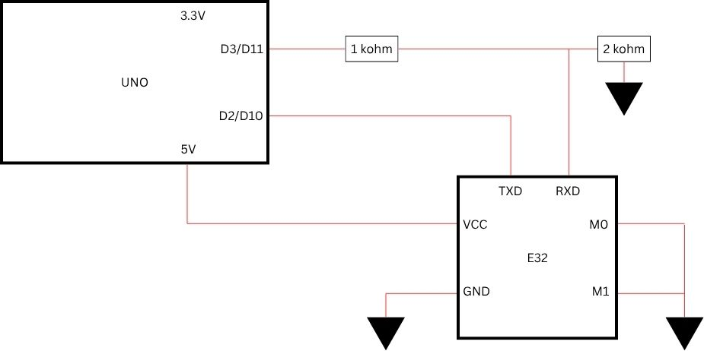
  - Block Circuit Diagram:
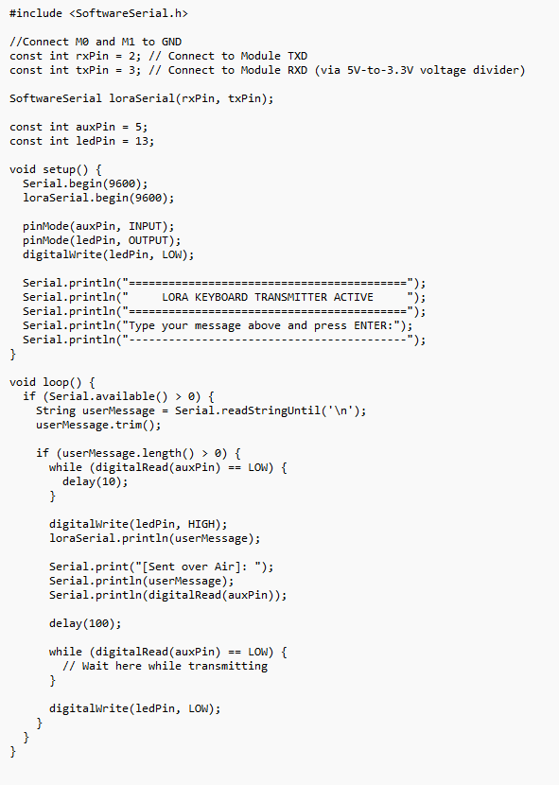
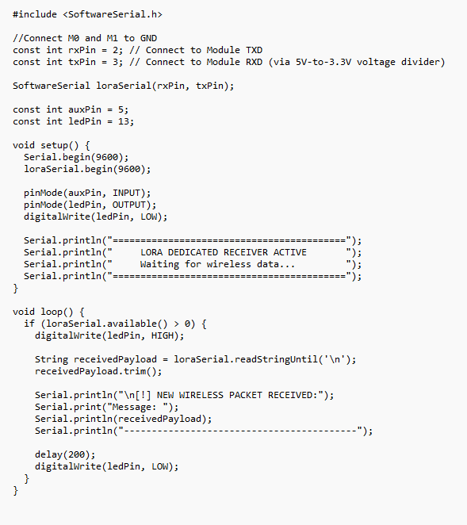
  - Code:
TX:
RX:
The RXD pin of receiver and the TXD pin of transmitter are redundant in these cases.
- Fixed Transmission Mode:
  - Overview:
The transmitter module sends data to with a particular address. Only the receiver module with that particular address receives the data.
To do this, we need to first configure the modules, so before transmission the M0 and M1 pins need to be HIGH (Consult configuration sketch above), and then they need to be brought to LOW for exchange of data (Consult transparent transmission). This can be done easily by digitally operating the M0 and M1 pins from Arduino pins via voltage divider.
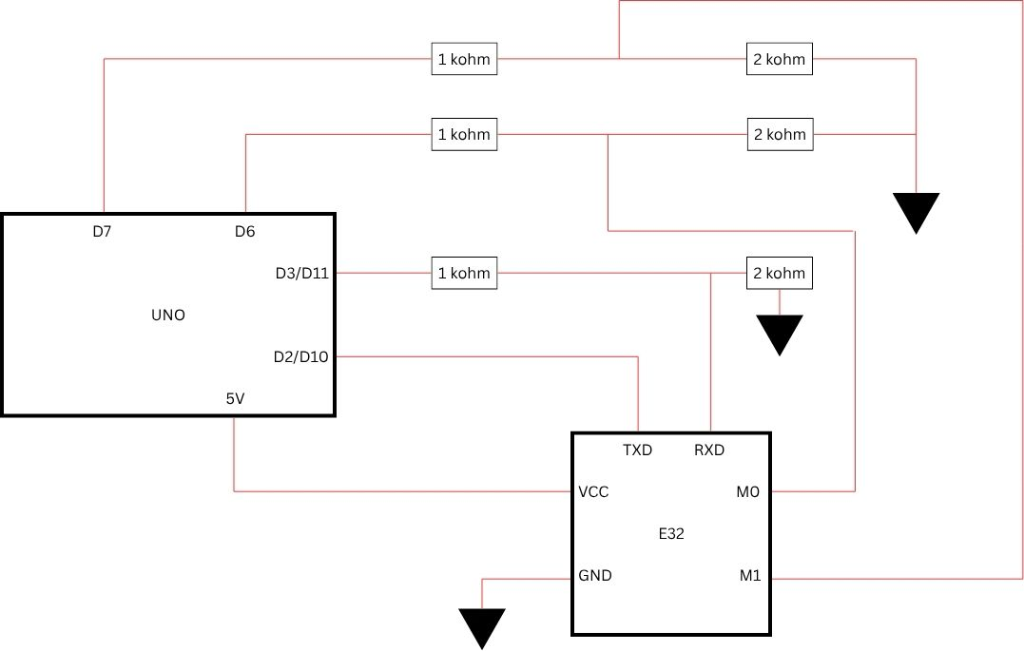
  - Block Circuit Diagram:
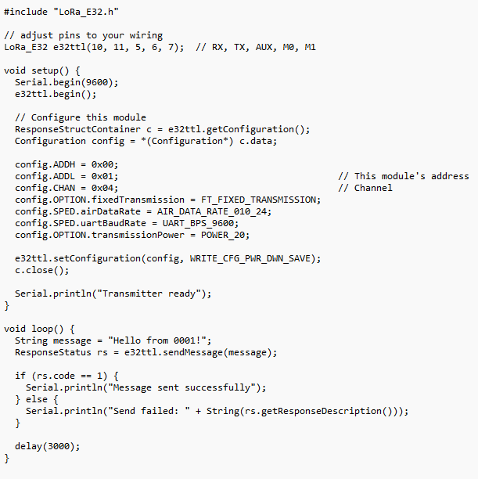
  - Code:
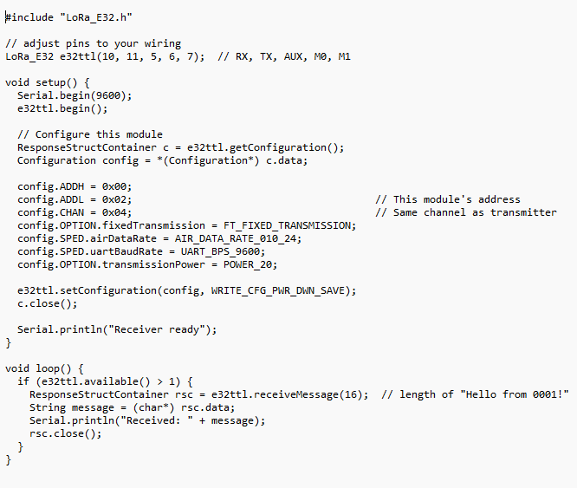
- With Lora_E32 Library:
TX:
RX:
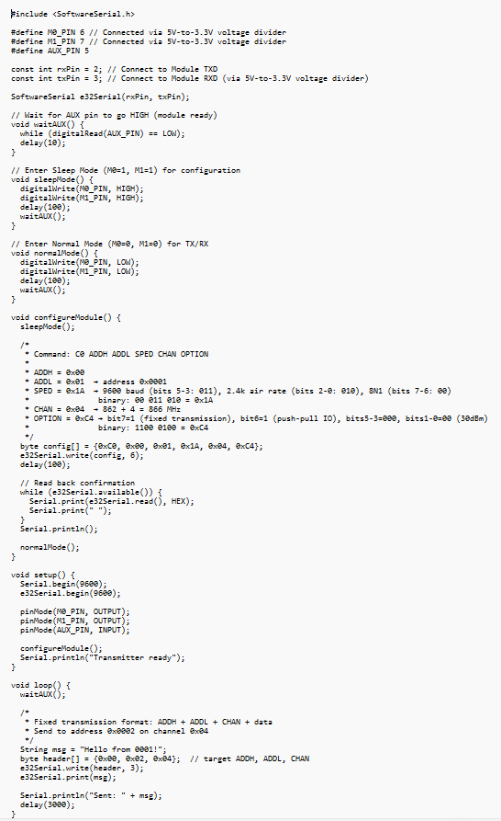
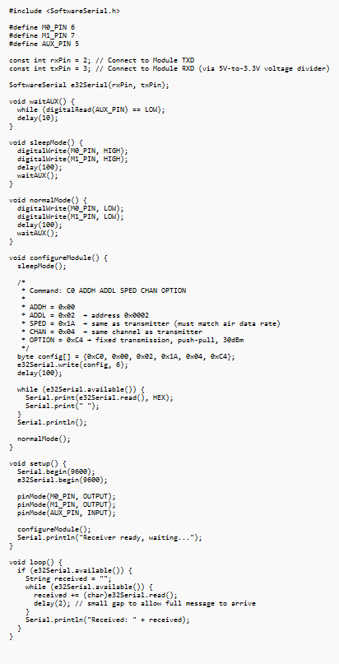
- Without LoRa_E32 library (Using Software Serial):
TX:
RX:
- Transmitting Temperature Data from DS18B20 sensor via E32 LoRa:
Datasheet of DS18B20 sensor: https://share.google/5PaLvnJNFEQ7hmiY9
  - Objective: To transmit temperature data from DS18B20 sensor via E32 LoRa module in transparent mode.
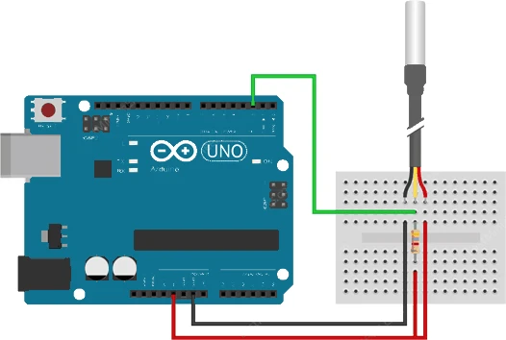
  - Block Circuit Diagram:
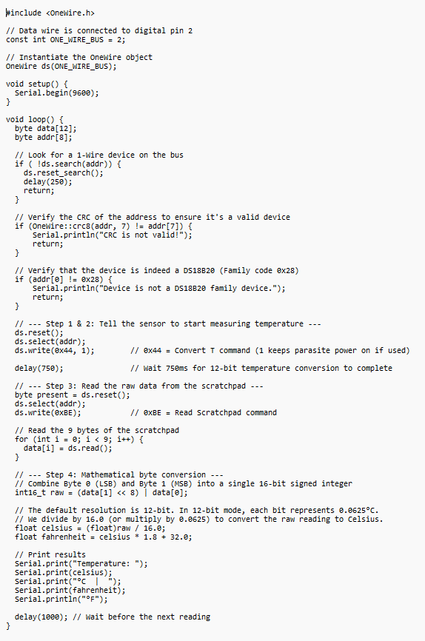
  - Temp Sensor Code:
  - Explanation of code:
- Device Discovery:
Because multiple devices can sit on a single digital pin, the Arduino must find the unique 64-bit hardware address (ROM ID) of the sensor. The ds.search(addr) function populates the 8-byte addr array with this unique identity. If no more sensors are found, it resets the search cycle so it can start fresh during the next loop execution.
- Issuing temperature command:
Every interaction with the sensor must follow a strict 3-step transaction sequence:
  - ds.reset(): Sends a reset pulse to wake up all devices on the line and prepare them to listen.
  - ds.select(addr): Targets the specific sensor found in Step 1, telling all other devices on the wire to ignore subsequent commands. (Note: If you only have one sensor attached to the pin, you can optimize this by using ds.skip() instead, which corresponds to the hex command 0xCC).
  - ds.write(0x44): Sends the explicit Hex command 0x44 (Convert T). This tells the DS18B20 to activate its internal ADC, read its analog onboard sensor element, and convert that raw voltage into a digital number inside its memory register.
  - Because the sensor takes up to 750ms to finish a 12-bit conversion, a delay(1000) gives it enough time to finalize the calculation before the Arduino attempts to pull data.
- Reading the Scratchpad Memory (0xBE):
Once the sensor finishes converting the temperature, the value is held inside its temporary internal RAM, known as the Scratchpad. To get this data, the Arduino performs another reset and select sequence, then writes the Hex command 0xBE (Read Scratchpad). Right after receiving this command, the sensor streams back 9 consecutive bytes of data, which the code captures into the data[] array using ds.read().
- Binary Reassembly and Floating-Point Math:
The actual temperature reading is split across the first two bytes of the scratchpad: data[0] is the Least Significant Byte (LSB) and data[1] is the Most Significant Byte (MSB).
  - Bit Shifting: (data[1] << 8) | data[0] takes the MSB, shifts its bits 8 positions to the left to occupy the upper half of a 16-bit integer, and merges it with the LSB using a bitwise OR (|). This reconstructs the complete signed 16-bit binary register (raw).
  - Resolution Scaling: By default, the DS18B20 operates at 12-bit resolution, meaning the lowest 4 bits of this raw integer represent fractional values
2⁻¹ = 0.5, 2⁻² = 0.25, 2⁻³ = 0.125, and 2⁻⁴ = 0.0625.
Shifting the decimal over to drop those 4 fractional bits into standard decimal formatting is mathematically achieved by dividing the entire float value by 2⁴ = 16.
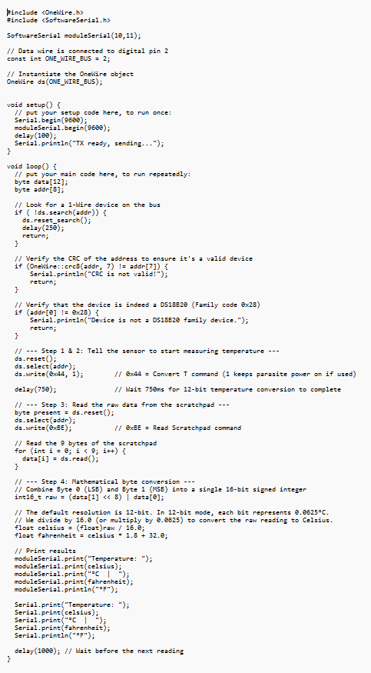
  - Temperature Sensor code with E32 transparent communication code:
For circuit diagram of transmitter, combine the circuits of DS18B20 and E32 in transparent mode. E32 receiver circuit will remain the same.
RX:
TX:

