PHASE TWO:
OBJECTIVE: To interface a LoRa EBYTE E32 900T30D module with a Raspberry Pi, and to send image data over it.
METHODOLOGY:
Note: Phase one is in Arduino-E32 folder
Raspberry Pi pins have a logic level of 3.3V, thus they are sufficient for connection with E32 LoRa module, and a voltage divider will not be required.
Username: stc-9
Password: 23304970
- UART Ports of RPi:
The RPi has 5 pairs of UART ports. The codes are mapped in the following way:
  - UART 0/1 → GPIO 14/15 → /dev/ttyAMA0 or /dev/ttyAMA1
  - UART 2 → GPIO 0/1 → /dev/ttyAMA2
  - UART 3 → GPIO 4/5 → /dev/ttyAMA3
  - UART 4 → GPIO 8/9 → /dev/ttyAMA4
  - UART 5 → GPIO 12/13 → /dev/ttyAMA5
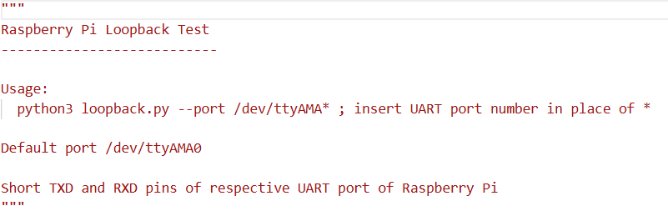
To activate all UART ports, open “boot/firmware/config.txt” and in the file write “dtoverlay = disable-bt” to disable Bluetooth and “dtoverlay = uart2” (and so on) to enable the UART ports. Bluetooth interferes with UART0 and it has to be disabled to proceed, however UART0 or 1 has not been used in project due to errors.
The loopback test can be used to check if the UART ports are healthy. In this test we short circuit the TXD and RXD pins of the respective UART port and we send data through the TXD pin. If this same data is received via the RXD pin, then the UART ports can be declared healthy.
To undergo this test run the python file loopback.py, the usage is given below:
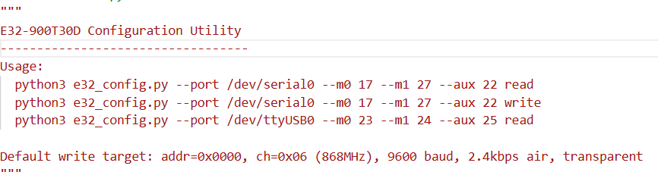
- Configuring E32 module:
Configuration of the module is done by the code stored in the e32_config.py python file. The code can be used to both read and write configuration data. The instructions to run this code are given below:
Note: The code is facing problems when changing SPED byte from 1A to 19 or 18, i.e, for changing air data rate to 0.3 kbps or 1.2 kbps. The speed register can be changed by writing “--sped” followed by the hexadecimal value such as “0x1a”. The problem should be taken into account and necessary modifications must be made to the code to allow such changes.
- Transmitting and Receiving strings:
The codes to transmit and receive strings are in the e32_tx.py and e32_rx.py files. We can do this using one single RPi module also, where we use two of the given five UART ports for each LoRa module, and run two terminals for RX and TX codes respectively.
Terminal 1- TX code: Run “python3 e32_tx.py”
Terminal 2- RX code: Run “python3 e32_rx.py”
Run receiver code before transmitting to get the data properly.
- Using camera:
There are two python files in the img_transmission_and_extraction folder. One is to directly take pictures in jpeg, the other is to take pictures in raw form. The codes to convert this raw image to JPEG is given in the folder and the steps to run it are given next.

- Steps to transmit images:
Terminal 1: Terminal 2:
cam.py
e32_file_rx_seq.py
dng_photo.py
dng_to_jpeg.py
make_packets_seq.py
The sequence first captures the image either in raw form (DNG) or in JPEG. If the image is captured in raw form, it is converted to JPEG. Images are compressed to a 50 KB jpeg baseline—using dynamic quality and resolution tuning for HEIC and DNG sources—with an option to further compress to a 20 KB target strictly by reducing the height and width dimensions. After that the image file is converted to a text file. This text file contains the mathematical compression instructions, which can be considered as a recipe generated by JPEG algorithm to create the image matrix. This text file is then packetized and stored into another text file. The advantage of this is that in the event of packet loss, the respective packet can be sent again easily.
The packetized file is now sent wirelessly one packet at a time. In the event of packet losses, the receiver and transmitter codes are written such that the receiver can send the count of the required missing packets to the transmitter so that it can send them again. This approach is however, untested.
Now in the receiver terminal, the packets are received and stored with their count in a text file. After all packets are received, the payloads are extracted from the packets and stored in another text file. This text file will now be converted to the output image.
jpeg_to_50kb.py
50kb_to_20kb.py
Haven’t been pushed into git
e32_file_tx_seq.py
text_to_img.py
Skip if image quality cannot be reduced anymore
extract_payloads.py
img_to_text.py

