Assignment-I Solutions

1. The simulation results together with the corresponding analytical result for the S-parameters using equation 1 and 2 of the article and the material properties for spleen tissue that we have exported from CST.

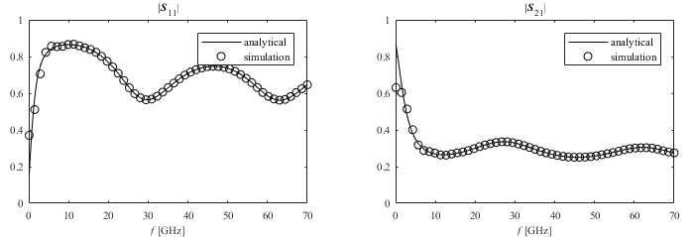

To display these complex parameters, we plot the real and imaginary parts as separate curves:

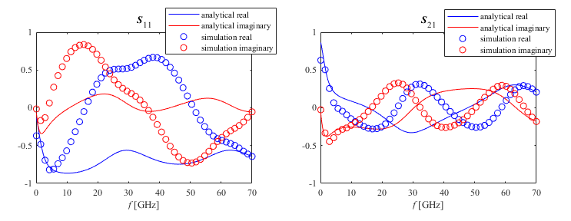

1. The S-parameters, exported from the first simulation, have reference planes coincident with the ports, separated from the spleen (biological tissue)/vacuum boundaries by a finite thickness of vacuum. The analytical calculation, with which we compared with, however uses reference planes exactly at the spleen (biological tissue)/vacuum boundary. The reference planes define the locations, along the propagation direction, at which the wave amplitude ratios (i.e. the S-parameters) obtained.
2. After adjusting the reference plane to the spleen (biological tissue)/vacuum interface, the agreement is quantitatively convincing at frequencies above 3GHz.

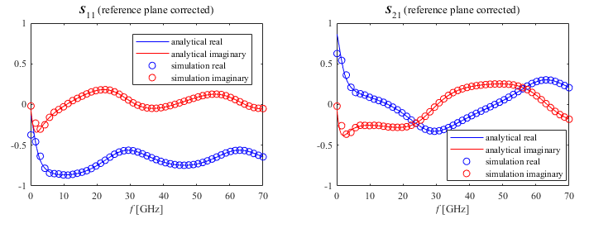

Redoing the plots with a frequency range of 0 to 3 GHz, the agreement tends to get worse.

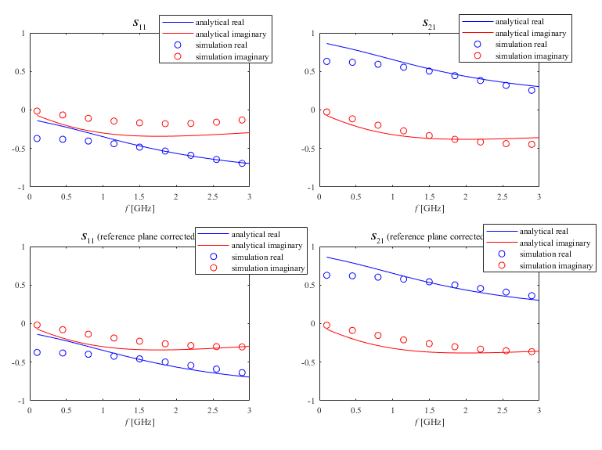

1. The two primary sources of error for FDTD simulations is meshing and truncation. Each of these may be the culprit for this low frequency discrepancy because firstly, with simulations involving adaptive meshing, it is difficult to predict up first as to what is going to the tradeoff between the meshing cell size and accuracy. Secondly, the simulation transient truncation oscillations might also not die out that fast in the simulation. Moreover, Open Boundary... settings might also create problems as the exact relative position of the ports can tend to interfere with the simulations. This i

Redoing the plots for -50 dB Accuracy, we get

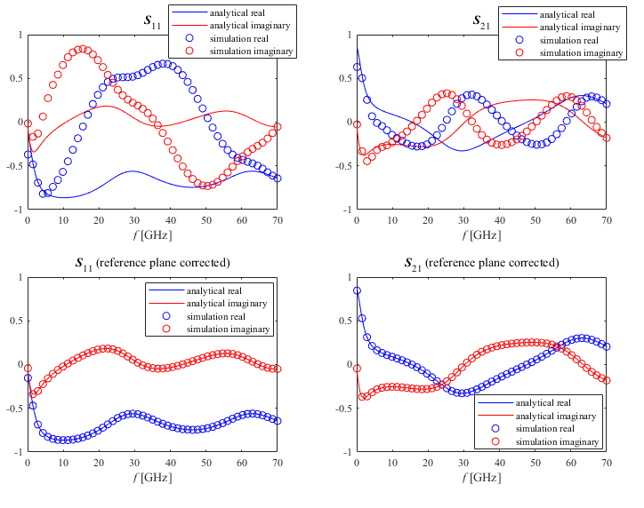

1. After redoing the simulation with -80 dB accuracy, the agreement is quantitatively convincing at all frequencies. Yes, it resolves the source of the low frequency disagreement. About the persistence of electromagnetic energy in the simulation domain versus frequency, we can say that it converges to a more accurate result when we go for a more stringent threshold level.

For -50 dB Accuracy:



For -80 dB Accuracy:

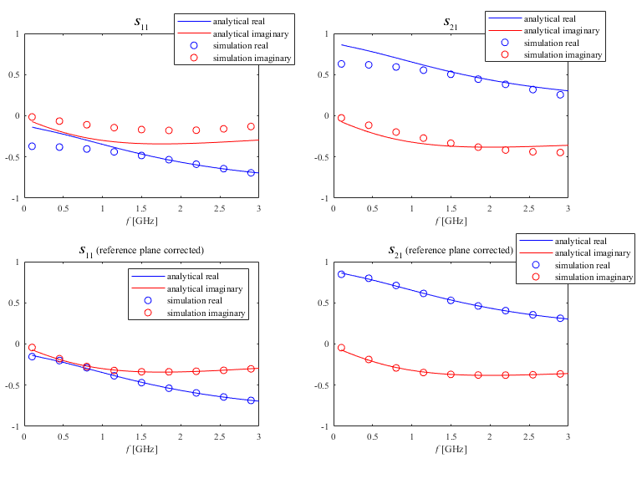

1. The plots comparing the real and imaginary part of the extracted μ and ε with the corresponding model properties used in the simulation (which we have already exported). We made one plot using the built in inverse cosine function, acos, function (i.e. without branch corrections), and one plot with the provided holomorphic inverse cosine function (i.e with branch corrections). (For μ the model properties are 1+0\*j.

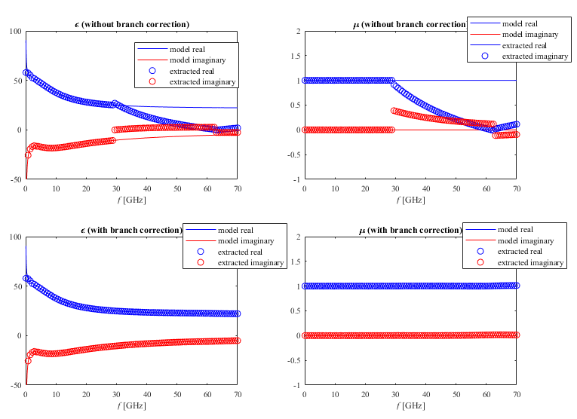



1. The real and imaginary parts of the permittivity and permeability as calculated from the S-parameters (using branch correction i.e. using the holomorphic arc-cosine) and from the Maxwell-Garnett theory,For -60 dB accuracy:

