Assignment-II Solutions

1. The plot of the real part of the ten extracted material properties i.e. permittivity εr and permeability µr versus frequency:

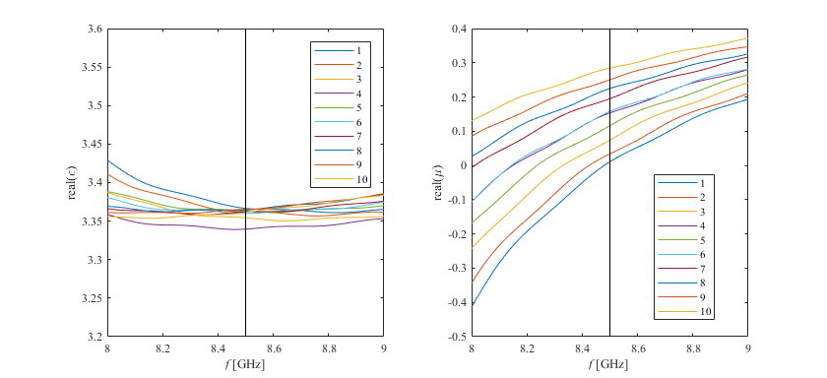

1. The plot of the real part of ε and μ versus radius, r, in the cloak at the operating frequency:

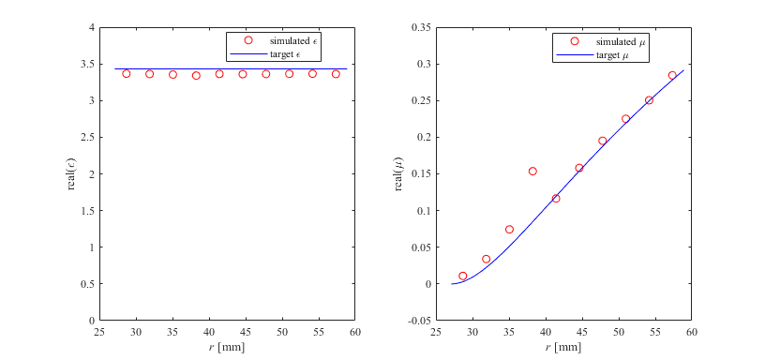

1. The following is the table of the ten target values and extracted values for the real and imaginary parts of permittivity and the permeability of the extracted material properties. (The target values for the imaginary parts would be zero, since a lossless device would be ideal.)

For permittivity ε:

|  |  |  |  |  |
| --- | --- | --- | --- | --- |
| Radius (m) | Target Values | | Extracted Values | |
| εr | εi | εr | εi |
| 0.028692 | 3.430649 | 0 | 3.366581 | 0.001002 |
| 0.031875 | 3.430649 | 0 | 3.361992 | -0.000650 |
| 0.035058 | 3.430649 | 0 | 3.354332 | 0.002222 |
| 0.038241 | 3.430649 | 0 | 3.339634 | 0.001049 |
| 0.041424 | 3.430649 | 0 | 3.363023 | 0.003388 |
| 0.044607 | 3.430649 | 0 | 3.359829 | 0.002192 |
| 0.047790 | 3.430649 | 0 | 3.362014 | 0.002372 |
| 0.050973 | 3.430649 | 0 | 3.364302 | 0.002091 |
| 0.054156 | 3.430649 | 0 | 3.365396 | 0.003101 |
| 0.057339 | 3.430649 | 0 | 3.361247 | 0.001419 |

For permeability µ:

|  |  |  |  |  |
| --- | --- | --- | --- | --- |
| Radius (m) | Target Values | | Extracted Values | |
| µ r | µi | µ r | µi |
| 0.028692 | 0.003077 | 0 | 0.010946 | 0.008745 |
| 0.031875 | 0.022439 | 0 | 0.033994 | 0.012017 |
| 0.035058 | 0.051524 | 0 | 0.074291 | 0.005267 |
| 0.038241 | 0.084875 | 0 | 0.153647 | 0.008511 |
| 0.041424 | 0.119570 | 0 | 0.116489 | 0.002092 |
| 0.044607 | 0.154034 | 0 | 0.158112 | 0.005060 |
| 0.047790 | 0.187434 | 0 | 0.195213 | 0.005501 |
| 0.050973 | 0.219350 | 0 | 0.225124 | 0.004802 |
| 0.054156 | 0.249596 | 0 | 0.250368 | 0.002477 |
| 0.057339 | 0.278125 | 0 | 0.284431 | 0.006149 |

1. The following are the plots for the invisibilty cloaks:
2. Ideal Cloak

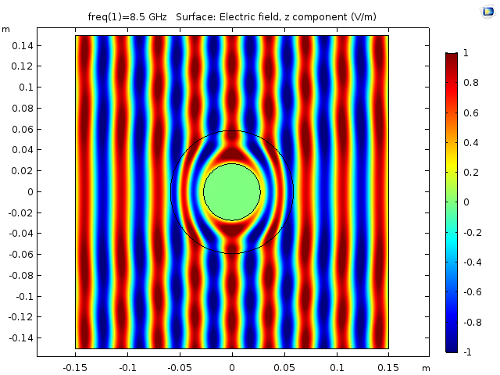

1. Reduced Cloak

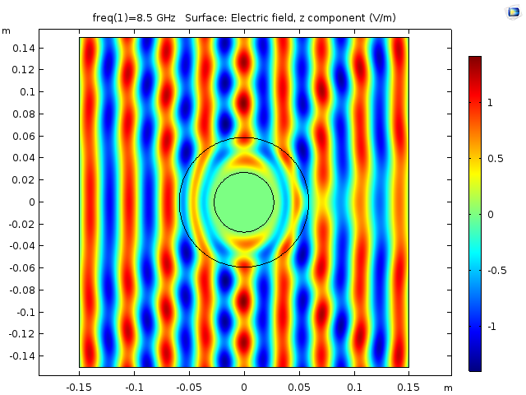

1. Metamaterial Cloak

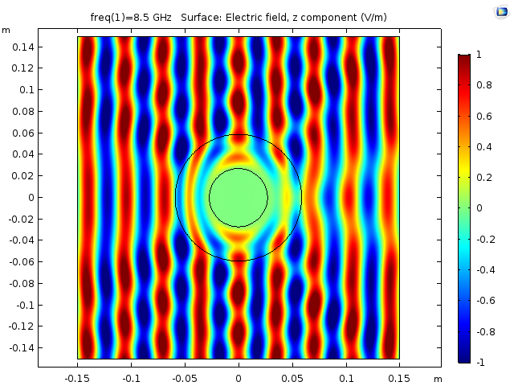

1. No Cloak

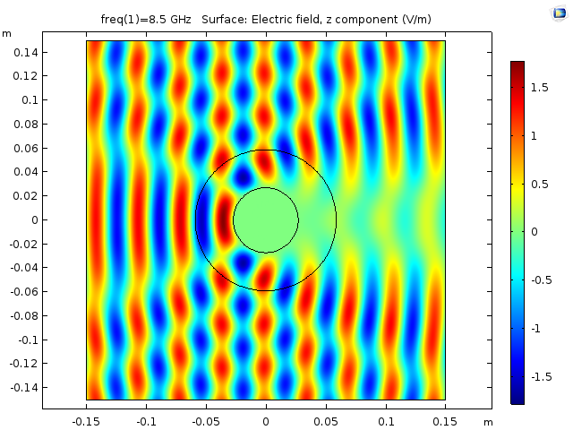

1. The following are the scattered plots for the invisibilty cloaks:
2. Ideal Cloak

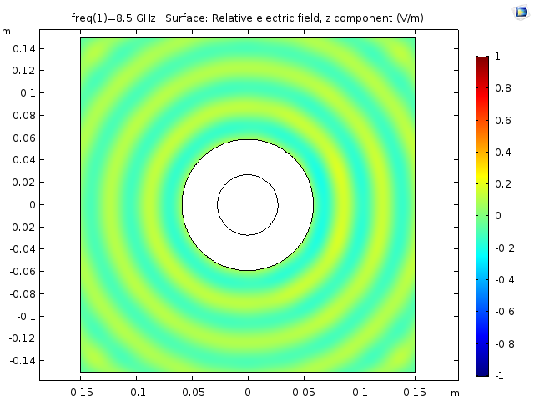

1. Reduced Cloak

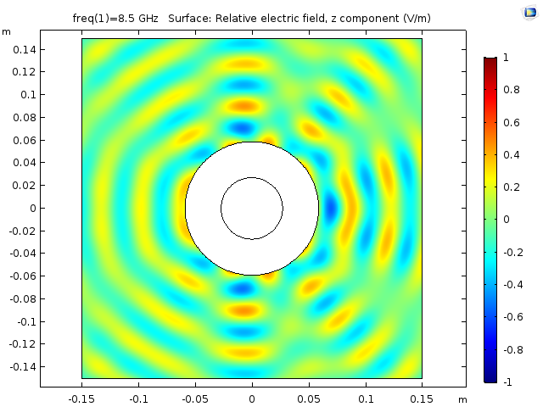

1. Metamaterial Cloak

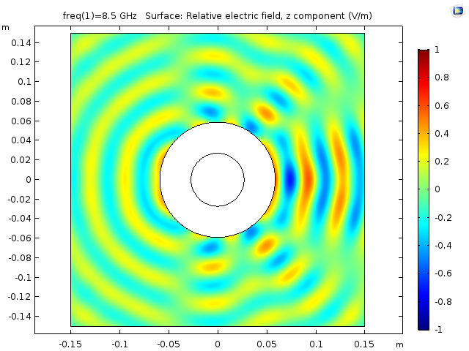

1. No Cloak

