Assignment-III Solutions

1. The plot of the port mode E field and H field:
2. Electric Field

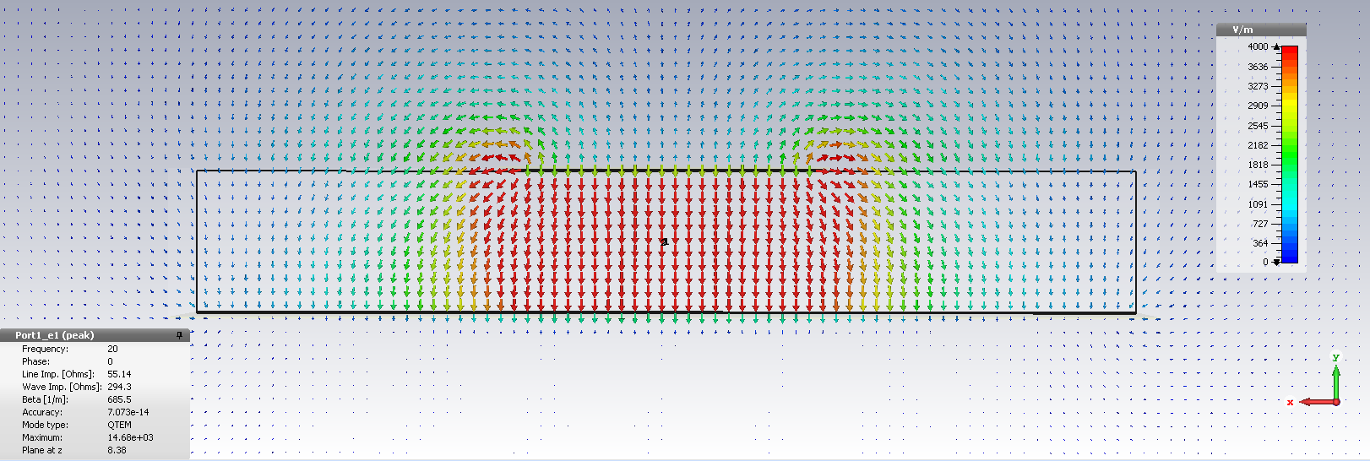

1. Magnetic Field

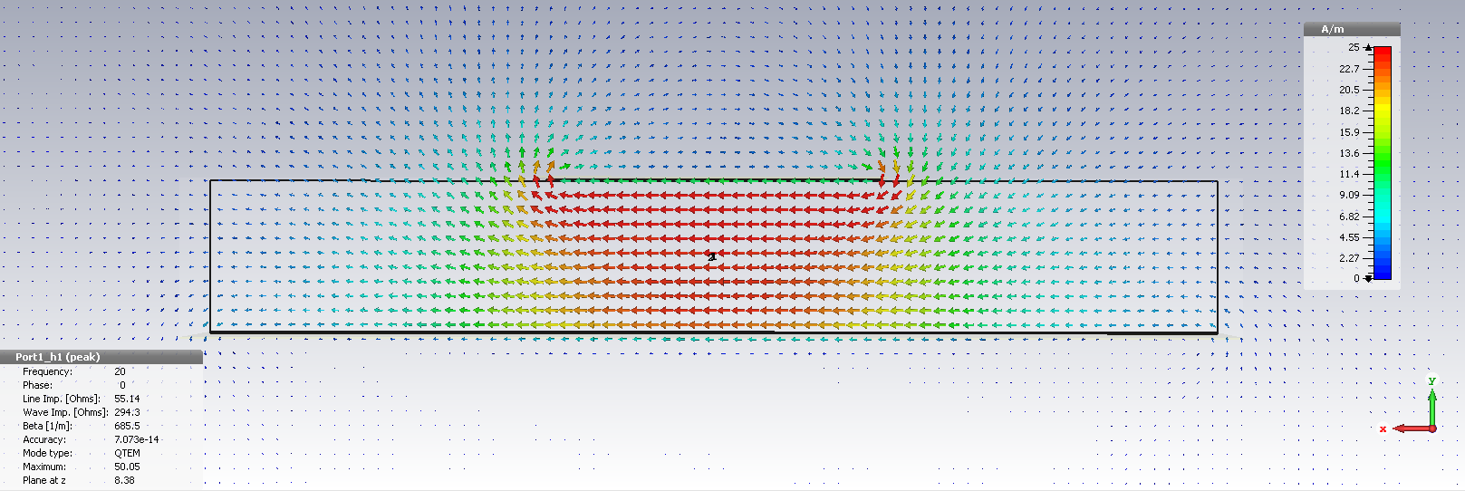

We can use a symmetry plane, and we should as it decreases simulation time by half. We cannot use a z symmetry plane since we are exciting the guide from one side, a non-symmetric excitation, with respect to the z direction. The microstrip guide is only mirror symmetric in the x direction and does not possess mirror symmetry in the y direction. We see that magnetic field is everywhere normal to the x = 0 plane (what CST calls the YZ plane). Therefore, we should choose a magnetic symmetry plane for preserving this mode.

1. A plot of phase (top) and magnitude (of the electric field, theta component)(bottom) vs the permittivity of the liquid crystal:
2. Phase

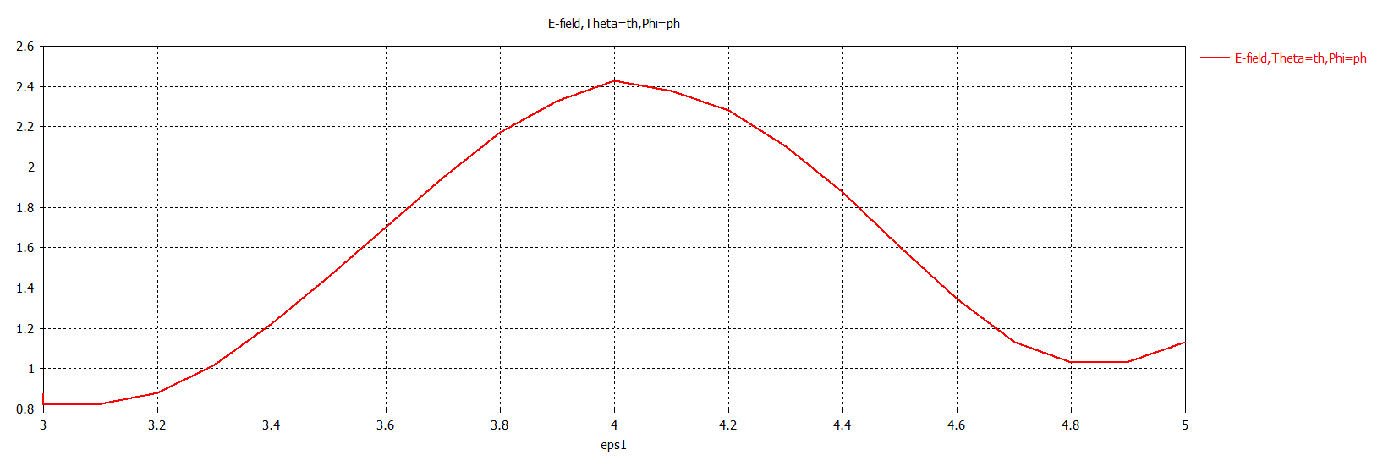

1. Magnitude

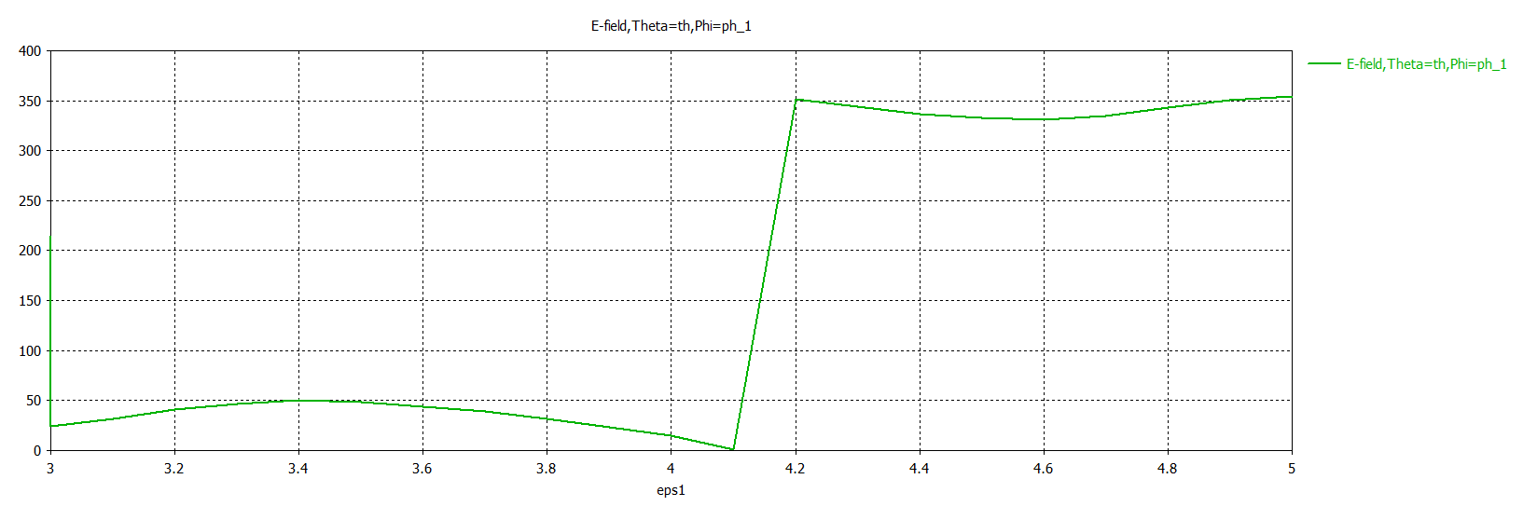

We see from both the phase and magnitude of the radiation, that the radiating element has its radiation condition centered at a permittivity of about 4. The range of permittivity to achieve the available range of phase is from 3.6 to 4.4.

1. The directivity in both a 3D and Polar plot:
2. 3D

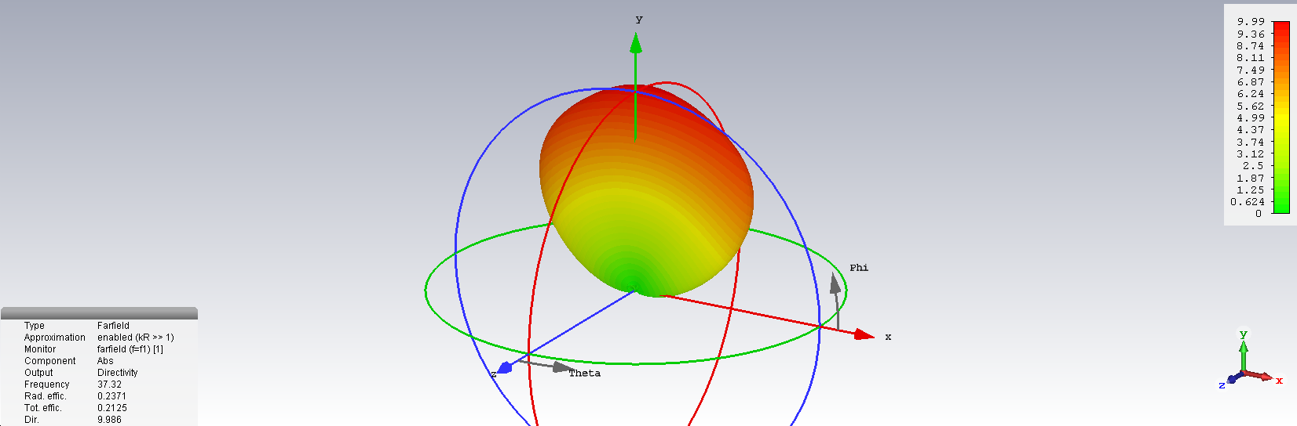

1. Polar

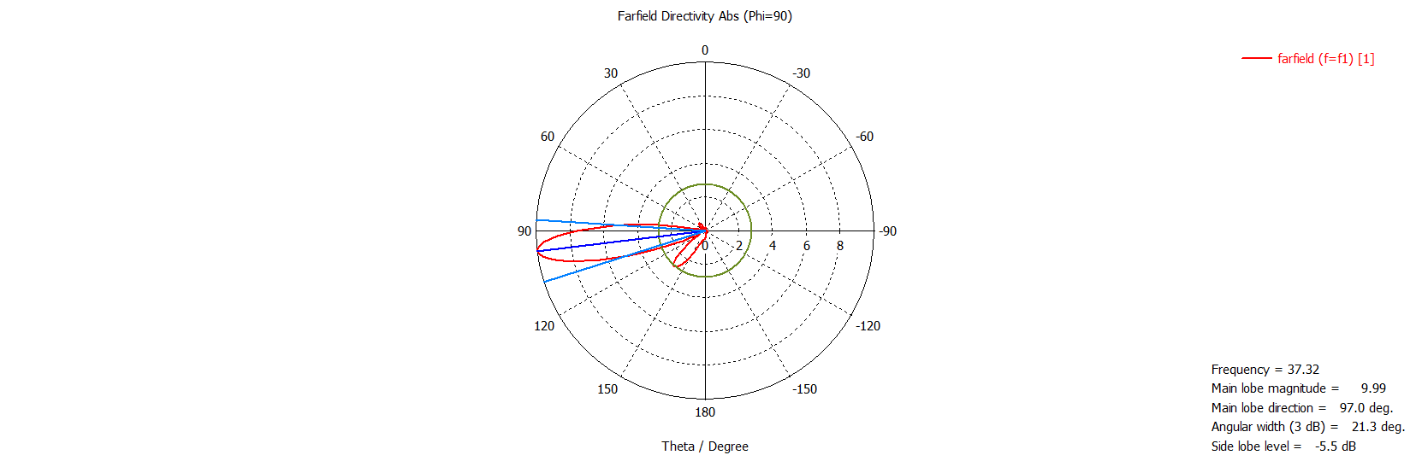

**Note:** The plot data is given as a separate .txt file: “3Dplotdata_sourangsubanerji.txt”.

1. The pattern should appear narrow in the y-z plane and broad in the x-direction. This is because:
2. Since our antenna element is essentially an x-oriented magnetic dipole, we expect to have only a theta component in broadside direction.
3. In end-fire arrays, the major lobe or lobes occur along the axis of the array. The pattern is sharper in the plane that is at right angles to the plane containing the elements.
4. The directivity at phi = 90 and theta =100 is 9.986 as compared to 18.8785 in the ideal model results.