Assignment-IV Solutions

1. The type and value of reactive component we added to the circuit is a capacitor (to cancel out the positive i.e. inductive reactance) with a value of 8.411259 pF. For a compact platform, it not quite a feasible component.
2. A plot of S[1,1] in both linear magnitude and Smith Chart form is given as follows:

Linear magnitude:

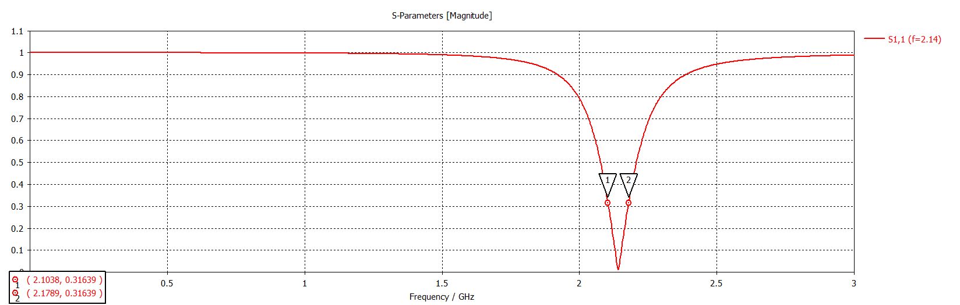.

Linear magnitude [in dB]:

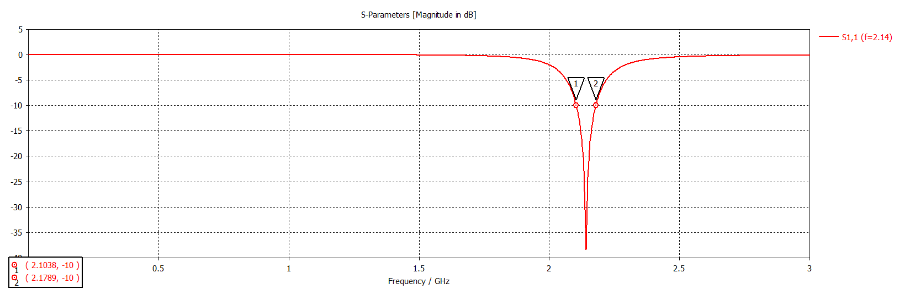

Smith Chart:

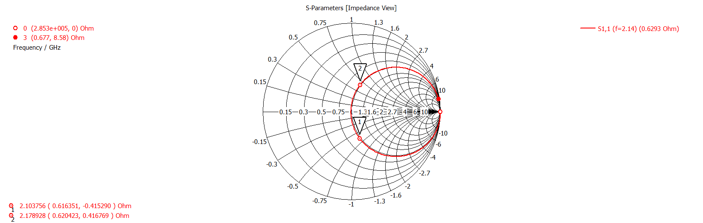

The bandwidth achieved in the simulation is 2103 MHz – 2178 MHz i.e. 75 MHz that is almost comparable to the LTE Band 1 Downlink, which has a range of 2110 MHz – 2170 MHz i.e. 60 MHz

1. 3D Farfield Plot with linear Directivity:

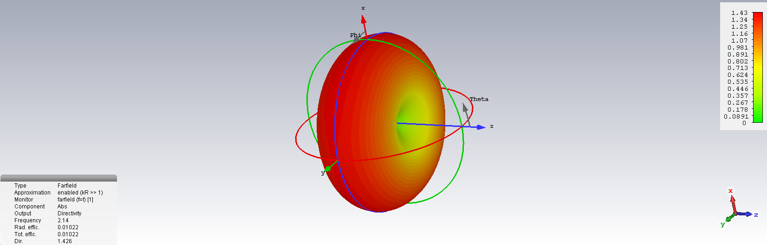

The efficiency achieved in the simulation is 0.01022 which is quite low. No, this does not seem like a good efficiency.

1. Based on the antenna directivity pattern, we should orient the watch face normal to x-y plane for best connectivity.