

Independent University, Bangladesh

School of Engineering, Technology & Sciences

**SUMMER 2023**

**CSE307**

***Assignment-1***

**Submitted To**

Sabrina Alam

**Submitted By**

Md. Showkat Jamil ID: 2010020

Tasnim Nazifa Kamal ID: 2010664

Md. Ezaz Ahamed ID: 2021757

Samiul Islam Sourav ID: 2031109

Sami Rashid ID: 2120326

**Date of Submission:** 15/6/2023

* **Proposed Project Title**

“Mr. Bin” is a smart waste app which will engage citizens in waste management. It will assist citizens in finding the appropriate bin for their trash type, such as general, glass, or plastic, as well as the closest available bin and how full it is. Citizens can take a photo and document any bin issues. Authorities can also compare the number of reduced pollutants.

* **Project Goal and Objectives**

**Goal:** The goal of this project is to enhance Bangladesh's trash management and collecting system. This system is smart, effective, and has both direct and indirect economic benefits from digital intervention. Citizens' lives will be made easier by this technology, which will also eliminate health risks. In the future, this system will be present throughout the nation and all trash cans will be linked to it to create a clean city.

**Objectives:**

* At first, this system will connect the trash cans of Dhaka as a model and testing period.
* After getting feedback from the users, it will add new features.
* Developing Smart Bangladesh through cleaner cities.
* **History leading to project request**

Since its independence in 1971, Bangladesh, especially its capital city Dhaka, has maintained a mostly unchanged traditional garbage management system. This technique permits waste to be dumped and burned in an open manner, disposed of in landfills, and even placed straight onto agricultural land in rural areas. Such behavior persists unchecked and is accepted after 50 years.

According to one study, "On average, 0.38 kg of waste is generated per person daily in rural areas, according to the government's first survey of its kind in the country**.** Thus, the daily waste generation amounts to 37,084.46 tons, 87% of which is compostable, and the remaining 13% is other waste. [1]. Even if there is genuine intent to recycle, the facilities that are currently available are apparently insufficient, according to conversations with the general population. The various recyclable materials cannot be separated; therefore, even if they are divided at home, they all wind up in one large pile at collection. Others argued that there aren't enough incentives to recycle; instead, they emphasized how much work it takes to recycle frequently, all in vain. Some people felt the effort was not worthwhile. In comparison to other modern cities, Dhaka's waste collection and handling system is incredibly unorganized and out of date. The conventional waste collection system requires a lot of manpower and employs few cutting-edge technological innovations. Another problem is the astonishing growth in the use of electronic products (e-products) in Bangladesh over the last two decades. Bangladesh itself produces about 3 MMT of e-waste each year[2].

Therefore, I have decided to address the issue. The current rickshaw vans that collect rubbish can be converted into effective waste collection vehicles with the use of smart technology. When the bins are full, a smart sensor chip at the top of the bins can help convey data to garbage collection facilities, setting off a regular pattern for waste collection.

* **Identify Problem, Solutions and Opportunities**

| **Problems** | **Solutions** |
| --- | --- |
| People dump garbage anywhere, creating pollution. | Now citizens can take a picture and report any problem with the bin. |
| The available process is not efficient using heavy manpower. | Waste collection facilities get notified when the bins are full, and commuting gets easier. |
| Not enough trash cans in remote areas. | Users can place a request for a bin at the nearby address. |
| People can’t see the live location of nearest trash cans to be more environmentally responsible for waste disposal. | People can get an interactive map of all the bins in the city divided by trash type and locate the nearest available empty bin. |
| Even if the trash is collected, they remain unsorted and unseparated for days. | Wastes will be managed accordingly to their types. |

This automated system can open a wide range of opportunities in the future as we will be able to analyze the data and work on new features as well as make necessary changes if needed. Some of the opportunities are listed below:

**Opportunities:**

* First the system will be tested and operated in Dhaka. In future it will be operational all over the country.
* The system will be added with more features in future such as when the user is dumping the garbage, the amount of plastic beverage bottles and cans will get them a refund for returning the package back to shops ensuring recycling.
* All data will be processed and stored in a secure environment, with limited access only to authorized users.
* **Product Description**

1. **Product Summary**

* First, the user needs to create an account in the app. They have to create an account with a phone number, password, and get the location from the GPS of the device. So, after creating the account whenever the user needs to sign in they can sign in with their phone number and password.
* They need to turn on their GPS system to locate how many bins are available near them.
* Upon selecting a bin, they can see how full the bin is, bin for the waste type they are dumping, and the shortest route to the bin.
* They can also report any problem with the bin.
* They can also place a request for a bin at the nearby address.
* The authority can keep track of waste trucks.
* Authority can compare the before and after results of the implementation.

That is how the entire process will be for this project.

1. **Product Stakeholders**

* Citizen
* Government Authority
* Driver
* Internal Stakeholders( Employees, managers, board of directors, developers, admin etc.)
* Investors

1. **Context Level Data Flow Diagram**

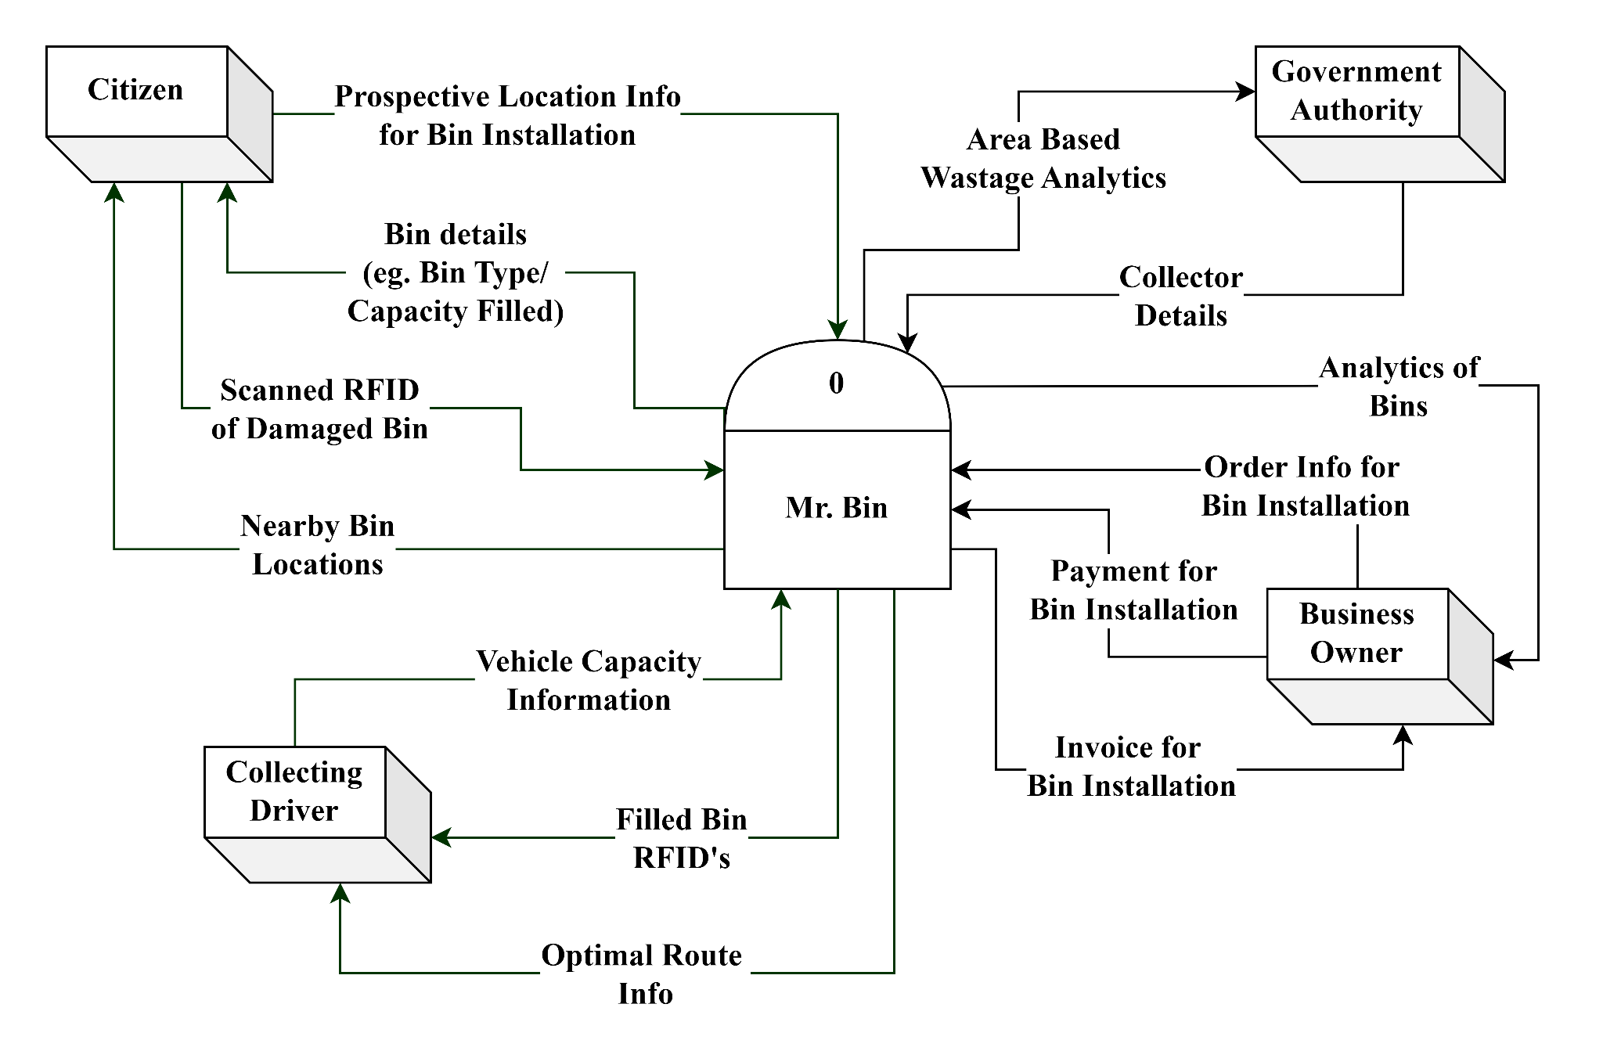

1. **Hardware and Software Details**

### Components:

* **Hardware Components**

1. Laptop/ PC

2. Smartphone

3. Internet Connectivity

4. Router

5. Ultrasonic Beam Sensor

* **Software Components**

1. XAMPP for windows 10 Pro v22h2 with PHP v8.1.16
2. MySQL server

### Architecture:

* **Hardware Architecture**

1. A laptop or PC with at least 8 GB RAM and 128 GB SSD and Intel Corei5 processors.
2. A smart phone with good RAM, ROM and good processor with processing power and clock speed.
3. A stable and reliable Internet connection( at least 5 mbps).

* **Software Architecture**

1. For Laptop/PC: Windows 11 v21H2 (at least Windows 10)
2. For Smartphone: Android version 8.0 (Oreo) or above with Google Play Services or at least iPhone 6 or better.
3. **Software key technical features**

* User friendly interface with easy to use and simple installation and updates.
* Data security with encryption and access control.

**Reference:**

1. <https://www.tbsnews.net/bangladesh/planned-rural-waste-management-cards-584490>
2. <https://thefinancialexpress.com.bd/views/views/electronic-waste-is-a-growing-public-health-threat-for-bd-1669645597>