

Independent University, Bangladesh

School of Engineering, Technology & Sciences

**SUMMER 2023**

**CSE307**

***Assignment-3***

**Submitted To**

Sabrina Alam

**Submitted By**

Md. Showkat Jamil        ID: 2010020

Tasnim Nazifa Kamal    ID: 2010664

Md. Ezaz Ahamed         ID: 2021757

Samiul Islam Sourav     ID: 2031109

Sami Rashid                  ID: 2120326

**Date of Submission:** 23/08/2023

**Project topic: Mr. Bin: A Waste Management System**

**Entity Relationship Diagram (ERD):**

**Logical Data Flow diagrams:**

Logical DFD of Citizen checking for nearby Bin locations:

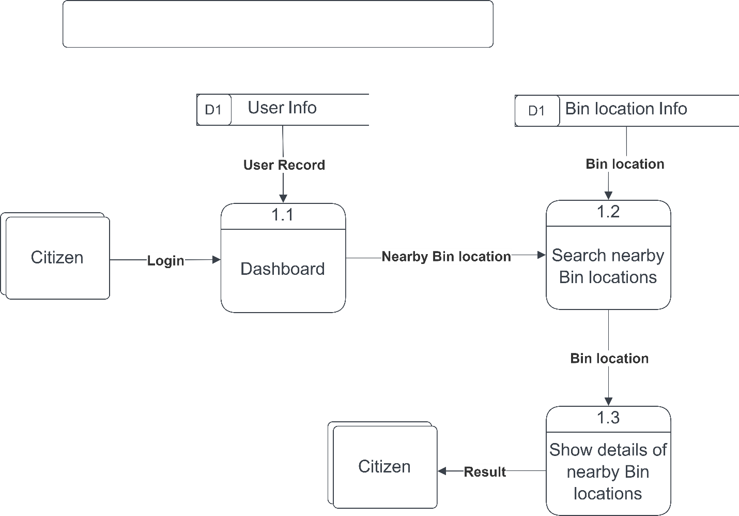

Logical DFD of Citizen Requesting of Installation of New Bin:

Logical DFD of Citizen monitoring Filled level of trash can:

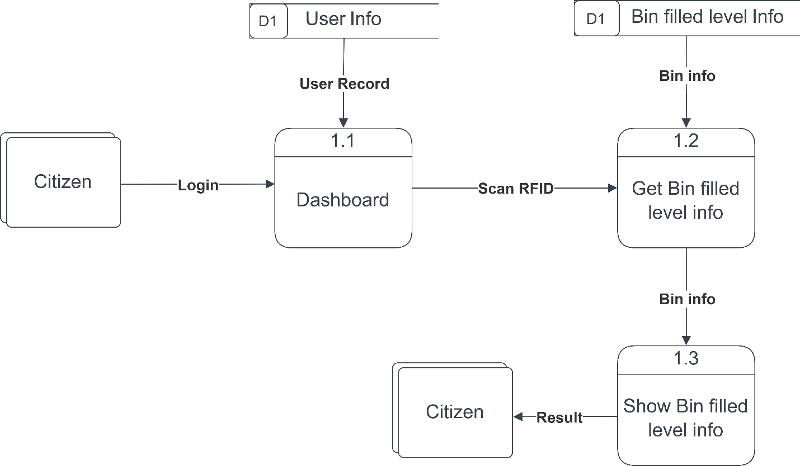

Physical DFD of Admin generating area-based wastage analytics:

Logical DFD of Citizen reporting instances of littering or illegal dumping:

**Physical Data Flow diagrams:**

Physical DFD of Citizen checking for nearby Bin locations:

Physical DFD of Citizen requesting of Installation of New Bin:

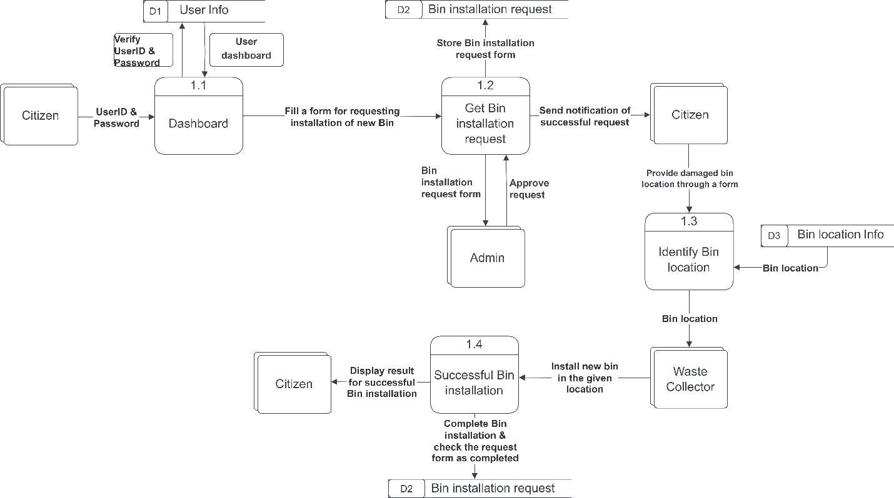

Physical DFD of Citizen monitoring Filled level of Trash Can:

Physical DFD of Admin generating area-based wastage analytics:

Physical DFD of Citizen reporting instances of littering or illegal dumping:

**Activity Diagram:**

**Figure-Activity Diagram of Registration**

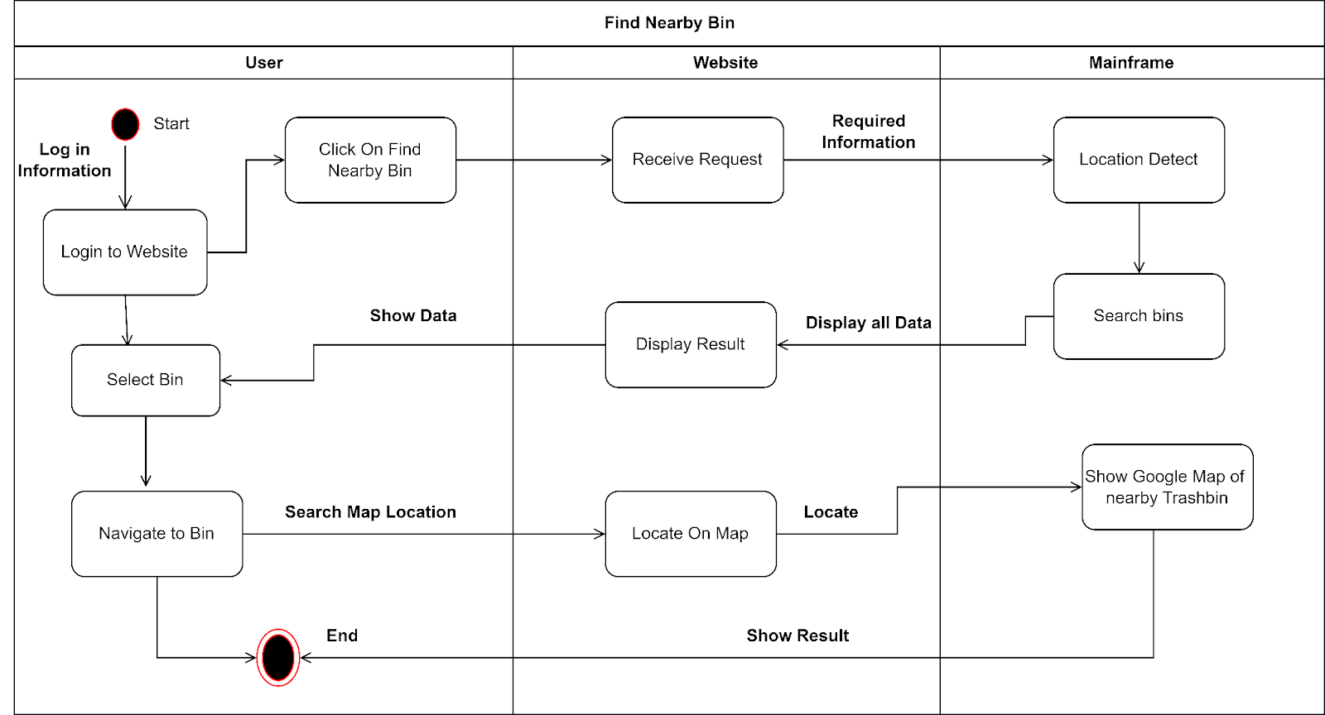

**Figure-Activity Diagram of Finding Nearby Bin**

**Figure-Activity Diagram of Monitor Filled Bin Level**

**Sequence Diagram:**

**Figure-Sequence: Diagram of Find Nearby Trash Can**

**Figure-Sequence Diagram of Registration**

**Communication Diagram:**

**Figure-Communication Diagram of Find Nearby Trash Can**

**Figure-Communication Diagram of Registration**

**Class Diagram:**

**Figure-Class Diagram of Mr. Bin**

**State Chart Diagram:**

**Figure-State Chart Diagram of Trash Bin Object**

**Crude Matrix:**

| **Activity** | **Citizen** | **Owner** | **Driver** | **Admin** | **TrashBin** | **Analytical**  **Data** | **Notification** |
| --- | --- | --- | --- | --- | --- | --- | --- |
| Register | C | C | C | R |  | C | C |
| Login | R | R | R |  |  |  | C |
| Edit profile | U | U | U | R |  |  | C |
| Remove account | D | D | D |  |  | D | D |
| Search  Trashbin | R | R | R | R | U | R |  |
| Add Information |  |  |  | C | U | U |  |
| Report  Activity | C | C | C | R |  | U |  |
| Check Collection route |  |  | R | CU |  | U |  |
| Request for New bin | C | C | C | RU | U | U | C |
| Advertising |  |  |  | CRUD |  |  | U |
| Collect Trash |  |  | C |  | D | U | U |