IT7742, Assignment 1
Sourav Singh
20231008
________________________________________________________________________
Report

This small system is made for handling customer details in an easy way. The idea from the client was that the same code should work for many types of screens like desktop or maybe later mobile too. So, the design I followed is Model-View-Controller because it keeps the work in different parts. The model is where the data stays, the view is what the user can see, and the controller connects both and does the thinking part. This helps when later changes are needed, we don’t have to fix everything again.

The main logic part in my project is the CustomerController class. I made this class to act like the middle person between the form and the customer data. Inside this class there is a list that stores all the customer records. This list is like a small memory-based database just for this app. The controller keeps this data safe and lets us add, change or delete any record without breaking the program. The diagram provided below shows the design.

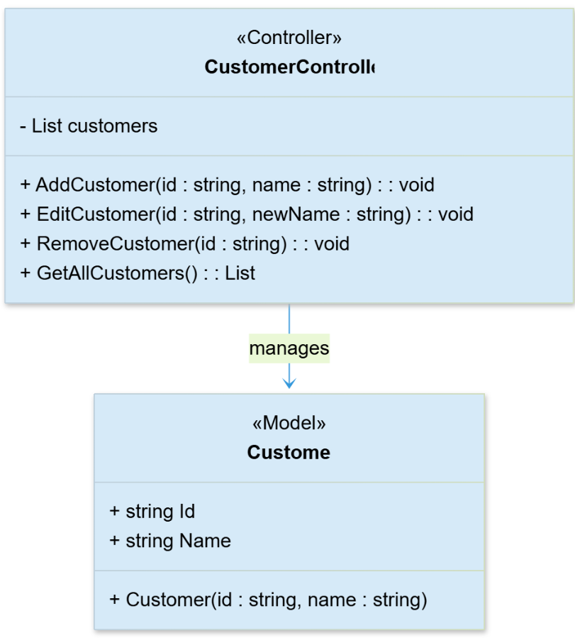

It has four main methods that make it work. The AddCustomer() method checks if both ID and name are written before saving. It helps avoid mistakes. The EditCustomer() method finds a record with the same ID and changes the name if it is found. The RemoveCustomer() method deletes the customer record completely. If the ID is not there the system gives an error message. The method GetAllCustomer() will return all the records and they will be shown in the datagridview box in the windows app form

This method is good because the program code does not interfere with the design. The form can be later used and redesigned for different platforms without changing the core code.
____________________________________________________________________________

