Order and Payment Platform – Project Documentation
Microservices
- Order Service
  - Handles order creation, cancellation, and status queries.
  - Publishes OrderCreated events to ActiveMQ.
- Payment Service
  - Consumes OrderCreated events.
  - Validates and processes payments.
  - Persists transactions in payment_transactions.
  - Publishes PaymentCompleted or PaymentFailed events.

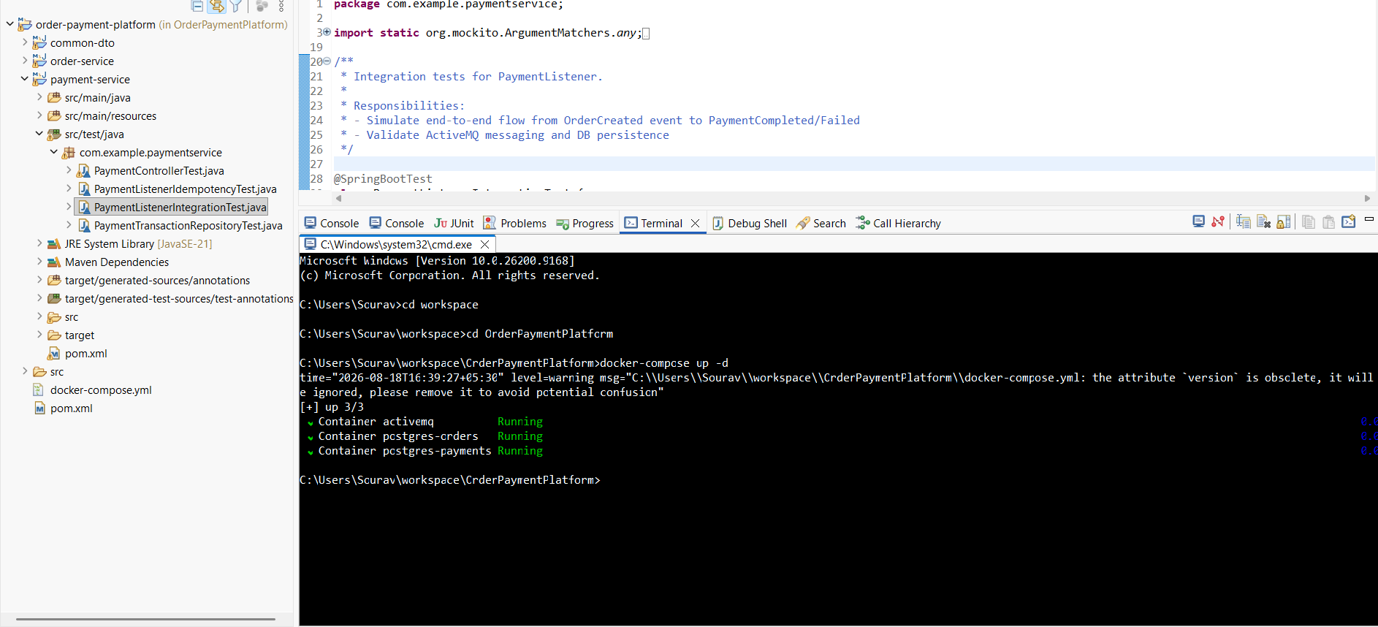
As shown in the above snapshot, the application consists of multiple independent services. In addition, a dedicated ActiveMQ container is running for asynchronous message communication, along with separate database containers associated with the respective services. This setup demonstrates the overall microservices-based architecture and the separation of application, messaging, and database components.

Microservice Design Pattern
- Event-Driven Communication Pattern
  - Order Service publishes events.
  - Payment Service consumes asynchronously via ActiveMQ.
  - Decouples services and ensures resilience.
OOAD Design Pattern
- Builder Pattern
  - Used for constructing complex objects (DTOs, entities, responses) in a clean and maintainable way.
  - Ensures immutability and readability when creating objects with multiple optional fields.
  - Applied in both Order Service and Payment Service for building entities like Order, PaymentTransaction, and response objects.
  - Improves code clarity and reduces constructor overloads.
Diagrams
- Use Case Diagram
  - Actors: User, Order Service, Payment Service, ActiveMQ, Database.
  - Use Cases: Place Order, Process Payment, Query Order/Payment.
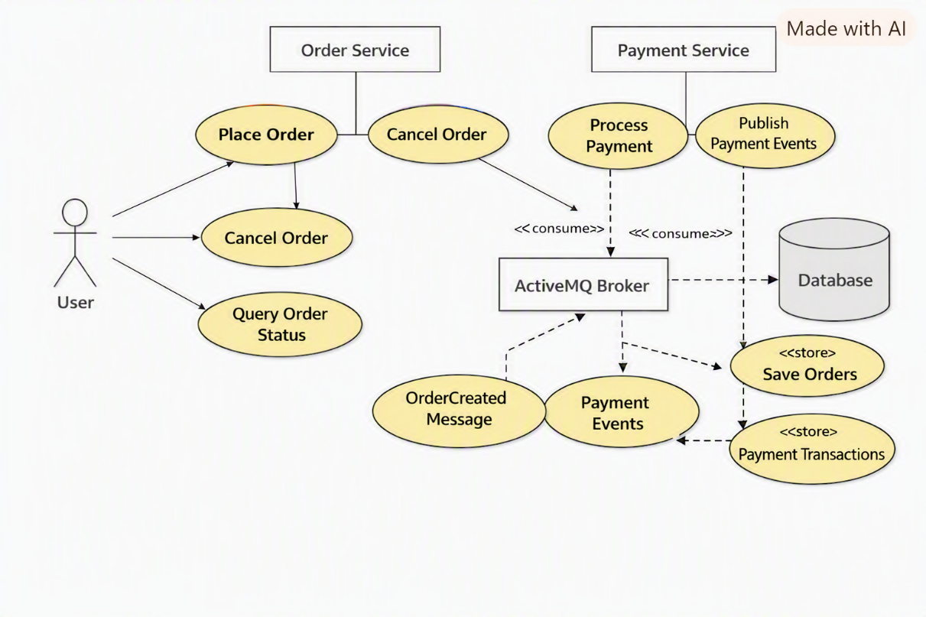

- Sequence Diagram
  - Flow: User → OrderController → OrderService → DB → Event → ActiveMQ → PaymentListener → PaymentTransactionRepository → DB → Event Published
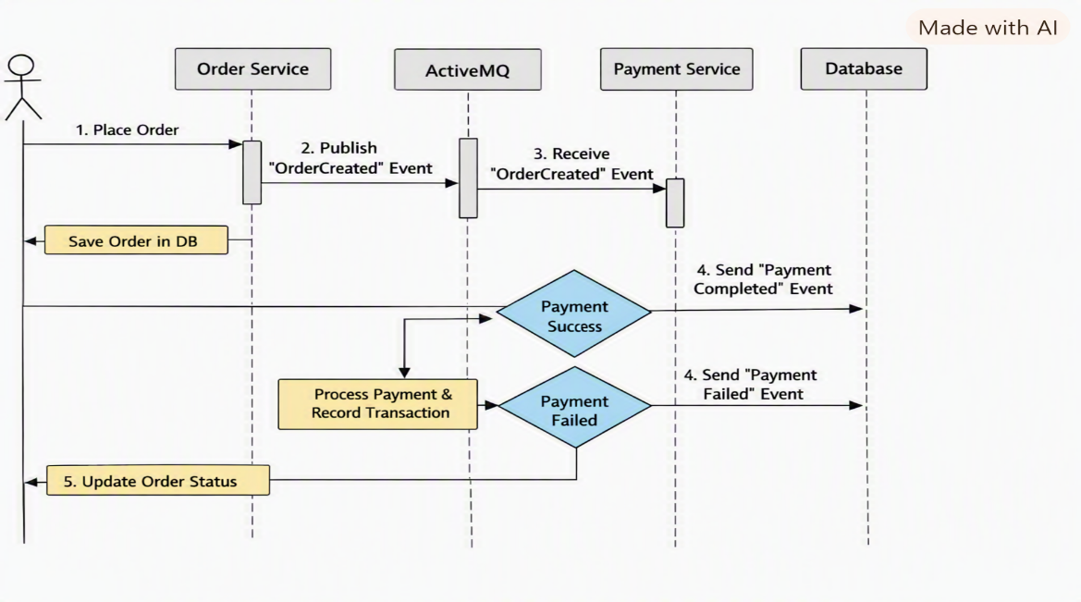

Technology Stack
- Java 21 → Modern language features.
- Spring Boot → Microservice scaffolding.
- REST API → Endpoints for orders and payments.
- Spring Data JPA → Persistence layer.
- ACID Transactions → Ensured via @Transactional in OrderService.

Messaging & Reliability
- ActiveMQ → Message broker for event-driven communication.
- Transactional Outbox → Ensures reliable event publishing after DB commit.
- Idempotency → Unique order_id constraint prevents duplicate payments.
- Retry/Redelivery → Configured with RedeliveryPolicy (5 retries, exponential backoff).

- Dead Letter Queue (DLQ) → Failed messages moved to ActiveMQ.DLQ after retries. Below Snapshot can show you the DLQ part.
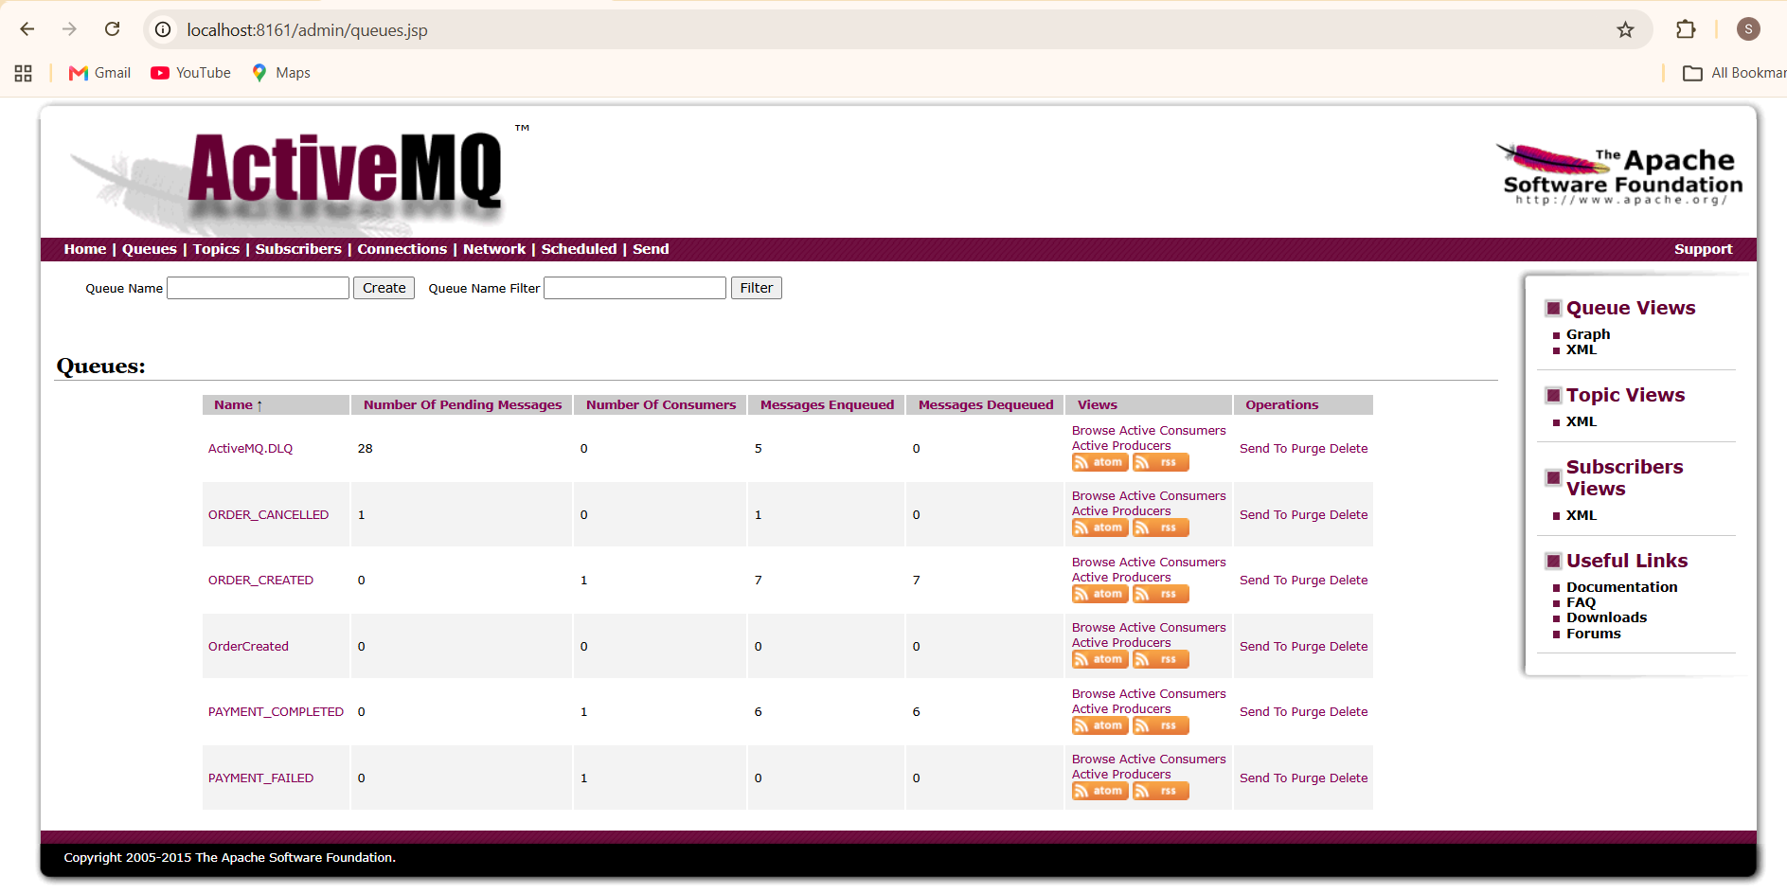

Quality Assurance
- Automated Tests → JUnit tests for controllers, services, and idempotency checks
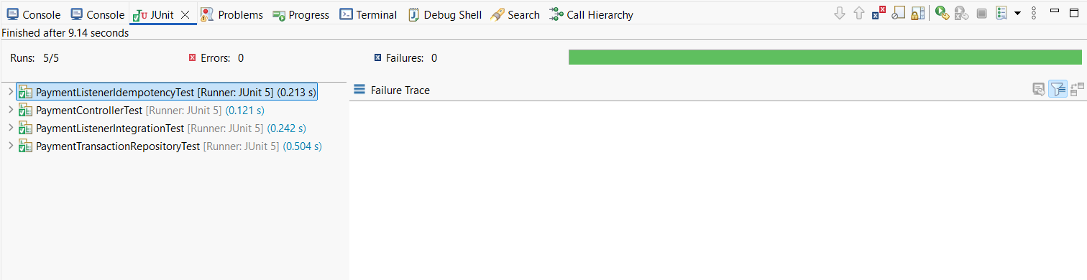
- Docker → Containerized deployment for Order Service, Payment Service, ActiveMQ, and DB.
