**MA335 Final Project Report**

**Sourav Ghosh Hansda**

**Date-20/06/2023**

**Abstract**

The report explores the relationship between different characteristics related to Alzheimer's disease and the diagnosis of individuals as "Demented" or "Nondemented." Through descriptive statistics and their analysis based on a battery of techniques, namely, cluster analysis, logistic regression and forward selection stepwise method, valuable insights are gained into potential factors contributing to the development of the disease. The dataset can be segmented into 2 or 3 clusters with some overlaps. Men, individuals with few years of education, and those with high socioeconomic status appear more vulnerable to dementia.

**Contents**

1. **Introduction**
2. **Descriptive Statistics**
3. **Clustering**
4. **Logistic Regression**
5. **Feature Selection**
6. **Conclusion**

**Appendix**

**1) Introduction**

Alzheimer is a progressive disease that destroys memory. Millions of people are afflicted with Alzheimer worldwide. As a data science consultant, I am tasked to analyse a dataset having different characteristics related to Alzheimer's. The report attempts to explore the relationship between these characteristics and the diagnosis on Alzheimer, distinguishing people as "Demented" or "Nondemented." By examining descriptive statistics and applying statistical techniques to the dataset, we can gain valuable insights into the potential factors that may contribute to the development of the disease.

The rest of the report is organized as under. Section 2 presents descriptive statistics and boxplots/histogram on the interrelationship of variables, based on the given dataset of patients with Alzheimer's disease. This dataset includes information on the patients' age, gender, education, socioeconomic status, Mini Mental State Examination (MMSE) score, Clinical Dementia Rating (CDR) score, estimated total intracranial volume (eTIV), normalized whole brain volume (nWBV), and Atlas scaling factor (ASF). In Section 3, the k means clustering algorithm is used to identify patterns and the groupings within the dataset. In Section 4, a logistic regression model is fitted while using the remaining observations to check the robustness of the model. In Section 5, a forward stepwise selection method is implemented to identify the significant features in understanding the Alzheimer's data set. Concluding observations are articulated in Section 6.

**2) Descriptive Statistics**

Summary Statistics of the Dataset

 M.F: M=1; F=0.

In the sample of 317 individuals, the group mean of 0.4 being closer to zero indicates larger proportion of nondemented individuals. Similarly, M.F mean of 0.43 implies larger proportion of females in the group. Individuals of 60 to 98 years are included in the group with an average age of 76 years. The number of years of education has been varying widely from 6 years to 23 years. While mean MMSE of 27.26 is below the mark of 30, it remains higher than 24, which is usually taken as the indication of possible cognitive impairment or dementia. This is also supported by the low mean CDR at 0.27. The low skewness of 0.07 for ASF suggests a roughly symmetric distribution while the kurtosis value of -0.26 implies a relatively flat distribution.

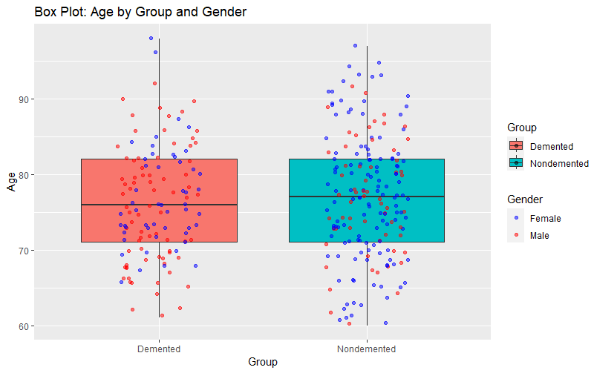

The minimum and maximum ages of the demented group is higher than those of the nondemented group. However, the median age of the demented group is lower than the nondemented group. There are more males in the demented group than females in contrast to the nondemented group. As the number of males are less than the number of females in the dataset, this means Alzheimer seems more prevalent in gents than in ladies.

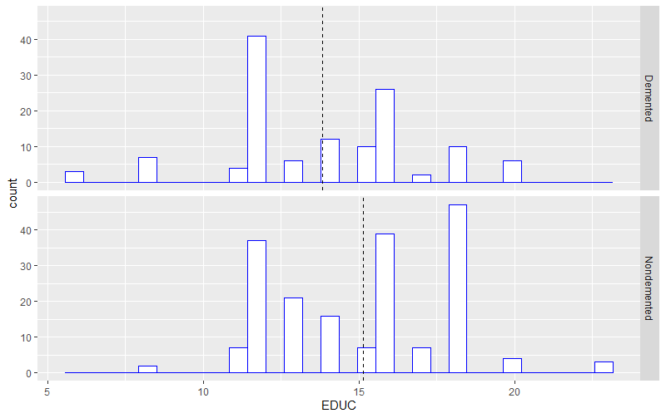

As per the above histogram, the average years of education at around 14 years for the demented group stand out lower than that at around 15 years for the nondemented group. Further, the number of demented persons peaks at around 12 years of education as against 18 years in the nondemented group.

**3) Clustering**

Towards implementing clustering algorithm, we first normalize the data by subtracting from the mean and dividing by standard deviation. We then calculate the Euclidean distance and use the following scree plot. The highest drop in the within groups sum of squares happens at number of clusters: 2 and 3. We have applied the technique of K mean clustering with 2 clusters, resulting in 90 and 227 observations in the clusters respectively. The within cluster sum of squares is 723.6541 and 1629.7171, respectively. Ideally, it should be as small as possible. The ratio between_SS cluster / total_SS cluster is 17.3%. Ideally, this ratio should be as large as possible. Cluster 1 is associated with higher chance of being male (on average), higher average of age, lower average education, higher average SES, lower average MMSE, higher average CDR, lower average eTIV, lower average nWBV, higher average ASF. Cluster 2 is associated with lower chance of being female (on average), while the other characteristics are likely to be the opposite vis-a-vis those in Cluster 1. K mean clustering with 3 clusters contains 161, 67 and 89 observations in the clusters respectively. The magnitude of within cluster sum of squares is much smaller as compared with Cluster 2. The ratio between_SS cluster / total_SS cluster is 36.8%, higher than Cluster2.

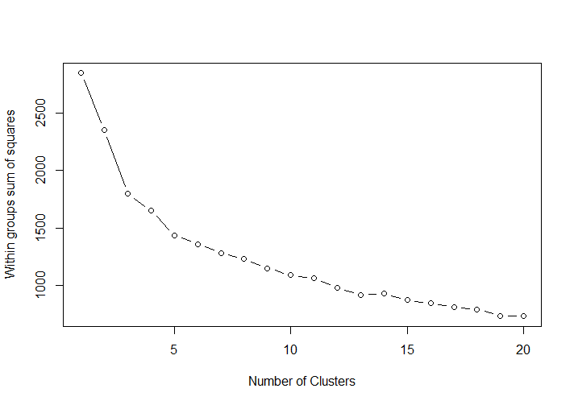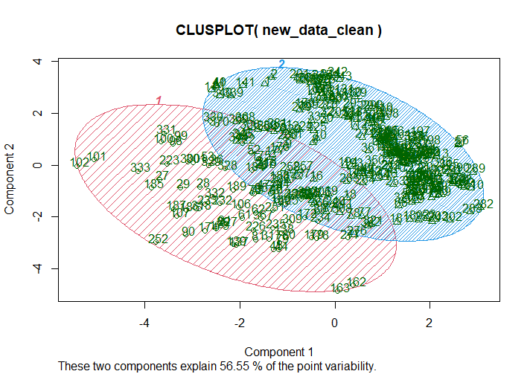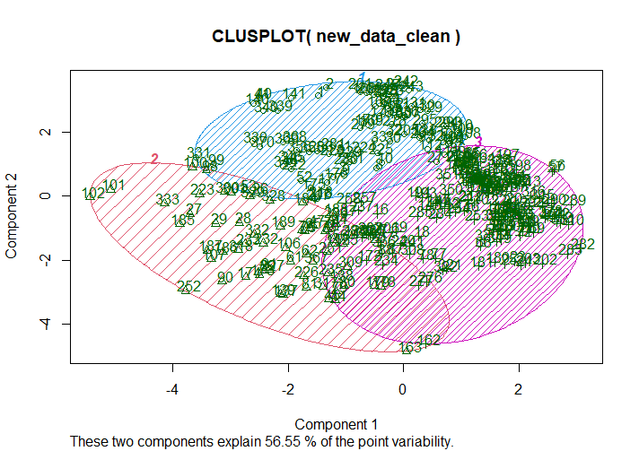

As we increase the number of clusters, the within sum of squares reduce and the ratio between_SS cluster / total_SS cluster increases, eg, with 4 clusters, it is 43.6%. The gain in ratio is not that high when we go from Cluster 3 to Cluster 4 as compared to that from Cluster 2 to Cluster 3. Therefore, Cluster 2 or Cluster 3 using k mean clustering may be appropriate.

**4) Logistic Regression**

We begin by taking log of the variables to scale down the values. Further we divide the data into training and testing data sets (80% training data and 20% testing data). In light of the interrelationship between demented/nondemented group and the independent variables as plotted /explained in the appendix, we construct the following model after several permutations and combinations: Group ~ Age + EDUC +MMSE+nWBV +SES + error

The coefficients of Age, EDUC, MMSE and nWBV are negative. Therefore, with an increase in any of these variables, a person is likely to be nondemented. The lowest SES (ie, represented by intercept) is statistically significant as compared to higher SES. Using confusion matrix, we find that the misclassification error in Training data set is 14.17% and it’s 14.28% in testing dataset (Appendix).

|  |  |  |  |  |
| --- | --- | --- | --- | --- |
|  | Estimate | Std. Error | z value | Pr(>|z|) |
| (Intercept) | 206.17 | 32.55 | 6.33 | 0.00*** |
| Age | -13.06 | 3.03 | -4.32 | 0.00*** |
| EDUC | -3.20 | 1.62 | -1.97 | 0.05* |
| MMSE | -35.78 | 5.77 | -6.20 | 0.00*** |
| nWBV | -29.64 | 7.53 | -3.94 | 0.00*** |
| SES2 | -1.18 | 0.63 | -1.88 | 0.06 |
| SES3 | 0.08 | 0.68 | 0.12 | 0.91 |
| SES4 | -0.59 | 0.78 | -0.75 | 0.45 |
| SES5 | -5.82 | 4.86 | -1.20 | 0.23 |

**5) Feature Selection**

We use a forward stepwise selection method to find the most important features. First, we fit the intercept-only model. This model had an AIC of -450.23. Next, we fit every possible one-predictor model. The model that produced the lowest AIC and also had a statistically significant reduction in AIC compared to the intercept-only model used the predictor CDR. This model had an AIC of -870.39. Next, we fit every possible two-predictor model. The model that produced the lowest AIC and also had a statistically significant reduction in AIC compared to the single-predictor model added the predictor EDU. This model had an AIC of -880.95. Next, we fit every possible three-predictor model. The model that produced the lowest AIC and also had a statistically significant reduction in AIC compared to the two-predictor model added the predictor M/F. This model had an AIC of -892.35. Next, we fit every possible four-predictor model. It turned out that none of these models produced a significant reduction in AIC. So, we stopped the procedure. The final model turns out to be:

Group ~ 4.23 + (1.05*CDR) - (0.18*EDU) + (0.17*M.F) – (0.51*eTIV)

|  |  |  |  |  |  |
| --- | --- | --- | --- | --- | --- |
| Step | Df | Deviance | Resid. Df | Resid. Dev | AIC |
|  | NA | NA | 316 | 76.119 | -450.22 |
| + CDR | -1 | 56.022 | 315 | 20.097 | -870.38 |
| +EDUC | -1 | 0.780 | 314 | 19.316 | -880.950 |
| +M.F | -1 | 0.799 | 313 | 18.516 | -892.35 |
| +eTIV | -1 | 0.725 | 312 | 17.791 | -903.02 |

The Group variable moves with CDR and M.F in the same direction and with EDUC and eTIV in the opposite direction. The magnitude of impact from changes in CDR on the Group is the maximum.

**6) Conclusion**

It looks like there are more men having dementia in comparison to women. Individuals having low number of years of education or belonging to the highest socio-economic status are likely to be particularly vulnerable to dementia. The demented and nondemented groups are not very different in respective of characteristics like eTIV and ASF. The observations can at the most be segmented into 2 or 3 clusters albeit with some overlapping borders. A forward step-wise selection method produces a 4 variable predictor model for the group with the CDR having the maximum impact on the Group variable.

**Appendix**

**Graph & Tables:**

Summary Statistics of the Demented



Summary statistics of the Non-Demented



Gender and Alzheimer (Demented or Non-Demented)

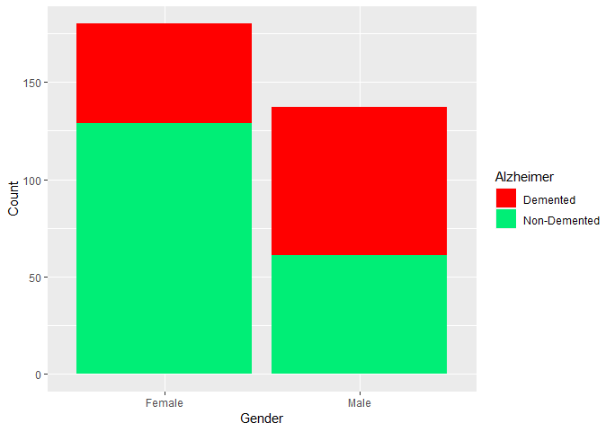

Age and Alzheimer (Demented or Non-Demented)

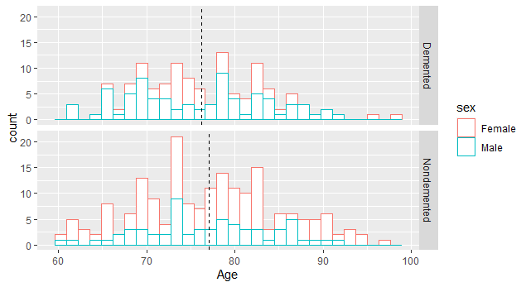

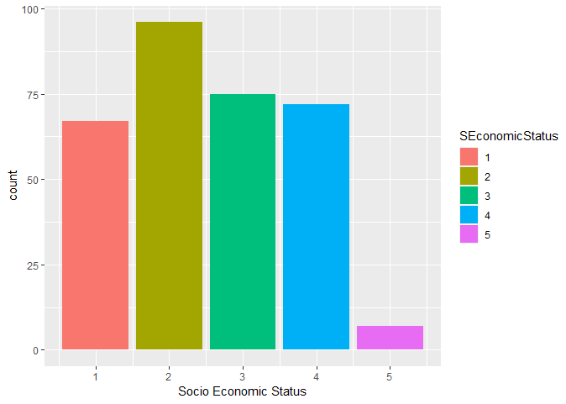Socioeconomic Status and Alzheimer (Demented or Non-Demented)

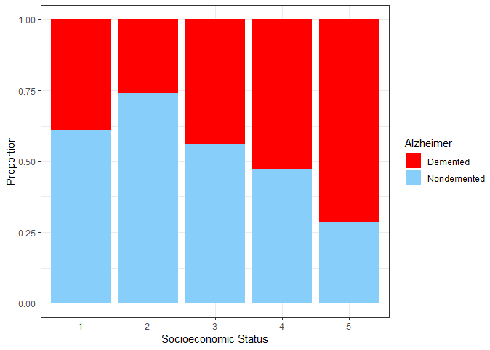

Mini Mental State Examination and Alzheimer (Demented or Non-Demented)

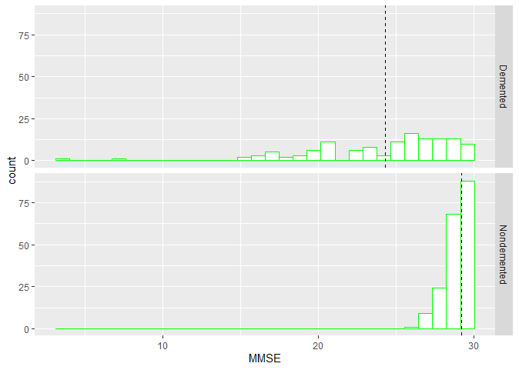

Clinical Dementia Rating and Alzheimer (Demented or Non-Demented)

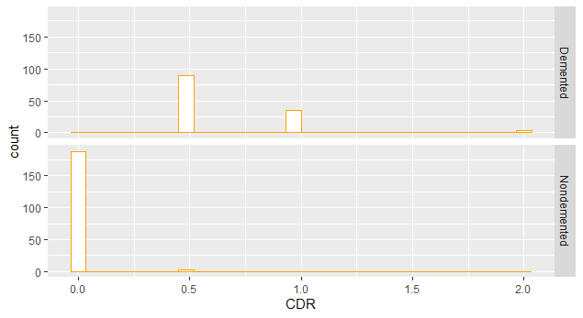

Estimated total intracranial volume and Alzheimer (Demented or Non-Demented)

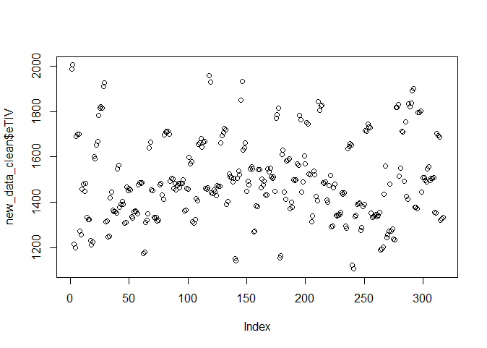

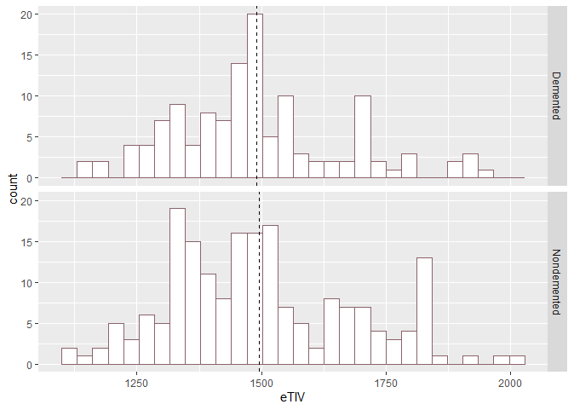

Normalize whole brain volume and Alzheimer (Demented or Non-Demented)

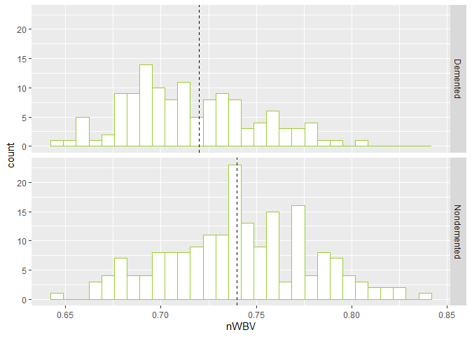

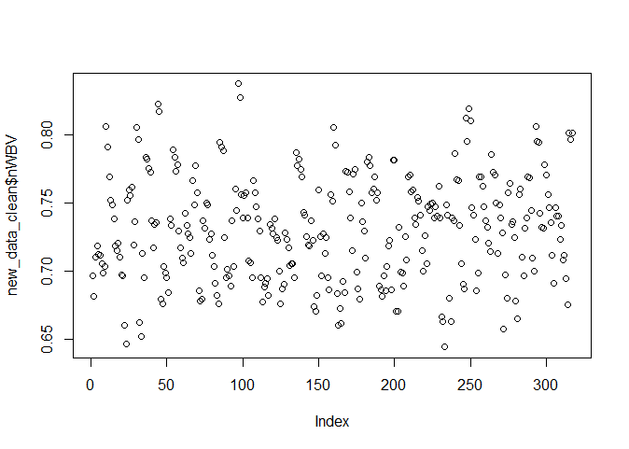

Atlas scaling factor and Alzheimer (Demented or Non-Demented)

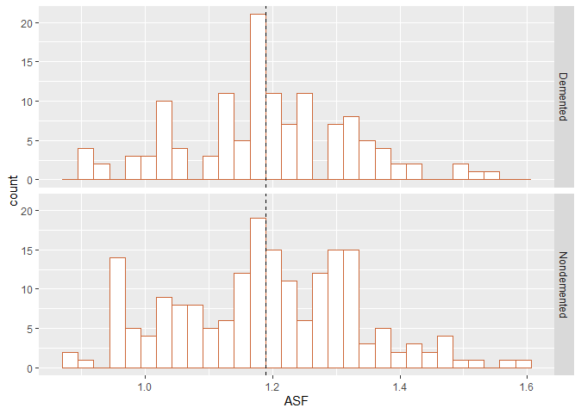

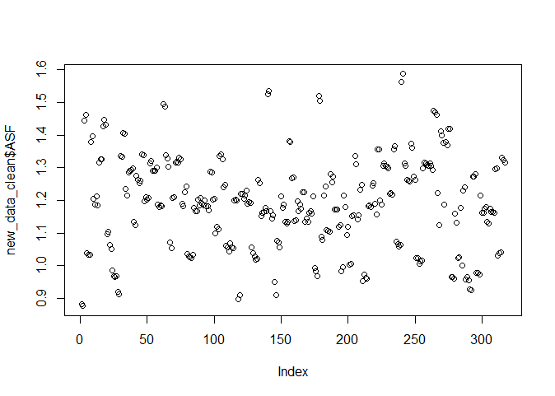

Correlation Plot of all Independent Variables

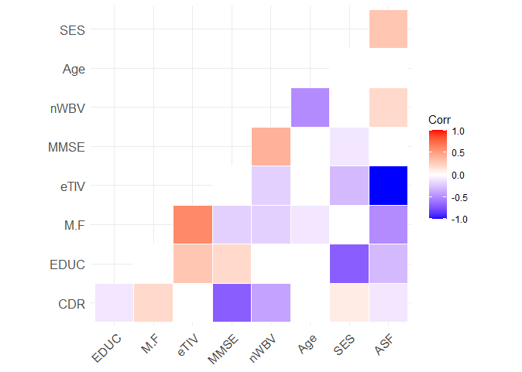

Misclassification error in Training Data using Confusion Matrix

|  |  |  |
| --- | --- | --- |
|  | Actual | |
| Predicted | 0 | 1 |
| 0 | 146 | 27 |
| 1 | 10 | 78 |

Misclassification error in Testing Data using Confusion Matrix

|  |  |  |
| --- | --- | --- |
|  | Actual | |
| Predicted | 0 | 1 |
| 0 | 31 | 5 |
| 1 | 3 | 17 |

**Code:**

**#**libraries loaded

library(ggplot2)

library(psych)

library("cluster")

library(ggcorrplot)

library(plyr)

# Read the csv file

myproject<-read.csv("C:/Users/Admin/OneDrive - University of Essex/MA335/Final project-20230509 2023-05-09 09_39_38/project data.csv",header = TRUE, sep=",")

#print column names

colnames(myproject)

# print first few rows of the dataset

head(myproject)

# print last few rows of the dataset

tail(myproject)

# number of rows in the dataset

nrow(myproject)

#count the frequencies of each unique value in the Group column

table(myproject$Group)

#count the frequencies of each unique value in the M.F column

table(myproject$M.F)

#Convert Male/Female into numerical value

myproject$M.F <- ifelse( myproject$M.F == "F", 0, 1)

myproject$M.F

#count missing values in dataset

num_na_values <- sum(is.na(myproject))

num_na_values

# Remove missing values

data_clean <- na.omit(myproject)

nrow(data_clean)

#Remove rows with Group="Converted"

new_data_clean <- subset(data_clean, !(Group == "Converted"))

# number of rows in the clean dataset

nrow(new_data_clean) #317

#Summary of cleaned dataset

summary(new_data_clean)

# count the frequencies of each unique value in the group column

table(new_data_clean$Group)

#getting unique values of the group column

unique(new_data_clean$Group)

###########################Summary Statistics############

#summary statistics of cleaned dataset

head(new_data_clean)

nrow(new_data_clean) #317

colnames(new_data_clean)

ncol(new_data_clean)

describe(new_data_clean[,2:10])

# Subset the cleaned dataset to include only rows with 'Group' equal to "Demented"

new_data_clean_D <- subset(new_data_clean, (Group == "Demented"))

head(new_data_clean_D)

nrow(new_data_clean_D) #127

colnames(new_data_clean_D)

ncol(new_data_clean_D)

describe(new_data_clean_D[,2:10])

# Subset the cleaned dataset to include only rows with 'Group' equal to "Nondemented"

new_data_clean_ND <- subset(new_data_clean, (Group == "Nondemented"))

head(new_data_clean_ND)

nrow(new_data_clean_ND) #190

colnames(new_data_clean_ND)

ncol(new_data_clean_ND)

describe(new_data_clean_ND[,2:10])

# Calculate the total number of rows in the 'Demented' and 'Nondemented' groups

nrow(new_data_clean_D)+nrow(new_data_clean_ND)#317

# Create a box plot to visualize the relationship between 'Group' and 'Age' with color-coded 'Gender'

ggplot(new_data_clean, aes(x = factor(Group), y = Age, fill = Group)) +

geom_boxplot() +

geom_jitter(aes(color = factor(M.F)), width = 0.2, alpha = 0.5) +

labs(x = "Group", y = "Age", fill = "Group", color = "Gender") +

scale_color_manual(values = c("blue", "red"), labels = c("Female", "Male")) +

ggtitle("Box Plot: Age by Group and Gender")

############Each independent variable relation with dependent variable###############

################Gender vs Alzeimer#######################

# Subset the data for males

M<-subset(new_data_clean, M.F == 1)

nrow(M) #137

# Subset the data for females

F<-subset(new_data_clean, M.F == 0)

nrow(F) #180

nrow(M)+nrow(F)#317

# Subset the data for demented males

MD<- subset(new_data_clean, M.F == 1 & Group == 'Demented')

nrow(MD) #76

# Subset the data for demented females

FD<- subset(new_data_clean, M.F == 0 & Group == 'Demented')

nrow(FD) #51

# Subset the data for nondemented males

MND<- subset(new_data_clean, M.F == 1 & Group == 'Nondemented')

nrow(MND) #61

# Subset the data for nondemented females

FND<- subset(new_data_clean, M.F == 0 & Group == 'Nondemented')

nrow(FND) #129

nrow(MD)+nrow(FD)+nrow(MND)+nrow(FND)#317

# Calculate the proportion of males with dementia

proportionMales<-round(76/137,2) #55% Males

proportionMales

# Calculate the proportion of females with dementia

proportionfemales<-round(51/180,2) #28% Females

proportionfemales

# Create a data frame for gender and demented count

gender <- c("Male", "Female", "Male", "Female")

demented <- c("Non-Demented", "Non-Demented", "Demented", "Demented")

count <- c(61,129,76,51)

df <- data.frame(gender, demented, count)

# Create a stacked bar plot to visualize the gender vs. count with fill representing dementia status

ggplot(df, aes(x = gender, y = count, fill = demented)) +

geom_bar(stat = "identity", position = "stack") +

labs(x = "Gender", y = "Count", fill = "Alzheimer") +

scale_fill_manual(values = c("red", "springgreen2"))

##########################Age vs Alzheimer#######################

# Assign "Male" or "Female" based on M.F variable

sex <- ifelse(new_data_clean$M.F == 1, "Male", "Female")

# Calculate the mean age for demented and non-demented groups

mu <- ddply(new_data_clean, "Group", summarise, grp.mean=round(mean(Age),2))

mu #Demented Mean Age is 76.20

#NonDemented Mean Age is 77.06

# Create a histogram of Age with color representing sex and facet by Group

p<-ggplot(new_data_clean, aes(x=Age, color=sex))+

geom_histogram(fill="white")+

facet_grid(Group ~ .)

p

# Add mean lines for demented and non-demented groups

p+geom_vline(data=mu, aes(xintercept=grp.mean),linetype="dashed")

########################Education vs Alzemier#################

# Calculate the mean education level for demented and non-demented groups

nu <- ddply(new_data_clean, "Group", summarise, grp.mean=round(mean(EDUC),2))

nu #Demented Mean EDUC is 13.83

#NonDemented Mean EDUC is 15.14

# Create a histogram of EDUC with color representing Group

q<-ggplot(new_data_clean, aes(x=EDUC))+

geom_histogram(color="blue", fill="white")+

facet_grid(Group ~ .)

q

# Add mean lines for demented and non-demented groups

q+geom_vline(data=nu, aes(xintercept=grp.mean),linetype="dashed")

########################Socio Economic Status vs Alzeimer###############

# Create a bar plot to visualize the distribution of Socio Economic Status

SEconomicStatus<-as.factor(new_data_clean$SES)

ggplot(new_data_clean) +

geom_bar(mapping = aes(x = SES,fill=SEconomicStatus)) +

labs(x = "Socio Economic Status")

# Create a bar plot to visualize the proportion of demented vs. non-demented based on Socioeconomic Status

ggplot(new_data_clean, aes(x = factor(SES), fill = factor(Group))) +

geom_bar(position = "fill") +

scale_fill_manual(values = c("red", "lightskyblue")) +

labs(x = "Socioeconomic Status", y = "Proportion", fill = "Alzheimer") +

theme_bw()

#######################Mini Mental State Examination vs Alzeimer################

new_data_clean$MMSE

count(new_data_clean$MMSE)

# Calculate the mean MMSE score for demented and non-demented groups

wu <- ddply(new_data_clean, "Group", summarise, grp.mean=round(mean(MMSE),2))

wu #Demented Mean MMSE is 24.32

#NonDemented Mean MMSE is 29.23

# Create a histogram of MMSE with color representing Group

g<-ggplot(new_data_clean, aes(x=MMSE))+

geom_histogram(color="green", fill="white")+

facet_grid(Group ~ .)

g

# Add mean lines for demented and non-demented groups

g+geom_vline(data=wu, aes(xintercept=grp.mean),linetype="dashed")

######################Clinical Dimentia Rating vs Alzeimer################

new_data_clean$CDR

# Calculate the mean CDR score for demented and non-demented groups

yu <- ddply(new_data_clean, "Group", summarise, grp.mean=round(mean(CDR),2))

yu #Demented Mean CDR is 0.67

#NonDemented Mean CDR is 0.01

count(new_data_clean$CDR)

# Create a histogram of CDR with color representing Group

f<-ggplot(new_data_clean, aes(x=CDR))+

geom_histogram(color="orange", fill="white")+

facet_grid(Group ~ .)

f

####################Estimated total intracranial volume vs Alzeimer#################

new_data_clean$eTIV

plot(new_data_clean$eTIV)

# Calculate the mean eTIV for demented and non-demented groups

ru <- ddply(new_data_clean, "Group", summarise, grp.mean=round(mean(eTIV),2))

ru #Demented Mean eTIV is 1490.7

#NonDemented Mean eTIV is 1495.5

count(new_data_clean$CDR)

# Create a histogram of eTIV with color representing Group

s<-ggplot(new_data_clean, aes(x=eTIV))+

geom_histogram(color="pink4", fill="white")+

facet_grid(Group ~ .)

s

# Add mean lines for demented and non-demented groups

s+geom_vline(data=ru, aes(xintercept=grp.mean),linetype="dashed")

################Normalize whole brain volume vs Alzeimer########

new_data_clean$nWBV

plot(new_data_clean$nWBV)

# Calculate the mean nWBV for demented and non-demented groups

pu <- ddply(new_data_clean, "Group", summarise, grp.mean=round(mean(nWBV),2))

pu #Demented Mean nWBV is 0.72

#NonDemented Mean nWBV is 0.74

# Create a histogram of nWBV with color representing Group

r<-ggplot(new_data_clean, aes(x=nWBV))+

geom_histogram(color="yellowgreen", fill="white")+

facet_grid(Group ~ .)

r

# Add mean lines for demented and non-demented groups

r+geom_vline(data=pu, aes(xintercept=grp.mean),linetype="dashed")

#############################Atlas scaling factor VS Alzeimer#################

new_data_clean$ASF

plot(new_data_clean$ASF)

# Calculate the mean ASF for demented and non-demented groups

du <- ddply(new_data_clean, "Group", summarise, grp.mean=round(mean(ASF),2))

du #Demented Mean ASF is 1.19

#NonDemented Mean ASF is 1.19

# Create a histogram of ASF with color representing Group

t<-ggplot(new_data_clean, aes(x=ASF))+

geom_histogram(color="sienna3", fill="white")+

facet_grid(Group ~ .)

t

# Add mean lines for demented and non-demented groups

t+geom_vline(data=du, aes(xintercept=grp.mean),linetype="dashed")

############Correlation Matrix######################

# Calculate the correlation matrix for the variables

corr <- round(cor(new_data_clean[,2:10]), 1)

head(corr)

# Visualize the correlation matrix using a heatmap

ggcorrplot(corr, hc.order = TRUE, type = "lower",

outline.col = "white")

#####################Clustering Algorithm###################

##################K mean Clustering##################

z <-new_data_clean[,-c(1,1)]

head(z)

# Calculate the mean and standard deviation for each variable

m<-apply(z,2,mean)

m

s<-apply(z,2,sd)

s

# Normalize the data by subtracting from the mean and dividing by the standard deviation

nor<-scale(z,center=m,scale =s)

head(nor)

# Calculate distance matrix

distance <- dist(nor)

print(distance, digits =2)

# Scree Plot to determine the optimal number of clusters

wss <- (nrow(nor)-1)*sum(apply(nor,2,var))

for (i in 2:20) wss[i] <- sum(kmeans(nor, centers=i)$withinss)

plot(1:20, wss, type="b", xlab="Number of Clusters", ylab="Within groups sum of squares")

# K-means clustering

set.seed(1234)

# Perform K-means clustering with k = 2

kc1<-kmeans(nor,2)

kc1

# Perform K-means clustering with k = 3

kc2<-kmeans(nor,3)

kc2

# Perform K-means clustering with k = 4

kc3<-kmeans(nor,4)

kc3

#Visualizing the clusters using clusplot

clusplot(new_data_clean,kc1$cluster,

color=T,shade= T,

labels=2, lines=0)

clusplot(new_data_clean,kc2$cluster,

color=T,shade= T,

labels=2, lines=0)

#######################Logistic Regression####################

#Check the structure of the dataset

str(new_data_clean)

head(new_data_clean)

head(new_data_clean$Group)

tail(new_data_clean$Group)

#Convert the "Group" variable to binary values

group <- ifelse(new_data_clean$Group== "Nondemented", 0, 1)

head(group)

tail(group)

# Create a new data frame 'logisticdata' with the 'group' variable and remaining columns from 'new_data_clean'

logisticdata<-data.frame(group,new_data_clean[,-1])

head(logisticdata)

# Convert 'SES' column to a factor variable

logisticdata$SES<-as.factor(logisticdata$SES)

head(logisticdata$SES)

# Apply logarithmic transformation to 'Age' column

logisticdata$Age<-log(logisticdata$Age)

head(logisticdata$Age)

# Apply logarithmic transformation to 'EDUC' column

logisticdata$EDUC<-log(logisticdata$EDUC)

head(logisticdata$EDUC)

# Apply logarithmic transformation to 'MMSE' column

logisticdata$MMSE<-log(logisticdata$MMSE)

head(logisticdata$MMSE)

# Apply logarithmic transformation to 'eTIV' column

logisticdata$eTIV<-log(logisticdata$eTIV)

head(logisticdata$eTIV)

# Convert 'M.F' column to a factor variable

logisticdata$M.F<-as.factor(logisticdata$M.F)

head(logisticdata$M.F)

head(logisticdata)

str(logisticdata)

# Partition data - train (80%) & test (20%)

set.seed(1234)

ind <- sample(2, nrow(logisticdata), replace = T, prob = c(0.8, 0.2))

head(ind)

train <- logisticdata[ind==1,]

head(train)

test <- logisticdata[ind==2,]

head(test)

# Logistic regression model using the train data

mymodel <- glm(group ~ Age + EDUC + MMSE + nWBV + SES , data = train, family = "binomial")

#summary of the logistic regression model

summary(mymodel)

# Prediction

p1 <- predict(mymodel, train, type = 'response')

head(p1)

tail(p1)

head(train)

tail(train)

# Misclassification error - train data

pred1 <- ifelse(p1>0.5, 1, 0)

tab1 <- table(Predicted = pred1, Actual = train$group)

tab1

1 - sum(diag(tab1))/sum(tab1)

# Misclassification error - test data

p2 <- predict(mymodel, test, type = 'response')

pred2 <- ifelse(p2>0.5, 1, 0)

tab2 <- table(Predicted = pred2, Actual = test$group)

tab2

1 - sum(diag(tab2))/sum(tab2)

#############################Stepwise Forward Selection#################

#define intercept-only model

intercept_only <- lm(group ~ 1, data=logisticdata)

#define model with all predictors

all <- lm(group ~ ., data=logisticdata)

#perform forward stepwise regression

forward <- step(intercept_only, direction='forward', scope=formula(all), trace=1)

forward

#view results of forward stepwise regression

forward$anova

#view final model

round(forward$coefficients,2)