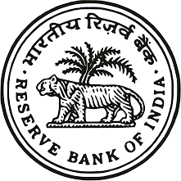

Dashboard & Analytics on India’s Locational Banking Statistics

Sourav Ghosh Hansda
Supervisor: Mr Somesh Kumar Jha
Director: Dr Pratik Mitra
July-December 2025

Acknowledgement

I would like to express my sincere gratitude to my Supervisor, Mr. Somesh Kumar Jha, for his valuable guidance, constant support, and insightful feedback throughout the course of this work. His encouragement and expertise were instrumental in shaping the direction and quality of this study.
I am deeply thankful to Director, Dr. Pratik Mitra, for his leadership, motivation, and institutional support, which provided an enabling environment for the successful completion of this project.
I would also like to acknowledge the support and cooperation extended by the officials and staff members of the International Banking Division.

Sourav Ghosh Hansda

Contents

Abstract 4
1. Background and Institutional Framework 5
Introduction 7
1 Data and Methodology 8
1.1 Data Coverage 8
1.2 Data Processing and Tools 10
1.3 Classification Framework 12
2 Analysis of International Assets 14
2.1 International Assets 14
2.2 Categories of Assets 18
3 Analysis of International Liabilities 22
3.1 Analysis of International Liabilities 22
3.2 Categories of Liabilities 26
4 Derivatives and Off-Balance-Sheet Expo- sures 30
5 Geographic and Currency Composition 34
5.1 Country Decomposition 34
5.2 Currency Decomposition 39
6 Sectoral Distribution of International Positions 41
7 Conclusion and Policy Implications 48
7.1 Conclusion 48
7.2 Policy Implications 49
8 References 51

Abstract
The study aims to explore the Internationally active banks that have assets/ liabilities in foreign currency or exposure to non-resident in any currency by using a Power BI Dashboard. The data used for this study is the quarterly data with a timeline from 2022 to 2025 in the csv format which is downloaded from Centralized Information Management System (CIMS). The report that is generated after examining the data is published on the Database on Indian Economy (DBIE) website under publications of Data on International Banking Statistics of India the insights are from statements 1 to 6. The L2 data is downloaded from CIMS in CSV format and then preprocessed in python where we add many other columns to better understand the codes of assets/liabilities/derivatives, we also add other columns to understand the codes of sectors as well. Then after adding all the extra columns, we upload the data into Power BI and then try to explore the data to find various insights that might give us some information on the data that we might have missed or were not able to extract by the old methodologies. Power BI tool was chosen to explore the data and create the dashboard because of its privacy.

1. Background and Institutional Framework
The Location Banking Statistics (LBS) framework constitutes a comprehensive reporting system developed to capture the cross-border financial positions of banks operating in India. The framework stems from the global statistical initiative coordinated by the Bank for International Settlements (BIS) and its Committee on the Global Financial System (CGFS), which aims to enhance transparency, comparability, and supervisory oversight of international banking activity. In alignment with these global standards, the Reserve Bank of India (RBI) introduced the LBS reporting structure to systematically record the foreign currency assets and liabilities of Indian banks as well as the cross-border exposures of foreign banks operating within India. The system provides granular, instrument-wise, sector-wise, and country-wise information that supports both domestic policy-making and international surveillance exercises.
The LBS framework covers all banks in India that maintain international positions defined as claims on or liabilities to non-residents, irrespective of whether they are denominated in foreign currency or Indian Rupees. The reporting structure reflects the dual objective of compiling consistent data for India’s contribution to BIS consolidated banking statistics and enabling the RBI to monitor external exposures, funding patterns, and potential vulnerabilities in the banking system. To ensure uniformity across institutions, LBS prescribes a detailed classification of instruments, counterparties, maturities, and currencies, along with standardized reporting templates that facilitate the aggregation of data across diverse banking entities.
Integral to the LBS system is its quarterly reporting cycle, under which banks submit their international positions within a specified timeline following the end of each quarter. The framework’s emphasis on standardization ensures that India’s data is fully comparable with that of other reporting jurisdictions participating in BIS global data collections. Beyond its statistical purpose, LBS serves as an important tool for macroprudential surveillance, enabling authorities to track trends in cross-border lending, foreign currency liquidity, and international risk transmission channels. In this way, the LBS framework strengthens the information base necessary for maintaining financial stability in an increasingly interconnected global banking environment.

Introduction
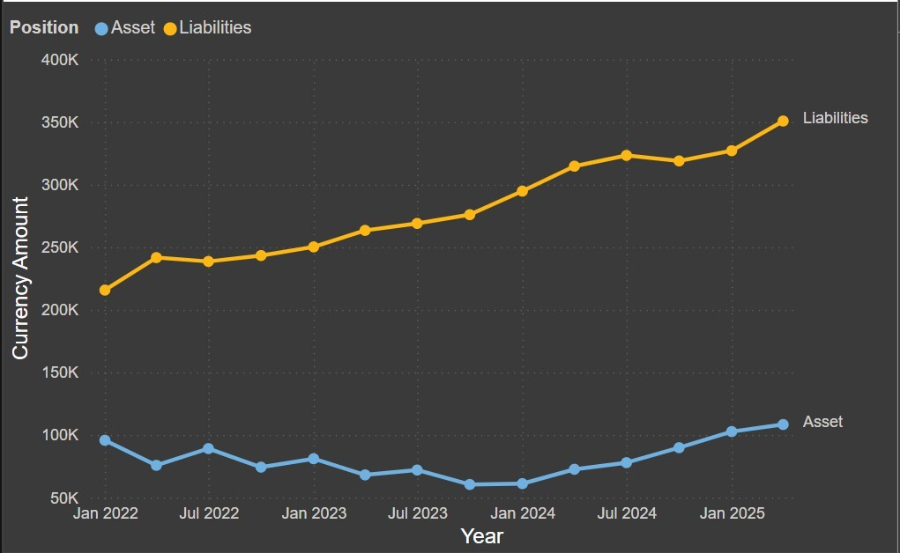
The internationally active banks submit the Location Banking Statistics (LBS) return every quarter as per the reporting instructions issued by the RBI based on Bank for International Settlements (BIS) guidelines on LBS. This data is compiled and aggregated in RBI and submitted to BIS in the Statistical Data and Metadata exchange (SDMX) format. LBS data are disseminated in the public domain through the Database on Indian Economy (DBIE) and are also used for compilation of the International Investment Position of India. LBS is used to explore the Internationally active banks that have assets/ liabilities in foreign currency or exposure to non-resident in any currency. The reporting population for the returns includes all the entities to whom the return is applicable. For LBS return reporting population consists of internationally active banks which include Indian banks and foreign banks located in India. For Overseas branches of Indian banks there is an additional document. The LBS reporting banks may submit the LBS return on every quarter within three weeks i.e. 21 days of the reporting quarter. The reporting banks need to submit the LBS return through Centralized Information Management System (CIMS).

Figure 1: Assets and Liabilities of LBS from 2022 to 2025

Data and Methodology

Data Coverage
The Location Banking Statistics (LBS) return covers comprehensive information on the international balance sheet of Indian banks and foreign banks operating in India, including trustee business. As defined in the RBI’s LBS Reporting Guidelines, international positions arise whenever assets or liabilities are denominated in foreign currency, or when they involve non-residents in any currency. Accordingly, the LBS framework captures both currency-based and residence-based exposures, making it a critical tool for assessing India’s external banking linkages.
LBS reporting includes a wide range of on-balance sheet items such as international loans and deposits, NOSTRO balances, securities, export bills, and equity claims as well as off-balance sheet exposures, including derivatives, letters of credit, credit commitments, and guarantees. Together, these items represent the cross-border risk footprint of internationally active banks and form an essential input for external sector surveillance and macroprudential monitoring.
A key conceptual foundation of the LBS system is the classification of all financial positions based on the residence of the counterparty and the currency of denomination. As illustrated in Figure 2 of the LBS framework, financial claims and liabilities fall into four categories:
A: Domestic positions in domestic currency (INR) Purely domestic exposure; not reported in the LBS return.
B: Domestic positions in foreign currencies — Positions with residents but denominated in non-INR currencies; included as international exposure.
C: Cross-border positions in domestic currency (INR) — Positions involving non-residents, even when denominated in INR; fully included.
D: Cross-border positions in foreign currencies — Foreign currency positions with non-residents; core component of LBS reporting.
Only categories B, C, and D together constitute international assets and liabilities and form the reporting universe of the LBS return. Category A is excluded, as it represents purely domestic INR-denominated positions without cross-border exposure.
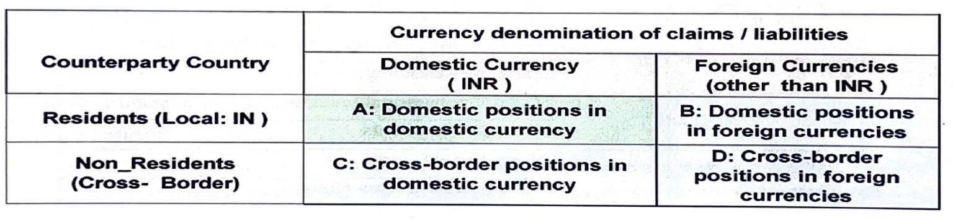
By integrating information across these dimensions’ currency, counterparty residence, instrument type, maturity structure, and sectoral classification the LBS framework provides a detailed and structured view of India’s international banking activity. Its comprehensive data cover- age, aligned with BIS international standards, enhances transparency and supports rigorous analysis of external vulnerability, funding dependencies, and global interconnectedness of the Indian banking system.

Figure 2: LBS Data Coverage

Data Processing and Tools
The raw Location Banking Statistics (LBS) Level 2 data were obtained from the Centralised Information Management System (CIMS) in comma separated values (CSV) format for the quarterly period spanning 2022 to 2025. At the granular account level, the raw dataset primarily contains numeric and alphanumeric reporting codes such as Assets/Liabilities Category Code (ALCD), Type Code (TYPECD), Sector Code (SECTD), and currency and country identifiers without descriptive labels. While this coding structure is suitable for regulatory submission, it necessitates further processing to enable analytical interpretation and visualization. Accordingly, a structured data processing pipeline was developed using Python to enhance the interpretability of the dataset. The first step involved importing and consolidating the quarterly LBS files into a unified panel dataset, ensuring consistency in variable names, formats, and reporting periods. Basic data quality checks were applied to identify missing values, validate code formats, and ensure internal consistency across reporting dimensions. Subsequently, additional descriptive columns were created by mapping the regulatory codes to their corresponding classifications as prescribed in the RBI’s International Banking Statistics Reporting Guidelines. In particular, the Assets/Liabilities Category Code (ALCD) was mapped to high level position categories such as International Loans and Deposits, International Holdings of Debt Securities, International Other Assets, Own Issues of International Debt Securities, International Other Liabilities, Derivatives, and Local Positions. This step enabled a clear distinction between assets, liabilities, derivatives, and local claims and liabilities within the analytical dataset.
Further granularity was introduced by mapping the Type Code (TYPECD) into detailed instrument-level descriptions. For example, within ALCD 11 (International Loans and Deposits–Assets), TYPECDs were mapped to instruments such as Loans to Non-Residents, Foreign Currency Loans to Residents, Outstanding Export Bills, Foreign Currency in Hand and Travelers’ Cheques, and NOSTRO Balances and Placements Abroad. Similarly, on the liabilities side (ALCD 51), TYPECD mappings were used to identify FCNR(B), NRE, NRO, RFC, EEFC deposits, VOSTRO balances, borrowings, embassy accounts, and escrow accounts. This mapping allowed the transformation of code-based entries into economically meaningful instrument categories suitable for analysis.
In addition, sector-level interpretation was facilitated by mapping the Sector Code (SECTD) to descriptive sector classifications such as Banks (related and unrelated), Central Banks, General Government, Non-Bank Financial Institutions, Non-Financial Corporations, Households, and Unallocated categories. To further improve analytical clarity, supplementary aggregation fields were created such as broader sector groupings (e.g., Banking Sector, Non-Financial Sector, Unallocated) which support higher-level sectoral analysis while remaining consistent with LBS reporting standards.
These mapping operations were implemented through Python-based data- processing scripts using libraries such as pandas and numpy. The processing framework was designed to be modular and reproducible, allowing updates in the mapping tables or additional reporting periods to be incorporated with minimal manual intervention. The enhanced dataset retained all original reporting variables while augmenting them with multiple derived columns that provide hierarchical views of instruments, sectors, and balance-sheet positions.
Once preprocessing and enrichment were completed, the transformed dataset was imported into Power BI for analysis and visualization. Power BI was used to construct interactive dashboards illustrating trends in international assets, international liabilities, derivatives, and off-balance-sheet exposures across time, sectors, countries, and currencies. The combination of Python-based preprocessing and Power BI-based visual analytics ensured both computational accuracy and interpretive clarity, enabling a comprehensive exploration of India’s international banking positions un- der the LBS framework.
Overall, this data-processing approach bridges the gap between regulatory reporting codes and analytical requirements. By systematically mapping ALCD, TYPECD, and SECTD codes into descriptive and economically meaningful categories, the study ensures that the analysis remains faithful to RBI and BIS reporting standards while enhancing transparency, interpretability, and policy relevance.

Classification Framework
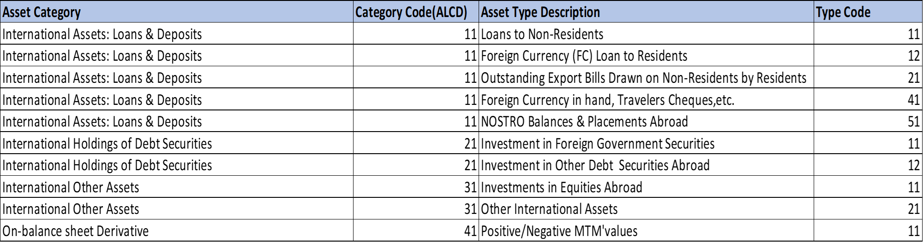
Figure 3: List of Assets
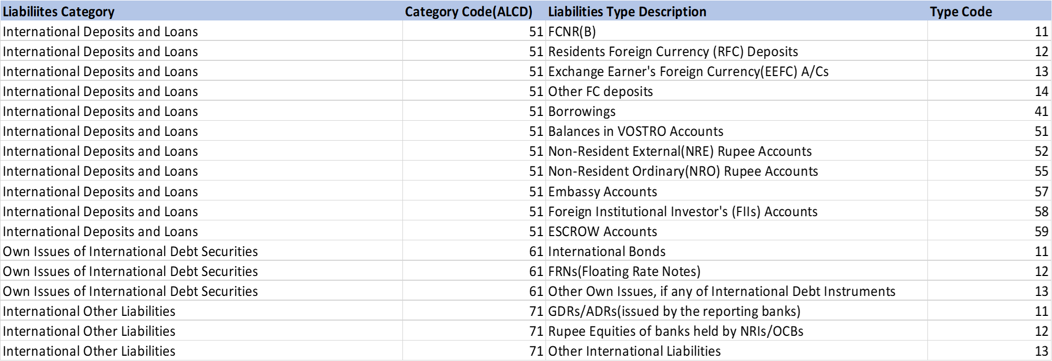
Figure 4: List of Liabilities
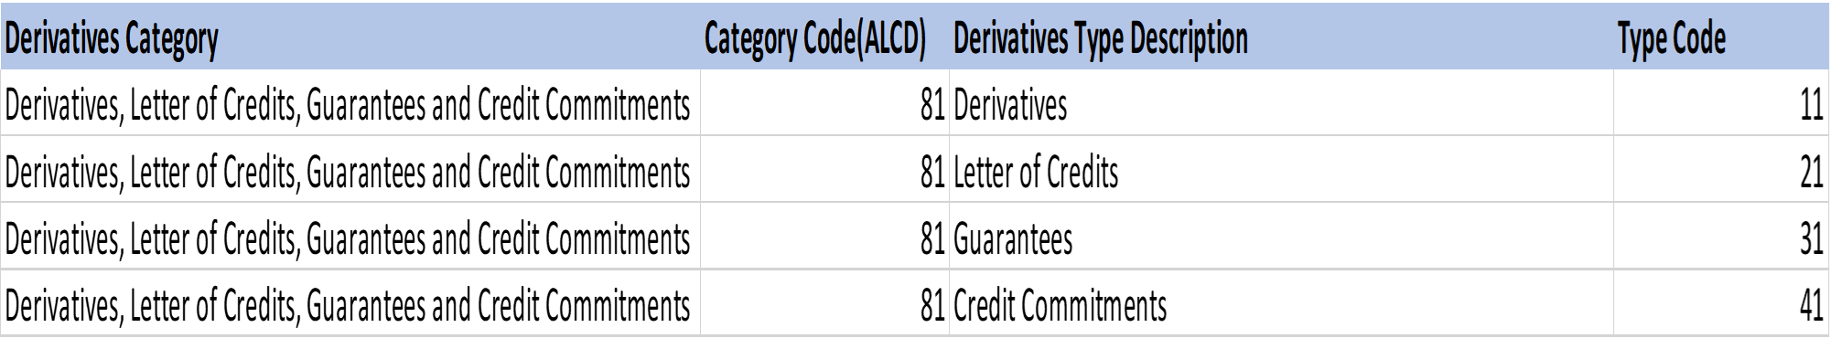
Figure 5: List of Derivatives

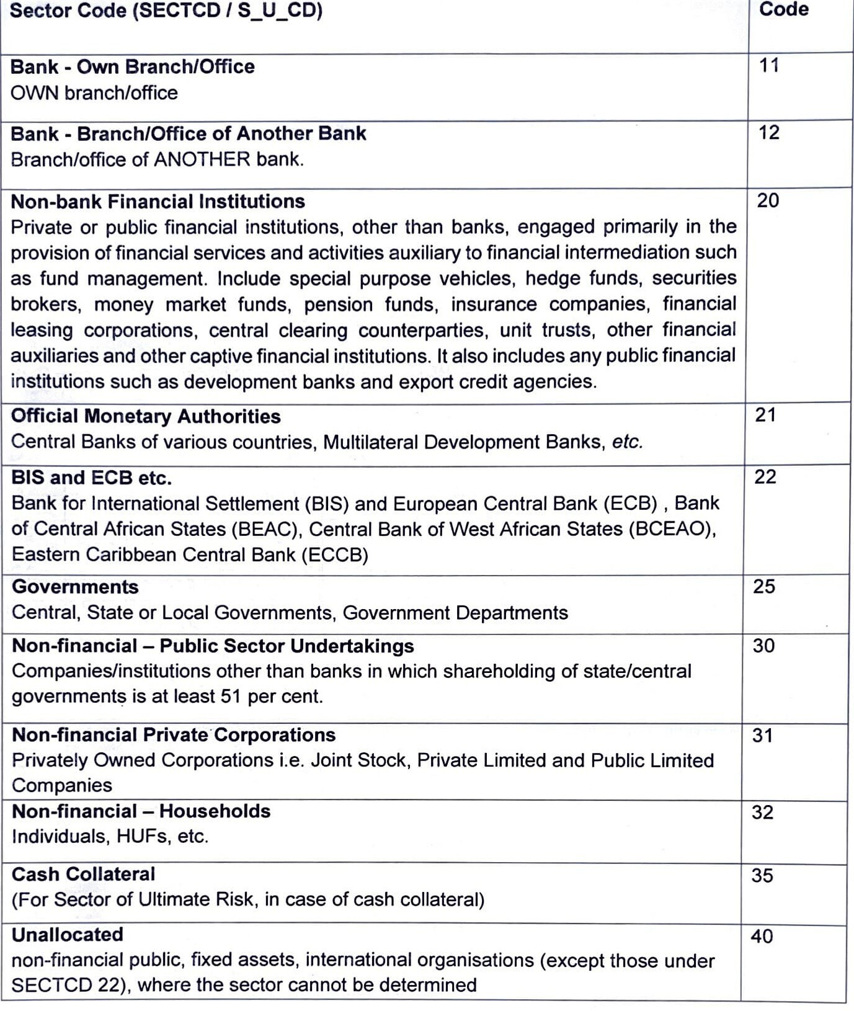
Figure 6: Sector List

Analysis of International Assets

International Assets
International Assets represent all financial claims that Indian banks and foreign banks operating in India hold on to non-resident entities. These assets include positions in foreign currency as well as any claim on a non-resident in domestic currency, thereby forming a comprehensive measure of India’s outward cross-border financial exposure. According to the RBI’s Location Banking Statistics (LBS) Reporting Guidelines International assets comprise both on-balance-sheet and off-balance-sheet positions and capture the full spectrum of a bank’s external claims.
As outlined in the LBS classification (see Table 1), international assets fall into four major categories:
- International Loans and Deposits (ALCD = 11) – loans to non-residents, foreign currency loans to residents, export bills, NOSTRO balances, and outstanding TC/DDs.
- Foreign Currency Investments (ALCD = 12) – investments in debt and equity securities issued abroad.
- International Other Assets (ALCD = 31) – capital subscribed to foreign branches and subsidiaries, receivables, accrued interest, and other miscellaneous foreign claims.
- On-Balance-Sheet Derivatives (ALCD = 41) – positive marked-to-market (MTM) values of derivative contracts with non-residents.
These assets reflect the outward linkages of the Indian banking system with global financial markets. They encompass lending to non-residents, investments in foreign securities, management of foreign currency liquidity through NOSTRO accounts, and participation in derivative markets. The diversity of asset types illustrates how banks support international trade financing, foreign investment flows, risk hedging, and overseas liquidity operations.

The LBS framework further requires reporting of international assets by currency, sector of counterparty, country of residence, ultimate risk, and maturity. This multidimensional structure provides granular insights into cross-border credit exposure, concentration risks, and the distribution of foreign claims across sectors such as banks, corporations, governments, and households.
Overall, International Assets serve as a key indicator of the global engagement of Indian banks, capturing how funds are deployed abroad and how external claims evolve with changes in global financial conditions. Their systematic reporting under LBS strengthens macroprudential analysis, supports international comparability, and helps evaluate the resilience and outward financial position of India’s banking sector.
Asset Category | Category Code (ALCD) | Asset Type Description | Type Code (TYPECD)
International Loans and Deposits | 11 | Loans to Non-residents | 11
International Loans and Deposits | 11 | Foreign Currency Loan to Residents | 12
International Loans and Deposits | 11 | Outstanding Export Bills drawn on non-residents | 21
International Loans and Deposits | 11 | Foreign Currency in hand, Travelers Cheques, etc. | 41
International Loans and Deposits | 11 | NOSTRO Balances and Placements Abroad | 51
International Holdings of Debt Securities | 21 | Investment in Foreign Government Securities | 11
International Holdings of Debt Securities | 21 | Investment in Other Debt Securities Abroad | 12
International Other Assets | 31 | Investment in Equities Abroad | 11
International Other Assets | 31 | Other International Assets | 21
On-balance sheet Derivative | 41 | Positive/ Negative MTM values of Derivative | 11

Table 1: International Assets Classification

Figure 7 shows the quarterly movement in total international assets of the Indian banking system from 2022 to 2025, as reported under the LBS framework. The series displays substantial cyclical variation in the initial period, followed by a strong upward trend beginning in 2024.
International assets start at a relatively elevated level of around 95K in early 2022, reflecting robust cross-border claims through loans, NOSTRO balances, and foreign currency assets. However, the series declines sharply by mid-2022, reaching approximately 76K, before temporarily recovering to nearly 89K in the third quarter of 2022. This early volatility suggests fluctuations in export bills, short-term foreign claims, and marked-to-market valuations of derivative assets, all of which are sensitive to global financial conditions.
Through 2023, international assets continue to oscillate, with values ranging between 68K and 81K, indicating unstable foreign currency lending activity and adjustments in short-term cross-border exposures. A notable low point occurs around January 2024, where assets fall to nearly 60K, marking the trough of the period.
From mid-2024 onward, the trend reverses sharply. International assets rise consistently across successive quarters, increasing from 72K to 78K, then to 90K in early 2025, and reaching the highest point of the series at approximately 110K by mid-2025. This sustained increase suggests stronger deployment of funds abroad, higher foreign currency claims on non-residents, and improved external lending and investment conditions.
Overall, the trend indicates that after a period of volatility and contraction in 2022–2023, the Indian banking system significantly expanded its international asset position during 2024–2025. This upward movement reflects enhanced cross-border financing activity, recovery in global trade flows, and a more favorable foreign currency liquidity environment. The pattern also highlights how international assets respond dynamically to global market cycles, consistent with the LBS emphasis on capturing both on-balance-sheet and off-balance-sheet foreign claims.

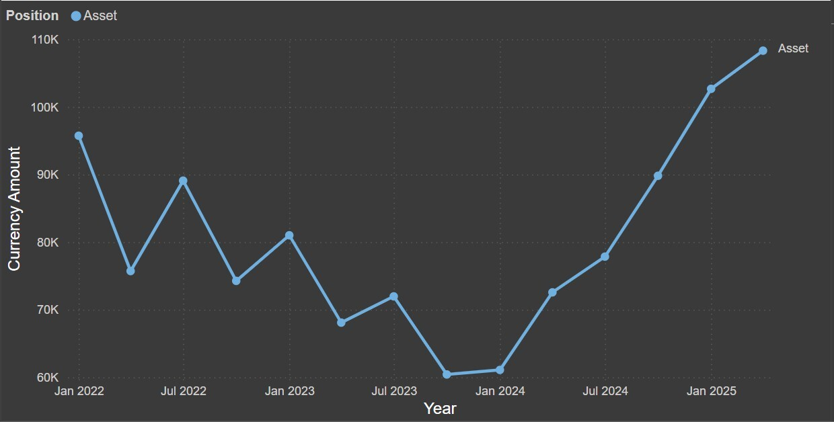

Figure 7: Quarterly Distribution of Assets between 2022 and 2025

Categories of Assets
Under the International Banking Statistics (LBS) framework, International Assets represent all cross-border financial claims held by Indian banks and foreign banks operating in India. These claims arise whenever a resident bank holds a financial asset against a non-resident, irrespective of whether the position is denominated in Indian Rupees or foreign currency. The LBS data definitions classify these assets primarily under ALCD codes and describe them through a set of TYPECDs, each representing a specific instrument or category of external claim.
- International Loans and Deposits (ALCD = 11)
(a) TYPECD 11: Loans to Non-Residents This category includes all loans extended to NRIs, Overseas Corporate Bodies (OCBs), and banks abroad. These loans may be denominated in INR or foreign currency and encompass housing loans as well as any other credit facilities. Loans granted to NRIs/OCBs against their NRI deposits must also be reported, and any credit balances arising in non-resident loan, cash-credit, or overdraft accounts are treated separately as liabilities.
(b) TYPECD 12: Foreign Currency Loans to Residents TYPECD 12 comprises all loans extended in foreign currency to resident individuals, corporates, and banks in India. It also includes foreign currency deposits maintained with any bank or institution in India. Loans issued to corporates out of FCNR(B) funds or under schemes such as Export Credit in Foreign Currency (PCFC) fall within this category. Credit balances in such accounts that represent liabilities are reported with a negative sign.
(c) TYPECD 21: Outstanding Export Bills Drawn on Non-Residents This category includes export bills negotiated, purchased, or discounted by banks. Only the negotiated or purchased value is reported and crystallized, or collection export bills are excluded. Bills acquired under sale-and-repurchase arrangements with domestic exporters are not treated as foreign assets, as they constitute domestic advances.
(d) TYPECD 41: Foreign Currency in Hand and Outstanding TCs/DDs TYPECD 41 includes foreign currency notes held by banks, as well as travelers’ cheques and demand drafts purchased by them. Drafts held merely for collection are excluded, while drafts purchased are included as international assets.
(e) TYPECD 51: NOSTRO Balances and Placements Abroad This category covers debit balances in mirror NOSTRO accounts, including fixed deposits, current accounts, loan accounts, and similar positions maintained with foreign banks. Debit balances are reported as assets, while credit balances are treated as liabilities. This category also includes placements with banks abroad, but excludes investments made through NOSTRO accounts in foreign government securities or equities.
Taking, these TYPECD definitions specify the full scope of cross-border financial claims reported as International Loans and Deposits. By providing precise rules for reporting loans, foreign currency advances, export bills, cash equivalents, and NOSTRO-related positions, the LBS framework ensures that international asset reporting remains consistent, comprehensive, and aligned with the economic characteristics of each instrument.
- International Holdings of Debt Securities (ALCD = 21)
  - TYPECD 11: Investments in Foreign Government Securities and Treasury Bills This category includes investments made through NOSTRO accounts in foreign government securities, including treasury bills. Investments made in the bank’s own name but on behalf of third parties as trustee business are also reported.
  - TYPECD 12: Investments in Other Debt Securities in Foreign Currencies This item includes investments through NOSTRO accounts in debt securities of foreign banks, companies, or other entities. Trustee-based investments undertaken in the bank’s own name on behalf of third parties are also included.
These TYPECDs together define the holdings of foreign-currency-denominated debt securities that constitute an important component of International Assets under the LBS system.
- International Other Assets (ALCD = 31)
  - TYPECD 11: Investments in Equities Abroad This includes investments made by banks in foreign equities, including investments in ADRs/GDRs of Indian or foreign entities. Investments in preferential shares issued abroad are also included.
  - TYPECD 21: Other International Assets This category captures capital supplied to the foreign branches of Indian banks, receivable profits from such branches, matured assets not claimed in NOSTRO accounts, and arrears of interest and principal due from non-residents. Unclassified international asset items may also be reported under this category. Losses incurred by banks are specifically excluded from LBS reporting.
These items constitute additional cross-border claims not captured under loans or securities and are essential for representing the full extent of external assets.
- On-Balance-Sheet Derivatives (ALCD 41 –TYPECD 11)
This category includes the marked-to-market (MTM) value of derivatives only when they appear as on-balance sheet assets. Only derivatives with a positive MTM value are included as international assets, in accordance with LBS reporting norms.
Figure 8 presents the composition of international assets reported under the LBS framework for the year 2025 in the IInd quarter where it is disaggregated by the four major asset categories. The distribution shows a highly concentrated asset structure, with International Loans and De- posits accounting for 90.78% of total international assets. This dominant share reflects the central role of cross-border lending, foreign currency loans to residents, outstanding export bills, foreign currency in hand, and NOSTRO balances each classified under TYPECDs 11, 12, 21, 41, and 51 within the international asset position of Indian banks. The magnitude of this category indicates that banks’ external claims are overwhelmingly driven by traditional international banking activities such as loans to non-residents, foreign currency lending, and liquidity operations via NOSTRO accounts.
On-balance-sheet Derivative Assets, representing positive marked-to-market values of derivative contracts with non-resident counterparties, contribute 4.31% of total assets. Though relatively small compared to loans and deposits, this share underscores the presence of derivative exposures within banks’ external claims and reflects the role of derivatives in currency and interest rate risk management under LBS reporting.
International Holdings of Debt Securities, which include foreign-currency investments in overseas debt instruments, constitute 2.91% of international assets. This indicates a modest exposure to foreign investment portfolios relative to the size of cross-border lending activities. Similarly, International Other Assets, accounting for 1.99%, include miscellaneous foreign claims such as capital invested in overseas branches, receivables, and accrued interest.

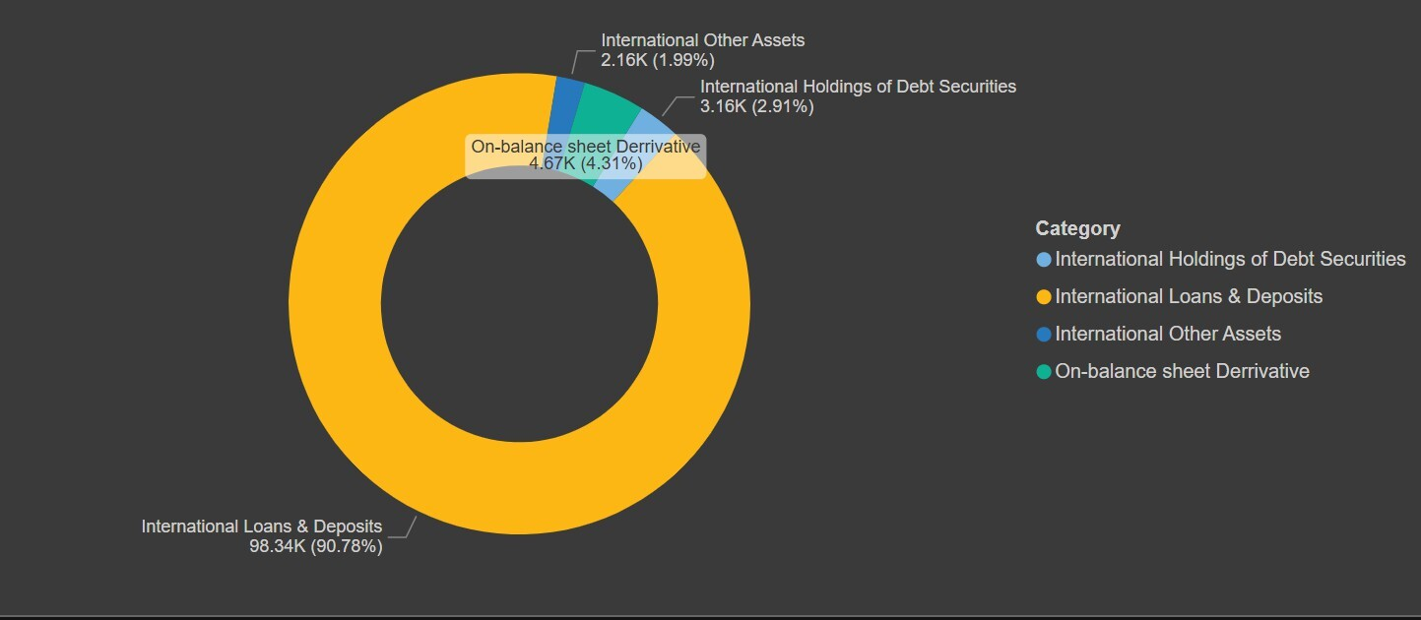
Overall, the composition highlights that international assets are overwhelmingly loan-driven, with limited exposures to securities investments, derivatives, and other miscellaneous asset categories. This pattern reflects the traditional structure of India’s external banking claims as captured by the LBS framework, where cross-border credit expansion and NOSTRO-related liquidity management form the core of outward financial linkages.

Figure 8: Asset Instrument Decomposition for the year 2025 in the IInd quarter

Analysis of International Liabilities

Analysis of International Liabilities
International Liabilities form a core component of the Location Banking Statistics (LBS) framework and represent all cross-border obligations of Indian banks and foreign banks operating in India. These liabilities capture the extent to which banks mobilize resources from non-residents and access global funding markets. Under LBS guidelines, liabilities arise not only from positions denominated in foreign currency but also from any obligation to non-residents in domestic currency, thereby providing a comprehensive measure of the external financial exposure of the Indian banking system.
The LBS framework classifies international liabilities into four principal categories based on the type and purpose of the instrument. As summarized in Table 2:
- ALCD 51 – International Deposits and Loans: FCNR(B), NRE/NRO deposits, RFC/EEFC accounts, VOSTRO balances, and foreign currency borrowings including interbank loans and ECBs.
- ALCD 61 – Own Issues of International Debt Securities: bonds, floating rate notes (FRNs), and other debt instruments issued to foreign investors.
- ALCD 71 – Other International Liabilities: ADR/GDR obligations and rupee equity held by NRIs/OCBs.
- ALCD 81 – Derivatives, Letters of Credit, Guarantees, and Credit Commitments: off-balance-sheet liabilities reported on a marked-to- market basis.
These categories ensure that all on-balance sheet and off-balance-sheet obligations to non-residents are systematically captured under LBS. The framework also requires reporting by currency, maturity, counterparty sector, and country of residence, enabling detailed analysis of external funding patterns and risk concentrations.
The structure of these liabilities provides important insights into the reliance of Indian banks on NRI deposits, their borrowing relationships with foreign banks and financial institutions, and the extent of participation by global investors in Indian banks’ securities. Movements in these liabilities often reflect changes in global liquidity conditions, interest-rate cycles, exchange-rate expectations, and foreign investor sentiment.
Overall, International Liabilities present a clear picture of the foreign funding base of India’s banking system and its interconnectedness with global financial markets. Their comprehensive reporting under LBS strengthens macroprudential surveillance, enhances international comparability, and supports policymakers in monitoring evolving external risks.
Liability Category | Category Code (ALCD) | Liability Type Description | Type Code (TYPECD)
International Deposits and Loans | 51 | FCNR(B) | 11
International Deposits and Loans | 51 | Resident’s Foreign Currency (RFC) Deposits | 12
International Deposits and Loans | 51 | Exchange Earner’s Foreign Currency (EEFC) A/Cs | 13
International Deposits and Loans | 51 | Other FC deposits | 14
International Deposits and Loans | 51 | Borrowings | 41
International Deposits and Loans | 51 | Balances in VOSTRO Accounts | 51
International Deposits and Loans | 51 | Non-Resident External (NRE) Rupee Accounts | 52
International Deposits and Loans | 51 | Non-Resident Ordinary (NRO) Rupee Accounts | 55
International Deposits and Loans | 51 | Embassy Accounts | 57
International Deposits and Loans | 51 | Foreign Institutional Investors’(FLLS) Accounts | 58
International Deposits and Loans | 51 | ESCROW Accounts | 59
Own Issues of International Debt Securities | 61 | International Bonds | 11
Own Issues of International Debt Securities | 61 | FRNs (Floating Rate Notes) | 12
Own Issues of International Debt Securities | 61 | Other Own Issues, if any, of International Debt Instruments | 13
International Other Liabilities | 71 | GDRs/ADRs (issued by the reporting banks) | 11
International Other Liabilities | 71 | Rupee Equities of banks held by NRIs/OCBs | 12
International Other Liabilities | 71 | Other international liabilities | 13

Table 2: International Liabilities Classification

Figure 9 presents the quarterly trend in total international liabilities of the Indian banking system from 2022 to 2025, as reported under the LBS framework. The series shows a steady and persistent upward trajectory, indicating a continuous expansion in cross-border obligations during the study period.
International liabilities rise from around $215K in early 2022 to approximately $350K by early 2025, reflecting an overall increase of more than 60% over three years. An initial jump is observed between January 2022 and April 2022, largely consistent with the rise in NRI deposits and foreign currency borrowings during the post-pandemic recovery period. After a brief stabilization around mid-2022, liabilities resume a gradual increase through 2023, supported by growing inflows into NRE/NRO deposits, higher VOSTRO balances, and steady foreign institutional participation.
The increase becomes more pronounced in 2024, where liabilities accelerate to cross $300K, suggesting strengthened foreign funding flows amidst improved global liquidity conditions, stabilizing interest rate expectations, and continued investor confidence in Indian banking instruments. A mild softening in late 2024 is visible, but the trend quickly rebounds in early 2025, ending the period at its highest recorded level.
Overall, the upward movement in international liabilities highlights the Indian banking system’s growing integration with global financial markets and its rising dependence on non-resident funding sources. The trend reflects both structural factors such as the dominance of NRI deposits and cyclical influences linked to global financial conditions. This steady expansion underscores the importance of monitoring external vulnerabilities, as higher international liabilities can amplify refinancing, currency, and liquidity risks under adverse market conditions.
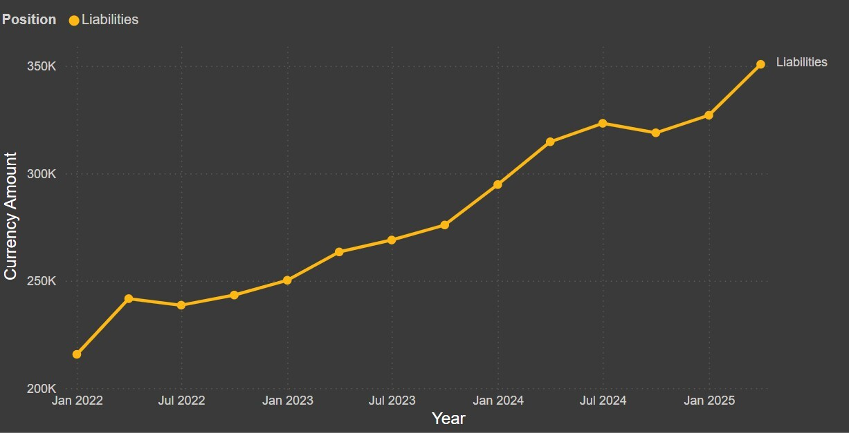
Figure 9: Quarterly Distribution of Liabilities between 2022 and 2025

Categories of Liabilities
International liabilities constitute an integral component of international banking statistics and reflect the external obligations of banks arising from cross-border transactions and domestic positions denominated in foreign currency. These liabilities are central to the assessment of a country’s external sector exposure, funding structure of the banking system, and the transmission of global financial conditions to domestic financial markets.
In India, international banking statistics are compiled in accordance with the Location Banking Statistics (LBS) Reporting Guidelines, 2024, issued by the Reserve Bank of India under the Centralised Information Management System (CIMS). The LBS return is submitted quarterly by internationally active Indian banks and foreign banks operating in India, in line with the reporting standards prescribed by the Bank for International Settlements (BIS). The data are also disseminated through the Database on Indian Economy (DBIE) and form an important input for external sector analysis and policy formulation.
Under the LBS framework, international liabilities are defined as banks’ balance-sheet liabilities that arise either in foreign currency or vis-`a-vis non-residents in any currency. These liabilities are reported on a gross basis and are classified using standardized category and type codes to ensure consistency, transparency, and international comparability. The classification of international liabilities is based on the Assets/Liabilities Category Code (ALCD), which groups liabilities according to the nature of the underlying financial instrument and the source of external obligation.
International liabilities are classified into four mutually exclusive categories. International Deposits and Loans (ALCD = 51) represent liabilities arising from deposits accepted from non-residents and residents’ foreign-currency deposits, as well as borrowings from overseas counterparties, and constitute the principal channel of external funding for banks. Own Issues of International Debt Securities (ALCD = 61) capture funds raised through debt instruments issued by banks in international markets. International Other Liabilities (ALCD = 71) comprise residual balance- sheet items such as capital received from head offices, accrued interest payable, and other liabilities not classified elsewhere. On balance-sheet Derivatives (ALCD = 41) reflect the negative marked-to-market values of derivative contracts recognized on the balance sheet, in accordance with LBS valuation principles.
The classification of international liabilities under the LBS framework facilitates a structured analysis of banks’ external obligations by distinguishing between traditional intermediation-based liabilities, market- based funding instruments, residual balance-sheet items, and derivative exposures. An examination of these categories provides important insights into the composition, stability, and risk profile of the banking system’s international liabilities. Accordingly, this paper uses LBS data to analyze the category-wise structure of international liabilities over the study period, forming the basis for subsequent analysis of trends and policy- relevant implications.
Figure 10 provides important evidence on the structure and stability of banks’ external obligations. The observed composition indicates a clear predominance of International Deposits and Loans, which account for approximately 63.5 per cent of total international liabilities. This dominance suggests that banks’ external funding continues to be largely anchored in traditional intermediation activities, such as deposits from non-residents and foreign-currency deposits of residents, along with borrowings from overseas counterparties. The reliance on deposit- and loan-based li- abilities reflects a funding structure that is primarily relationship-driven rather than market-based, with implications for liquidity management and rollover risk.
International Other Liabilities constitute the second-largest component, contributing around 34.4 per cent of total international liabilities. This sizeable share indicates that a significant portion of external liabilities arises from residual balance-sheet items, including accrued interest payable, capital received from head offices in the case of foreign banks, and other liabilities not classified under deposits, loans, or debt securities. The prominence of this category highlights the role of accounting adjustments, intra-group positions, and valuation effects in shaping the overall external liability profile. Consequently, changes in this component may not necessarily reflect new external borrowing and therefore require careful interpretation in external sector analysis.
On-balance-sheet Derivatives account for a relatively small share, at about 2.1 per cent of total international liabilities. These liabilities represent the negative marked-to-market values of derivative contracts recognized on the balance sheet. Although limited in magnitude, derivative-related liabilities are analytically important due to their potential volatility and sensitivity to exchange rate and interest rate movements. The modest share suggests that derivative exposures remained contained relative to traditional liability components, reducing the likelihood of significant balance-sheet stress arising from derivative positions.
Own Issues of International Debt Securities form a negligible proportion of international liabilities, accounting for around 0.02 per cent of the total. This indicates minimal reliance by banks on issuing debt securities in international capital markets as a source of external funding. While this reduces exposure to global bond market volatility and sudden stops in market-based funding, it also implies limited diversification of external funding sources beyond deposits and loans.
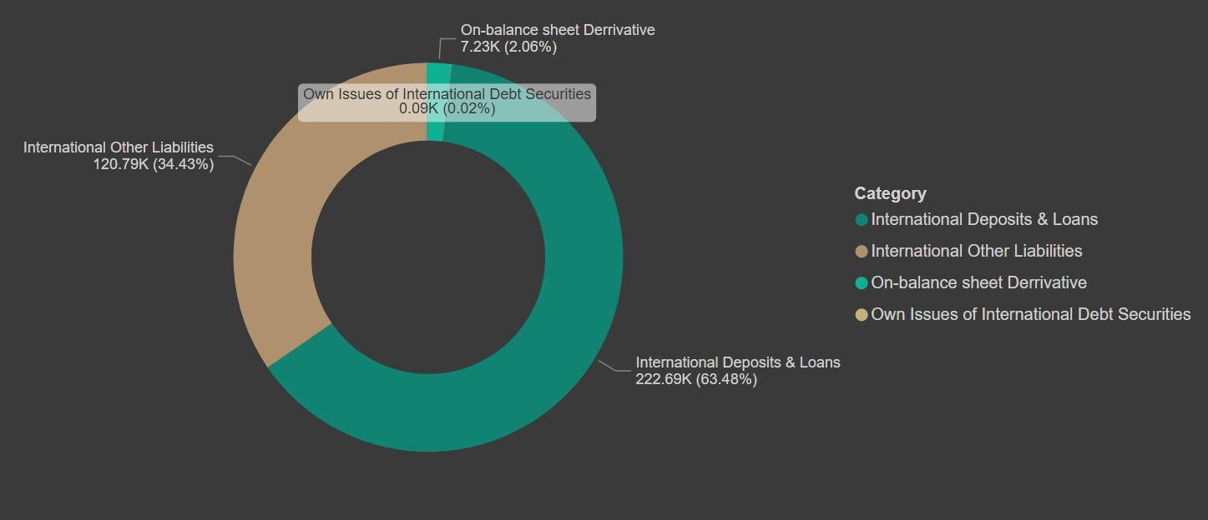
Overall, the composition of international liabilities reflects a structurally stable external funding profile dominated by traditional banking instruments, with limited dependence on market-issued debt and a contained derivative footprint. This structure has important implications for assessing external vulnerability and funding resilience, as it suggests that risks are more closely linked to deposit behavior, currency composition, and maturity profiles rather than to capital-market fluctuations. The category- wise analysis therefore provides a critical foundation for evaluating the sustainability and risk characteristics of banks’ international liabilities.

Figure 10: Liabilities Instrument Decomposition for the year 2025 in the IInd quarter

Derivatives and Off-Balance-Sheet Exposures
Derivatives constitute a critical component of the Location Banking Statistics (LBS) system, capturing the off-balance-sheet financial exposures that arise from cross-border derivative contracts entered into by Indian banks and foreign banks operating in India. According to the LBS Reporting Guidelines 2024, derivatives encompass a wide range of financial instruments including foreign exchange forwards, swaps, interest rate derivatives, options, and commodity related derivative contracts that derive their value from underlying financial variables, and whose market value may fluctuate significantly over time.
Under LBS, derivative positions are reported only when they create international exposures. Thus, any derivative contract with a non-resident counterparty, or any contract that results in a cross-border claim or liability, must be recorded in the LBS return. Importantly, the reporting framework requires banks to capture derivatives at their Marked-to-Market (MTM) values, separately identifying positive MTM (international assets) and negative MTM (international liabilities). This MTM-based valuation is explicitly mandated to ensure that the dataset reflects the true economic exposure rather than the notional size of the underlying contracts, which may be substantially larger than their current financial value.
The LBS framework provides a standardized derivative coding system, presented in Table 3: where the LBS classification identifies derivatives under Assets/Liabilities Category Code ALCD = 81, with Type Code TYPECD = 11,21,31 and 41, placing them in the same structural category as Letters of Credit and Guarantees.
This ensures consistency in reporting across all off-balance-sheet positions. The guidelines additionally emphasize that derivative exposures must reflect the country of the counterparty and sector of ultimate risk, enabling granular assessment of cross-border risk concentrations. Furthermore, it explains that derivative exposures, whether held for hedging or trading purposes, must be reported at fair value, aligning the LBS dataset with global standards set by the Bank for International Settlements (BIS).
This structured reporting provides valuable insights into the international risk profile of Indian banks. Derivatives often involve complex risk transfers, and their valuation is sensitive to movements in exchange rates, interest rates, and global financial market conditions. By requiring MTM-based reporting, counterparty-sector classification, and country-of-risk attribution, LBS makes it possible to analyze how derivatives contribute to foreign exposures, liquidity risk, and systemic vulnerability. Consequently, derivatives reporting under LBS enhances transparency, strengthens cross-country comparability, and enables policymakers to monitor evolving risks in India’s international banking sector.
Derivative Category | Category Code (ALCD) | Derivative Type Description | Type Code (TYPECD)
Derivatives, Letter of Credits, Guarantees and Credit Commitments | 81 | Derivatives | 11
Derivatives, Letter of Credits, Guarantees and Credit Commitments | 81 | Letter of Credits | 21
Derivatives, Letter of Credits, Guarantees and Credit Commitments | 81 | Guarantees | 31
Derivatives, Letter of Credits, Guarantees and Credit Commitments | 81 | Credit Commitments | 41

Table 3: International Derivatives Classification
Figure 11 illustrates the quarterly evolution of India’s international derivatives position as reported under the LBS framework from 2022 to 2025. The series begins at a relatively high level in early 2022, with derivative exposures exceeding 100,000 units, reflecting strong mark-to-market (MTM) gains on outstanding contracts during a period of heightened global interest rate volatility. Through 2022, the derivative position shows a gradual moderation, declining from above 105,000 to around 80,000 by January 2023. This decline is consistent with the global tightening cycle stabilizing and the compression of interest rate differentials, which typically reduces MTM values of foreign exchange and interest rate derivative contracts held by banks.
A pronounced and singular dip occurs in the first quarter of 2023, where the derivative position approaches zero. Such a steep fall is characteristic of broad-based MTM reversals, and may reflect sharp changes in exchange rates, unwinding of major derivative positions, or revaluation losses triggered by abrupt global financial market movements. Under LBS rules, derivatives are reported at their MTM value (not notional exposure), so a drop toward zero indicates near complete flattening of net claims or liabilities on derivative portfolios during that period.
Following this temporary collapse, the series rebounds sharply by mid- 2023, returning to levels above 85,000, and thereafter stabilizes through 2024 and early 2025 with only minor quarter-to-quarter fluctuations. The derivative position remains relatively stable in the range of 82,000 to 90,000, suggesting a period of reduced volatility and more balanced hedging activity. This steadiness indicates that banks’ cross-border derivative exposures normalized after the 2023 shock, aligning with the broader global financial environment that saw easing rate volatility and a more predictable foreign exchange market landscape.
Overall, the trend demonstrates that India’s international derivatives exposure is highly sensitive to global market conditions, reflecting the MTM based valuation requirements under LBS reporting. The steep mid-2023 trough underscores the importance of derivatives as dynamic and rapidly adjusting components of international banking positions, while the post 2023 stabilization highlights banks’ calibrated risk-management strategies and the normalization of global financial conditions.
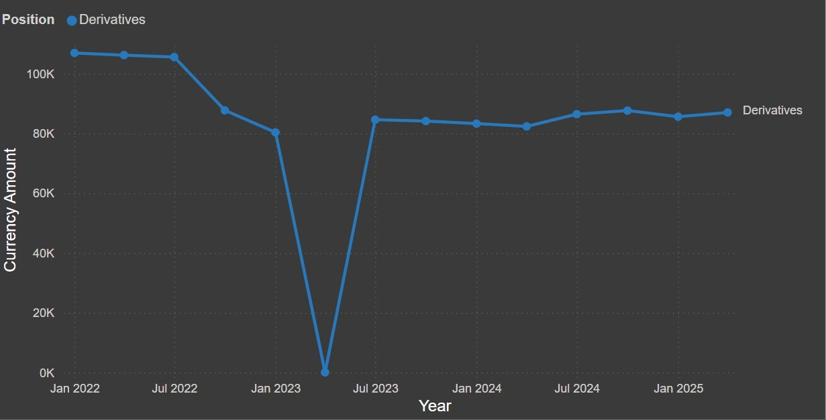

Figure 11: Quarterly Distribution of Derivatives between 2022 and 2025

Geographic and Currency Composition

Country Decomposition
Country-wise decomposition constitutes a core analytical dimension of the Location Banking Statistics (LBS), as it facilitates an assessment of banks’ cross-border linkages and geographical concentration of external exposures. Under the LBS framework, international positions are classified according to the residence country of the counterparty, irrespective of the nationality of the reporting bank, thereby enabling a consistent and internationally comparable measurement of cross-border banking relationships.
The country decomposition of international assets and liabilities provides insights into the extent to which banks’ external balance sheets are exposed to specific jurisdictions, global financial centers, and regional economies. Such decomposition is critical for identifying concentration risks, understanding the structure of international financial intermediation, and assessing potential spillovers arising from country-specific macroeconomic, financial, or geopolitical shocks. By distinguishing exposures across counterparty countries, the analysis captures the spatial distribution of cross- border claims and obligations, which is central to monitoring external vulnerability and systemic risk.
In the LBS reporting architecture, country classification is based on internationally standardized country codes and is applied uniformly across assets, liabilities, and selected off-balance-sheet items. This approach ensures that positions arising from direct cross-border transactions, as well as foreign-currency-denominated domestic positions, are appropriately mapped to the relevant counterparty country. Consequently, country-wise decomposition reflects both traditional cross-border banking activities and the international dimension of domestic balance-sheet positions.
From a policy perspective, analyzing international positions by counter-party country supports macro-financial surveillance by highlighting the relative importance of major economies and financial hubs in banks’ external portfolios. It also aids in evaluating diversification patterns and dependence on specific jurisdictions, which may amplify exposure to external shocks transmitted through trade, capital flows, or global liquidity cycles. Accordingly, country-wise decomposition serves as a foundational tool for assessing the resilience of the banking system and for informing policy deliberations related to external sector stability.
Figure 12 provides important insights into the geographical concentration and diversification of banks’ external exposures. Under the Location Banking Statistics (LBS) framework, international assets represent banks’ balance-sheet claims arising from positions vis-`a-vis non-residents in any currency and domestic positions denominated in foreign currency, classified by the residence country of the counterparty.
The distribution of assets across reported countries indicates a high degree of concentration in a small number of jurisdictions. The United States emerges as the single largest counterparty country, accounting for the highest share of international assets. This reflects the central role of the US as a global financial hub, deep financial market liquidity, and the prevalence of dollar-denominated assets in international banking. Concentration of assets in the US implies significant exposure to developments in US financial markets and monetary policy conditions, underscoring its importance in external risk assessments.
India represents the second-largest reported country in terms of inter- national assets. The substantial magnitude of assets reported against India suggests the prominence of foreign-currency-denominated domestic positions and inter-office or intra-group exposures within the LBS framework. This highlights the relevance of domestic foreign currency activity in shaping the overall international asset profile, in addition to cross-border claims.
The United Kingdom occupies the next position, reflecting its role as a major international banking and financial center. Exposure to the UK is indicative of banking relationships linked to global capital markets, trade finance, and cross-border intermediation. Other countries such as Singapore and the United Arab Emirates also feature prominently, underscoring their importance as regional financial hubs and gateways for international financial flows, particularly in Asia and the Middle East.
Assets reported against Japan, Germany, Hong Kong, France, and other jurisdictions constitute comparatively smaller shares. The presence of these countries points to a diversified, though less concentrated, set of exposures across advanced economies and international financial centers. While individually modest, such exposures contribute to geographical diversification and may help mitigate concentration risks associated with excessive reliance on a single counterparty country.
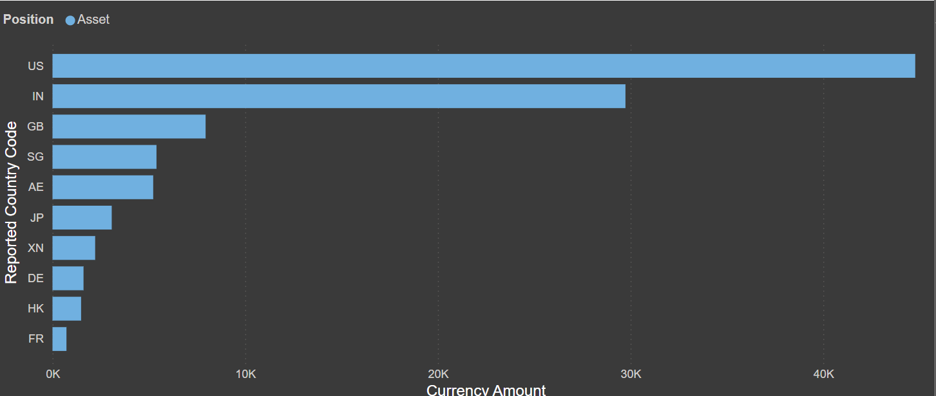
Overall, the country-wise distribution of international assets reveals a pattern characterized by strong concentration in major global financial centers, complemented by a broader set of exposures across other advanced and regional economies. This structure has important implications for assessing external vulnerability, as it highlights sensitivity to country-specific shocks in dominant jurisdictions, while also reflecting the benefits of diversification across multiple economies. The analysis of international assets by counterparty country therefore provides a critical foundation for evaluating concentration risk, spillover channels, and the resilience of banks’ external asset portfolios under the LBS framework.

Figure 12: Top 10 Country Decomposition Assets for the year 2025 in the IInd quarter

Figure 13 provides important insights into the geographical concentration of banks’ external obligations and the structure of their cross-border funding relationships. Under the Location Banking Statistics (LBS) framework, international liabilities comprise balance-sheet obligations arising from positions vis-`a-vis non-residents in any currency and domestic positions denominated in foreign currency, classified according to the residence country of the counterparty.
The distribution of international liabilities across reported countries indicates a high degree of concentration in a few key jurisdictions. The United States accounts for the largest share of international liabilities, underscoring its central role in global banking and financial markets. This concentration reflects the prominence of the US as a source of international deposits, interbank funding, and other cross-border liabilities, and implies significant sensitivity of banks’ external obligations to developments in US financial markets, interest rate conditions, and liquidity cycles.
The United Arab Emirates emerges as the second most significant counter party country for international liabilities. This highlights the importance of the UAE as a regional financial hub and a major center for deposit mobilization and cross-border banking activity, particularly in relation to trade, remittances, and offshore financial flows. The sizeable liabilities vis-`a-vis the UAE point to strong regional linkages and the relevance of Middle Eastern financial centers in banks’ external funding structures.
The United Kingdom constitutes another major contributor to international liabilities, reflecting its role as a global financial center and an important node in international interbank markets. Liabilities towards the UK are indicative of banks’ engagement with international capital markets, correspondent banking relationships, and wholesale funding channels. Together, exposures to the US, UAE, and UK account for a substantial proportion of total international liabilities, suggesting a concentration of external obligations in a limited set of globally and regionally significant jurisdictions.
India also features prominently among the reported countries, indicating the presence of foreign-currency-denominated domestic liabilities and inter-office or intra-group positions captured under the LBS framework. This underscores the role of domestic foreign-currency activity in shaping the international liability profile, in addition to purely cross-border obligations. Other jurisdictions such as Singapore, Japan, Mauritius, Germany, and Canada account for comparatively smaller shares, reflecting a broader but less concentrated distribution of liabilities across advanced economies and offshore financial centers.
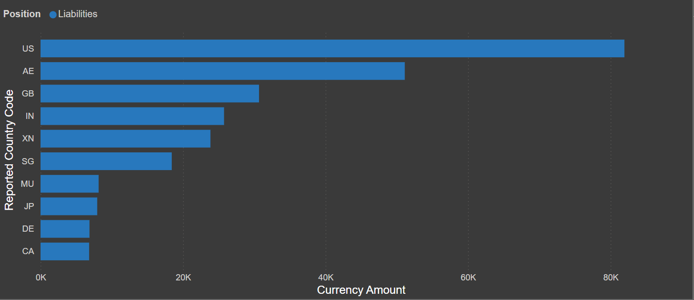
Overall, the country-wise composition of international liabilities reveals a pattern characterized by concentration in major global and regional financial centers, complemented by a diversified set of smaller exposures across other economies. This structure has important implications for assessing external vulnerability and funding risk, as it highlights potential exposure to country-specific shocks in dominant jurisdictions, while also reflecting some degree of geographical diversification. The country decomposition of international liabilities therefore serves as a critical input for evaluating concentration risks, spillover channels, and the resilience of banks’ external funding profiles within the LBS framework.

Figure 13: Top 10 Country Decomposition Liabilities for the year 2025 in the IInd quarter

Currency Decomposition
Currency composition is a core analytical dimension of the Location Banking Statistics (LBS), as it provides critical insights into the currency specific exposure of banks’ international assets and liabilities. Currency decomposition enables an assessment of vulnerabilities arising from exchange rate movements, maturity and rollover risks, and the transmission of global financial shocks through foreign currency channels. In an increasingly integrated global financial system, the denomination of cross-border banking positions assumes particular importance for both macro-financial surveillance and prudential oversight.
Under the LBS framework prescribed by the Reserve Bank of India, in line with the recommendations of the Bank for International Settlements, international banking positions are reported by currency of denomination. Positions are classified across domestic currency and foreign currencies, with further identification of major international currencies such as the US dollar, euro, and other currencies, depending on reporting requirements. This classification allows policymakers to distinguish between exposures arising from domestic currency activities and those linked to foreign currency funding and lending.
Currency decomposition is particularly relevant for economies with significant cross-border banking activity, as foreign currency liabilities may amplify balance sheet risks during periods of exchange rate volatility or tightening global liquidity conditions. A higher reliance on foreign currency funding can increase susceptibility to sudden stops, currency mismatches, and valuation effects, while foreign currency assets may expose banks to credit and market risks originating in external jurisdictions. Accordingly, analyzing currency composition supports a more granular understanding of systemic risk and external sector sustainability.
In this study, currency decomposition is employed to examine the structure and evolution of international banking positions over the period under review. By disaggregating assets and liabilities by currency, the analysis highlights shifts in currency preferences, the relative dominance of key international currencies, and the implications for financial stability. Such an approach complements country and sectoral decompositions and contributes to a comprehensive assessment of India’s international banking linkages within the global financial system.

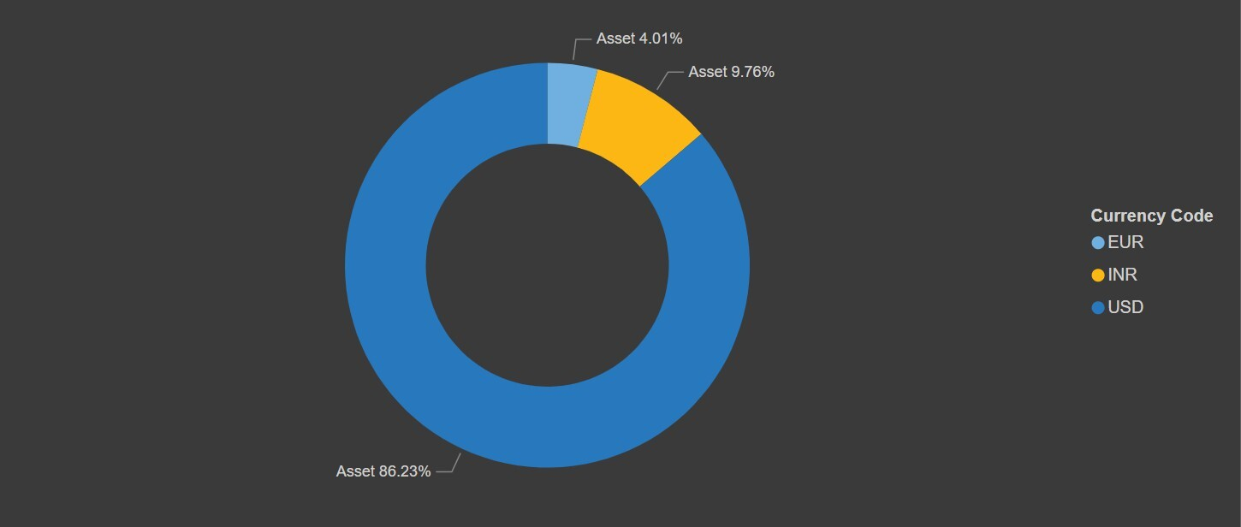

Figure 14: Top 3 Currency Decomposition Assets for the year 2025 in the IInd quarter
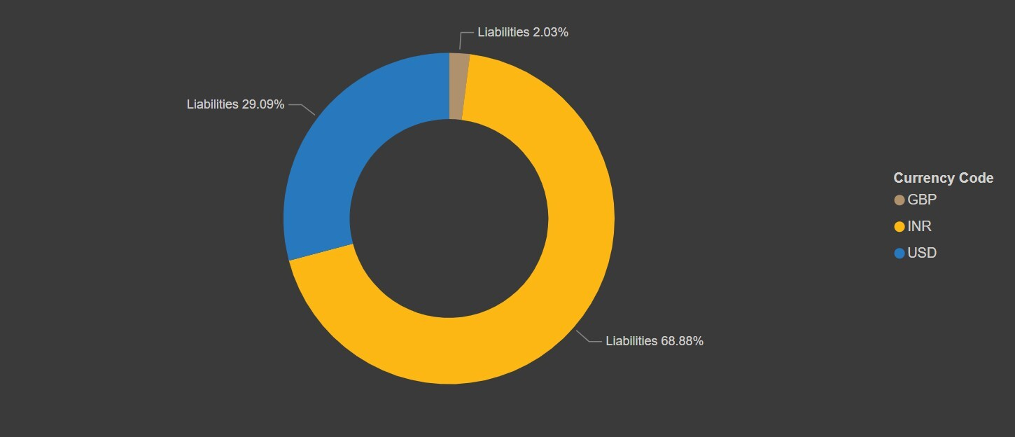

Figure 15: Top 3 Currency Decomposition Liabilities for the year 2025 in the IInd quarter

Sectoral Distribution of International Positions
The sector classification under the Location Banking Statistics (LBS) framework plays a central role in identifying the nature of cross-border financial linkages of Indian banks and foreign banks operating in India. Each international asset or liability position must be allocated to a specific economic sector based on the sector of the borrower or customer, sector of ultimate risk, or the counterparty’s institutional category. This sectoral breakdown is essential for understanding the distribution of foreign exposures across different segments of the global economy, enabling regulators, analysts, and policymakers to assess concentration risks, monitor financial stability, and study shifts in international financial flows.
The LBS framework provides a standardized sector coding system, presented in Table 4: Sector Code, which classifies counterparties into categories such as Banks (related and unrelated banks), Central Banks, General Government, Non-Financial Corporations, Non-Bank Financial Institutions, Households, and Others. This classification allows for a granular decomposition of international claims and liabilities by economic function, institutional type, and risk category. For example, exposures to foreign banks, including unrelated banks, related branches or subsidiaries, and central banks provide insight into interbank liquidity operations and global financial interconnectedness. Similarly, exposures to non-financial corporations reflect international trade credit, corporate borrowing patterns, and commercial lending behavior, while exposures to non-bank financial institutions capture interactions with asset managers, insurance companies, and other intermediaries. The inclusion of households, government entities, and uniquely coded categories such as unallocated or cash collateral further ensures comprehensive sectoral coverage.
Importantly, the LBS guidelines emphasize the use of ultimate risk, where exposures are reallocated based on the final obligor after accounting for risk transfers such as guarantees or collateral arrangements. This ensures that sectoral allocation reflects the true economic risk rather than merely the immediate counterparty. By adopting these detailed sectoral classifications, the LBS system enables a robust analysis of the structure, direction, and concentration of international financial exposures.
Overall, the sector classification within LBS serves as a foundational tool for understanding the composition of India’s international banking activities. It provides a structured lens to examine how exposures are distributed across global economic sectors, helps identify vulnerability channels, and supports cross-country comparability in line with the Bank for International Settlements (BIS) standards. The sectoral dimension therefore strengthens the analytical value of LBS data, making it indispensable for research, surveillance, and policy formulation.

Sector (SECTCD / S U CD) | Code
Bank – Own Branch/Office: OWN branch/office | 11
Bank– Branch/Office of Another Bank: Branch/office of another  Bank | 12
Non-bank Financial Institutions: Private or public financial institutions other than banks, engaged primarily in the provision of financial services and activities auxiliary to financial intermediation such as fund management. Includes SPVs, hedge funds, securities brokers, money market funds, pension funds, insurance companies, financial leasing corporations, central clearing counterparties, unit trusts, financial auxiliaries, captive financial institutions and development banks/export credit agencies. | 20
Official Monetary Authorities: Central Banks of various countries,  Multilateral Development Banks, etc. | 21
BIS and ECB etc.: Bank for International Settlements (BIS),  European Central Bank (ECB), Bank of Central African States (BEAC), Central Bank of West African States (BCEAO), Eastern  Caribbean Central Bank (ECCB) | 22
Governments: Central, State or Local Governments, Government  Departments | 25
Non-financial – Public Sector Undertakings: Companies/institutions (other than banks) with at least 51  Non-financial Private Corporations: Privately owned corporations such as Joint-stock companies, Private Limited and Public Limited companies | 31
Non-financial – Households: Individuals, HUFs, etc. | 32
Cash Collateral: Applicable only for Sector of Ultimate Risk incase of cash collateral | 35
Unallocated: Non-financial public, fixed assets, international organizations (except those under SECTCD 22) or cases where the  sector cannot be determined | 40
Table 4: Sector Classification

The sector-wise distribution of international assets for the year 2025 in the IInd quarter, as illustrated in Figure 18, reveals that Banks Unrelated Banks constitute the largest share, accounting for 47.88% of total cross- border exposures. This indicates that nearly half of the international claims reported under the LBS framework are directed towards foreign banks without a direct relationship to the reporting Indian bank, reflecting the prominence of interbank placements, Nostro balances, and other short-term liquidity operations conducted in global markets. The second-largest component is Non-Financial Corporations, contributing 19.81%, suggesting a substantial volume of cross-border lending, trade credit, and foreign currency exposures to corporates engaged in international trade and investment activities. Households represent 10.36%, largely driven by outward remittances, NRI-related exposures, and retail foreign currency transactions.
Banks Related Offices, which include exposures to the bank’s own foreign branches or subsidiaries, account for 12.14%, highlighting intra-group international financial flows and liquidity management. Non-Bank Financial Institutions form 5.61% of the total, reflecting exposures to mutual funds, insurance companies, pension funds, and other financial intermediaries operating abroad. General Government accounts for 3.14%, representing sovereign exposures and investments in foreign government securities. A small portion, 0.06%, is held in Banks Central Banks, which reflects placements with foreign monetary authorities, while Unallocated by Sector constitutes the remaining 1%, representing items where sector classification is not available in the raw data.
Overall, this sectoral distribution demonstrates that India’s international banking exposures are heavily concentrated in global interbank markets, followed by non-financial corporate exposures, while sovereign, household, and institutional segments represent smaller but significant proportions. This composition provides crucial insight into the nature of India’s cross-border financial linkages and the risk distribution across different counterparty sectors under the LBS framework.

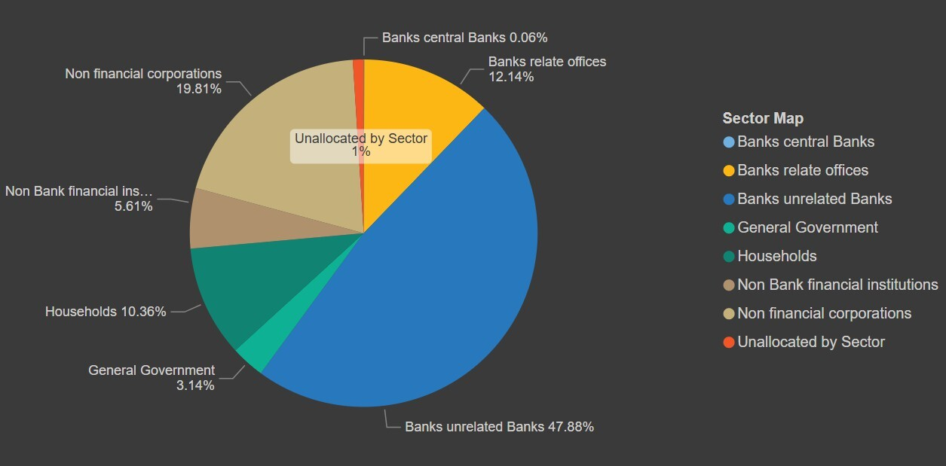
Figure 16: Sector Decomposition by Assets for the year 2025 in the IInd quarter

Figure 19 presents the sectoral distribution of international liabilities reported under the LBS framework for the year 2025 in the IInd quarter. The composition reveals that Households constitute the largest share of foreign liabilities at 42.3%, indicating the dominant role of NRI deposits particularly NRE, NRO, and FCNR(B) accounts in shaping India’s external liability structure. This underscores the continued importance of the household sector as a major source of foreign currency and rupee-denominated funding for the Indian banking system.
The second-largest contributor is Non-Bank Financial Institutions, accounting for 24.26% of the total. This reflects substantial liabilities owed to foreign financial intermediaries such as asset management companies, insurance firms, pension funds, and other institutional investors. Their presence highlights the growing integration of Indian banks with global capital markets and non-bank financial channels.
Non-Financial Corporations represent 18.48% of liabilities, pointing to commercial and corporate funding relationships, including deposits, trade related balances, and other forms of cross-border borrowing from foreign corporates. Meanwhile, Banks Related Offices make up 7.41%, capturing intra-group financial flows between Indian banks and their own foreign branches or subsidiaries.
Liabilities to Banks Unrelated Banks account for 5.98%, indicating exposures to unrelated foreign banks through interbank borrowings, placements, or other short-term liquidity arrangements. General Government contributes a modest 0.98%, reflecting limited sovereign-sector liabilities. Central Banks represent only 0.28%, indicating minimal direct borrowing or obligations to foreign monetary authorities. Finally, Unallocated by Sector, at 0.3%, covers items where counterparty sector information is unavailable in the underlying LBS Level 2 data.
Overall, this sectoral profile demonstrates that India’s external liabilities are heavily concentrated in household-driven NRI flows, followed by institutional funding from global non-bank financial entities. The distribution highlights how different sectors contribute to the external funding structure of the banking system and provides critical insight into the nature of India’s cross-border financial dependence under the LBS framework.
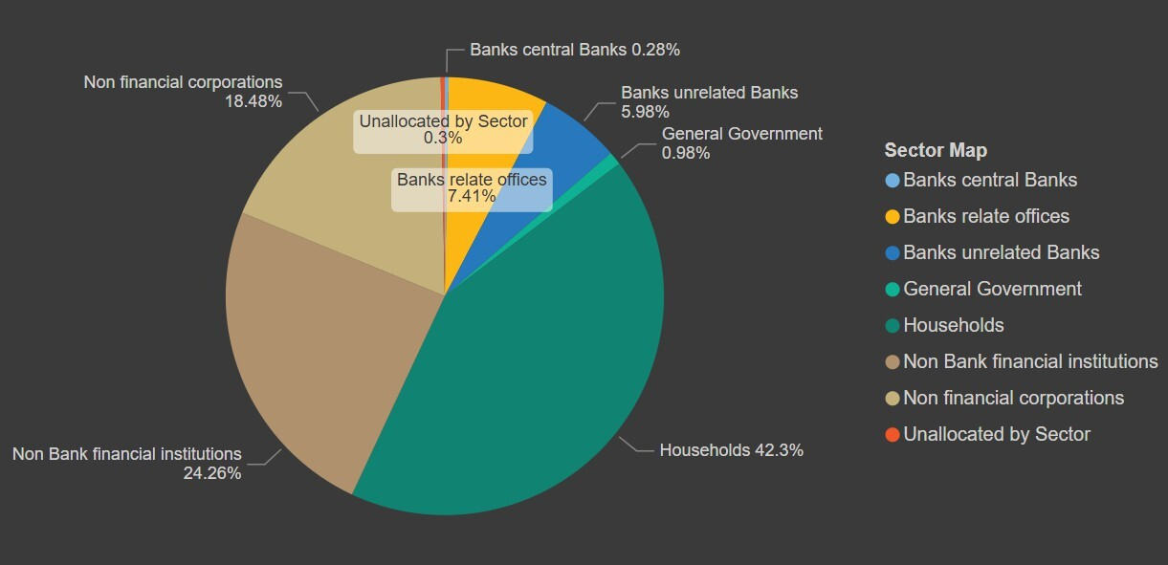
Figure 17: Sector Decomposition by Liabilities for the year 2025 in the IInd quarter

Conclusion and Policy Implications

Conclusion
This study analyzed India’s international banking positions using the Location Banking Statistics (LBS) framework for the period 2022–2025. By examining international assets, international liabilities, derivatives, and their geographic, currency, and sectoral composition, the analysis provides an integrated view of the external balance sheet of internationally active banks operating in India.
The results indicate a clear expansion in India’s international banking exposure in the latter part of the study period. After a phase of volatility during 2022–2023, international assets recorded a sustained increase from 2024 onwards, reflecting improved global financial conditions and a recovery in cross-border banking activity. International assets remain predominantly concentrated in loans and deposits, suggesting that India’s cross-border banking engagement continues to be driven primarily by traditional intermediation rather than market-based instruments.
International liabilities also exhibited steady growth, underscoring the rising integration of the Indian banking system with global financial markets. Deposits and loans particularly non-resident deposits, constitute the dominant component of international liabilities, highlighting the importance of relationship-based external funding. While such funding is relatively stable compared to wholesale market borrowing, it also exposes banks to shifts in depositor confidence, interest rate differentials, and exchange rate expectations.
The analysis of derivatives reveals significant marked-to-market driven volatility, especially during periods of global financial uncertainty. Although derivatives account for a smaller share of total international positions, their sensitivity to global interest rates and exchange rate movements underscores their potential to amplify balance-sheet risks. Geographic decomposition further shows a concentration of international positions in major global financial centers, including the United States and the United Kingdom, while currency composition remains dominated by major international currencies. Sectoral analysis indicates that international assets are largely linked to interbank and non-financial corporate exposures, whereas international liabilities are primarily driven by the household sector through non-resident deposits.
Overall, the findings demonstrate the analytical strength of the LBS framework in capturing the scale, structure, and evolution of India’s international banking activity. The multidimensional coverage of LBS data pro- vides a robust basis for monitoring external vulnerabilities and assessing the resilience of the banking system to global financial shocks.

Policy Implications
The findings of this study carry important implications for external sector surveillance and macroprudential oversight. First, the continued expansion of international assets and liabilities reinforces the need for close and regular monitoring of cross-border banking exposures, particularly during periods of global financial tightening or heightened geopolitical uncertainty. Granular LBS data remain essential for identifying emerging risks and transmission channels.
Second, the dominance of non-resident deposits in international liabilities highlights the importance of monitoring deposit behavior, rollover patterns, and currency composition. Policymakers should closely assess the sensitivity of such funding to changes in global interest rates and exchange rate expectations, given its implications for foreign currency liquidity and external vulnerability.
Third, the concentration of international positions in a limited set of countries and currencies underscores the relevance of incorporating country and currency-specific shocks into stress-testing and macroprudential frameworks. Enhanced use of LBS data can improve the assessment of concentration risks and potential spillovers from major international financial centers.
Fourth, the observed volatility in derivative positions emphasizes the importance of accurate valuation, counterparty classification, and country-of-risk attribution. Continued supervisory focus on derivatives reporting under the LBS framework is necessary to ensure transparency and to mitigate the build-up of hidden balance-sheet risks.
Finally, the study highlights the value of combining LBS data with modern analytical tools for effective surveillance and policy analysis. Strengthening analytical use and dissemination of LBS statistics will further enhance their role in supporting evidence-based policymaking and safeguarding financial stability.
In conclusion, the LBS framework remains a critical component of India’s external sector statistics. Continued improvements in data quality, analytical depth, and supervisory integration will further strengthen its contribution to financial stability monitoring and policy formulation.

References
- Reserve Bank of India, International Banking Statistics Reporting Guidelines, Centralised Information Management System (CIMS), Reserve Bank of India, 2024.
- Reserve Bank of India, Data on International Banking Statis- tics of India, Database on Indian Economy (DBIE). Available at: https://data.rbi.org.in/DBIE//dbie/reports/Publication/TimeSeries
- Reserve Bank of India, Centralised Information Management System (CIMS). Available at: https://cims.rbi.org.in//login.

