

Non-Resident Deposit Comprehensive Single Return (NRDCSR):

Dashboard & Analytics for India

Sourav Ghosh Hansda
Supervisor: Ms. Shraddha Singh
Director: Dr Pratik Mitra
July-December 2025

Acknowledgement
I would like to express my sincere gratitude to my Supervisor, MS. Shraddha Singh, for her valuable guidance, constant support, and insightful feedback throughout the course of this work. Her encouragement and expertise were instrumental in shaping the direction and quality of this study.
I am also deeply thankful to my Director, Dr. Pratik Mitra, for his leadership, motivation, and institutional support, which provided an enabling environment for the successful completion of this project.
I would also like to acknowledge the support and cooperation extended by the officials and staff members of the International Banking Division.

Sourav Ghosh Hansda

Contents

1 Abstract 4
2 Background and Institutional Framework 5
3 Introduction 7
4 Data and Methodology 10
4.1 Data Source 10
4.2 Data Processing and Tools 11
5 Deposit Schemes under NRD-CSR 13
6 Bank Categories 18
7 Flow Analysis: Inflows and Outflows 22
7.1 Inflows (FI, IR, PR, LI) 22
7.2 Outflows (PA, IA, PL, IL, LW, TR) 27
8 Stock Analysis: Balances 33
9 Banks Decomposition 37
10 Maturity and Currency Decomposition 41
10.1 Original Maturity Decomposition 41
10.2 Residual Maturity Decomposition 43
10.3 Currency Decomposition 46
11 Conclusion and Policy Implications 53
11.1 Conclusion 53
11.2 Policy Implications 54
12 References 56

Abstract
The study has explored different deposit accounts under the schemes like NRER (Non-resident External Rupee Account) or NROR (Non-Resident Ordinary Rupee Account) or FCNR (Foreign Currency Non-Resident A/c) of NRI accounts which dabbles with Record types like Inflows, Outflows, and Balances. The data that is being explored for this study is from 2015 to 2025. We mainly keep an eye out on the Amount in USD in millions even though we have Amount in INR in crores. This data is not published anywhere but it is accessible from the Centralized Information Management System (CIMS). This data is generated at the end of every month. Thus the data is downloaded in comma separated values(csv) format from CIMS and pre-processed by using python only to be imported into Power BI with ease and then the data is explored and various plots are created and put together a dashboard where its results will give us keen insights about the data throughout the years and a better under- standing about the data from the year 2015 to 2025. Power BI tool was chosen to explore the data and create the dashboard because of its privacy.

Background and Institutional Framework
The Non-Resident Deposits – Comprehensive Single Return (NRD-CSR) framework is the Reserve Bank of India’s standardized system for collecting detailed information on non-resident deposit liabilities of banks operating in India. The framework was introduced to replace multiple legacy returns with a unified, XBRL-based reporting structure that captures inflows, outflows, balances, currency composition, maturity profiles, and country-wise distribution of non-resident deposits. By consolidating all reporting requirements into a single return, NRD-CSR enhances consistency, removes duplication, and strengthens the supervisory and analytical utility of non-resident deposit data.
Under the NRD-CSR system, banks are required to submit monthly data on three major NRI deposit schemes: Foreign Currency Non-Resident [FCNR(B)] deposits, Non-Resident External (NRE) Rupee Accounts, and Non-Resident Ordinary (NRO) Rupee Accounts, each identified through specific Scheme Codes prescribed in Code. The reporting template also requires classification by maturity, currency, country of depositor, account type, and the nature of each transaction using a comprehensive set of Record Type Codes. These record types covering opening balances, closing balances, inflows, outflows, renewals, interest components, unclaimed deposits, and adjustments ensure that the full lifecycle of non-resident deposit activity is captured with precision.
A central feature of NRD-CSR is its built-in validation structure, which links opening balances, inflows, outflows, and adjustments through the accounting identity Closing Balance = Opening Balance + Inflows – Outflows. The framework also prescribes strict consistency checks for maturity classification, currency eligibility (e.g., FCNR(B) permitted only in freely convertible currencies), and proper treatment of credit and debit entries. These validations ensure high-quality, internally consistent data that meets supervisory standards.
By providing bank-wise, currency-wise, maturity-wise, and country-wise granular data, NRD-CSR plays a critical role in monitoring external liabilities of the Indian banking system. The dataset supports risk assessment related to foreign currency exposures, maturity mismatches, deposit concentration, and external vulnerability. It also facilitates policy analysis on NRI deposit behavior, FX liquidity, and the role of non-resident funding in India’s external accounts. As such, the NRD-CSR framework forms a foundational component of India’s broader external sector statistics and supervisory reporting architecture.

Introduction
NRI itself stands for Non-Resident Indian, and the International Banking Division at RBI handles the financial deposit data of such individuals. An Indian citizen is declared as a Non-Resident Indian if they are living outside the country for more than 6 months or 182 days for the purposes like employment, business or education. NRI can have special banking privileges such as opening NRE and NRO accounts and are subject to specific tax rules on income earned in India. NRIs are taxed on the income they earn or receive in India, though their tax obligations depend on their specific situation and the source of their income. Due to their status, they open specific accounts under schemes like NRER (Non-resident External Rupee Account) or NROR (Non-Resident Ordinary Rupee Account) or FCNR (Foreign Currency Non-Resident A/c) to manage foreign earnings and in- vestments.
Non-Resident Deposit Comprehensive Single Return (NRDCSR) is a regulatory reporting framework prescribed by the Reserve Bank of India (RBI) for monitoring the inflows, outflows, and outstanding balances of non-resident deposits. The return is submitted by all scheduled commercial banks on a monthly basis and provides a consolidated, standardized dataset describing the behavior of Non-Resident Indian (NRI) and Person of Indian Origin (PIO) banking activities.
NRDCSR enables RBI to track the movement of foreign currency and rupee- denominated deposits under various NRI schemes in accordance with the Foreign Exchange Management Act (FEMA). Each monthly submission contains structured information such as:
- Bank identification details and reporting period
- NRD Scheme Code (FCNR(B), NRE, NRO)
- Account type and maturity classification
- Currency and country (SWIFT-based codes)
- Transaction type (inflow, outflow, balance)
- Associated monetary amounts
This standardized return helps RBI analyze external sector vulnerabilities, liquidity patterns, currency exposure, and maturity risk related to NRI deposits. It also supports policy formulation for foreign exchange management and banking sector stability.
From Figure 1 below, a pronounced decline in the closing balance during 2016 is evident. This reduction can be attributed to the Government of India’s demonetization initiative, which triggered a substantial rise in the redemption of FCNR deposits. In response, banks accelerated the repatriation of funds abroad, as depositors sought to mitigate potential risks arising from exchange- rate volatility. The scheme-wise analysis of non-resident deposits reveals that the sharp contraction in aggregate closing balances (CB) during October to December 2016 was predominantly driven by the Foreign Currency Non-Resident (FCNR) scheme, while the Non-Resident External (NRER) and Non-Resident Ordinary (NROR) schemes remained broadly stable.
A decomposition of balance-adjusting flows indicates that outflows dominated FCNR movements during this period. Transfers to other accounts and non-renewals (TR) alone accounted for approximately 44 per cent of FCNR balance-adjusting flows, followed by principal remittances abroad (PA), which contributed around 34 per cent. Together, these two outflow components constituted nearly four-fifths of total FCNR flows, underscoring the extent of repatriation and rollover aversion among non-resident depositors. In contrast, fresh inflows (FI) remained subdued at about 6 per cent, while renewals and transfers from other accounts (PR) were insufficient to offset the scale of outflows.
The NRER scheme exhibited a markedly different pattern. Balance-adjusting flows were dominated by renewals (PR) and transfers (TR), supported by moderate fresh inflows. As a result, NRER closing balances did not experience a comparable contraction during the same period. Similarly, NROR balances remained structurally stable, with movements largely reflecting domestic-oriented transactions such as local inflows (LI) and local withdrawals (LW), consistent with the scheme’s INR-denominated and resident-linked nature.
Overall, the results confirm that the observed decline in aggregate non-resident deposit balances in late 2016 was not system-wide, but highly concentrated within the FCNR segment, reflecting its greater sensitivity to external financial conditions and maturity structures.
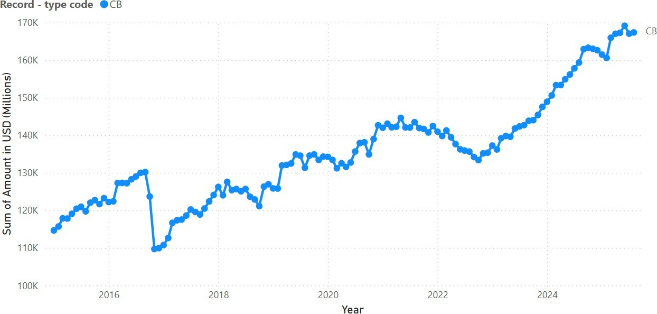
Figure 1: Overview of Closing Balance (CB) of NRDCSR from 2015 to 2025

Data and Methodology

Data Source
This study is based on data compiled from the Non-Resident Deposits – Com- prehensive Single Return (NRD-CSR), an XBRL-based regulatory return prescribed by the Reserve Bank of India (RBI) for the systematic reporting of non-resident deposit transactions and balances by scheduled commercial banks. The NRD-CSR provides granular, bank-level information on non-resident deposits, covering all major schemes namely Foreign Currency Non-Resident (FCNR), Non-Resident External (NRE), and Non-Resident Ordinary (NRO) accounts across multiple dimensions including maturity, currency, country of origin, and transaction type. The dataset captures both stock variables (such as opening balances, closing balances, and unclaimed balances) and flow variables (including inflows, outflows, renewals, transfers, and interest-related transactions) on a monthly reporting basis. Each record in the NRD-CSR is uniquely identified by a combination of bank code, reporting period, deposit scheme, account type, original maturity, remaining maturity, currency, country code, and record-type classification, ensuring consistency and completeness in reporting.
A key strength of the NRD-CSR dataset lies in its standardized coding structure, which allows precise identification of inflows (e.g., fresh inflows from abroad, interest reinvested), outflows (e.g., principal remitted abroad, local withdrawals), and balance positions (opening and closing balances). Additionally, the availability of both original maturity and remaining maturity information enables a detailed assessment of the tenor structure and rollover risk associated with non-resident deposits.
The data used in this study are aggregated from the NRD-CSR returns reported by banks and disseminated through RBI’s statistical systems, ensuring high reliability, regulatory consistency, and suitability for macro-financial analysis. Given its comprehensive coverage and granular classification, the NRD-CSR dataset is particularly well suited for analyzing the structure, dynamics, and maturity profile of non-resident deposits, as well as their implications for banking system liquidity and external vulnerability.

Data Processing and Tools
Given the granular and multi-dimensional nature of the Non-Resident Deposits – Comprehensive Single Return (NRD-CSR) dataset, systematic data processing was essential to ensure consistency, temporal comparability, and analytical usability. The NRD-CSR data are reported at a highly disaggregated level by bank, scheme, account type, maturity, country, currency, and record-type codes necessitating careful transformation and standardization prior to analysis.
The raw monthly NRD-CSR files, covering the period from January 2015 to August 2025, were first downloaded from the Centralised Information Management System (CIMS) of the Reserve Bank of India. Data preparation was carried out using a combination of Python (Jupyter Notebook) for programmatic preprocessing and Microsoft Power BI (Power Query) for transformation, validation, and aggregation. This hybrid tool-based approach ensured both computational efficiency and transparency in data handling.
In the initial stage, the monthly files were imported into a Jupyter Notebook environment, where additional temporal identifiers specifically Year and Month were created to facilitate time-series analysis. Monthly data were then consolidated into annual datasets, with full-year aggregation applied for 2015–2024 and partial-year aggregation for 2025 (January–August), ensuring consistency across years. These annual datasets were subsequently concatenated into a single master file to enable unified analysis across the entire study period.
Further processing was undertaken in Power BI using Power Query, where the reporting period was standardized to represent the last day of each month, in line with balance reporting conventions. Additional transformations included merging external mapping files to derive analytical variables such as bank category, based on bank working codes, and applying value standardization for selected country (SWIFT) codes to address reporting inconsistencies. All transformations were executed within Power Query and applied consistently across the dataset to preserve reproducibility.
The processed dataset was subjected to internal consistency checks aligned with NRD-CSR validation rules particularly those governing the relationship between opening balances, inflows, outflows, and closing balances before being finalized for analysis. The resulting cleaned and consolidated dataset forms the basis for all empirical results presented in this study and is well suited for examining the structure, flows, and maturity profile of non-resident deposits over time.

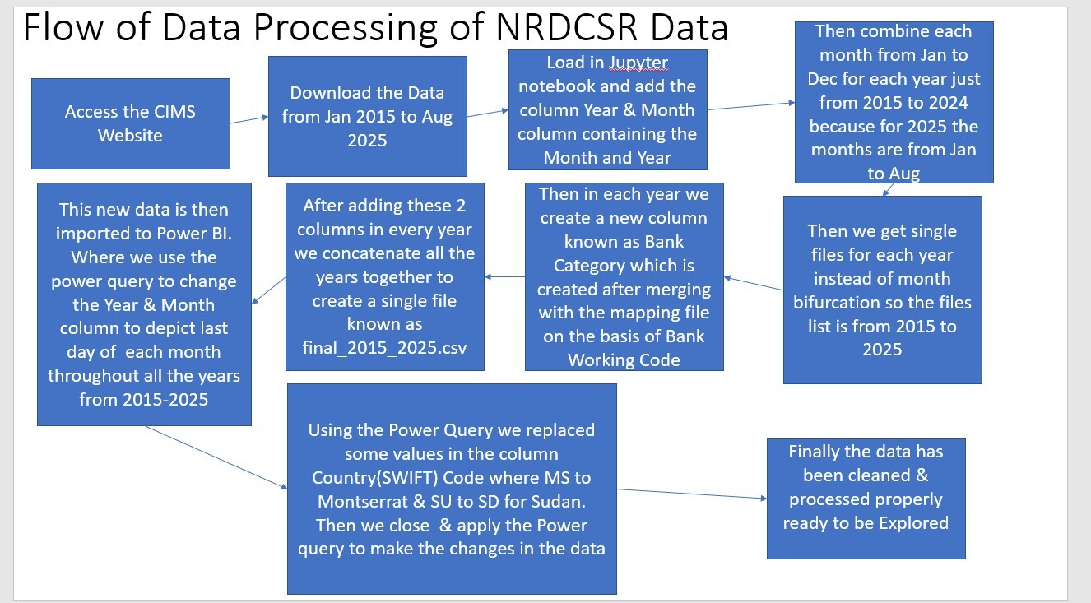
Figure 2: Pre-Processing data before uploading it to Power Bi

Deposit Schemes under NRD-CSR
Under the Non-Resident Deposits Comprehensive Single Return (NRD-CSR) reporting framework of the Reserve Bank of India (RBI), all banks accepting non-resident deposits are required to classify their accounts into clearly defined deposit schemes. These schemes constitute the foundation of NRD-CSR reporting and determine how inflows, outflows, balances, maturity structures, and currency compositions are captured. The scheme classification ensures uniformity across institutions and enables consistent monitoring of India’s non-resident deposit base, which forms a significant component of external sector liabilities.
The NRD-CSR prescribes three principal deposit schemes, each associated with distinct regulatory characteristics, currency rules, repatriation provisions, and customer profiles. Schemes like these include the Foreign Currency Non- Resident [FCNR(B)] Account, the Non-Resident External (NRE) Rupee Account, and the Non-Resident Ordinary (NRO) Rupee Account. Together, these schemes capture the full spectrum of foreign-currency and rupee-denominated deposits maintained by non-residents with Indian banks.
FCNR(B) accounts permit deposits in freely convertible foreign currencies such as USD, GBP, EUR, JPY, AUD, and CAD, and are reported based on foreign-currency amounts and maturity classifications. NRE accounts, maintained exclusively in INR, represent fully repatriable rupee deposits of non- residents, whereas NRO accounts capture non-resident income earned in India also denominated in INR but with partial repatriation restrictions. Each scheme follows distinct reporting rules for maturity, account type, allowable currencies, and record-type codes for inflows, outflows, and balances.
By clearly separating deposit behavior across these three schemes, the NRD-CSR framework allows for systematic analysis of India’s non-resident deposit dynamics ranging from foreign-currency mobilization under FCNR(B) to domestic income flows under NRO. This structured classification not only strengthens transparency in external sector reporting but also enhances the analytical value of NRD-CSR data for policy, research, and financial-stability assessment. According to the official NRD-CSR specification, the return consolidates both stock and flow data related to three key NRI deposit schemes:

Foreign Currency Non-Resident Account [FCNR(B)]:
FCNR(B) the “B” stands for “Bank” thus this deposit scheme allows Non-Resident Indians (NRIs) to open a fixed deposit in India in a freely convertible foreign currency for example like USD, GBP, EUR, JPY, CAD, or AUD. It protects against exchange rate fluctuations, has a tenure of one to five years, and offers tax-free interest income in India. The principal and interest are fully repatriable (can be transferred overseas). It is a type of fixed deposit that keeps our foreign earnings in their original currency, shielding us from the risk of the Indian Rupee depreciating against that currency. An FCNR (B) account does not involve conversion, preserving the exact value of your deposit in its original currency.

Non-Resident External Rupee Account (NRE / NRER):
NRER stands for Non-Resident External (NRE) Rupee Account is an Indian bank account that allows Non-Resident Indians (NRIs), Persons of Indian Origin (PIOs), and Overseas Citizens of India (OCIs) to deposit and manage their foreign income in Indian Rupees (INR). This account scheme converts the foreign currency to INR. A Non-Resident External (NRE) Rupee Account is a bank account maintained in Indian Rupees (INR) by Non-Resident Indians (NRIs) or Persons of Indian Origin (PIOs) for depositing income earned outside India.
- Non-Resident Ordinary Rupee Account (NRO / NROR): NROR stands for Non-Resident Ordinary (NRO) Rupee Account is a regular Indian bank account (in Indian Rupees) that a Non-Resident Indian (NRI) uses to manage their income earned in India. A bank account which is maintained in Indian Rupees (INR) by NRIs/PIOs to manage income earned within India, such as rent, dividends, interest, or pension.
These accounts differ in currency denomination, repatriation rules, permissible flows, and maturity structures, making accurate reporting essential for supervisory and policy analysis.
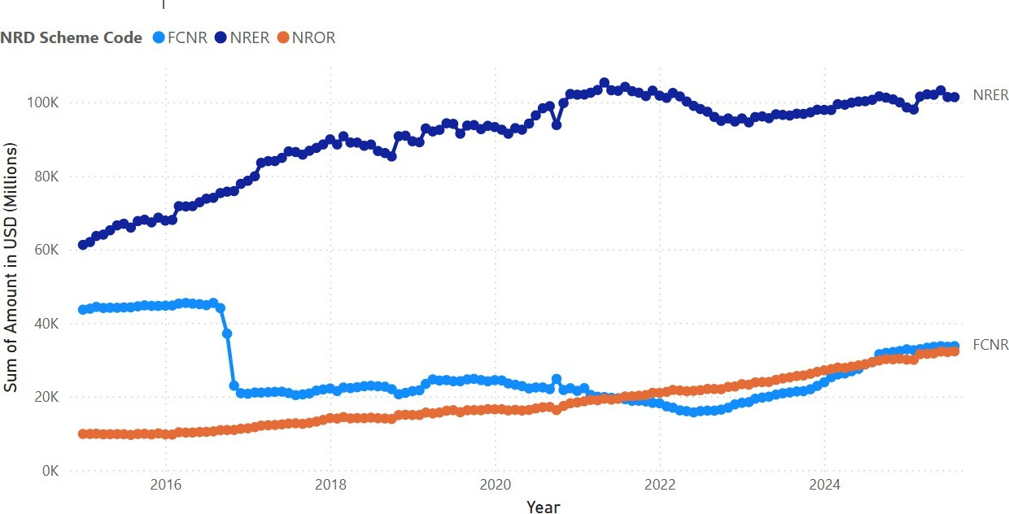
Figure 3: Accounts under the schemes

Figure 4 is a stacked bar chart presents the scheme-wise composition of non- resident deposit balances (in USD terms) for the month of August across multiple years, disaggregated into Foreign Currency Non-Resident (FCNR), Non-Resident External (NRER), and Non-Resident Ordinary (NROR) schemes. The analysis is based on closing balance data reported under the Non-Resident Deposits Comprehensive Single Return (NRD-CSR) framework, which provides a consistent and granular classification of non-resident deposits by scheme, currency, and reporting period.
A key feature evident from the chart is the dominance of the NRER scheme across all observed years. In most August snapshots, NRER accounts for approximately 60–73 per cent of total non-resident deposit balances. This sustained predominance reflects the structural importance of INR denominated, fully repatriable deposits in the non-resident deposit landscape. The relative stability of NRER shares over time indicates strong depositor preference for rupee denominated instruments, supported by their liquidity, reparability, and suitability for both savings and transactional purposes.
The FCNR scheme constitutes the second-largest component, though its share exhibits noticeable variation across years. FCNR balances typically account for about 12–37 per cent of total non-resident deposits in August, with higher shares observed in certain years and lower shares in others. This variability underscores the sensitivity of FCNR deposits to global financial conditions, particularly interest rate differentials and exchange rate expectations. Periods of elevated FCNR share are likely associated with favorable returns on foreign currency deposits or heightened demand for currency risk hedging, whereas declines in FCNR share may reflect shifts in global monetary policy or reduced incentives for holding foreign currency denominated deposits.
The NROR scheme represents a smaller but gradually increasing share of total non-resident deposits, generally ranging between 8 and 19 per cent across the years shown. The upward trend in NROR share in later years suggests a growing role of non-repatriable, rupee-denominated accounts in the non-resident deposit ecosystem. This may be linked to increased domestic engagement of non-residents, including income generation within India and greater use of NRO accounts for local transactions.
Taken together, the August scheme wise distribution highlights a structurally stable hierarchy in non-resident deposits, with NRER as the anchor, FCNR as a more cyclically sensitive component, and NROR as a complementary, domestically oriented segment. The persistence of this structure across years suggests that seasonal effects associated with August do not materially alter the relative importance of schemes but rather reflect underlying depositor preferences and regulatory features embedded in each scheme.
From a policy perspective, the scheme-wise composition has important implications for liquidity management and external vulnerability assessment. The dominance of NRER deposits provides a relatively stable funding base, while fluctuations in FCNR shares warrant closer monitoring due to their responsiveness to global financial conditions. The NRD-CSR–based scheme level analysis thus offers valuable insights into the evolving structure of non-resident deposits and supports informed assessment of the banking system’s exposure to external shocks.

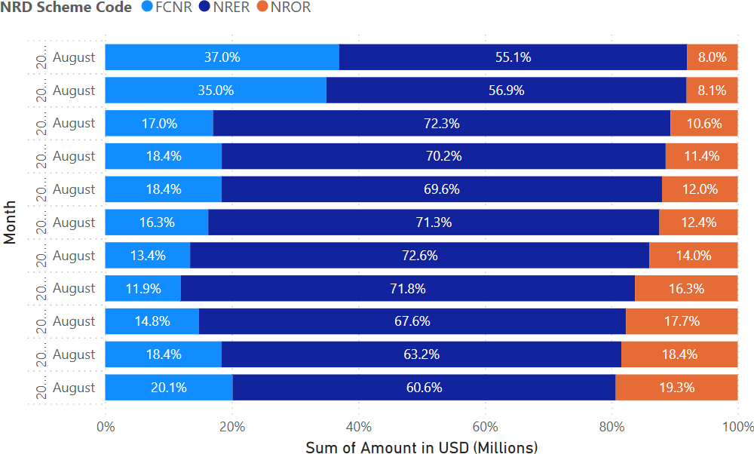

Figure 4: Accounts under the schemes throughout the years for the month of August

Bank Categories
The Non-Resident Deposits Comprehensive Single Return (NRD-CSR) framework classifies reporting banks into distinct institutional categories, each differing in ownership structure, regulatory scope, operational mandate, and their relative participation in NRI deposit mobilization. This classification is essential for analyzing variations in foreign currency inflows, outflows, maturity structures, and the composition of NRE, NRO, and FCNR(B) deposits across the Indian banking system. Understanding these bank categories allows for a more accurate interpretation of deposit behavior, inter-bank heterogeneity, and systemic patterns within India’s external financial linkages.
Within the NRD-CSR reporting system, six categories of banks participate in the submission of foreign currency and rupee-denominated NRI deposit data. These include:

Corporative Banks:
Co-operative Banks are financial institutions owned and operated by their members (usually small borrowers, farmers, traders, and local communities). They work on a co-operative ownership model, where profits are shared among members and lending is typically focused on local needs. Includes Urban Co-operative Banks (UCBs) that accept NRI deposits.

Foreign Banks:
Foreign Banks are banks that are incorporated outside India but operate within India through branches. Follow RBI regulations for Indian operations. Provide corporate banking, NRI services, trade finance. Headquarters are located abroad. Their NRI deposit reporting is limited compared to domestic banks because they usually focus on corporate and wholesale banking.

Private Sector Banks:
Private Sector Banks are Indian banks in which private shareholders hold the majority stake (more than 51%). They operate under RBI’s banking regulations and are run by private management. Examples: HDFC Bank, ICICI Bank, Axis Bank, Yes Bank, etc. These banks hold a large share of NRE, NRO, and FCNR(B) deposits due to strong retail NRI networks.

Public Sector Banks:
Public Sector Banks are banks in which the Government of India holds a majority stake (≥ 51%). Examples: SBI, Bank of Baroda, Punjab National Bank. These banks are Government-owned and are mandatory priority sector in lending. The banks have a Large rural and semi-urban presence. PSBs report the largest overall NRI deposit base due to their extensive branch network.

Regional Banks:
Regional Rural Banks are government-owned specialized banks created to serve rural areas, jointly owned by Government of India, State Government and Sponsor Public Sector Bank. Their mandate is Rural development, Agricultural credit and financial inclusion. Only a few RRBs accept NRI deposits; their share is very small.

Small Finannce Banks:
Small Finance Banks are niche banks licensed by RBI to serve small businesses, Low-income households and Micro and small industries They focus on financial inclusion and small-ticket loans. Most SFBs do not hold significant NRI deposits; some may not be permitted to accept certain NRI accounts (like FCNR(B)).
Figure 5 gives the bank-category–wise distribution of non-resident deposit closing balances (CB) for August 2025 reveals a pronounced concentration of balances within scheduled commercial banks, highlighting their dominant role in mobilizing and intermediating non-resident deposits in India. The analysis is based on closing balance data reported under the Non-Resident Deposits Comprehensive Single Return (NRD-CSR), which provides granular, bank-level information on non-resident deposits across schemes and reporting institutions.
Private sector banks account for the largest share, at 53.92 per cent, indicating their leading position in the non-resident deposit market. This dominance reflects sustained strategic emphasis on the non-resident segment, supported by competitive deposit offerings, extensive use of digital banking platforms, and customized relationship management for non-resident customers. Over time, private sector banks have leveraged technology-driven service delivery and operational flexibility to enhance customer engagement and retention, resulting in a structural shift of non-resident deposits towards this bank category.
Public sector banks constitute the second-largest share, at 41.07 percent, underscoring their continued importance in non-resident deposit mobilization. Their substantial share is underpinned by wide domestic branch networks, long- standing relationships with the Indian diaspora, and depositor confidence arising from perceived sovereign support. Although their share is lower than that of private sector banks, public sector banks remain a critical conduit for non-resident savings, particularly among depositors with a preference for stability and continuity.
Foreign banks account for a modest 3.72 per cent of aggregate non-resident deposit balances. Their limited contribution reflects structural factors such as a narrower branch footprint in India, selective business models, and a stronger focus on wholesale, corporate, or niche client segments rather than large scale retail deposit mobilization. Consequently, while foreign banks play a role in servicing specific non-resident clientele, their overall impact on aggregate non-resident deposits remains constrained.
The remaining bank categories small finance banks (0.98 per cent), cooperative banks (0.16 per cent), and regional rural banks (0.15 per cent) together account for less than two per cent of total non-resident deposit balances. These institutions are structurally limited by regulatory constraints, restricted geographical reach, and business mandates primarily oriented towards domestic financial inclusion and localized banking activities. As a result, their engagement with non-resident depositors is minimal.
Overall, the August 2025 distribution highlights a highly concentrated structure of non-resident deposit intermediation, with private and public sector banks jointly accounting for the overwhelming majority of balances. This concentration has important implications for liquidity management and financial stability, as fluctuations in non-resident deposits driven by global interest rate movements, exchange rate expectations, or external shocks are likely to be transmitted primarily through these two bank categories. Accordingly, bank-category-wise monitoring of non-resident deposits, as facilitated by the NRD-CSR reporting framework, remains essential for assessing systemic liquidity conditions and the external vulnerability of the banking system.

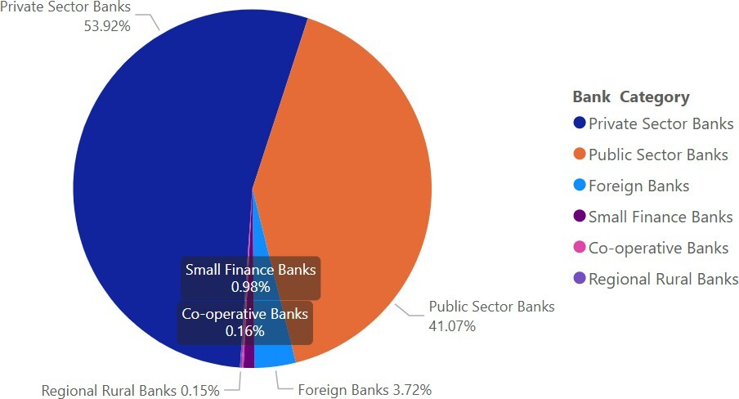

Figure 5: Bank Categories for August 2025

Flow Analysis: Inflows and Outflows

Inflows (FI, IR, PR, LI)
Inflows represent the total additions to Non-Resident Indian (NRI) deposits within a given reporting period and are a critical indicator of the attractiveness of India’s banking system to the global NRI community. Inflows capture all sources of funds entering NRE, NRO, and FCNR(B) accounts, whether from abroad, from interest earnings, from domestic sources (in the case of NRO accounts), or from renewals and transfers from other accounts. A strong inflow signals confidence among NRIs in the Indian economic environment, favorable interest rate conditions, and stable exchange-rate expectations. Inflows are composed of several elements:
    - Fresh Inflows from abroad (FI), which indicate new cross-border remittances.
    - Interest Reinvested (IR), representing the accumulation of earnings back into deposits.
    - Renewals or Transfers (PR), which capture the continuation of maturing deposits; and
    - Local Inflows (LI), which apply specifically to NRO savings accounts.
Together, inflows reflect the dynamic interaction of global economic conditions, domestic monetary policies, interest rate differentials, and NRI saving behaviors. They serve as a vital measure of the strength of India’s external financial position and are widely used by policymakers, analysts, and banks to gauge liquidity, foreign exchange potential, and the overall stability of foreign currency and rupee-denominated deposits from NRIs. Money coming into NRI accounts fresh foreign remittances, interest added, renewed deposits, and local credits. These represent all additions or increases to NRI deposits during the month.

FI – Fresh Inflows from abroad:
New deposits sent by NRIs from outside India into FCNR/NRE/NRO accounts.

IR – Interest Reinvested:
Monthly interest is added back to the deposit instead of being withdrawn.

PR – Amount Renewed / Transfer from other A/c:
Deposits that mature and are renewed, or deposits shifted from another NRI account.

LI – Local Inflow (NRO Savings):
Money deposited locally into an NRO savings account (e.g., rent, dividends).

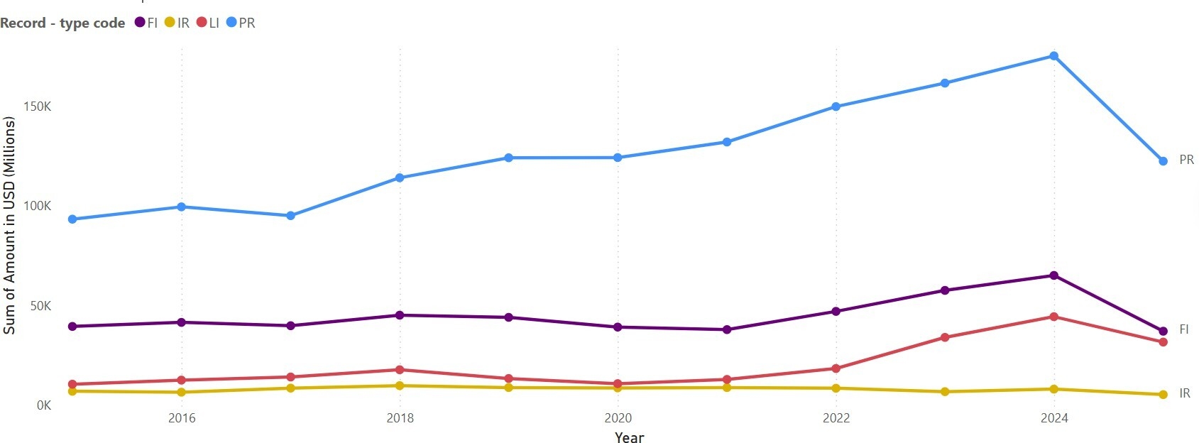

Figure 6: Inflows from 2015-2025

Figure 7 illustrates the composition of inflows into non-resident deposits for selected years, with a particular focus on August observations, classified by record-type codes as defined under the Non-Resident Deposits Comprehensive Single Return (NRD-CSR) reporting framework. Inflows comprise fresh inflows from abroad (FI), interest reinvested (IR), amount renewed or transferred from other accounts (PR), and local inflows (LI), as applicable across deposit schemes. These components collectively determine the gross additions to non-resident deposit balances during the reference period.
A salient feature of the chart is the dominance of renewals and transfers (PR) across all observed years. In most August snapshots, PR accounts for well over half of total inflows, with shares typically ranging between about 58 per cent and over 70 per cent. This pattern indicates that non-resident deposit growth is largely driven by the rollover of existing deposits rather than by new money entering the system. Such reliance on renewals underscores the importance of depositor retention and maturity management in sustaining non-resident deposit balances.
Fresh inflows from abroad (FI) constitute the second most important component, though their relative contribution varies across years. The chart shows FI shares generally in the range of approximately 17–32 per cent, with a noticeable decline from higher levels observed in earlier years (for instance, around the mid-2010s) to relatively lower and more stable levels in recent years. This moderation suggests a gradual weakening in the pace of new inflows, possibly reflecting changing global interest rate conditions, exchange rate expectations, and alternative investment opportunities available to non-resident depositors.
Local inflows (LI), which are relevant primarily for NRO savings accounts, account for a smaller but non-negligible share of total inflows. Their contribution typically remains in the single digit to low percentage range, indicating that while domestic receipts credited to NRO accounts add to inflows, they do not play a dominant role in shaping aggregate non-resident deposit dynamics. The presence of LI nonetheless highlights the mixed domestic external character of NRO deposits within the broader non-resident deposit framework. Interest reinvested (IR) represents the smallest component of inflows throughout the period. Its consistently low share suggests that accrued interest contributes only marginally to gross inflows when compared with renewals or fresh deposits. This is consistent with the accounting structure of non-resident deposits, where interest flows are relatively modest in size relative to principal amounts.
Taken together, the inflow composition depicted in the August chart points to a structural dependence on renewals, with fresh inflows playing a secondary role and local inflows and interest reinvestment contributing marginally. From a policy and stability perspective, this composition implies that the sustainably of non-resident deposit balances is closely tied to rollover behavior rather than continuous external inflows. Consequently, shifts in depositor confidence, interest rate differentials, or global financial conditions that affect renewal decisions can have a pronounced impact on aggregate non-resident deposits. The NRD-CSR based decomposition of inflows thus provides critical insights into the underlying drivers of non-resident deposit dynamics and serves as an important input for monitoring liquidity conditions and external vulnerability of the banking system.

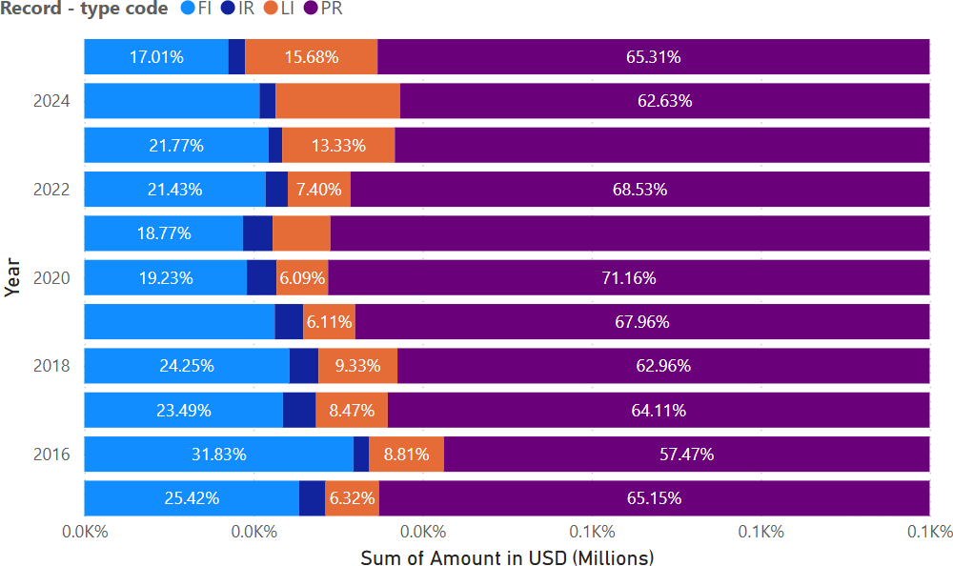

Figure 7: Inflows throughout the years for the month of August

The Figure 8 presents the country-wise distribution of non-resident deposit inflows for the month of March, capturing year-end inflow dynamics across the top five source countries that are United Arab Emirates (AE), United States (US), United Kingdom (GB), Singapore (SG), and India (IN). The analysis is based on inflow related record-type codes reported under the Non-Resident Deposits Comprehensive Single Return (NRD-CSR) framework, primarily comprising fresh inflows from abroad (FI), interest reinvested (IR), and renewals or transfers from other accounts (PR), expressed in USD terms for cross-country comparability.
A prominent feature of the March inflow profile is the historically dominant role of the United Arab Emirates (AE) as a source country. In the earlier part of the sample period, AE exhibits relatively high and sometimes volatile inflows, reflecting the strong concentration of the Indian diaspora in the Gulf region and the importance of the UAE as a remittance and deposit mobilization corridor. Peaks in AE inflows around certain years suggest periods of heightened deposit placement, possibly linked to favorable interest rate conditions or exchange rate expectations. However, in later years, AE inflows appear to stabilize, indicating a maturing deposit base with a greater emphasis on renewals rather than sharp surges in fresh inflows.
In contrast, inflows from the United States (US) show a clear and sustained upward trend over time, becoming increasingly prominent in the more recent March observations. This pattern points to a gradual reorientation of non- resident deposit inflows towards advanced economies. The growing contribution from the US likely reflects higher income levels of the diaspora, increased financial integration, and portfolio diversification motives, as well as periods when relative returns on Indian non-resident deposits were attractive vis-`a-vis alternative assets.
The United Kingdom (GB) and Singapore (SG) contribute moderate but relatively stable inflows throughout the period. These countries, both established financial centers with long standing NRI communities, exhibit less volatility compared to AE and a slower growth trajectory compared to the US. Their inflows are often associated with renewals and interest reinvestment, indicating a stable but mature depositor base. Such stability adds resilience to aggregate inflows, even if the absolute magnitudes remain lower.
Inflows attributed to India (IN) which largely reflect local inflows under NRO related transactions remain comparatively small but non-negligible. These inflows underscore the role of domestic income and transactions involving non-resident accounts, complementing overseas inflows and contributing to the overall inflow structure captured in March.
Overall, the March inflow pattern reveals a gradual diversification in the geographical sources of non-resident deposit inflows. While traditional corridors such as the UAE continue to play a significant role, there is a visible and persistent rise in inflows from the United States, suggesting increasing sensitivity of India’s non-resident deposit base to economic and financial conditions in advanced economies. From a policy perspective, this evolving country-wise composition has important implications for assessing external vulnerability and liquidity risk, as inflows may increasingly respond to global monetary policy cycles and cross-border portfolio rebalancing. The NRD-CSR based country- wise inflow data thus provides critical inputs for monitoring shifts in the external funding structure of the banking system.

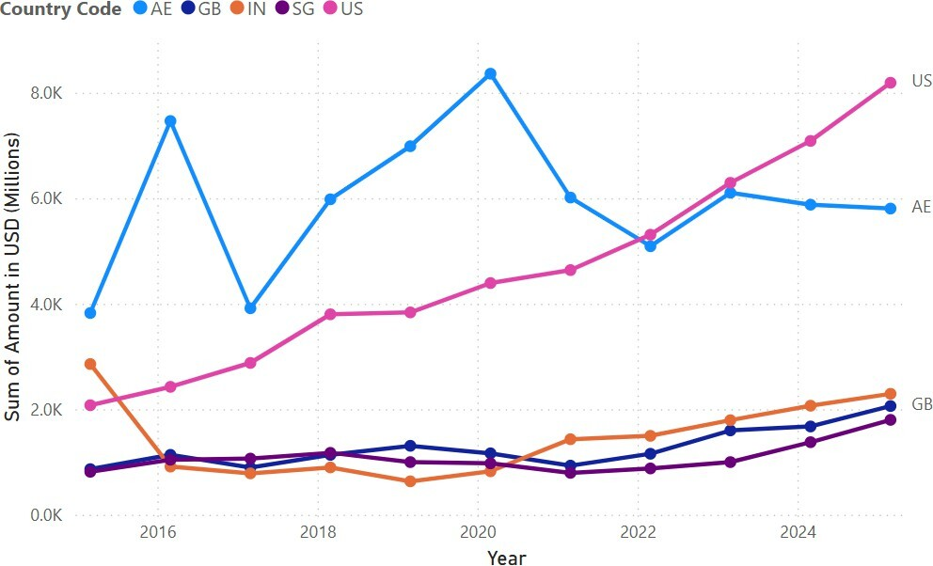

Figure 8: Inflows of Top 5 Countries

Outflows (PA, IA, PL, IL, LW, TR)
Outflows represent the total withdrawals or reductions from NRI deposit accounts during the reporting period and serve as a key indicator of repatriation behavior, domestic financial usage, and global economic sentiment among NRIs. Outflows capture the movement of funds away from India either through repatriation abroad or through domestic withdrawals within India. These include the remittance of principal and interest abroad, local withdrawals for consumption or investment, and transfers or closures of accounts. Outflows are influenced by numerous factors such as shifts in global interest rates, exchange-rate volatility, liquidity needs of NRIs, geopolitical developments, and domestic regulatory guidelines. The NRDCSR identifies several components of outflows, including:
    - Principal Remitted Abroad (PA) and Interest Remitted Abroad (IA), which reflect outward foreign exchange flows
    - Principal and Interest Remitted Locally (PL and IL), representing spending or reinvestment within India
    - Local Withdrawals (LW) for expenses such as taxes, gifts, or donations
    - Transfers to Other Accounts (TR), which include reclassification or renewal of deposits.
Outflows play a vital role in determining net deposit growth and have implications for bank liquidity, foreign exchange reserves, and the stability of NRI deposit portfolios. Monitoring outflows helps banks and policymakers understand withdrawal cycles, gauge NRI confidence, and anticipate shifts in foreign currency liquidity and repatriation patterns. Money going out of NRI accounts withdrawals, repatriation abroad, interest paid out, local withdrawals, and transfers. These represent all reductions or withdrawals from NRI deposits during the month.

PA – Principal Remitted Abroad: Main amount (not interest) sent back abroad to the NRI.
  - IA – Interest Remitted Abroad: Interest payments transferred outside India.
  - PL – Principal Remitted Locally: Principal withdrawn inside India.
  - IL – Interest Remitted Locally: Interest withdrawn inside India.
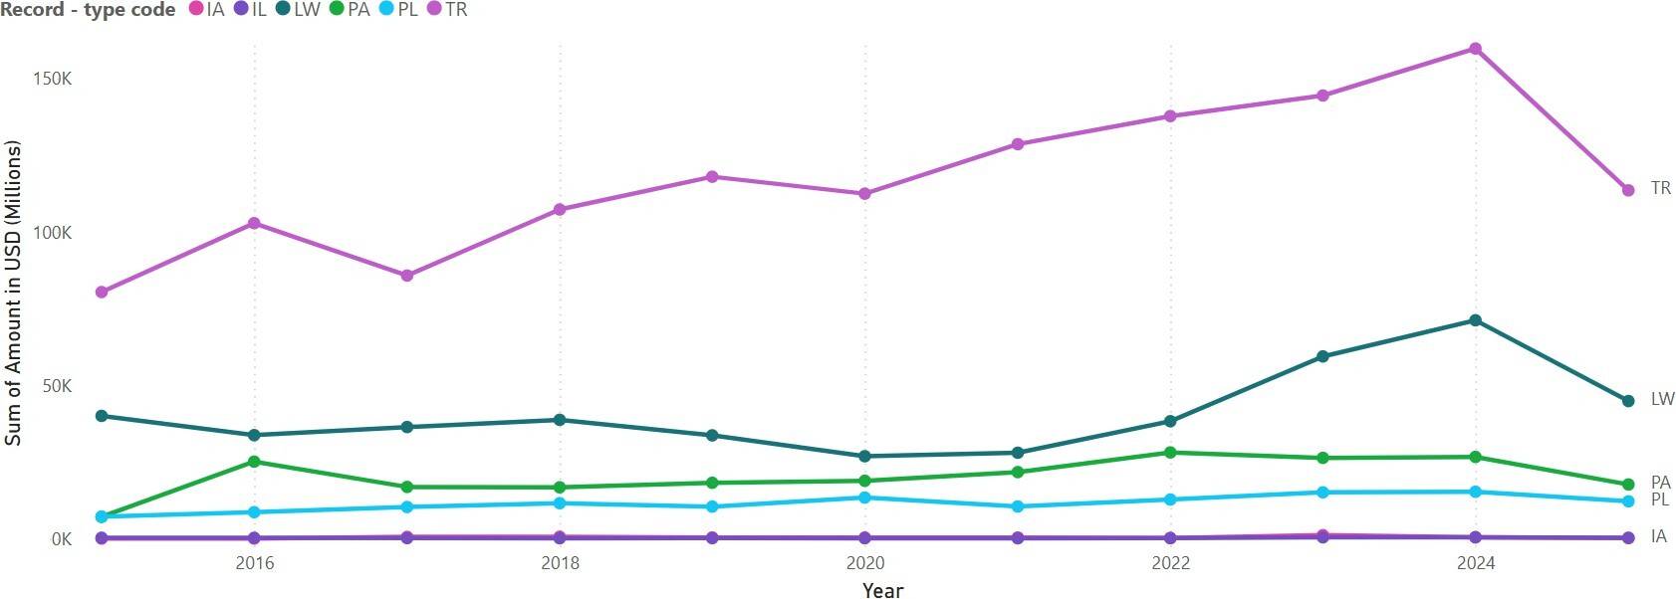
Figure 9: Outflows from 2015-2025

Figure 10 is a stacked bar chart that depicts the composition of outflows from non-resident deposit accounts for selected years, with a focus on August observations, disaggregated by record-type codes as prescribed under the Non-Resident Deposits Comprehensive Single Return (NRD-CSR) reporting framework. Outflows include principal remitted abroad (PA), interest remitted abroad (IA), principal remitted locally (PL), interest remitted locally (IL), local withdrawals (LW), and transfers to other accounts including renewals (TR). These components jointly determine the gross withdrawals from non-resident deposits during the reference period.
A key feature evident from the chart is the dominant role of transfers to other accounts (TR) across all observed years. In most August snapshots, TR constitutes more than half of total outflows, with shares typically ranging from about 56 per cent to nearly 68 per cent. This predominance indicates that a substantial portion of outflows reflects account-to-account movements and renewals, rather than permanent withdrawal of funds from the banking system. Such behavior is consistent with rollover-driven deposit management, where funds are shifted across schemes or maturities instead of being repatriated.
Local withdrawals (LW) represent the second most significant outflow component in several years, with shares generally in the range of about 15–32 per cent. These withdrawals, which include payments for local expenses such as taxes, gifts, or donations, are particularly relevant for NRO accounts, where domestic utilization of funds is permitted. The variability in LW shares across years suggests changing patterns of domestic usage of non-resident funds, possibly influenced by regulatory conditions, income flows, or household expenditure needs.
Principal remitted abroad (PA) accounts for a moderate but stable share of total outflows, typically in the single digit to low percentage range. This component captures the actual repatriation of principal outside India and thus represents a more direct channel of capital outflow. The relatively contained share of PA indicates that, despite fluctuations in global financial conditions, outright repatriation of principal remains limited compared to internal transfers and local withdrawals.
Principal remitted locally (PL) also contributes a non-negligible share, generally ranging between about 5 and 8 per cent in most years. PL reflects local utilization of principal amounts within India and, together with LW, highlights the importance of domestic channels in shaping aggregate outflows from non- resident deposits.
In contrast, interest remitted abroad (IA) and interest remitted locally (IL) constitute the smallest components of total outflows throughout the period. Their consistently low shares suggest that interest payments are relatively modest in magnitude compared to principal-related movements, which dominate the outflow structure.
Overall, the August outflow composition underscores that non-resident deposit outflows are largely driven by internal transfers and renewals rather than by large-scale repatriation of funds. From a policy and financial stability perspective, this structure implies that short-term volatility in outflows is more closely linked to rollover and account management behavior than to abrupt capital exit. Consequently, monitoring the composition of outflows particularly the balance between transfers, local withdrawals, and principal remittances abroad under the NRD-CSR framework is essential for assessing liquidity conditions, rollover risks, and the external vulnerability of the banking system.

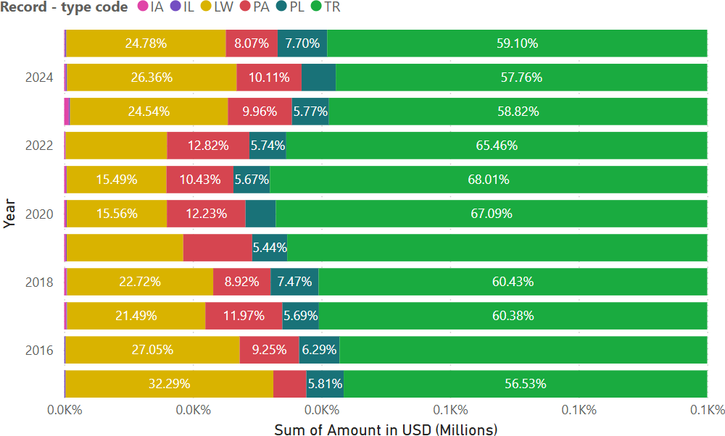

Figure 10: Outflows throughout the years for the month of August

The Figure 11 illustrates the country-wise distribution of non-resident deposit outflows during the month of March across the top five source countries which are United Arab Emirates (AE), United States (US), United Kingdom (GB), Singapore (SG), and India (IN). The analysis is based on outflow related record- type codes reported under the Non-Resident Deposits Comprehensive Single Return (NRD-CSR) framework, which classifies outflows into components such as principal remitted abroad (PA), interest remitted abroad (IA), principal remitted locally (PL), interest remitted locally (IL), local withdrawals (LW), and transfers to other accounts including renewals (TR).
A prominent feature of the March outflow profile is the historically large and volatile outflows associated with the United Arab Emirates (AE). In the earlier years, AE-related outflows were relatively elevated, reflecting the size and maturity of the deposit base linked to the Gulf corridor. These outflows likely capture a combination of renewals and transfers (TR) as well as local withdrawals and remittances, consistent with the high turnover of deposits originating from this region. In later years, AE outflows appear to moderate and stabilize, suggesting a shift towards a more settled deposit structure and smoother rollover behavior. Outflows attributed to the United States (US) show a clear upward trend over time, particularly in the more recent March observations. This pattern mirrors the growing importance of the US as a source of non-resident deposits and indicates that as inflows from the US have expanded, associated outflows through renewals, transfers, and selective repatriation have also increased. The rising US outflows underscore the increasing sensitivity of India’s non-resident deposit dynamics to financial conditions and portfolio decisions in advanced economies.
The United Kingdom (GB) and Singapore (SG) exhibit moderate and relatively stable outflow profiles across the period. These countries, both well-established financial centers with mature NRI communities, show less pronounced volatility compared to AE and US. Outflows from GB and SG are likely dominated by transfers and renewals, reflecting steady account management behavior rather than abrupt withdrawals. Their stability contributes to a more predictable pattern of aggregate outflows.
Outflows recorded under India (IN) which largely correspond to local withdrawals and local utilization of funds, particularly under NRO accounts remain comparatively smaller in magnitude but show a gradual increase in later years. This trend suggests growing domestic engagement of non-resident account holders, with increased use of funds for local expenditures, investments, or transfers within the domestic financial system.
Overall, the March outflow pattern across the top five countries indicates that outflows are driven more by internal transfers, renewals, and local utilization than by large-scale repatriation of funds abroad. The dominance of mature corridors such as AE in earlier years and the rising prominence of the US in recent years highlight a gradual shift in the geographical composition of outflows, in line with changing inflow patterns. From a policy perspective, these findings suggest that while non-resident deposit outflows remain substantial, they are largely associated with rollover and account management behavior rather than abrupt capital exit. Continuous monitoring of country-wise outflows under the NRD-CSR framework is therefore essential for assessing liquidity conditions, rollover risks, and the evolving external vulnerability of the banking system.

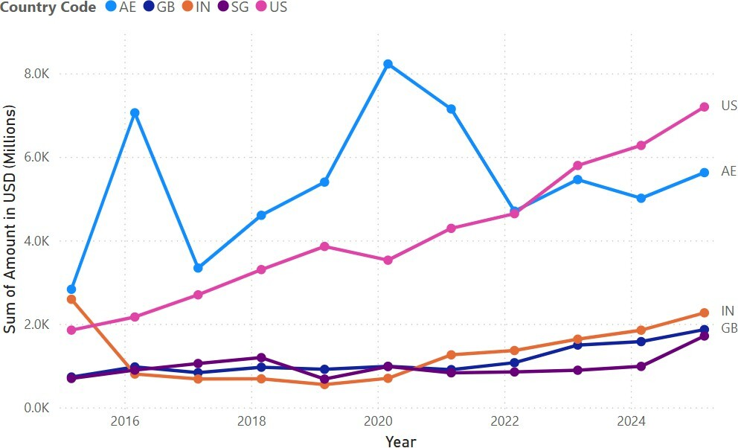

Figure 11: Outflows of Top 5 Countries (USD)

Stock Analysis: Balances
Balances represent the stock of NRI deposits held in various banking schemes at the beginning and end of a reporting period, serving as the most fundamental measure of the overall size and stability of NRI deposit liabilities in the Indian banking system. The Opening Balance (OB) provides a benchmark of the de- posit position at the start of the month, while the Closing Balance (CB) reflects the cumulative effect of all inflows and outflows during the reporting cycle. The NRDCSR framework also includes Unclaimed Balances (UC), Interest Accrued (AI), and Interest Suspense Balances (SB), which together provide a complete, structured overview of all components contributing to the final reported deposit position.
Balances play a crucial analytical role because they capture the net effect of NRI behavior, global macroeconomic trends, repatriation patterns, currency movements, and domestic policy changes. The formula prescribed by the NRD- CSR— CB = OB + INFLOWS – OUTFLOWS ensures consistency and enables accurate tracking of monthly changes. A rising balance indicates strong NRI engagement and favorable economic sentiment, while a declining balance may suggest increased repatriation or shifts in global financial conditions.
Overall, balances offer a comprehensive snapshot of the health, liquidity potential, and foreign exchange value embedded within the NRI deposit system. They form the core of trend analysis, policy evaluation, and bank-level risk assessment in the management of India’s non-resident deposit ecosystem. Opening and closing stock of deposits in NRI accounts, including accrued and unclaimed amounts. Balances represent the stock levels the amount standing in the account at the beginning and end of the period.

OB – Opening Balance:
Amount present in the account at the start of the month.

CB – Closing Balance:
Amount present in the account at the end of the month. consistency rule: CB = OB + Inflows – Outflows for each scheme. “CB = OB + INFLOWS (FI+IR+PR) – OUTFLOWS (PA+PL+TR)” for FCNR(B).

UC – Unclaimed Balance:
Deposits did not operate for long periods.
- AI – Interest Accrued: Interest earned but not yet paid.

SB – Interest Suspense Balance:
Interest that is due but kept in suspense because it is not yet paid or credited.
The Figure 12 depicts the closing balances (CB) of non-resident deposits for the month of March, disaggregated across the top five country codes are United Arab Emirates (AE), United States (US), United Kingdom (GB), Saudi Arabia (SA),
and India (IN). Closing balance, as defined under the Non-Resident Deposits Comprehensive Single Return (NRD-CSR) framework, represents the outstanding stock of deposits at the end of the reference month after accounting for all inflows and outflows during the period.
The March position is particularly significant as it coincides with the financial year end, when balance sheet adjustments, renewals, and portfolio reallocation decisions are most pronounced.
Among the five countries, the United Arab Emirates (AE) consistently accounts for the largest share of outstanding balances throughout the period under review. The elevated AE balances reflect the structural importance of the Gulf region as a source of non-resident deposits, driven by a large Indian expatriate workforce, stable remittance channels, and a high propensity to hold savings in Indian banking instruments. While AE balances exhibit some year-to-year fluctuations, the overall trend remains upward, with a notable strengthening in the most recent years. This pattern suggests a combination of sustained inflows and high rollover rates, particularly under NRE and FCNR schemes.
The United States (US) emerges as the second most significant contributor to closing balances, with a clear and persistent upward trajectory over time. Unlike AE, where balances show periodic moderation, US balances display a steady accumulation, especially in the later years. This trend underscores the growing role of advanced economies in India’s non-resident deposit base and reflects higher income levels, deeper financial integration, and portfolio diversification motives among US-based non-resident Indians. The rising US share in closing balances also indicates increased sensitivity of aggregate deposits to global financial conditions and interest rate differentials.
Balances associated with the United Kingdom (GB) remain moderate but stable across the period. The relatively flat trajectory suggests a mature depositor base characterized by regular renewals and limited volatility. GB’s contribution, while smaller than AE and US, adds stability to the overall stock of non-resident deposits, reducing concentration risk and supporting balance sheet predictability for banks.
The Saudi Arabia (SA) category, though smaller in absolute terms, exhibits a gradual upward movement in closing balances. This reflects the steady expansion of the Indian expatriate population in the region and a growing preference for maintaining deposits in Indian banks. The consistency of SA balances suggests that deposits from this corridor are largely relationship driven and less prone to abrupt withdrawals.
Finally, balances reported under India (IN) primarily linked to NRO accounts show a noticeable increase in the later years. This rise points to greater domestic utilization of non-resident accounts for local transactions, investments, and income retention within India. The strengthening of IN balances highlights the increasing integration of non-resident funds into the domestic financial system.
Overall, the March closing balance profile reveals a highly concentrated but gradually diversifying country-wise structure of non-resident deposits. While AE continues to dominate stock position, the rising prominence of the US and steady contributions from GB and SA indicate a broadening of the external depositor base. From a policy perspective, these trends have important implications for liquidity management, rollover risk assessment, and external sector monitoring. The NRD-CSR based country-wise closing balance data thus provides a critical lens for evaluating the stability and resilience of non-resident deposits at the financial year end.
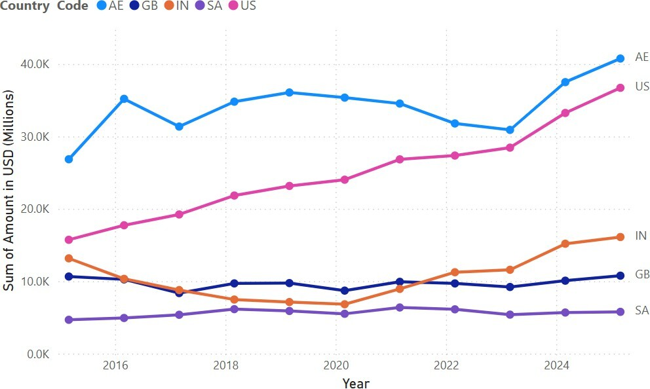

Figure 12: Closing Balance (USD) of Top 5 Countries

Banks Decomposition
The decomposition of banks within the Non-Resident Deposits Comprehensive Single Return (NRD-CSR) framework is essential for understanding how different banking institutions mobilize, hold, and report non-resident deposits in India. The NRD-CSR system, as prescribed by the Reserve Bank of India (RBI), establishes a uniform XBRL-based reporting structure through which each reporting bank provides detailed information on its non-resident deposit positions, including inflows, outflows, balances, currency composition, maturity structure, and the nature of account holdings. The reporting template, presented in the NRD-CSR format, requires banks to disclose their deposit scheme code (FCNR, NRE, or NRO), account type, original and residual maturity, currency, country, and Record Type Code for every line of data submitted.
Bank decomposition in this context refers to the disaggregation of NRD activity at the individual-bank level, enabling comparative assessment across commercial banks, foreign banks, public sector banks, private sector banks, and other authorized institutions. Because each bank reports data using standardized codes including scheme codes (FCNR, NRER, NROR), maturity classifications, and inflow/outflow indicators the NRD-CSR dataset allows a granular evaluation of institutional behavior in mobilizing non-resident deposits. The Code Box definitions (pages 1–2) further ensure uniform interpretation across banks by codifying maturity categories, SWIFT currency codes, and deposit scheme identifiers.
A central feature of bank-level decomposition is the Record Type Code system, which classifies each transaction or position into inflows (FI, IR, PR, LI), outflows (PA, IA, PL, IL, LW, TR), and balances (OB, CB, UC, AI, SB). This enables the construction of detailed behavioral profiles for each bank such as which banks attract the highest inflows under FCNR(B), which banks show higher local withdrawals in NRO accounts, or how renewal and maturity patterns differ across institutions.
Furthermore, the sample dataset highlights the variation in transactional magnitudes across banks and provides concrete evidence of the heterogeneity in deposit behavior. Banks differ significantly in terms of currency usage, maturity distribution, principal vs. interest flows, and their reliance on specific deposit schemes like FCNR(B) or NRE. Such decomposition allows researchers to analyze the concentration of non-resident deposit activity, identify dominant banks in terms of foreign currency mobilization, and evaluate how institutional characteristics influence the scale and direction of NRD flows.
In summary, the NRD-CSR framework provides a structured and comprehensive basis for decomposing the contribution of individual banks to India’s non-resident deposit landscape. By enabling consistent, code-driven reporting, it facilitates robust analysis of cross-bank differences in inflows, outflows, balances, and maturity structures, and allows researchers to assess institutional behavior within India’s external banking ecosystem.
Figure 3 presents a bank-wise distribution of NRI deposit closing balances (CB) for August 2025. It highlights a pronounced concentration of non-resident deposits among a limited set of large commercial banks. The data, compiled from the Non-Resident Deposits Comprehensive Single Return (NRD-CSR), reflect the relative scale, outreach, and market positioning of individual banks in mobilizing non-resident deposits across FCNR, NRE, and NRO schemes.
At the apex of the distribution, the State Bank of India (SBI) emerges as the largest holder of NRI deposits among the top ten banks, with balances significantly exceeding those of its peers. SBI’s dominance reflects its extensive domestic and overseas branch network, longstanding engagement with the Indian diaspora, and strong depositor confidence arising from its public sector status. Its ability to mobilize large volumes of NRI deposits underscores the importance of scale and institutional trust in this segment.
Among private sector banks, HDFC Bank Ltd. and ICICI Bank Limited occupy the second and third positions, respectively, with substantial NRI deposit balances. Their strong presence highlights the increasing role of large private sector banks in the non-resident deposit market. Competitive pricing, advanced digital platforms, and tailored services for NRI customers have enabled these banks to attract and retain significant non-resident funds. The proximity of their balances to those of SBI also points to a gradual narrowing of the gap between leading public and private sector banks in NRI deposit mobilization.
The next tier comprises Axis Bank Limited and Federal Bank Ltd., both of which maintain moderate but meaningful shares of NRI deposits. Federal Bank’s position is particularly noteworthy, given its historically strong ties with the Indian diaspora in certain regions and its focused NRI banking strategy. These banks illustrate how targeted regional presence and specialized NRI services can translate into sizeable deposit bases even without the scale of the largest banks. Further down the distribution, Bank of Baroda and Canara Bank represent public sector banks with comparatively lower NRI deposit balances. While they continue to play an important role, their relative position suggests differences in strategic emphasis, overseas presence, and competitive positioning vis-`a-vis larger peers. Their inclusion among the top ten nonetheless indicates that public sector banks, beyond SBI, remain relevant players in the NRI deposit space.
The lower end of the top ten is occupied by IndusInd Bank Ltd., Kotak Mahindra Bank Ltd., and Union Bank of India. These banks hold smaller NRI deposit balances relative to the leaders, reflecting more selective engagement with the non-resident segment or comparatively limited international outreach. However, their presence among the top ten banks indicates a diversified participation of both private and public sector institutions in mobilizing NRI deposits. Overall, the August 2025 distribution reveals a highly skewed structure, where a few large banks account for a disproportionate share of NRI deposits. This concentration has important implications for liquidity management and financial stability, as changes in NRI deposit behavior driven by global interest rate movements, exchange-rate expectations, or external shocks are likely to be transmitted primarily through these leading banks. Consequently, bank-level monitoring of NRI deposits, as facilitated by the NRD-CSR framework, is essential for assessing institution-specific exposure as well as system wide liquidity conditions.
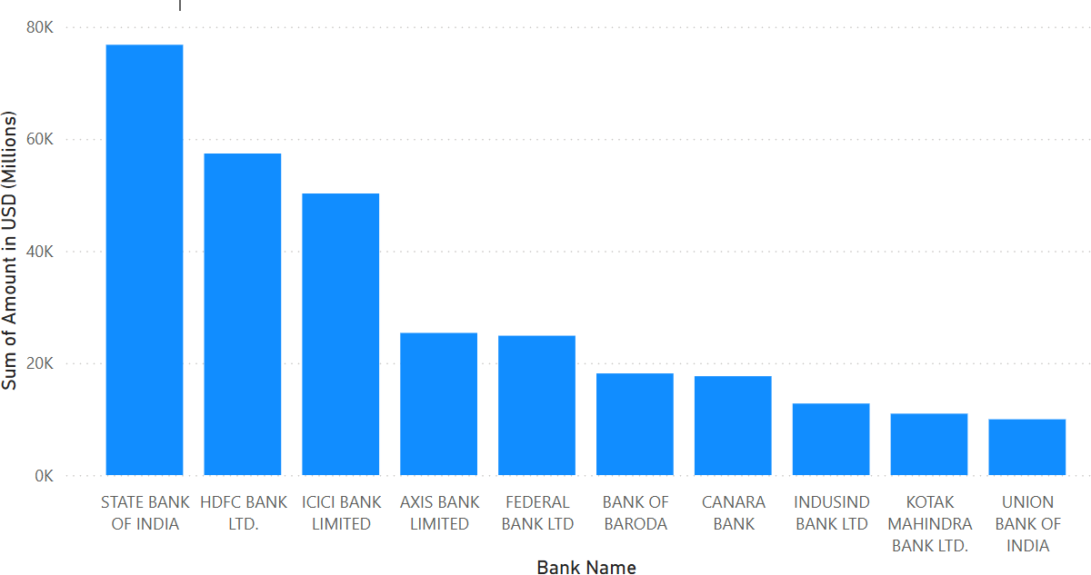

Figure 13: NRI deposits of Top ten banks

Maturity and Currency Decomposition
Maturity classification is a critical dimension in the analysis of non-resident deposits, as it provides insights into the tenor structure, rollover risk, and liquidity profile of banking system liabilities. Under the Non-Resident Deposits Comprehensive Single Return (NRD-CSR) reporting framework, each non- resident deposit is classified by both Original Maturity and Remaining (Residual) Maturity, allowing a nuanced assessment of deposit behavior from both structural and short-term risk perspectives. The distinction between original and remaining maturity is analytically important. Original maturity captures the structural composition of deposits, indicating the extent to which banks rely on short, medium, or long-term non-resident funding. Remaining maturity, on the other hand, is more closely linked to liquidity risk and rollover pressure, as it identifies the proportion of deposits that may mature in the near term. A banking system with a large share of deposits having short remaining maturity may be more vulnerable to changes in interest rate differentials, exchange rate expectations, or global financial conditions, even if the original maturity profile appears long-term. The maturity code is classified into six groups, namely 1, 2, 3, 4, 5, and 6. For analytical purposes, maturity codes 1 and 2 are clubbed together and classified as < 1 year (less than one year). Maturity code 3 is re- classified as < 2 years (less than two years), while maturity code 4 is reclassified as < 3 years (less than three years). Maturity code 5 is reclassified as > 3 years (more than three years), and maturity code 6 is classified as Unallocated.

Original Maturity Decomposition
Original maturity is a critical structural characteristic of non-resident deposits, reflecting the initial contractual tenure agreed upon at the time of deposit origination. Unlike residual maturity, which changes dynamically over time, original maturity remains fixed and provides insights into depositor preferences, banks’ liability planning, and the long-term stability of external funding. In the context of India’s Non-Resident Deposits (NRD) framework, original maturity plays a central role in assessing rollover risks, interest rate sensitivity, and the durability of foreign currency and rupee liabilities.
As per the Non-Resident Deposits Comprehensive Single Return (NRD-CSR) reporting format prescribed by the Reserve Bank of India, original maturity is classified into six maturity codes. These codes capture the initial time horizon of deposits, ranging from very short-term instruments to long-term placements, with a separate category for unallocated accounts such as savings and current deposits. For analytical clarity in this study, these six maturity codes are reclassified into broader maturity buckets. Specifically, maturity codes 1 and 2 (up to six months and over six months up to one year) are clubbed together and classified as less than one year (< 1 year). Maturity code 3 (over one year up to two years) is reclassified as less than two years (< 2 years), while maturity code 4 (over two years up to three years) is classified as less than three years (< 3 years). Maturity code 5 represents more than three years (> 3 years), capturing long-term deposits, and maturity code 6 is retained as Unallocated, primarily reflecting savings, current, and unclaimed accounts where maturity cannot be determined.
Figure 14 is the March-wise original maturity distribution that reveals several important structural trends. Across most years, deposits with longer original maturities (> 3 years) constitute a substantial share, particularly during the mid-2010s. This indicates a strong preference among non-resident depositors for long-term placements, likely driven by relatively attractive interest rate differentials, expectations of currency stability, and the use of NRD instruments as medium to long-term savings vehicles. Such long-term maturity concentration enhances funding stability for banks but also increases exposure to interest rate cycles over extended horizons.
At the same time, the share of short-term deposits (< 1 year) exhibits noticeable variation across years. Periods marked by heightened global uncertainty, exchange rate volatility, or shifts in international monetary policy tend to show an increased preference for shorter original maturities. This behavior reflects depositors’ desire for liquidity and flexibility in response to uncertain macro-financial conditions. The observed fluctuations in the < 1 year category suggest that non-resident depositors actively adjust maturity choices based on evolving global and domestic economic signals. The < 2 years and < 3 years maturity segments together form an important intermediate layer in the maturity structure. These categories often act as transition bands between short-term liquidity driven placements and long-term investment-oriented deposits. Changes in their relative shares over time point to gradual shifts in depositor confidence and expectations regarding interest rates, regulatory policies, and exchange rate movements.
Overall, the original maturity profile for March highlights a balanced but evolving maturity structure of non-resident deposits. While long-term deposits continue to dominate, the non-trivial presence and variability of shorter maturities underscore the sensitivity of NRD flows to macroeconomic and financial conditions. From a policy perspective, monitoring original maturity distributions is essential for assessing rollover risks and ensuring the resilience of banks’ external liabilities. A sustained shift toward shorter original maturities could increase refinancing pressures, whereas a stable or rising share of long-term deposits supports balance sheet stability and enhances the effectiveness of liquidity risk management frameworks.

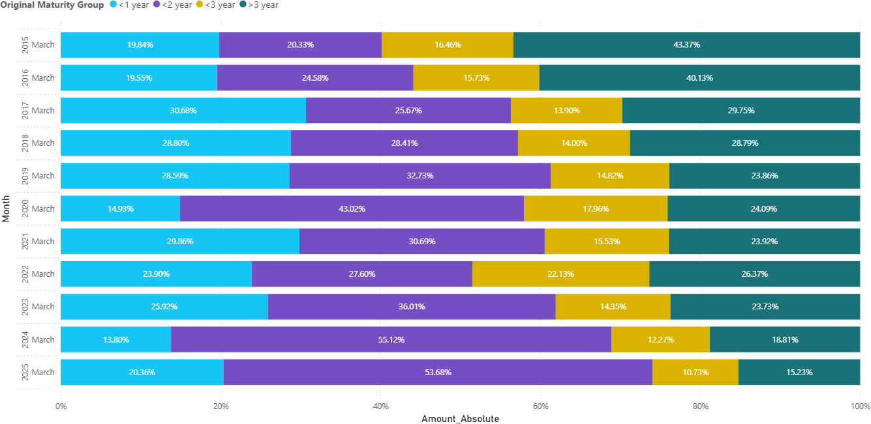

Figure 14: Original Maturity for the month of March throughout the years

Residual Maturity Decomposition
Remaining maturity, also referred to as residual maturity, represents the time left until the contractual maturity of a deposit as on the reporting date. In the context of Non-Resident Deposits (NRDs), residual maturity is a critical indicator of liquidity risk, rollover pressure, and the short-term stability of external liabilities in the banking system. Unlike original maturity, which captures depositor intent at the time of deposit creation, remaining maturity evolves dynamically over time and reflects both depositor behavior and banks’ balance sheet adjustments. As per the NRD–CSR reporting framework, remaining maturity is classified into six codes (1 to 6). For analytical clarity, maturity codes 1 and 2 are clubbed and classified as less than one year (< 1 year), code 3 as less than two years (< 2 years), code 4 as less than three years (<3 years), code 5 as more than three years (>3 years), while code 6 is treated as unallocated, primarily applicable to savings, current, and unclaimed accounts where residual maturity cannot be determined.
Figure 15 is a March-wise remaining maturity distribution from 2015 to 2025 reveals a pronounced and persistent dominance of short-term deposits, particularly those with residual maturity of less than one year. In March 2015, deposits with remaining maturity below one year accounted for approximately 41.4 percent of total outstanding NRDs. This share increased sharply in subsequent years, reaching around 66.5 percent in March 2016 and remaining above 59 per cent for most of the period thereafter. The consistently high proportion of 1-year residual maturity reflects the mechanical ageing of term deposits, as well as periodic renewals and withdrawals that compress the maturity profile closer to the reporting date.
Deposits with residual maturity of less than two years form the second largest segment throughout the period under study. Their share generally fluctuates between 12 and 25 per cent, with a notable increase observed in the post-2022 period, reaching about 25.7 per cent by March 2025. This rise suggests a growing concentration of deposits in the near-term maturity bucket, which may be indicative of shorter rollover cycles and cautious depositor behavior amid changing global interest rate conditions.
The share of deposits with remaining maturity of less than three years remains relatively stable but modest, typically ranging between 8 and 16 per cent. A temporary increase is observed in March 2022, when the less than 3 years category rises to over 16 percent, possibly reflecting medium-term deposit renewals during a period of heightened uncertainty following the COVID-19 pandemic and global monetary tightening. However, this share declines again in subsequent years, indicating a reversion toward shorter tenors.
Deposits with remaining maturity exceeding three years constitute the smallest share across all years, declining steadily from about 15.2 percent in March 2015 to below 7 percent by March 2025. This downward trend signals a gradual reduction in long-dated external liabilities, implying lower long-term rollover risk but higher short-term liquidity sensitivity. The contraction of the 3-year bucket may also reflect depositor preference for flexibility and banks’ cautious liability management strategies in a volatile global financial environment.
Overall, the remaining maturity profile underscores a structural tilt toward short-term maturities in India’s non-resident deposit base. While this enhances depositor liquidity and responsiveness to interest rate movements, it also increases the banking system’s exposure to sudden withdrawals and rollover risks. From a policy perspective, the predominance of deposits with residual maturity below one year highlights the importance of maintaining adequate foreign exchange liquidity buffers, closely monitoring external funding conditions, and calibrating interest rate incentives to encourage longer-term deposit retention. The residual maturity analysis thus provides valuable insights into the evolving risk characteristics of non-resident deposits and complements the original maturity perspective in assessing external sector stability.

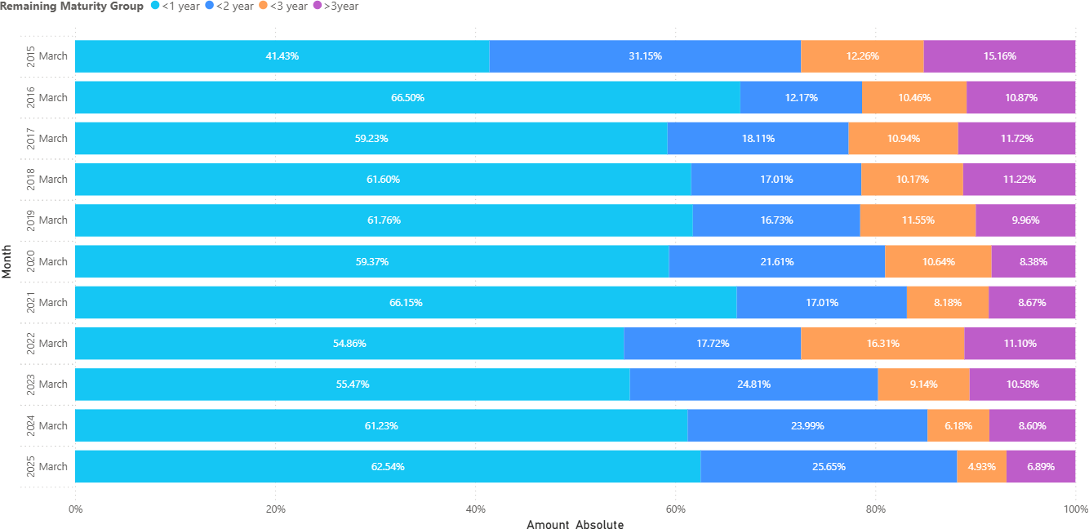

Figure 15: Remaining Maturity for the month of March throughout the years

Currency Decomposition
Figure 16 presents the currency-wise distribution of closing balances (CB) of Foreign Currency Non-Resident (FCNR) deposits for the month of August, disaggregated across the top five permitted currencies are US Dollar (USD), British Pound (GBP), Euro (EUR), Japanese Yen (JPY), and Australian Dollar (AUD). Under the Non-Resident Deposits Comprehensive Single Return (NRD-CSR) framework, closing balance represents the outstanding stock of FCNR deposits at the end of the reference month, after accounting for all inflows and outflows during the period, and is reported currency-wise for each freely convertible currency allowed under FCNR(B) regulations.
A key feature of the August FCNR closing balance profile is the overwhelming dominance of the US Dollar (USD), which consistently accounts for well over three-fourths of total FCNR balances, with shares exceeding 80 per cent in several years. This pronounced concentration reflects the USD’s role as the primary global reserve and transaction currency, as well as the strong preference of non-resident depositors for holding foreign currency deposits in USD to mitigate exchange-rate risk and enhance international liquidity. The persistence of USD dominance over time indicates a structurally embedded currency preference rather than a short-term cyclical phenomenon.
The British Pound (GBP) and Euro (EUR) constitute the second tier of currencies in FCNR deposits, though their shares remain significantly lower than that of USD. The chart indicates that GBP and EUR balances typically account for mid-single to low-double digit shares, with some inter-temporal variation. These fluctuations may be attributed to changing interest rate differentials be- tween India and the respective currency areas, as well as movements in exchange rates that affect depositor preferences at the margin. Nonetheless, the continued presence of GBP and EUR highlights the importance of Europe based non-resident Indians in FCNR mobilization.
The Japanese Yen (JPY) and Australian Dollar (AUD) together form a small but stable component of FCNR closing balances. Their relatively limited shares reflect narrower depositor bases and more specialized use cases, often linked to region-specific employment patterns or portfolio diversification strategies. Despite their small contribution, the consistent reporting of JPY and AUD balances underscores the multi-currency nature of FCNR deposits and the breadth of currency options available to non-resident depositors under the regulatory framework.
From a risk and policy perspective, the high degree of currency concentration in USD has important implications for banks’ balance sheet management. While USD dominance simplifies liquidity management and hedging strategies due to deep and liquid global USD markets, it also exposes banks to currency specific shocks, such as abrupt changes in US monetary policy or global dollar liquidity conditions. The presence of secondary currencies like GBP and EUR provides some degree of diversification, but their relatively small shares limit their mitigating impact.
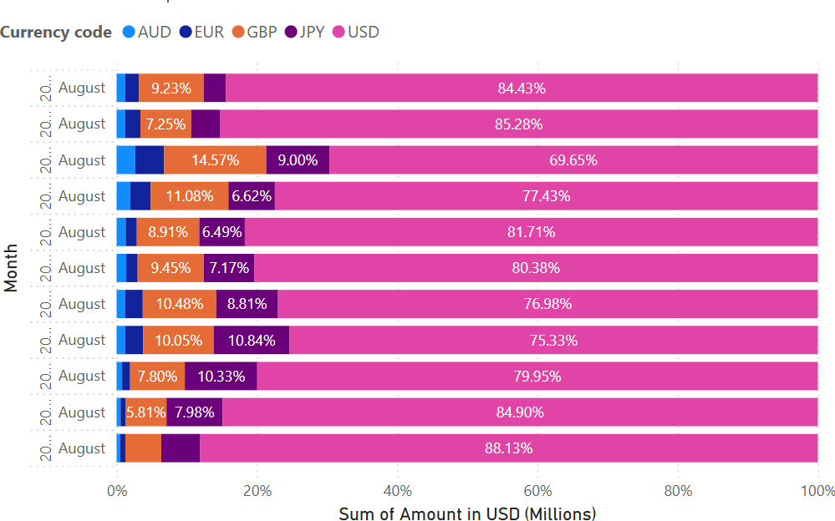
Overall, the August currency-wise FCNR closing balance profile reveals a structurally stable but highly concentrated currency composition, with USD serving as the anchor currency for non-resident foreign currency deposits. Continuous monitoring of this composition through the NRD-CSR framework is essential for assessing currency risk exposure, designing hedging strategies, and evaluating the resilience of FCNR deposits under varying global financial conditions.

Figure 16: Closing Balance (USD) of the Top 5 Currencies

Figure 17 presents the currency-wise distribution of inflows into Foreign Currency Non-Resident (FCNR) deposits for the month of August, disaggregated across the top five permitted foreign currencies are US Dollar (USD), British Pound (GBP), Euro (EUR), Japanese Yen (JPY), and Swiss Franc (CHF). The analysis is based on inflow related record types reported under the Non-Resident Deposits Comprehensive Single Return (NRD-CSR) framework, which classifies FCNR inflows into fresh inflows from abroad (FI), interest reinvested (IR), and amounts renewed or transferred from other accounts (PR), and reports them currency-wise for each reporting period.
A dominant and persistent feature of the August inflow profile is the overwhelming predominance of the US Dollar (USD). Across the years shown in the chart, USD inflows consistently account for the largest share, often exceeding 80 percent and rising above 90 percent in recent years. This strong concentration reflects the USD’s role as the principal international reserve and transaction currency, as well as the preference of non-resident depositors to place foreign currency deposits in USD to minimize exchange-rate risk and ensure global liquidity. The increasing USD share in later years suggests a structural shift towards greater currency concentration rather than a transient cyclical movement.
The British Pound (GBP) and Euro (EUR) form the second tier of FCNR inflow currencies, though their shares remain significantly lower than USD. The chart indicates that GBP and EUR inflows typically account for mid-single to low double digit shares, with noticeable inter-temporal variation. These fluctuations may be linked to changes in interest rate differentials between India and the respective currency areas, as well as exchange rate movements that influence depositor incentives at the margin. Periods of higher GBP or EUR shares are likely associated with relative yield advantages or increased participation by Europe-based non-resident Indians.
The Japanese Yen (JPY) and Swiss Franc (CHF) represent a small but persistent component of FCNR inflows. Their relatively modest shares reflect narrower depositor bases and more specialized usage, often related to employment or financial linkages with specific regions. Despite their limited contribution, the continued presence of these currencies highlights the multi-currency design of the FCNR scheme and the regulatory provision allowing deposits in a range of freely convertible currencies.
From a policy and risk-management perspective, the high and rising concentration of FCNR inflows in USD has important implications. While USD dominance simplifies liquidity management and hedging due to deep global dollar markets, it also increases banks’ exposure to currency-specific shocks, particularly shifts in US monetary policy or global dollar liquidity conditions. The declining relative shares of non-USD currencies imply reduced natural diversification within the FCNR portfolio, heightening the importance of active currency risk management.
Overall, the August currency-wise inflow profile for FCNR deposits reveals a structurally stable but increasingly concentrated pattern, with USD emerging as the anchor currency for new foreign currency inflows. Continuous monitoring of this composition through the NRD-CSR framework is essential for assessing currency concentration risk, understanding depositor behavior in response to global financial conditions, and evaluating the resilience of FCNR deposits as a component of India’s external funding base.

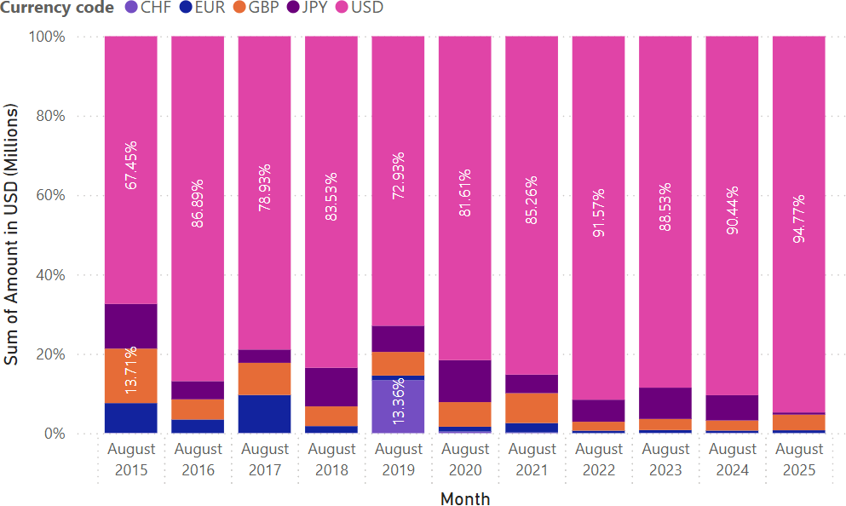

Figure 17: Inflows of the Top 5 Currencies (USD)

The currency-wise analysis of outflows from Foreign Currency Non-Resident (FCNR) deposits during the month of August, as presented in the chart, provides important insights into the withdrawal behavior, maturity dynamics, and currency preferences of non-resident depositors. The analysis is based on outflow-related record-type codes reported under the Non-Resident Deposits Comprehensive Single Return (NRD-CSR) system, namely principal remitted abroad (PA), interest remitted abroad (IA), principal remitted locally (PL), interest remitted locally (IL), local withdrawals (LW), and transfers to other accounts including renewals (TR), expressed in USD terms for comparability.
A striking feature of the August outflow composition is the overwhelming dominance of the US dollar (USD) across all years under review. Figure 18 shows that USD-denominated outflows consistently account for more than three-fourths of total FCNR outflows, with the share rising further in recent years and exceeding 90 per cent by August 2024–2025. This pattern reflects the structural preference for USD as the principal currency for FCNR deposits, driven by its role as the global reserve currency, lower exchange rate risk, and its widespread use in international trade and financial transactions. Consequently, most maturities, renewals, and repatriations under FCNR accounts are executed in USD.
Outflows in other major currencies GBP, EUR, JPY, and AUD remain comparatively limited and show a declining or marginal share over time. The GBP and EUR segments, while visible in earlier years, exhibit a gradual reduction in their proportional contribution to total outflows. This trend is indicative of a gradual consolidation of FCNR deposits into USD-denominated instruments, possibly reflecting both depositor risk preferences and banks’ product offerings. JPY denominated outflows show episodic spikes in certain years, which may be associated with currency-specific interest rate differentials or the unwinding of legacy FCNR positions, but these remain modest in magnitude relative to USD.
The temporal evolution of the outflow structure also reveals important behavioral insights. Periods marked by elevated USD outflows often coincide with maturity bunching, portfolio rebalancing, or renewals and transfers (TR), rather than abrupt capital flight. This interpretation is consistent with NRD-CSR validation rules, under which FCNR closing balances are mechanically linked to opening balances, inflows, and outflows on a currency-wise basis. The dominance of USD outflows therefore does not necessarily signal stress but rather reflects the normal lifecycle of FCNR deposits.
From a policy and stability perspective, the concentration of FCNR outflows in USD has dual implications. On the one hand, it enhances transparency and ease of monitoring, as currency risk is largely concentrated in a single denomination. On the other hand, it increases sensitivity to global USD liquidity conditions, US monetary policy cycles, and exchange rate movements. Sudden shifts in interest rate differentials or global risk sentiment could amplify USD outflows, thereby affecting banks’ foreign currency liquidity management.
In summary, the August outflow profile of FCNR deposits underscores the structural predominance of the USD, the diminishing role of alternative currencies, and the maturity-driven nature of withdrawals. These findings highlight the importance of continuous currency wise monitoring under the NRD-CSR framework to assess external sector resilience, manage foreign currency liquidity risks, and design calibrated policy responses aimed at maintaining the stability of non-resident deposit flows.

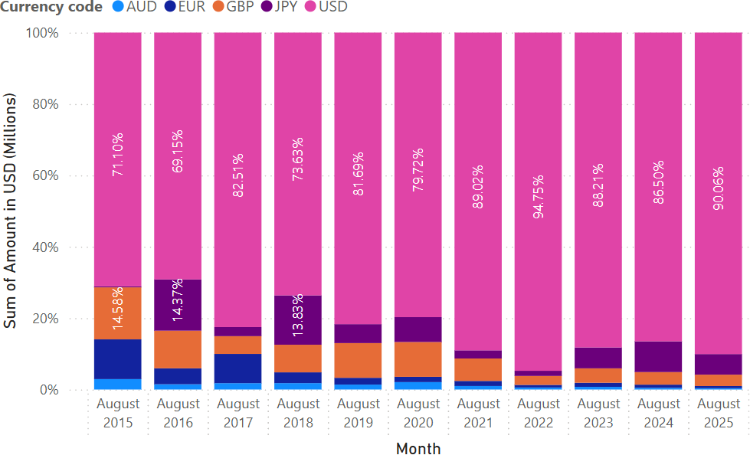

Figure 18: Outflows of the Top 5 Currencies (USD)

Conclusion and Policy Implications

Conclusion
This study provides a comprehensive analysis of India’s non-resident deposit landscape using granular monthly data reported under the Non-Resident Deposits Comprehensive Single Return (NRD-CSR) framework for the period 2015–2025. By examining inflows, outflows, balances, bank-wise distribution, country composition, maturity profiles, and currency denomination, the paper offers an integrated view of the structure and dynamics of non-resident deposits in the Indian banking system.
The analysis reveals that Non-Resident External (NRE/NRER) deposits constitute the dominant share of non-resident balances, reflecting strong depositor preference for fully repatriable, INR-denominated instruments. FCNR(B) deposits emerge as the most volatile segment, exhibiting sensitivity to global interest rate cycles, exchange rate expectations, and external shocks most notably during periods such as 2016–17. NRO deposits, while smaller in share, show a gradual increase over time, indicating growing domestic engagement of non-residents through income retention and local transactions.
Flow analysis indicates that renewals and transfers (PR/TR) dominate both inflows and outflows, underscoring that the sustainability of non-resident deposits depends more on rollover behavior than on continuous fresh inflows. Fresh inflows from abroad play a secondary but important role, while outright repatriation of principal remains relatively contained. This structure suggests that fluctuations in non-resident deposits are driven primarily by maturity management decisions rather than abrupt capital exits.
Country-wise decomposition highlights the continued dominance of Gulf corridors, particularly the UAE, in both inflows and outstanding balances, reflecting long-standing remittance and deposit linkages. At the same time, a clear and sustained rise in the contribution of the United States points to a gradual reorientation of India’s non-resident deposit base towards advanced economies. This shift increases the sensitivity of deposits to global monetary policy conditions and financial market developments in these jurisdictions.
The maturity analysis provides important insights into liquidity and rollover risk. While original maturity distributions show a meaningful presence of long- term deposits, the residual maturity profile is heavily skewed toward less than one year, especially at financial year-end (March). This compression reflects the mechanical ageing of deposits and frequent renewals, implying elevated short- term rollover exposure despite longer original tenors.
Currency-wise analysis particularly for FCNR(B) deposits shows overwhelming dominance of the US dollar, with other currencies playing a marginal and declining role. This concentration exposes the banking system to USD- centric currency risk, even as it simplifies liquidity management.
At the institutional level, the study finds a high concentration of non-resident deposits among a small set of large public and private sector banks, with private sector banks gaining prominence due to superior digital infrastructure and targeted NRI services. This concentration amplifies the systemic importance of leading banks in transmitting global shocks through the non-resident deposit channel.
Overall, the findings confirm that India’s non-resident deposit base is structurally stable but cyclically sensitive, with stability anchored in renewals and institutional concentration, and vulnerability arising from short residual maturities, FCNR volatility, and geographic concentration.

Policy Implications
The empirical findings of this study carry several important policy implications for regulators, policymakers, and banking institutions.
First, the dominance of renewals and short residual maturities highlights the need for enhanced monitoring of rollover risk. Regulators should place greater emphasis on residual maturity indicators alongside original maturity when assessing liquidity risk and stress scenarios related to non-resident deposits.
Second, the cyclical sensitivity of FCNR(B) deposits calls for calibrated policy tools during periods of global financial stress. Temporary incentives, interest rate flexibility, or macroprudential buffers may be warranted to smooth volatility in foreign currency deposits and mitigate sudden withdrawal pressures.
Third, the growing role of advanced economies such as the United States in both inflows and balances implies increased exposure to global monetary tightening cycles. Policymakers should incorporate country-wise concentration metrics into external vulnerability assessments and stress-testing frameworks.
Fourth, the strong concentration of deposits among a few large banks necessitates institution specific supervision. Large deposit-holding banks should be subject to enhanced disclosure, stress testing, and contingency planning related to NRI deposit withdrawals.
Fifth, the USD-heavy currency composition of FCNR(B) deposits suggests a need to monitor currency concentration risk closely. Encouraging diversification where feasible could reduce systemic exposure to single-currency shocks. Finally, the study underscores the analytical strength of the NRD-CSR framework itself. The richness of the dataset allows regulators to move beyond aggregate indicators and adopt a more granular, forward-looking approach to external sector monitoring. Continued strengthening of data quality, validation, and analytical use of NRD-CSR returns will be essential for informed policy formulation.
In conclusion, non-resident deposits remain a vital and largely stable source of funding for the Indian banking system. However, their evolving maturity, currency, and country composition necessitates continuous, granular monitoring to safeguard liquidity, financial stability, and external resilience.

References
[1] Reserve Bank of India, Non-Resident Deposits – Comprehensive Single Return (NRD-CSR), August 07, 2013, Centralised Information Management System (CIMS), Reserve Bank of India.

