1. **Update refrigerator product price to 800.**

**Sol:-**

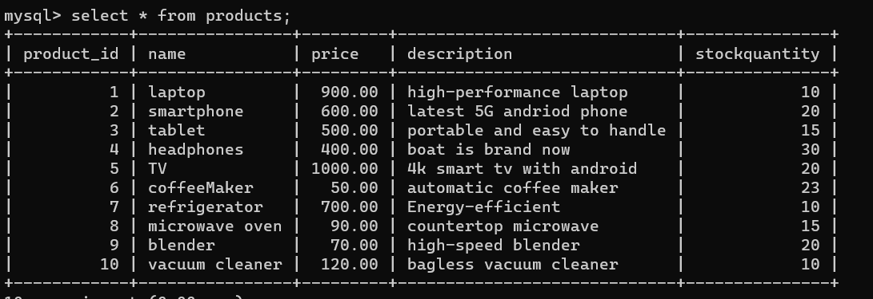

1. **Remove all cart items for a specific customer.**

1. **Retrieve Products Priced Below $100.**

**Sol:-**

1. **Find Products with Stock Quantity Greater Than 5.**

**Sol:- I am taking stock quantity grater than 10 because my all products stock quantity is greater than 5..**

1. **Retrieve Orders with Total Amount Between $500 and $1000.**

**Sol:-**

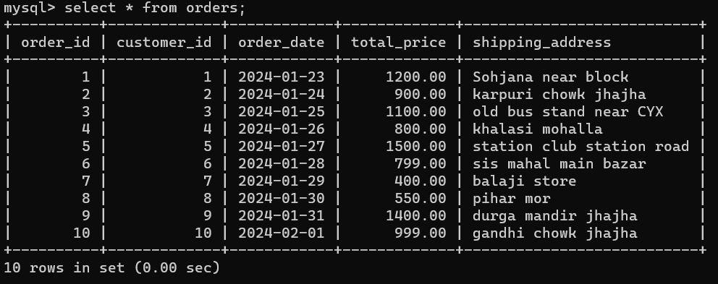

1. **Find Products which name end with letter ‘r’**.

**Sol:-**

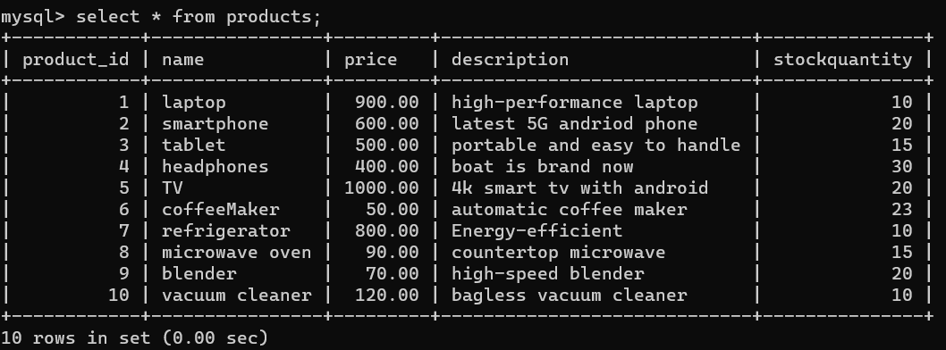

1. **Retrieve Cart Items for Customer 5.**

**Sol:-**

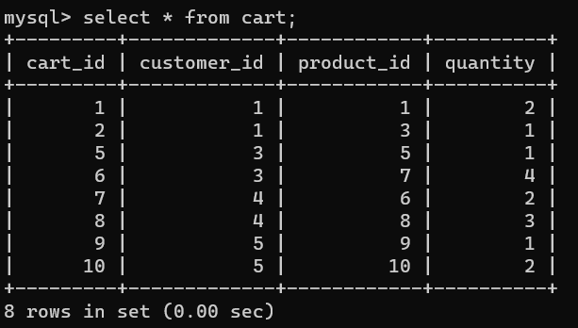

1. **Find Customers Who Placed Orders in 2023**

**Sol:-**

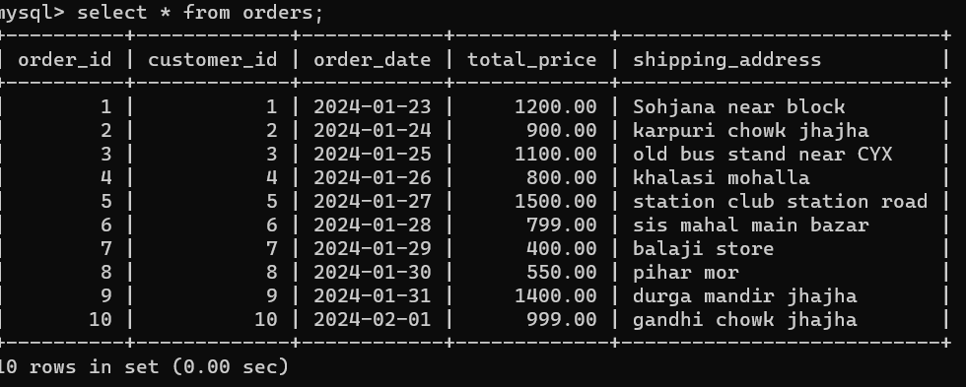

1. **Determine the Minimum Stock Quantity for Each Product Category**.

**Sol:-**

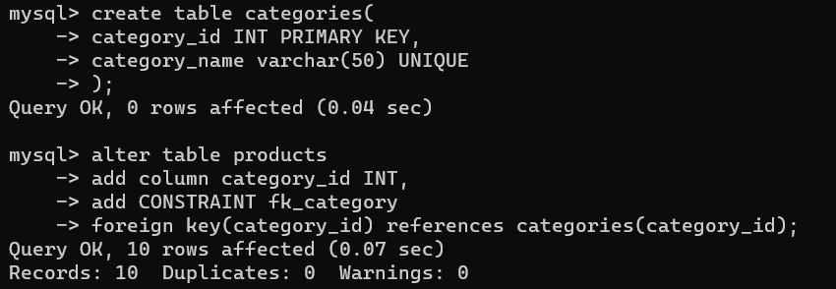

1. **Calculate the Total Amount Spent by Each Customer**.

Sol:-

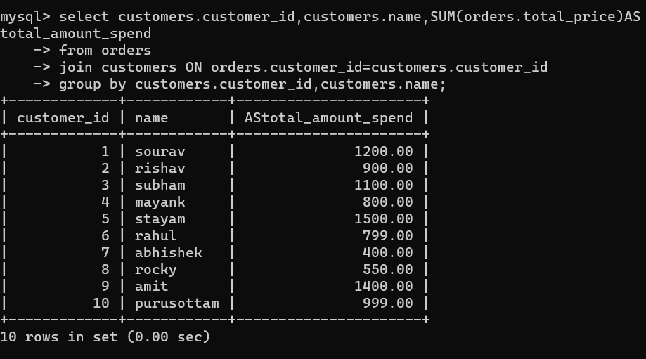

1. **Find the Average Order Amount for Each Customer.**

**Sol:-**

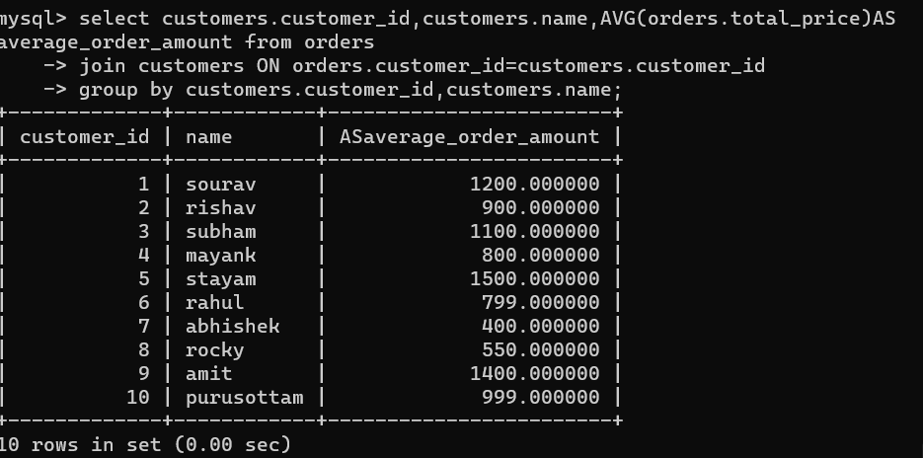

1. **Count the Number of Orders Placed by Each Customer**

**Sol:-**

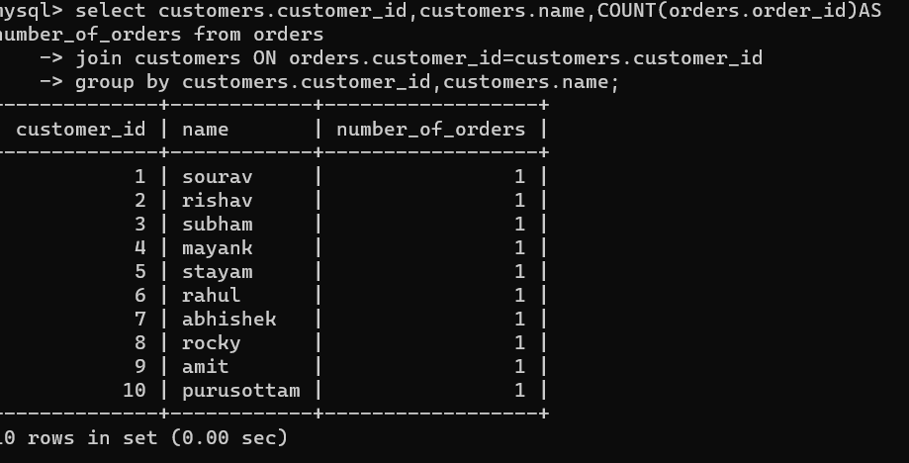

1. **Find the Maximum Order Amount for Each Customer.**

**Sol:-**

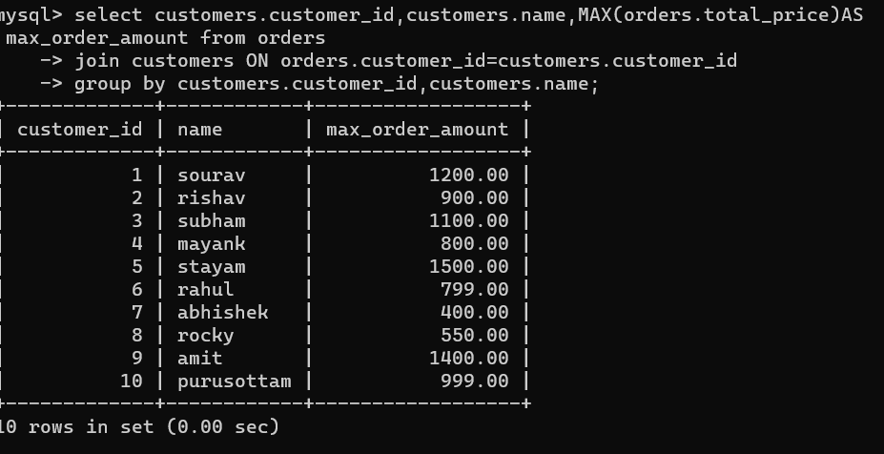

1. **Get Customers Who Placed Orders Totaling Over $1000.**

**Sol:-**

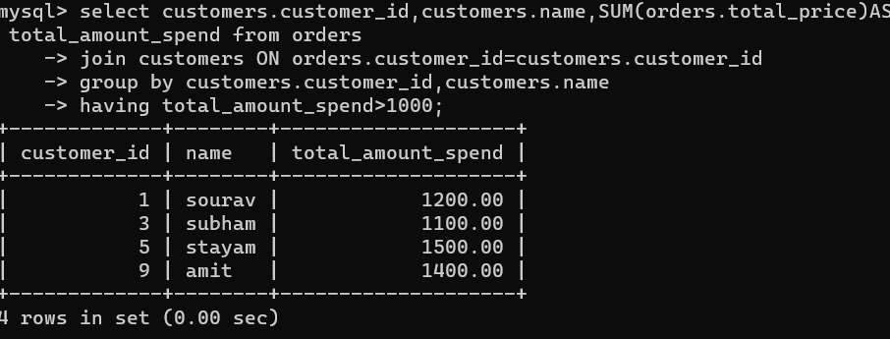

1. **Subquery to Find Products Not in the Cart.**

**Sol:-**

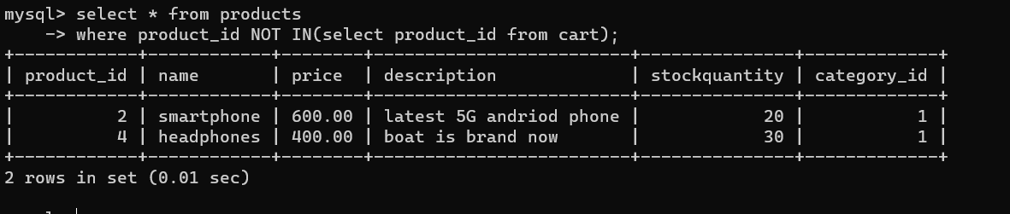

1. **Subquery to Find Customers Who Haven't Placed Orders**

**Sol:-**

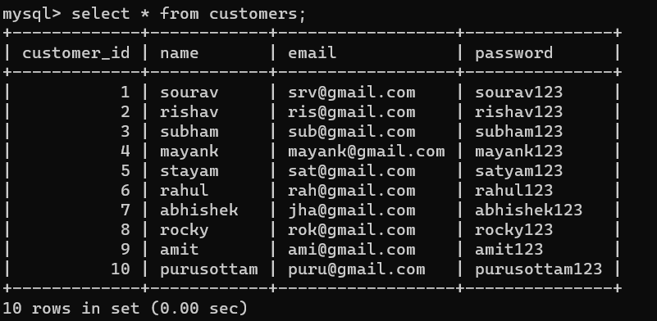

1. **Subquery to Calculate the Percentage of Total Revenue for a Product**.

**Sol:-percentage=(amount/total amount*100)**

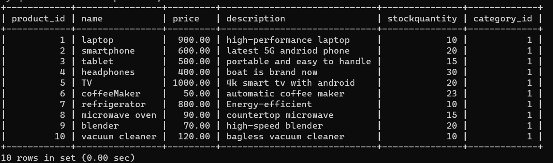

1. **Subquery to Find Products with Low Stock.**

**Sol:-here, low stocks means less then the average stock quantity**

1. **Subquery to Find Customers Who Placed High-Value Orders**

**Sol:-**



