**Tasks 1: Database Design:**

**1. Create the database named "TicketBookingSystem"**

**2. Write SQL scripts to create the mentioned tables with appropriate data types, constraints, and relationships. • Venu • Event • Customers • Booking**

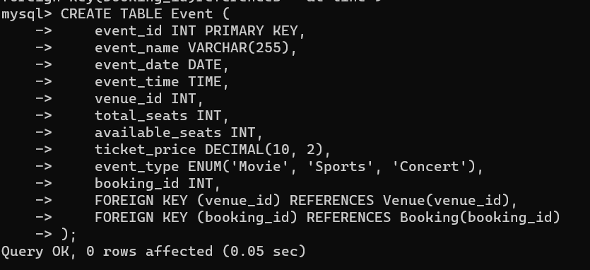

**3. Create an ERD (Entity Relationship Diagram) for the database**

**4. Create appropriate Primary Key and Foreign Key constraints for referential integrity**.

**Tasks 2: Select, Where, Between, AND, LIKE:**

1. **Write a SQL query to insert at least 10 sample records into each table**

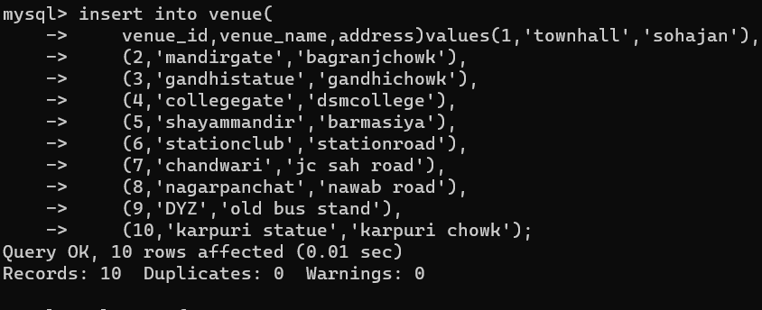

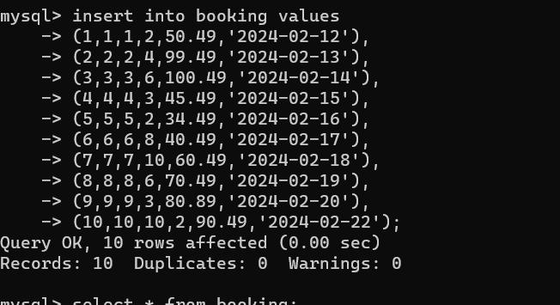

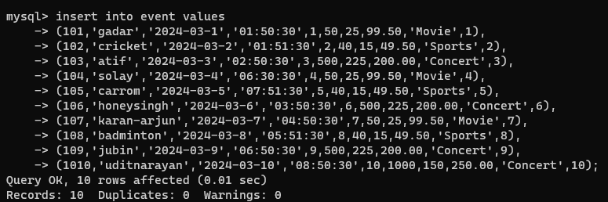

1. **Write a SQL query to list all Events.**

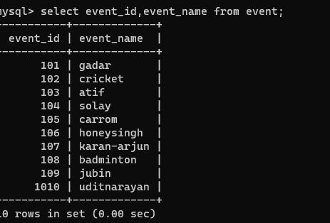

1. **Write a SQL query to select events with available tickets.**

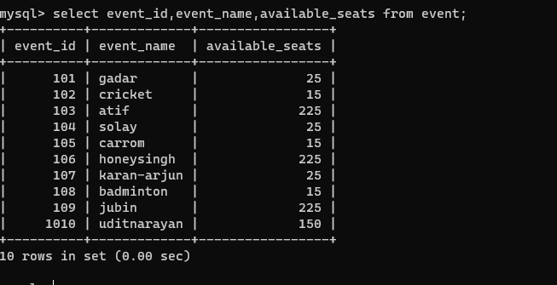

**4. Write a SQL query to select events name partial match with ‘cup’**

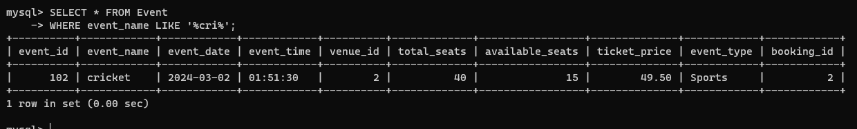

**5.Write a SQL query to select events with ticket price range is between 1000 to 2500.**

**I have taken range of price between 50 to 300…**

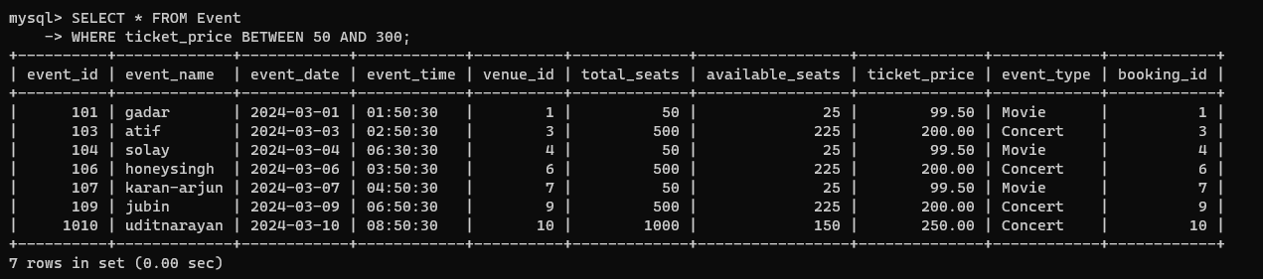

**6. Write a SQL query to retrieve events with dates falling within a specific range.**

**7. Write a SQL query to retrieve events with available tickets that also have "Concert" in their name**.

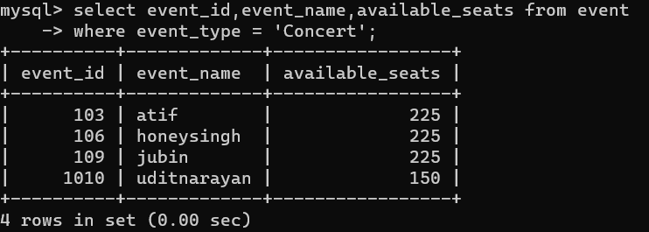

**8. Write a SQL query to retrieve users in batches of 5, starting from the 6th user**

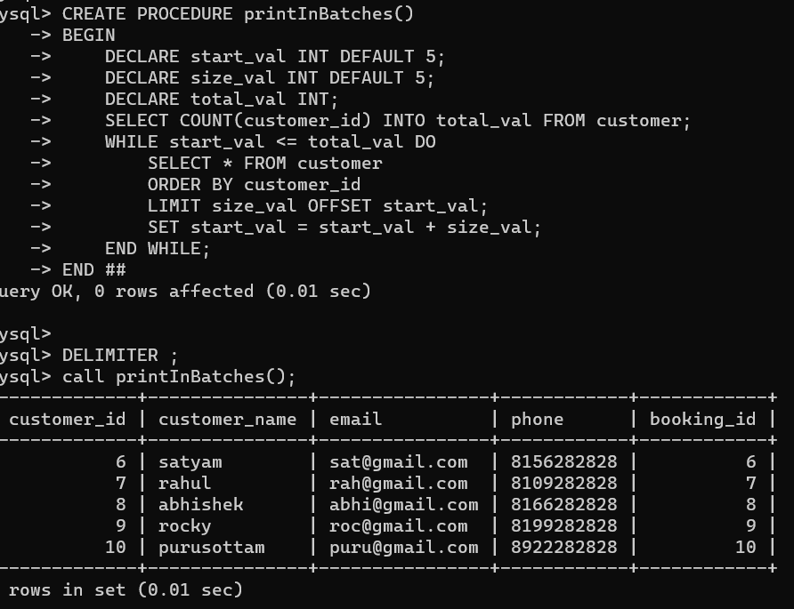

**9. Write a SQL query to retrieve bookings details contains booked no of ticket more than 4.**

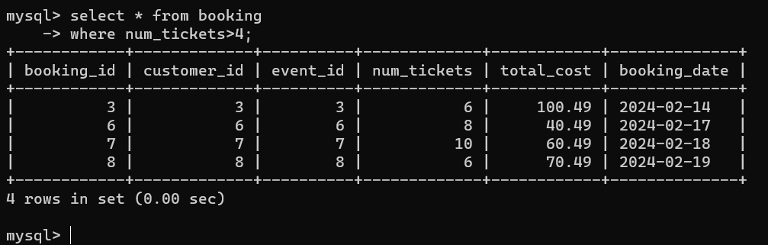

**10. Write a SQL query to retrieve customer information whose phone number end with ‘000’**

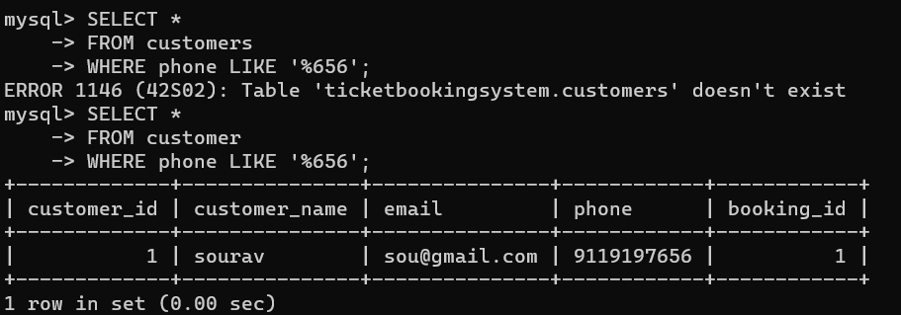

**11. Write a SQL query to retrieve the events in order whose seat capacity more than 15000.**

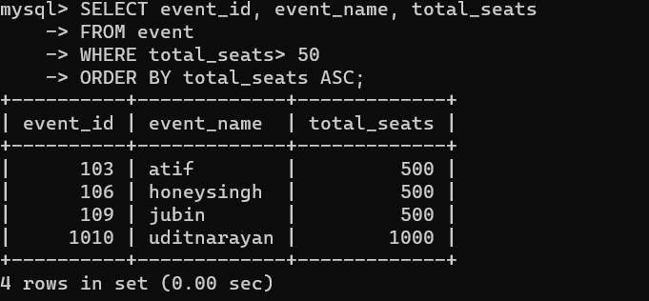

**12. Write a SQL query to select events name not start with ‘x’, ‘y’, ‘z’**

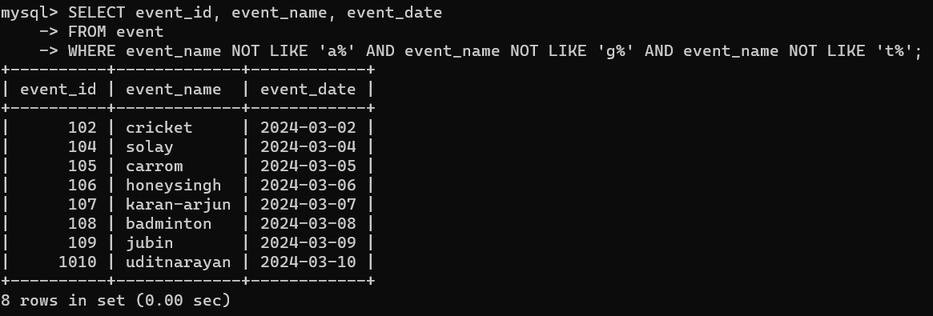

**Tasks 3: Aggregate functions, Having, Order By, GroupBy and Joins:**

1. **Write a SQL query to List Events and Their Average Ticket Prices**

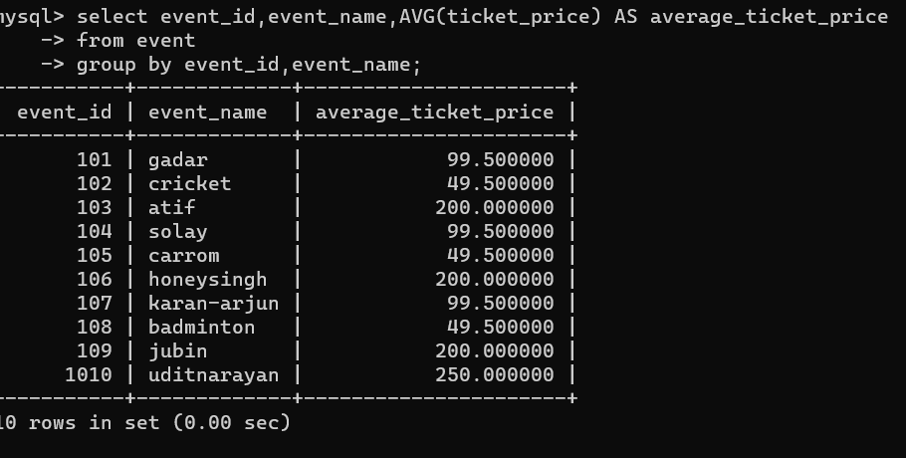

1. **Write a SQL query to Calculate the Total Revenue Generated by Events**

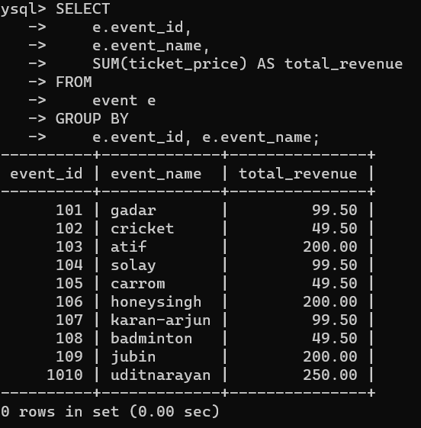

1. **Write a SQL query to find the event with the highest ticket sales**

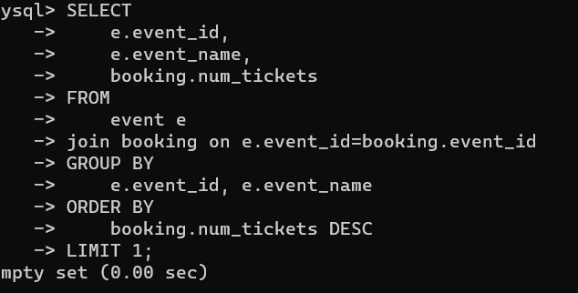

1. **Write a SQL query to Calculate the Total Number of Tickets Sold for Each Event.**

5. Write a SQL query to Find Events with No Ticket Sales.

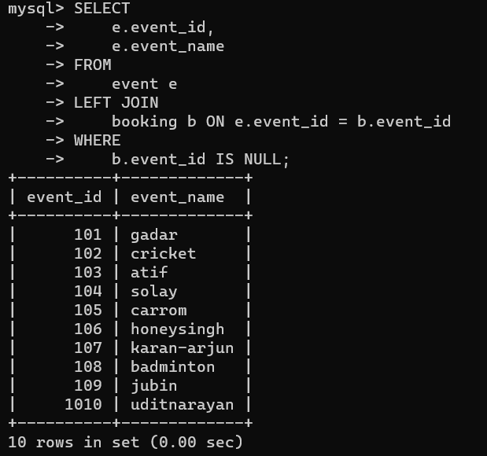

**6.Write a SQL query to Find the User Who Has Booked the Most Tickets**.

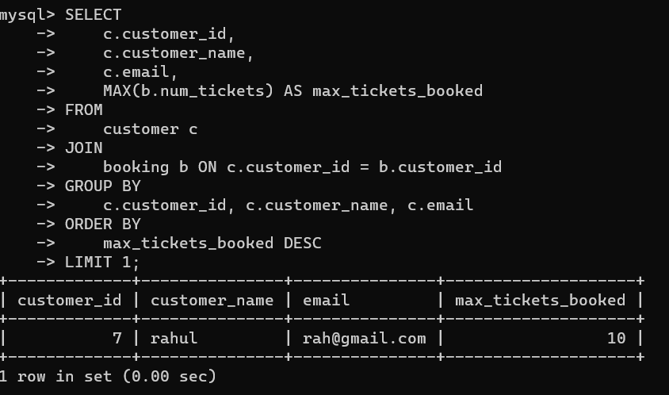

**7.Write a SQL query to List Events and the total number of tickets sold for each month**.

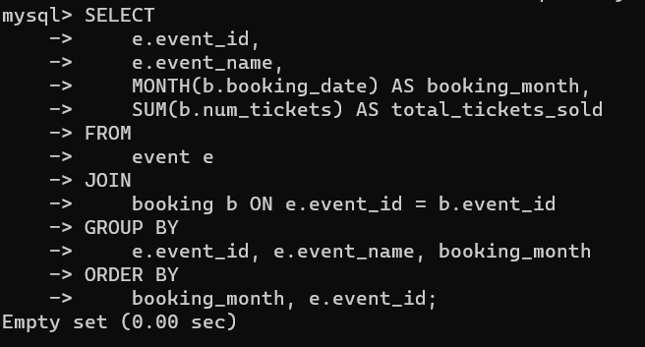

**8. Write a SQL query to calculate the average Ticket Price for Events in Each Venue.**

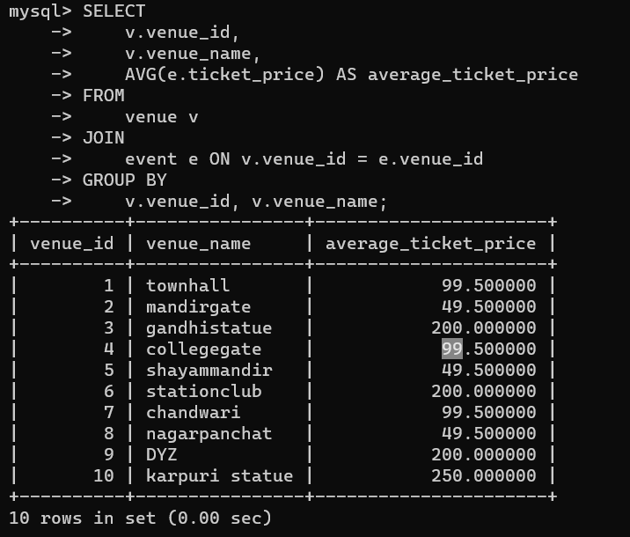

**9. Write a SQL query to calculate the total Number of Tickets Sold for Each Event Type**

**10. Write a SQL query to calculate the total Revenue Generated by Events in Each Year**.

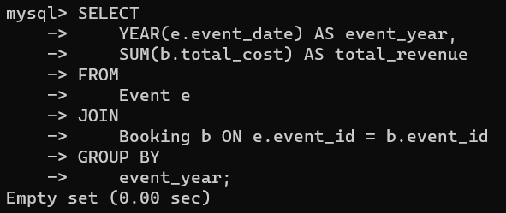

**11. Write a SQL query to list users who have booked tickets for multiple event**

**12. Write a SQL query to calculate the Total Revenue Generated by Events for Each**

**Costumer**

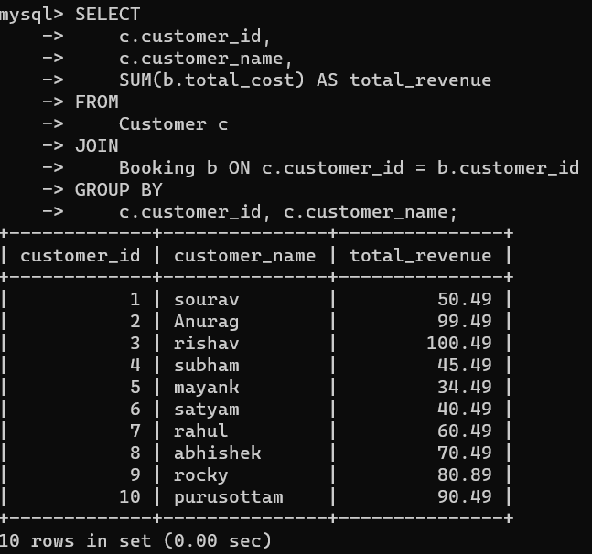

**13. Write a SQL query to calculate the Average Ticket Price for Events in Each Category and Venue.**

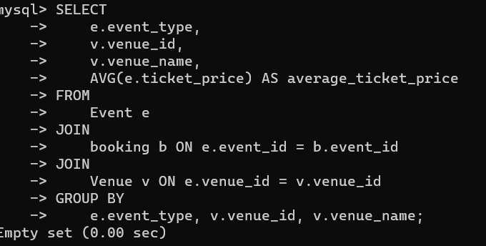

**14. Write a SQL query to list Users and the Total Number of Tickets They've Purchased in the Last 30 Days**

**Tasks 4: Subquery and its types**

1. **Calculate the Average Ticket Price for Events in Each Venue Using a Subquery**

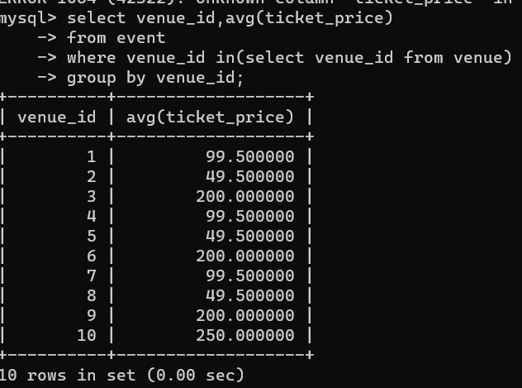

1. **Find Events with More Than 50% of Tickets Sold using subquery.**

1. **Calculate the Total Number of Tickets Sold for Each Event.**

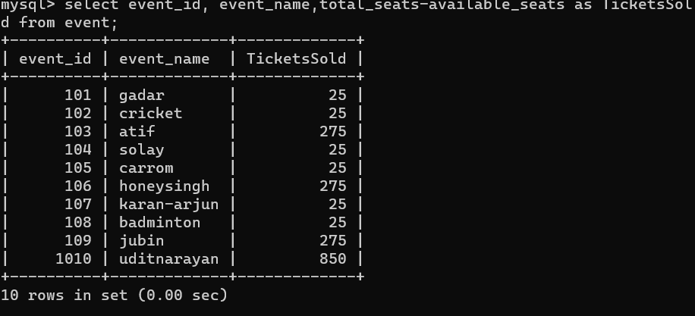

1. **Find Users Who Have Not Booked Any Tickets Using a NOT EXISTS Subquery.**

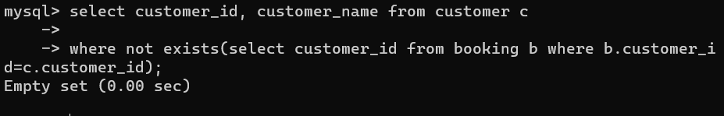

1. **List Events with No Ticket Sales Using a NOT IN Subquery.**

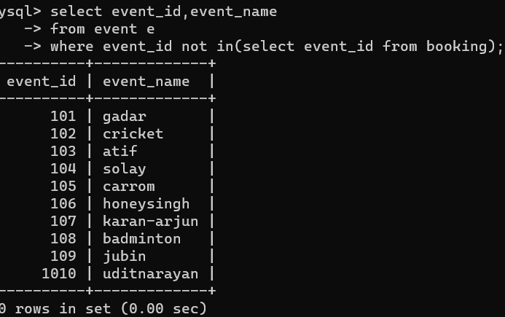

1. **Calculate the Total Number of Tickets Sold for Each Event Type Using a Subquery in the FROM Clause.**

1. **Find Events with Ticket Prices Higher Than the Average Ticket Price Using a Subquery in the WHERE Clause.**

**8.Calculate the Total Revenue Generated by Events for Each User Using a Correlated Subquery.**

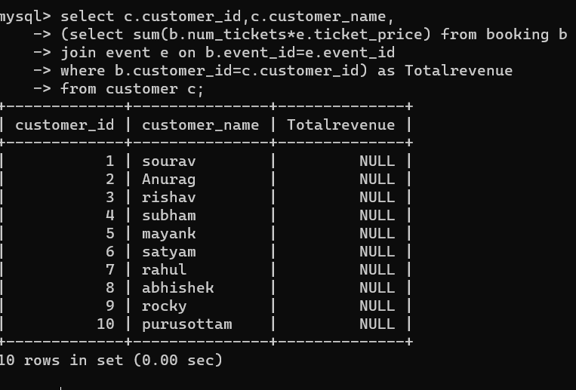

**9List Users Who Have Booked Tickets for Events in a Given Venue Using a Subquery in the WHERE Clause**

**10Calculate the Total Number of Tickets Sold for Each Event Category Using a Subquery with GROUP BY.**

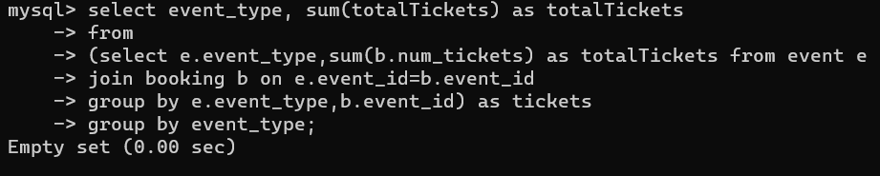

**11. Find Users Who Have Booked Tickets for Events in each Month Using a Subquery with DATE_FORMAT.**

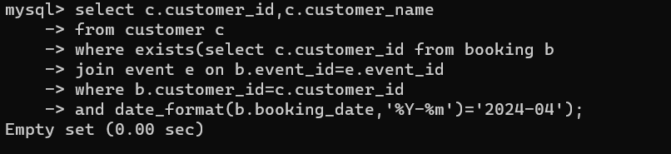

**12. Calculate the Average Ticket Price for Events in Each Venue Using a Subquery**

