PII Masking System – Technical Documentation

1. Purpose of This Document
This document describes the design, implementation, and usage of the PII Masking System built to protect sensitive information present in chatbot datasets. It explains why the system is required, what problem it solves, how it works internally, and how it should be used and extended. The goal is to provide a clear, complete, and audit-ready understanding of the solution for developers, reviewers, and stakeholders.
Following is a chart showing what exactly our purpose is:
PII Type | Example in Chatbot Data | Masked Output
Name | My name is Rahul Sharma | My name is [PERSON]
Email | Contact me at rahul@gmail.com | Contact me at [EMAIL]
Phone | Call me on +91 9876543210 | Call me on [PHONE]
Location | I live in Mumbai | I live in [GPE]
Organization | I work at Dentsu | I work at [ORG]
Date | My joining date is 12/06/2024 | My joining date is [DATE]

2. Current Scenario and Problem Statement
Modern chatbots continuously process large volumes of conversational data containing user queries and AI responses. These conversations often include Personally Identifiable Information (PII) such as:
Names, Email addresses, Phone numbers, Locations, Identification numbers, Dates and organizational references
Storing or reusing this data without protection introduces serious risks:
- Privacy violations
- Regulatory non-compliance (GDPR, DPDP, internal policies)
- Unsafe logging and analytics
- Potential data leakage during model training or debugging
Key Challenge
Chatbot data must remain useful for analytics, training, and debugging, while ensuring sensitive information is never exposed.

3. Solution Overview
The PII Masking System provides a config-driven, deterministic, and extensible mechanism to identify and mask sensitive entities in text data.
High-Level Capabilities
- Detect PII using Regex, NLP (spaCy NER), or both
- Replace detected entities with standardized masking tokens
- Produce structured metadata for auditing and validation
- Store masked outputs in timestamped result files

4. Inputs and Outputs

4.1 Input
Primary Input
- Raw text (user query or chatbot response)
Configuration Input (JSON)
- Masking strategy (regex, ner, hybrid)
- Regex patterns for deterministic PII
- NLP model selection
- Entity labels to mask

4.2 Output
Each masking operation returns a stable result dictionary containing:
- masked_text – Text with PII replaced by tokens
- entities – List of detected entities with type and span
- stats – Count of each masked entity type
Additionally, results are written to disk as timestamped JSON files for traceability.

5. Masking Strategies
The system supports three masking modes, selected entirely through configuration.
Mode | Uses Regex | Uses NLP (spaCy) | Accuracy | Speed | Determinism | Recommended Use
Regex | Yes | No | Medium | Very High | High | Logs, batch jobs
NER | No | Yes | Medium–High | Medium | Medium | Context-heavy text
Hybrid | Yes | Yes | High | High | High | Chatbots, datasets

5.1 Regex Mode

Detects structured PII using predefined patterns (e.g., emails, phone numbers). Fast, deterministic, and ideal for high-volume or log-based processing.

5.2 NER (spaCy) Mode

Uses NLP to identify contextual entities like names, locations, and organizations. Best suited for free-form, context-rich text but is language-dependent and probabilistic.

5.3 Hybrid Mode (Recommended)

Combines regex and NLP detection with deterministic overlap resolution. Delivers the best balance of precision, context awareness, and reliability.

6. Internal Processing Flow
At runtime, the system follows a predictable pipeline:
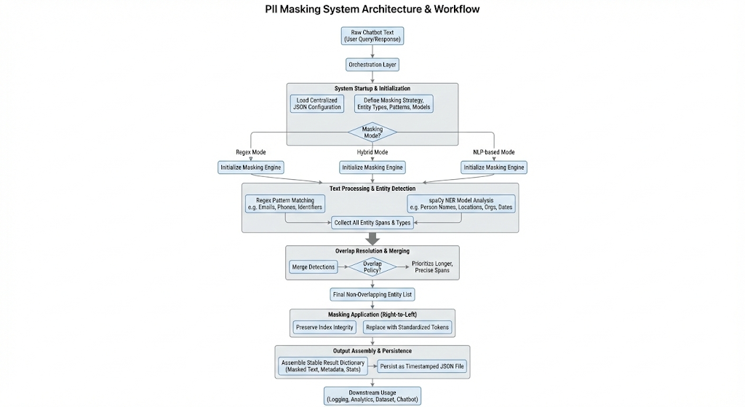

7. Overlap Resolution Logic
When multiple detection mechanisms identify overlapping portions of text, the system applies a deterministic overlap-resolution strategy to ensure consistent and predictable masking behavior. All detected entities are first ordered based on their position in the text, with entities starting earlier processed first and longer spans given higher priority. This ordering ensures that broader, more informative matches—such as a full email address or complete name—are preserved over shorter or partially overlapping detections. As the system iterates through the sorted entities, each candidate span is compared against those already accepted; if any overlap is detected, the candidate is discarded to prevent double masking or fragmented replacements. Through this approach, every character range in the original text is masked at most once, eliminating ambiguity and ensuring that the final masked output remains stable and identical regardless of the order in which different detectors originally identified the entities.

8. Why This Design Was Chosen
The system intentionally avoids over-engineering while maintaining production readiness.
Design Principles
- Configuration over code changes
- Deterministic behavior where possible
- Clear separation of orchestration and logic
- Stable function interfaces
- Minimal file count
This makes the system easy to review, extend, and integrate.

9. Integration Scenarios
Chatbot Integration
The masking engine can be placed directly before any chatbot or LLM call to ensure:
- No raw PII reaches external systems
- Logs remain privacy-safe
- Training data is sanitized
Dataset and XLSX Integration
The same masking logic can be applied row-wise to structured datasets (e.g., Excel files) without modification to core logic.

10. FAQ
10.1 Why not rely only on Regex?
Regex cannot reliably detect contextual entities such as names or locations in free-form text.
10.2 Why not rely only on NLP?
NLP models can misclassify structured data such as emails or IDs and are probabilistic by nature.
10.3 Why is hybrid mode preferred?
It combines the strengths of both approaches while minimizing their weaknesses.
10.4 Is the system deterministic?
Yes. Given the same input and configuration, the output will always be identical.
10.5 Can the masking behavior be changed without code changes?
Yes. All behavior is controlled via the configuration file.
10.6 Is this suitable for production use?
Yes. The system is designed for auditability, traceability, and controlled extensibility.

11. Summary
This PII Masking System provides a robust, configurable, and production-ready solution for protecting sensitive information in chatbot datasets. By combining deterministic patterns matching with contextual NLP detection and enforcing clean architectural practices, it ensures privacy without sacrificing usability or maintainability.

