Graph RAG – Knowledge Graph retrieval augmented generation

- Purpose:
The primary purpose of GraphRAG is to enable Large Language Models (LLMs) to deeply understand and reason across an entire dataset, rather than just retrieving isolated snippets of text based on keyword matches. While standard retrieval methods excel at fetching specific facts, they often fail to "connect the dots" between information scattered across different documents. GraphRAG solves this by converting unstructured text into a structured Knowledge Graph—mapping out entities (like people, concepts, or organizations) and the meaningful relationships between them. This structure allows the AI to perform complex tasks like multi-hop reasoning (tracing indirect connections between distinct events) and global summarization (synthesizing broad themes from thousands of documents), ensuring that the final answers are comprehensive, contextually aware, and grounded in the complete "web" of your data

Q.1 What Is Graph RAG?
Ans.: Retrieval-Augmented Generation (RAG)
RAG is an AI technique where a Large Language Model (LLM) doesn’t just hallucinate an answer — it retrieves relevant data from external sources (documents, DBs, etc.) and uses that to generate more accurate, context-grounded responses. You can think of it like:
“Search first, then generate.”
Knowledge Graph
A knowledge graph is structured data where entities (nodes) connect via relationships (edges). Think people, companies, products all linked in a graph that models real relations.
Graph RAG
Graph RAG extends RAG by using graph-structured data (knowledge graphs) as the retrieval foundation instead of flat text or vector similarity only. It augments LLMs with richly interconnected knowledge, allowing structured reasoning and deeper context than traditional RAG.
So:
Graph RAG = RAG + Knowledge Graphs
Enhancing how machines retrieve and interpret knowledge.

Q.2 Why Graph RAG? Use Cases & What Problem It Solves
Ans. = When to Use Graph RAG:
Graph RAG shines when you need:
- Complex relationship reasoning (e.g., “What customers impacted by both policy X and product defect Y?”)
- Highly structured domain knowledge (healthcare, legal, finance)
- Multi-hop inference — drawing insights across linked data
- Explainability — answers trace back to real graph relations
- Combining heterogeneous data (structured + unstructured)

When Not to Choose It
- Avoid Graph RAG if:
- Your data is small and simple (flat documents)
- You don’t need relational reasoning
- Low latency requirements where a vector RAG is enough
- You can’t build a graph schema easily
In such cases, standard vector RAG (text → embeddings → similarity search → LLM) may be simpler.

- Real-World Use Cases
- Enterprise Knowledge Assistants — answering deep company queries from structured docs
- Medical or Legal Q&A — interpreting relationships in large, linked datasets
- Customer 360 Applications — connecting user activity, purchases, feedback
- Scientific Research Repositories — linking publications, concepts, citations

- Core Components of Graph RAG
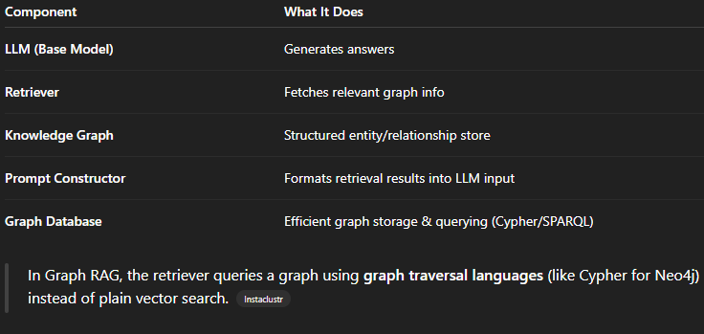
- Typical Graph RAG Workflow
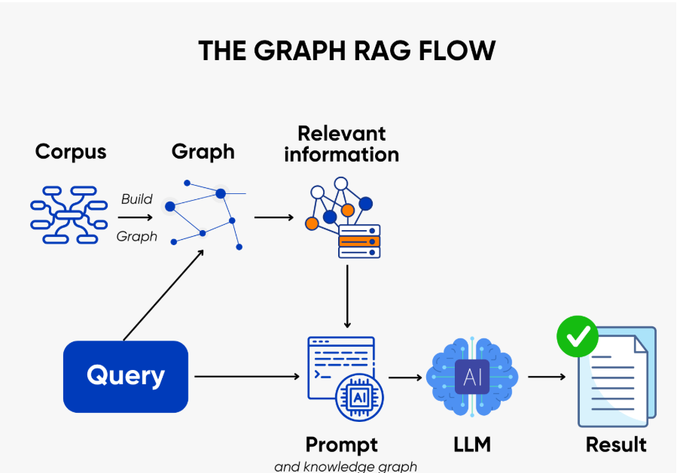
Here’s the flow — from raw data to AI generation:
1. Corpus
The process begins with a corpus—a collection of raw, unstructured data. This could be anything from articles to documents, and it’s where all the information will come from.
2. Building the graph
Next, this data is used to build a knowledge graph. Think of the graph as a network of connected points, where each point (or node) represents something specific, like a person or an event. The lines (or edges) that connect these points represent the relationships between them. This organized structure allows the model to “understand” the data in a more connected and meaningful way.
3. Relevant information retrieval
Once the graph is built, when a query is made, the system can quickly navigate through the graph to find related data. This is much smarter than just pulling a random paragraph of text—it retrieves information that’s actually connected and relevant to the question.
4. Query input
When you input a query, Graph RAG looks through the knowledge graph for pieces of information that are directly linked to your question. The model doesn’t just grab random text—it finds exactly what’s most relevant, based on the relationships in the graph.
5. Prompt and knowledge graph integration
The relevant data from the graph is then used to inform the model. This step is like giving the model a clearer, more detailed picture of what’s being asked, so it can generate a more accurate response.
6. LLM and result generation
With the help of the large language model (LLM), the system processes the query and the data from the graph to produce a well-informed, contextually aware answer. The result is a response that is both precise and grounded in relevant, structured knowledge.
7. Final result
Finally, the result is delivered: a more accurate, coherent response based on a combination of real-time information from the graph and the model’s understanding.

- Vector database vs Knowledge graph:
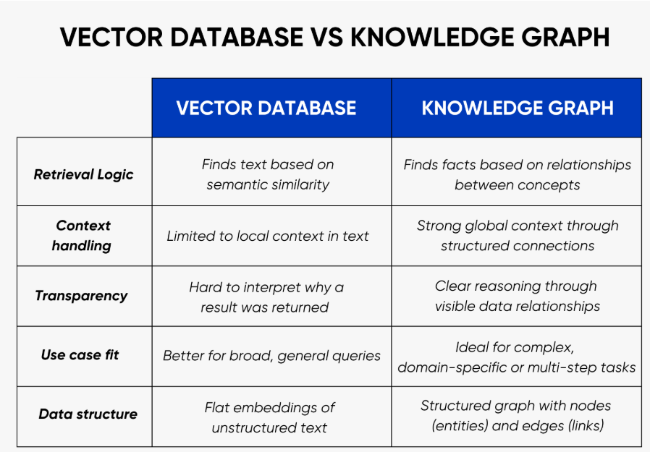
- Example where we can try hands on:

  - Building a graph using neo4j:
Graph RAG using LangChain (Simple Explanation)
Graph RAG can be built easily using LangChain’s graph utilities and an LLM, without manually designing nodes and relationships. The idea is simple: we give raw text to an LLM, the framework converts it into a graph, stores it in Neo4j, and later uses that graph for retrieval and reasoning.

How the Graph Is Built
Instead of manually writing Cypher queries, we let the framework do the heavy work.
We start with plain text such as documents, emails, or notes. This text may contain entities (people, companies, products) and relationships (works for, owns, related to).
LangChain uses an LLM to:
- Read the text
- Identify entities
- Identify relationships between entities
- Convert them into a structured graph format
This graph is then automatically stored in Neo4j.

Basic Flow
First, we connect LangChain to Neo4j.
Then we load the text we want to convert into a graph.
The LLM processes the text and extracts structured knowledge.
LangChain writes this knowledge as nodes and relationships into Neo4j.
At this point, the graph is ready.
Later, when a user asks a question, LangChain queries the graph, fetches the relevant connected entities, and sends that structured context to the LLM to generate an answer.

  - Using the Graph in RAG
Once the graph is created in Neo4j, it becomes the knowledge source for RAG.
Instead of searching plain text chunks like normal RAG, the system now retrieves connected entities and relationships from the graph. This gives more accurate and structured context to the LLM.
When a user asks a question, the flow is:
- The question is sent to the LLM.
- The LLM converts the question into a graph query.
- Neo4j returns the relevant nodes and relationships.
- That structured data is sent back to the LLM.
- The LLM generates a final answer using graph context.

This avoids hallucination and improves reasoning because the answer is grounded in real relationships stored in the graph.

  - What Happens Internally
The LLM does not directly answer from memory.
It first queries the graph, finds related entities like Company → Product, and then uses that retrieved structure as context to generate the answer.
This is what makes it Graph RAG instead of normal RAG.

- Example (Implementation):
  - Let us build a graph first
Here is the code snippet for it:
Let us create a graph first, here is the code snippet:

Before that, keep your .env file ready with required credentials

- First code snippet is for graph generation from a given content/data.
- Second code snippet is for the RAG which will use the generated graph.
