GraphQL learning documentation

Purpose: To learn and explore GraphQL, how it can be used in different suitable use cases, what are it’s pros and cons. A basic research on the topic for exploration.

- Big Picture: What EXACTLY is GraphQL?
- https://www.tutorialspoint.com/graphql/images/graphql_server_integrating_existing_systems.
- https://cdn.cosmicjs.com/7d9a6f90-7080-11eb-87a2-9be5e90cdf74-GraphQLvsRest.pngjpg
- https://www.netlify.com/v3/img/blog/graphql-post.png

GraphQL is a query language + runtime for APIs that lets clients ask for exactly the data they need, nothing more, nothing less.
In REST:
GET /users/123
GET /users/123/posts
GET /users/123/followers
Problems:
- Over-fetching (extra fields you don’t need)
- Under-fetching (need multiple requests)
- API shape decided by backend, not frontend

GraphQL mental model
In GraphQL:
POST /graphql
And the client decides the shape of the response.
One request, Exact fields, Nested data, Strong typing
REST = endpoint-centric
GraphQL = data-centric

Example query:
{
user(id: 123) {
name
}
}

GraphQL has 5 core concepts.
https://tailcall.run/images/graphql/graphql-schema-structure.png
https://www.datensen.com/blog/wp-content/uploads/2022/03/line-mode-simple-graphql.png

The GraphQL type system is a core part of the GraphQL specification that defines the structure, capabilities, and data shape of a GraphQL API. It acts as a contract between the client and the server, ensuring data consistency and enabling powerful developer tools like introspection and automatic type-checking.
The schema defines:
- What data exists
- What can be queried
- What can be modified
Example (GraphQL Schema Define Language):
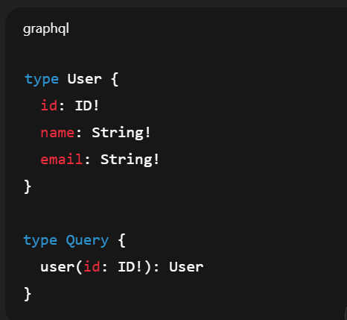
Query (READ operations)
Query = read-only data fetch
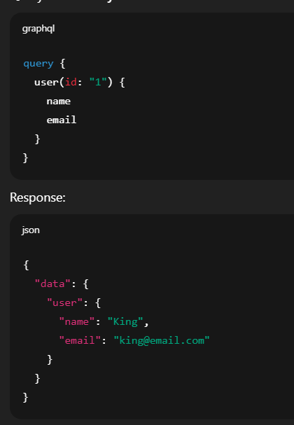
Mutation (WRITE operations)
Mutation = create/update/delete
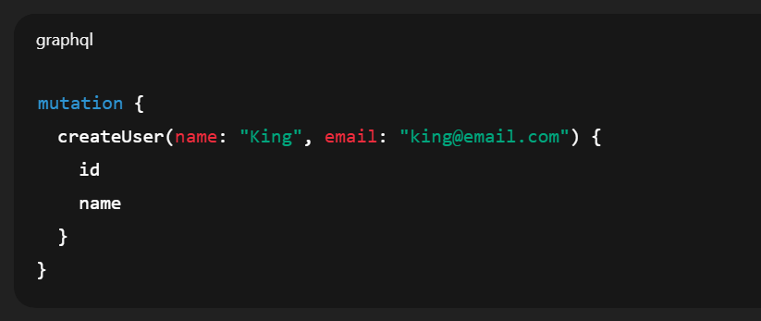
Resolver (THE MOST IMPORTANT PART)
Resolvers are the functions that actually fetch data.
GraphQL itself does not know databases, APIs, or logic.
Resolvers connect:
Query → Python function → DB / API / Logic
Type System (Why GraphQL feels “clean”)
Types:
- String
- Int
- Float
- Boolean
- ID
- Custom types
Modifiers:
- ! → non-null
- [] → list
Example:
posts: [Post!]!
Means:
- Always returns a list
- List contains no nulls
How GraphQL actually works (request lifecycle)
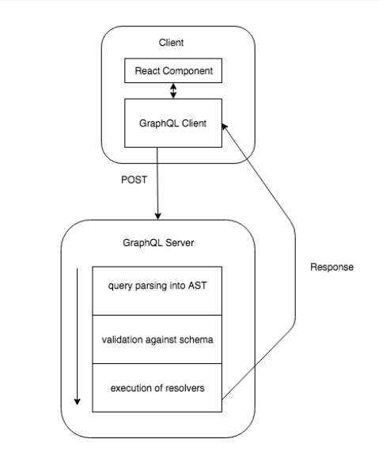
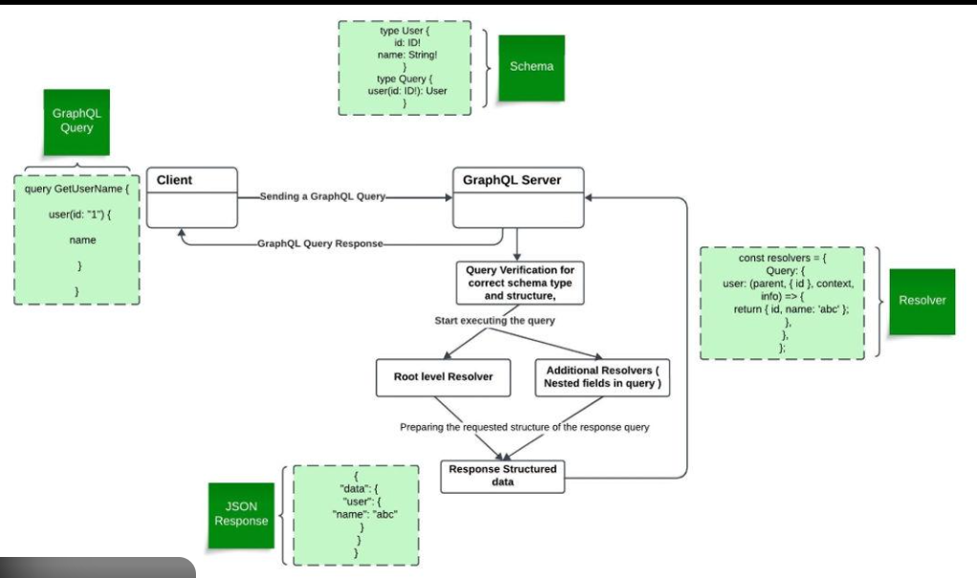

Step-by-step:
- Client sends GraphQL query
- GraphQL engine validates query against schema
- Engine calls resolvers
- Resolvers fetch data (DB, API, cache)
- GraphQL assembles response
- JSON returned
If query asks for invalid field → rejected before execution
Sample Code:
What is Ariadne? What backend are we using?

Backend Stack in example code
Layer | Technology | Role
Web Server | uvicorn | ASGI server
Web Framework | FastAPI | HTTP server, routing
GraphQL Engine | Ariadne | Parses GraphQL, validates, runs resolvers
Protocol | GraphQL | Query language over HTTP
So:
- FastAPI = normal Python backend framework
- Ariadne = GraphQL implementation library for Python
- uvicorn = runs the app
Ariadne is not a backend by itself.
It is a GraphQL execution engine that plugs into FastAPI.
Architecture flow:
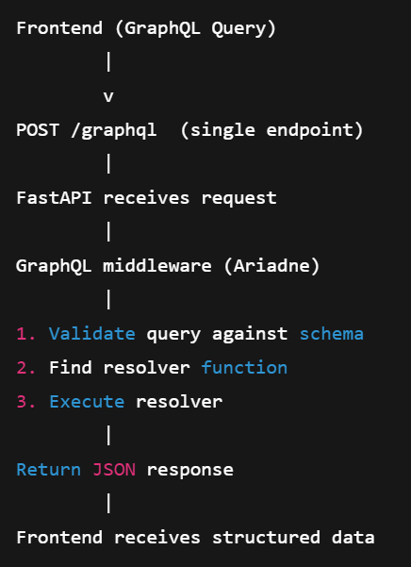

Example code:

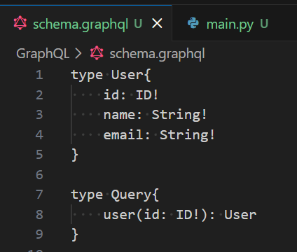
This says:
- Query root has a field user
- It takes argument id
- It returns a User object

What is .graphql file?
This is Schema Definition Language (SDL) file.
Meaning:
- There is a type User with 3 fields
- There is a query user(id) that returns a User
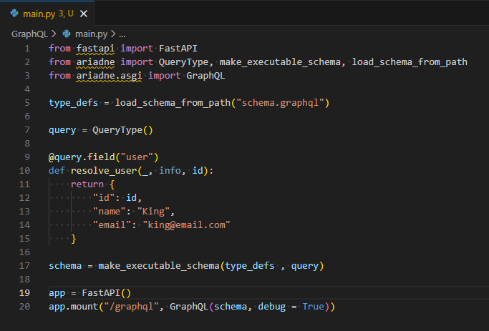
Concept:
- QueryType → maps GraphQL fields to Python functions
- make_executable_schema → binds schema + resolvers
- GraphQL → ASGI app to handle /graphql
query = QueryType() ->
This is the Query resolver registry.

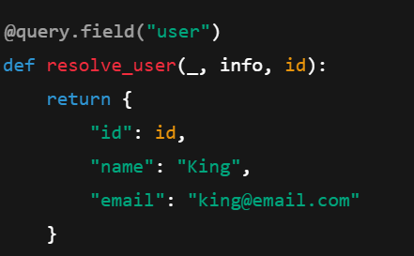
This means:
GraphQL | -> Python
Query.user | -> resolve_user()
Argument id | -> Python param id
Return User | -> Dict with matching keys
Important:
- GraphQL engine automatically maps:
  - dict keys → fields
  - only returns fields requested by client

schema = make_executable_schema(type_defs, query)
This creates:
Schema structure, Field → resolver mapping and Validation rules

Request → Execution → Response Flow (Detailed)
Client sends:
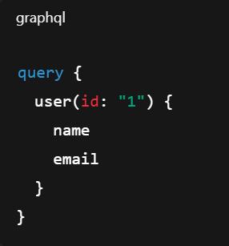
Flow:
- FastAPI receives POST /graphql
- Ariadne:
  - Parses query
  - Validates against schema
  - Finds resolver for Query.user
- Calls: resolve_user(_, info, id="1")
- Resolver returns full object:
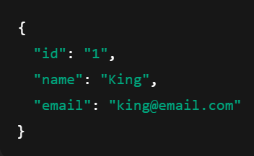
- GraphQL engine filters fields:

Client asked only:
- name
- email
So response becomes:
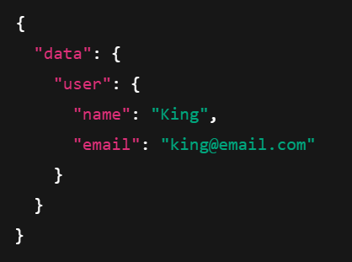

When to Use GraphQL
GraphQL is the ideal choice for scenarios where client flexibility and network performance are priorities:
- Complex, Nested Data Relationships: If your data is highly relational (e.g., fetching a user, their posts, comments on those posts, and the authors of those comments in one go), GraphQL can retrieve this in a single request, whereas REST might require multiple, costly network calls.
- Mobile and Low-Bandwidth Devices: Because clients specify exactly what data they need, GraphQL reduces payload size, conserving bandwidth and battery life on mobile devices.
- Frontend-Heavy Applications (Web/Mobile): When the UI changes frequently, frontend teams can update their queries to fetch new fields without waiting for backend teams to modify endpoints.
- Aggregating Multiple Data Sources: If you need to combine data from microservices, multiple databases, or third-party APIs into a single, cohesive view (e.g., a dashboard), GraphQL acts as a unified data layer.
- Real-Time Applications: Using GraphQL subscriptions, you can handle real-time data updates efficiently, similar to WebSockets.
- Rapid Prototyping: The schema-driven approach allows developers to mock data and iterate quickly on the frontend.
When Not to Use GraphQL
For many applications, the overhead of GraphQL is not justified by its benefits.
- Simple Applications/CRUD Services: If your application is a simple CRUD (Create, Read, Update, Delete) app with a straightforward, shallow data structure, RESTful APIs are simpler, faster to implement, and more suitable.
- Heavy Caching Requirements: REST relies on native HTTP caching (based on URLs), which is easy to set up. GraphQL typically runs over a single POST endpoint, requiring more complex, custom caching strategies.
- Limited Team Experience/Resources: The learning curve for GraphQL is steep, involving understanding schemas, resolvers, and SDL. If your team is already proficient in REST, the added complexity might not be worth it.
- File Uploads: While possible, file uploading is not a native strength of GraphQL, which is optimized for JSON data. RESTful APIs are generally better for file-heavy applications.
- Limited Server Power: GraphQL queries can be complex, and poorly structured queries can put heavy strain on the server, whereas REST provides more predictable server-side loads.
Common Use Cases for GraphQL
- Mobile Applications: (e.g., Facebook, Instagram, Shopify) for performance optimization.
- Social Media and News Feeds: To fetch nested, interrelated data (posts, likes, users) efficiently.
- Dashboards and Analytics Tools: To aggregate data from multiple backend services.
- Backend for Frontend (BFF): Using GraphQL to unify multiple legacy backend services into a single API for a web or mobile client.
- E-commerce Product Catalogs: To fetch detailed product information with varying nested attributes.

Quick comparison with REST API
Summary: GraphQL vs. REST
Feature | REST | GraphQL
Data Fetching | Fixed, often causes over/under-fetching | Flexible, clients ask for exact data
Endpoints | Multiple (e.g., /users, /posts) | Single (/graphql)
Versioning | Often requires /v1/, /v2/ | Versionless (add/deprecate fields)
Caching | Excellent (native HTTP) | Complex (requires custom strategies)
Learning Curve | Low | High

FAQs:
Q.1 What is Ariadne?
Answer:
Ariadne is a Python GraphQL library that implements the GraphQL execution engine.
It handles parsing, validation, execution of queries and maps schema fields to Python resolver functions.
It is framework-agnostic and integrates with ASGI frameworks like FastAPI.

Q.2 What backend are we using in example code?
We are using FastAPI as the HTTP/ASGI backend and mounting Ariadne as a GraphQL middleware at /graphql.
Uvicorn runs the ASGI server.

Q.3 What is .graphql file?
It is the Schema Definition Language (SDL) file that defines the GraphQL contract — types, queries, mutations, and relationships.
It acts as a strict API specification between frontend and backend.

Q.4 What exactly is happening in example code?
We define a schema, bind resolvers to schema fields using Ariadne, mount a single /graphql endpoint in FastAPI, and let the GraphQL engine dynamically resolve only the requested fields per query.
Where does DB come in? (Real backend version)
In real use case:
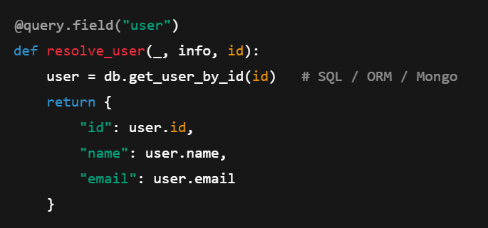

Some flow diagrams which help us to understand the layer of graphql between the application:
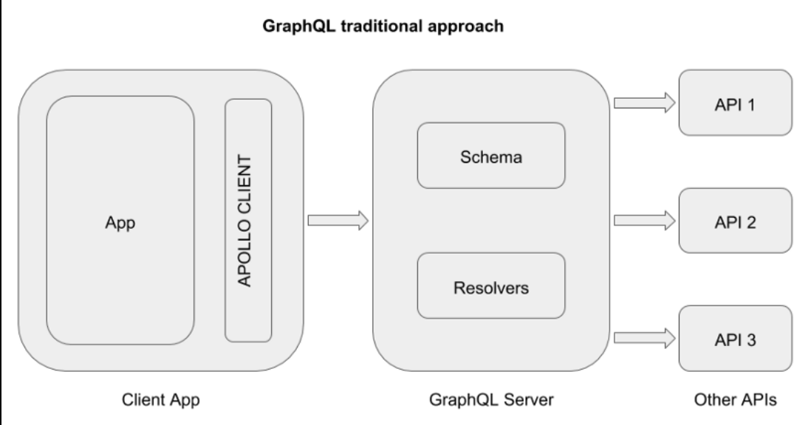

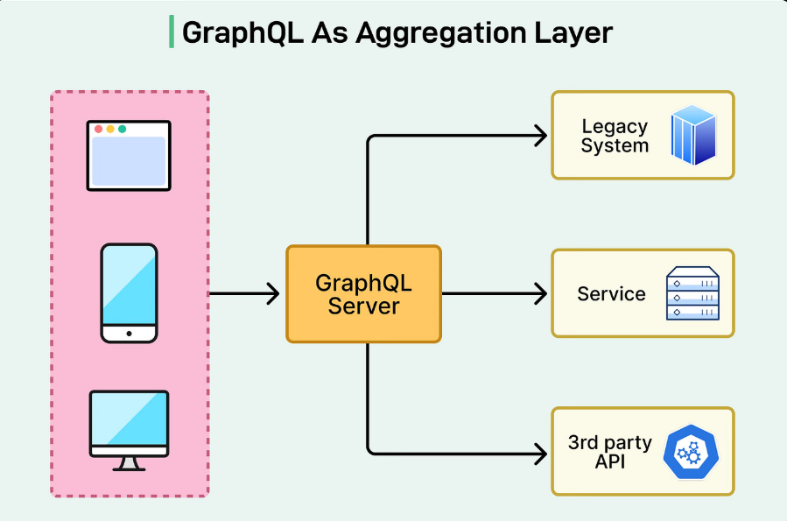

- Conclusion:

GraphQL is a way to build APIs where the client asks the server exactly what data it wants, and the server returns only that data, nothing extra and nothing missing. Instead of having many fixed endpoints like REST, GraphQL usually has a single endpoint and a schema that clearly defines what data is available and how it is connected. The client sends a query describing the shape of the data it needs, and GraphQL fetches and assembles that data for the response. This makes APIs more flexible, predictable, and efficient—especially when dealing with complex or nested data—while keeping a clear contract between the client and the server.
A simple example and use case of GraphQL can be seen in a social media or blog application. Suppose a screen needs to show a user’s name and the titles of their posts. With REST, the app usually has to call multiple endpoints like one to fetch the user details and another to fetch the user’s posts, and each response may contain many unnecessary fields. With GraphQL, the client sends a single query describing exactly what it needs—only the user’s name and the post titles—and the server responds with just that data in one request. This makes the app faster, reduces network usage, and avoids over-fetching or under-fetching data. GraphQL is especially useful in applications where different screens or clients (web, mobile) need different data shapes but want to use the same backend API efficiently.

LET US BUILD NOW A MINI PROJECT WHICH WILL SHOW A DEMONSTRATION OF GRAPHQL.
  - We will create 2 actions, first is read only (query) and second is creation of the data (mutation)
Code:
main.py:
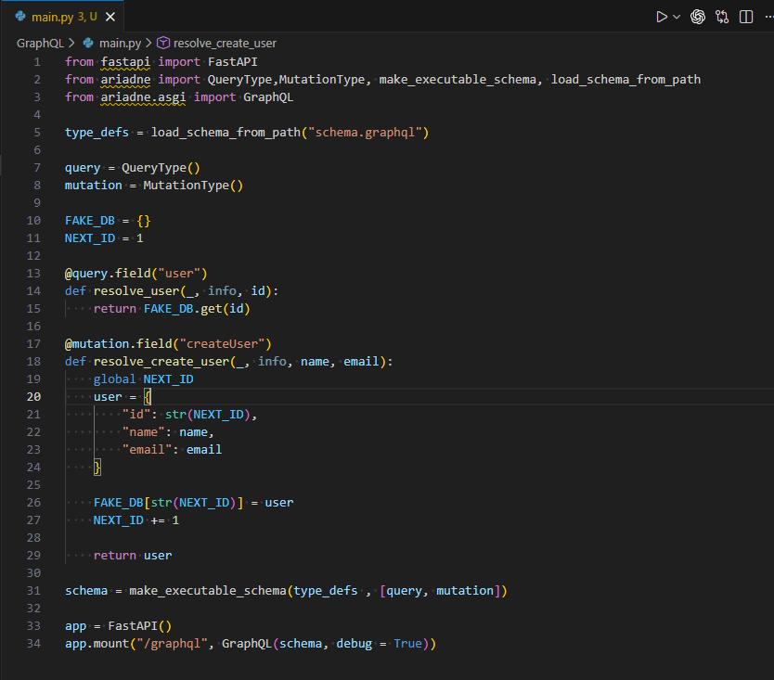

Schema.graphql:
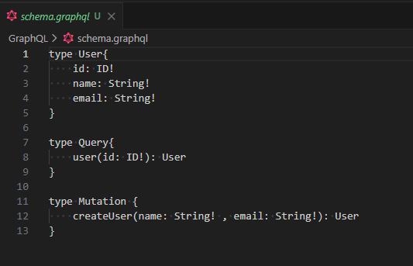

GraphQL User API (FastAPI + Ariadne)
This service exposes a simple GraphQL API using FastAPI and Ariadne with an in-memory data store.
- The GraphQL schema is defined in schema.graphql and loaded at runtime.
- QueryType handles read operations, allowing clients to fetch a user by id.
- MutationType handles write operations, allowing clients to create a new user by providing name and email.
- User data is stored in an in-memory dictionary (FAKE_DB) with auto-incremented IDs.
- Ariadne binds schema definitions to Python resolver functions and executes queries and mutations.
- The GraphQL API is mounted at /graphql with GraphiQL enabled for interactive testing.
Endpoint
POST /graphql

Supports:
- query user(id) – fetch a user
- mutation createUser(name, email) – create a new user

Output: mutation
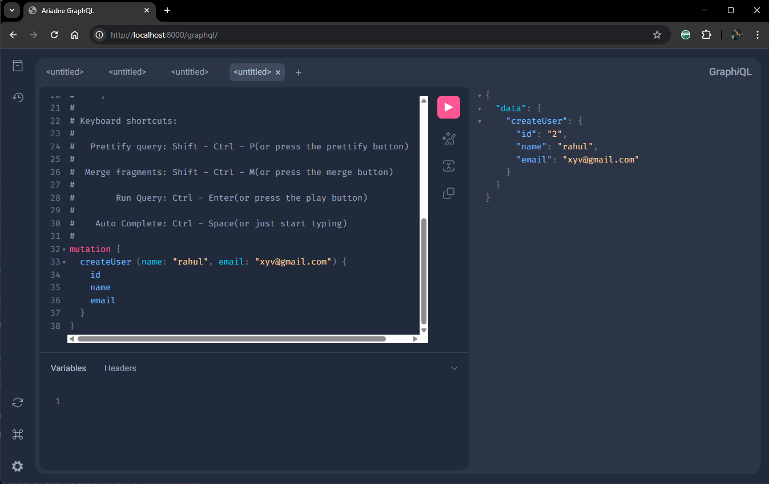
Output: Query (read only)
