1. 🏗️ High-Level Architecture: The "Big Picture"
Instead of a linear chatbot (User $\to$ Bot $\to$ Answer), we will build a Hub-and-Spoke Agentic System.
The Core Components:
- The Brain (Orchestrator): Manages the MCP state. It doesn't "think"; it routes traffic.
- The Knowledge Graph (GraphRAG): Your HR Policy Book converted into nodes (e.g., Node: Sick Leave) and edges (e.g., REQUIRES -> Medical Certificate).
- The Guard (PII Layer): Intercepts data before it leaves your secure environment.
- The Agents: Specialized workers (Planner, Retriever, Writer).
Architecture Flow Diagram
Code snippet
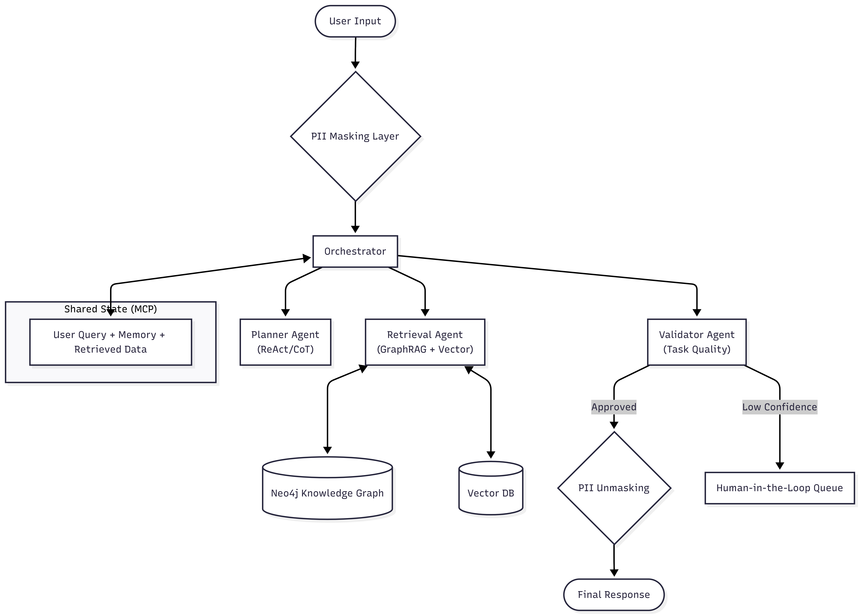

2. 🧠 The Knowledge Core: GraphRAG vs. Vector
Recommendation: Use a Hybrid Approach (GraphRAG).
- Why Graph? HR policies are highly relational.
  - Vector DB (Similarity): Good for "What is the policy?"
  - Graph DB (Structure): Essential for "If I take 3 days off, do I need a certificate?" (The graph explicitly links Sick Leave $\xrightarrow{requires}$ Certificate if days > 2).
- GraphQL Integration: Use GraphQL as the API layer for your agents to query the Neo4j database. It provides a strict schema so agents don't hallucinate Cypher queries.
📄 Chunking & Ingestion Strategy
This is where Task Quality begins. Garbage in, garbage out.
- RCTS (Recursive Character Text Splitter):
  - What it is: Splits text by size (e.g., 500 chars).
  - Verdict: Too crude for HR. It might split a policy rule in half.
- Semantic Chunking (Recommended):
  - What it is: Uses an embedding model to scan the document. When the "topic" shifts (e.g., from "Maternity Leave" to "Paternity Leave"), it creates a new chunk.
  - Implementation: Use LangChain's SemanticChunker.
- Structured RAG:
  - Don't just store text. Extract Entities (Policies, Roles, Documents) and Relations during ingestion.
  - Agentic Connection: An "Ingestion Agent" reads the chunk, extracts the rule, and updates the Graph.

3. 🛡️ Security & PII Masking (Entity Masking)
This must happen before data hits any external LLM.
- The Technique: Named Entity Recognition (NER).
- Workflow:
  - Input: "My name is Rohit and my employee ID is 12345."
  - Masking Layer (Presidio/Spacy): Detects PERSON and ID.
  - Transform: Replaces with tokens $\to$ "My name is <PERSON_1> and ID is <ID_1>."
  - Processing: Agents process the safe string.
  - Unmasking: Before showing the user, replace <PERSON_1> back to "Rohit" (if necessary for the UI, otherwise keep it masked for safety).

4. 🧩 Integrating the Complex Agentic Concepts
Here is how we map your advanced requirements to the architecture:
A. Planning (ReAct, CoT, ToT)
The Planner Agent is responsible for "Intent Preservation."
- ReAct (Reasoning + Acting): The agent thinks "To answer this, I first need to check the leave balance, THEN check the policy."
- CoT (Chain of Thought): The agent outputs its internal monologue into the MCP context. Structure: Thought: User asks for leave. Action: Query Graph.
- ToT (Tree of Thoughts): For complex cases (e.g., "Maternity leave extension with sick leave"), the Planner generates 3 possible paths and evaluates which is most compliant before proceeding.
B. Memory System (Short & Long Term)
- Short-Term (Session):
  - Storage: Redis or In-Memory List.
  - MCP: Passed in every prompt. "User previously said: 'I am tired'."
- Long-Term (Persistence):
  - Storage: The Graph itself.
  - Implementation: Create a User node in Neo4j. Link it to Topic nodes.
  - Query: MATCH (u:User {id: '123'})-[:INTERESTED_IN]->(t:Topic) RETURN t
  - Benefit: If user asks "How many days left?", the system checks the User node's metadata.
C. Tool Orchestration & Goal Decomposition
- Goal Decomposition: The Planner breaks "I want to go on vacation" into sub-tasks:
  - Check eligibility (Tool: GraphRetriever).
  - Check balance (Tool: HRIS_API).
  - Draft request (Tool: EmailDraft).
- Tool Orchestration: The Orchestrator calls the tools based on the Planner's list.
D. Self-Improving Agents & HITL
- Human-in-the-Loop (HITL):
  - If the Validator Agent calculates a confidence score $< 70\%$, the system pauses.
  - It routes the query to an HR Admin dashboard.
  - Admin answers manualy.
- Self-Improvement:
  - The Admin's correct answer is fed back into the Vector DB/Graph as a "Golden Example." Next time, the RAG retrieves this example.

5. 📝 Step-by-Step Implementation Plan
Phase 1: Data Foundation (The "Knowledge")
- Ingest HR Policy: Use Semantic Chunking to split the PDF/Doc.
- Build Graph: Use an LLM to extract nodes (Policies) and edges (Rules) from chunks. Load into Neo4j.
- Setup GraphQL: Expose the Neo4j data via a GraphQL endpoint.
Phase 2: The Core (MCP & Orchestrator)
- Define MCP Schema: Create the Python class that holds UserQuery, MaskedQuery, MemoryContext, Plan, and DraftAnswer.
- Build Orchestrator: A Python loop that passes this object between functions (Agents).
Phase 3: The Agents (Logic)
- Planner: Implement ReAct logic. "Given the user query, what steps do I need?"
- Retriever: The bridge between MCP and your Graph/Vector DB.
- Privacy: Implement the Microsoft Presidio (or similar) masking wrapper.
Phase 4: Persistence & Interface
- State Persistence: Save the MCP state to a JSON/Database after every turn (as per your coding rules).
- Chatbot UI: A simple frontend connecting to the Orchestrator API.
6. Example Workflow Trace
- User: "Can I take leave for my surgery?"
- PII Layer: "Can I take leave for my [MEDICAL_EVENT]?"
- Orchestrator: Initializes MCP. Fetches Memory (User is Full-Time).
- Planner (ReAct):
  - Thought: I need to find "Medical Leave" policies.
  - Action: Call GraphRetriever.
- Retriever (GraphRAG):
  - Query: MATCH (p:Policy)-[:COVERS]->(e:Event) WHERE e.name CONTAINS 'surgery' RETURN p
  - Result: Found "Sick Leave Policy" and "Hospitalization Benefit".
- Answer Agent: "Yes, under the Sick Leave Policy..."
- Validator: Checks against "Task Quality" rules (No hallucinations).
- Final Output: "Yes, you can take leave..."

The big plan:
This is a solid plan. We are moving from a theoretical architecture to a concrete execution roadmap.
Here is the strategy to address your specific points before we dive into the phases:
🧩 Strategic Clarifications
1. The "Two Graphs" & Vector DB Question: You don't necessarily need two separate databases. You need One Graph Database (Neo4j) that holds two distinct types of sub-graphs, plus One Vector Index.
- Sub-Graph A (Knowledge): The HR Policy nodes (Nodes: Policy, Rule, Document).
- Sub-Graph B (Memory/User): The User nodes (Nodes: User, Preference, PastInteraction).
- Vector DB: Stores the text embeddings of your policy chunks.
  - Usage: You use Vector to find the right node ("Find policies about 'Sick Leave'"), then you use Graph to traverse the logic ("Check what 'Sick Leave' requires").
2. GraphQL Decision: Verdict: Skip it for now.
- Why: While GraphQL is great, adding it now introduces a separate server layer that complicates the Python-centric Agent workflow.
- Alternative: We will build Python Tools (functions) that the Agents call directly. This keeps the architecture tighter and easier to debug in the early phases.

📂 Project Structure
Adhering to your strict coding rules (input, src, config, etc.).
Plaintext
hr_agentic_system/
├── config/
│ ├── app_config.json # Main settings (Models, Thresholds)
│ ├── secrets.env # API Keys (GitIgnored)
│ └── prompt_templates.json # Agent Prompts (System Instructions)
├── input/
│ ├── raw_docs/ # Place your HR Policy PDF/Docx here
│ ├── history/ # Session logs (Short-term memory)
│ └── graph_schema/ # Schema definitions for Neo4j
├── doc/
│ ├── architecture.mermaid # The flow diagram
│ ├── phase_tracker.md # Tracking Phase 1-4 progress
│ └── api_contracts.md # MCP Schema definitions
├── results/
│ ├── res/ # Final answers & logs with timestamps
│ ├── ingestion_logs/ # Logs from the Chunking/Graph build process
│ └── validation_reports/ # Quality checks from Validator Agent
├── src/
│ ├── __init__.py
│ ├── main_orchestrator.py # The "Brain" (Wrapper)
│ ├── mcp_schema.py # The Context Protocol Class
│ ├── ingestion/ # Phase 1: Data Pipeline
│ │ ├── chunking.py # Semantic & RCTS Chunking logic
│ │ ├── vector_store.py # Vector DB Connectors
│ │ └── graph_builder.py # Neo4j Node/Edge extraction
│ ├── agents/ # Phase 2 & 3: The Workers
│ │ ├── planner_agent.py # ReAct/CoT Logic
│ │ ├── retrieval_agent.py # Hybrid Search (Graph + Vector)
│ │ ├── writer_agent.py # Answer Generation
│ │ └── validator_agent.py # Phase 4: Quality & Hallucination Check
│ ├── memory/ # Phase 3: Memory Systems
│ │ ├── short_term.py # Session handling
│ │ └── long_term.py # User Graph interactions
│ └── security/ # Phase 4: PII
│ └── pii_masking.py # Presidio/NER logic
├── misc/
│ └── demo_images/
├── venv/
├── .gitignore
└── main.py # Entry point

🚀 Execution Roadmap: The 4 Phases
We will build this iteratively. Each phase adds a layer of intelligence.
🌑 Phase 1: The Knowledge Foundation (Data Pipeline)
Goal: Turn your HR Policy Book into a queryable "Hybrid Brain" (Vector + Graph). Focus: Ingestion, Chunking, Storage.
- Task 1.1 (Semantic Chunking): Implement the ingestion script. Instead of just cutting text every 500 characters (RCTS), we will use an embedding model to detect when the topic changes from "Leave" to "Insurance" and cut there.
- Task 1.2 (Vector Store): Store these chunks in a Vector Store (e.g., ChromaDB or Neo4j Vector Index) for similarity search.
- Task 1.3 (Graph Construction):
  - Use an LLM to read chunks and extract entities: (Sick Leave)-[:REQUIRES]->(Medical Certificate).
  - Load these into Neo4j.
- Outcome: A script run_ingestion.py that takes a PDF and populates your databases.
🌓 Phase 2: The Agentic Core (Brain & Orchestrator)
Goal: A working "Question Answering" system using MCP. Focus: Orchestrator, Basic Agents, MCP Context.
- Task 2.1 (MCP Implementation): Define the MCPContext python class. This is the packet that will travel between agents.
- Task 2.2 (Orchestrator Loop): Build the main loop in src/main_orchestrator.py that passes the MCP context from Planner -> Retriever -> Writer.
- Task 2.3 (Retrieval Agent): Connect the agent to the Phase 1 database. It should be able to say, "I found these 3 policy chunks."
- Outcome: A console-based chatbot where you ask a question, and it gives a raw answer based on the document.
🌔 Phase 3: Advanced Intelligence (Memory & Planning)
Goal: Make it "Smart" and "Personal." Focus: ReAct Planning, Memory, Intent Preservation.
- Task 3.1 (Planner Agent - ReAct): Implement the "Reasoning" engine. The agent will output: Thought: User wants to know about maternity leave. Action: Search Graph.
- Task 3.2 (Short-Term Memory): Enable the system to remember the last 5 questions (e.g., "And does it apply to me?" -> "It" refers to the previous topic).
- Task 3.3 (Long-Term Memory): Create the "User Graph". When a user logs in, load their node (:User {id: 123}) and link it to their department so the bot knows which policies apply to them.
- Outcome: A context-aware system that can handle multi-turn conversations and complex multi-step questions.
🌕 Phase 4: Enterprise Hardening (Safety & UI)
Goal: Make it "Safe" and "User-Friendly." Focus: PII Masking, Validation, HITL, UI.
- Task 4.1 (PII Masking): Implement the security/pii_masking.py module. It intercepts the user query before the Orchestrator sees it, hiding names/IDs.
- Task 4.2 (Validator Agent): A final check before the answer is shown. It compares the generated answer against the retrieved chunks to score "Hallucination Risk."
- Task 4.3 (Human-in-the-Loop): If the Validator score is low, flag the output for review instead of showing it.
- Task 4.4 (UI/Main Wrapper): Final polish of main.py to make the interaction smooth.
- Outcome: A production-ready, secure, and verifiable HR Assistant.

Code completion and explanation till now:
Agents:
Retrieval agent.py:
Big Picture — What this code does
This code defines a Retrieval Agent that:
- Takes a user query from a shared context (MCP context).
- Searches relevant data from:
  - Vector DB → ChromaDB (semantic similarity search).
  - Graph DB → Neo4j (entity relationships — planned, not implemented yet).
- Stores retrieved knowledge chunks back into the context.
- Logs each step for traceability.
So it’s basically the Knowledge Fetcher of your system.

