Memory Systems in RAG and Multi-Agent Systems
1. Purpose of This Topic
The purpose of this document is to explain how memory systems are designed and used in modern AI applications, with a focus on Retrieval-Augmented Generation (RAG) and multi-agent architectures. As AI systems move from single-turn question answering to long-running, collaborative, and personalized workflows, memory becomes a foundational requirement rather than an optional feature.
This documentation aims to give engineers and learners a clear mental model of what memory means in AI systems, where it fits in the overall architecture, and how it is typically implemented in practice. The emphasis is on engineering understanding and system design, not theoretical depth or framework-specific details.
The goal is not deep theory, but practical understanding:
- why memory is required
- how it is implemented
- how it works in RAG and multi-agent systems

2. One-Page Summary
Memory systems allow AI models to store and retrieve information across interactions.
In RAG, memory is mainly used to fetch relevant knowledge from documents using embeddings and vector databases.
In multi-agent systems, memory is used to share state, coordinate work, and maintain consistency between agents.
Together, these systems turn stateless LLMs into stateful, reliable, and scalable AI applications.

3. What Problem Does Memory Solve?
LLMs:
- do not remember users
- do not remember past decisions
- do not track task progress
Memory solves this by:
- storing important information outside the model
- retrieving only what is needed at the right time
- keeping AI behavior consistent across sessions
Without memory, AI feels repetitive and unreliable.
With memory, AI becomes usable in real applications.

4. Memory in RAG (Retrieval-Augmented Generation)
In traditional RAG systems, memory is limited to document retrieval. The system fetches relevant documents from a knowledge base, injects them into the prompt, generates an answer, and then discards the interaction entirely. While this approach improves factual grounding, it does not support learning or adaptation over time.
Memory-augmented RAG extends this model by treating past interactions and system decisions as retrievable knowledge. Along with documents, the system can retrieve prior conversation summaries, user preferences, or previously generated outputs. The model reasons over both static knowledge and dynamic memory, producing responses that are more consistent and context-aware. After responding, important information is written back to memory, enabling continuity across sessions.
5. Types of Memory Used in RAG
In practice, memory in RAG systems is usually divided into layers based on scope and lifetime.
Short-term memory captures session-level context such as recent user messages, intermediate reasoning steps, or temporary task state. This memory is typically fast and ephemeral, often stored in memory or short-lived data stores.
Long-term memory stores persistent information such as user preferences, historical decisions, or accumulated knowledge derived from interactions. This data must survive across sessions and is usually stored in databases.
Semantic memory represents experiences and interactions as embeddings stored in vector databases. This enables similarity-based recall, allowing the system to retrieve relevant past experiences even when exact keywords do not match.
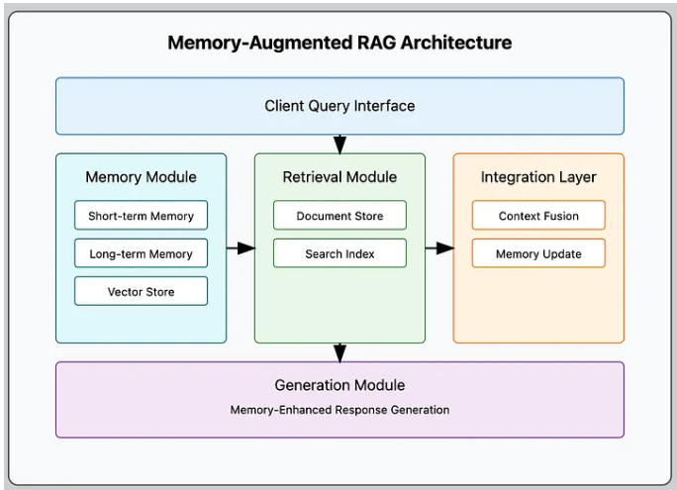
6. How Memory Works in a RAG Pipeline
From a system perspective, memory-augmented RAG follows a predictable flow. When a user submits a query, the system retrieves relevant documents from the knowledge base and relevant entries from memory. These sources are merged into a single context, which is passed to the language model for reasoning and response generation. After the response is produced, selected information—such as summaries, decisions, or feedback—is stored back into memory.
This read–reason–write cycle is what transforms a single-turn RAG pipeline into a system capable of learning from experience.

7. Memory in Multi-Agent Systems
In multi-agent systems, memory plays a more critical role than in single-agent setups. Agents often work on different parts of a task and must coordinate their actions over time. Memory enables agents to share findings, track progress, and maintain consistency without direct coupling.
Rather than being a private store, memory in multi-agent systems often acts as a shared state layer that agents read from and write to. This shared memory allows agents to collaborate asynchronously and build upon each other’s work.

8. Common Memory Patterns in Multi-Agent Architectures
A common approach is shared memory, where all agents interact with a central store that represents the current state of the system. Another approach uses message history as memory, treating inter-agent communication logs as the source of shared context. More advanced systems adopt hierarchical memory, separating global memory accessible to all agents from local memory used for agent-specific reasoning.
These patterns reduce duplication, prevent contradictions, and enable scalable collaboration.

9. Conclusion
Memory systems fundamentally change how RAG and multi-agent systems behave. RAG provides access to knowledge, but memory provides continuity. In multi-agent systems, memory enables coordination, consistency, and long-running workflows.
As AI systems evolve from simple responders to autonomous agents, memory is no longer an advanced feature—it is a core architectural requirement. Understanding how memory fits into RAG and multi-agent systems is essential for building reliable, scalable, and intelligent AI applications.

10. Reference:
https://medium.com/aingineer/a-complete-guide-to-implementing-memory-augmented-rag-c3582a8dc74f

