- Introduction:
Project Name: DailyQuote+ – Inspirational Quotes & Sharing Mobile Application

- Objectives:

The DailyQuote+ Mobile Application aims to inspire users by delivering a fresh motivational quote every day, while also allowing them to save their favorite quotes and share them effortlessly. The application focuses on simplicity, offline access, content inspiration, and personalized motivation, ensuring users can stay positive and encouraged throughout their daily routine.

- Target Users:
- Students seeking daily motivation
- Working professionals
- Content creators & writers
- Social media users who like sharing quotes
- Self-improvement enthusiasts
- Individuals struggling with stress or low productivity
- People practicing journaling or mindfulness
- Anyone who enjoys inspirational or philosophical quotes

- System Diagram

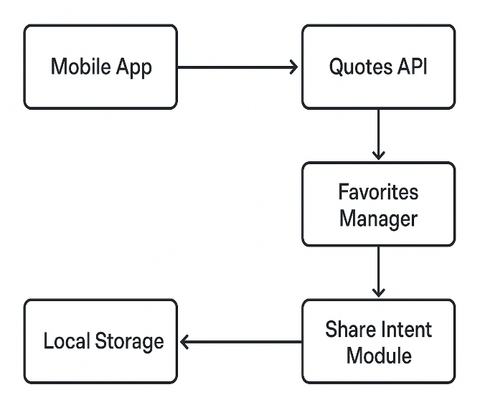

Figure 1: System Design

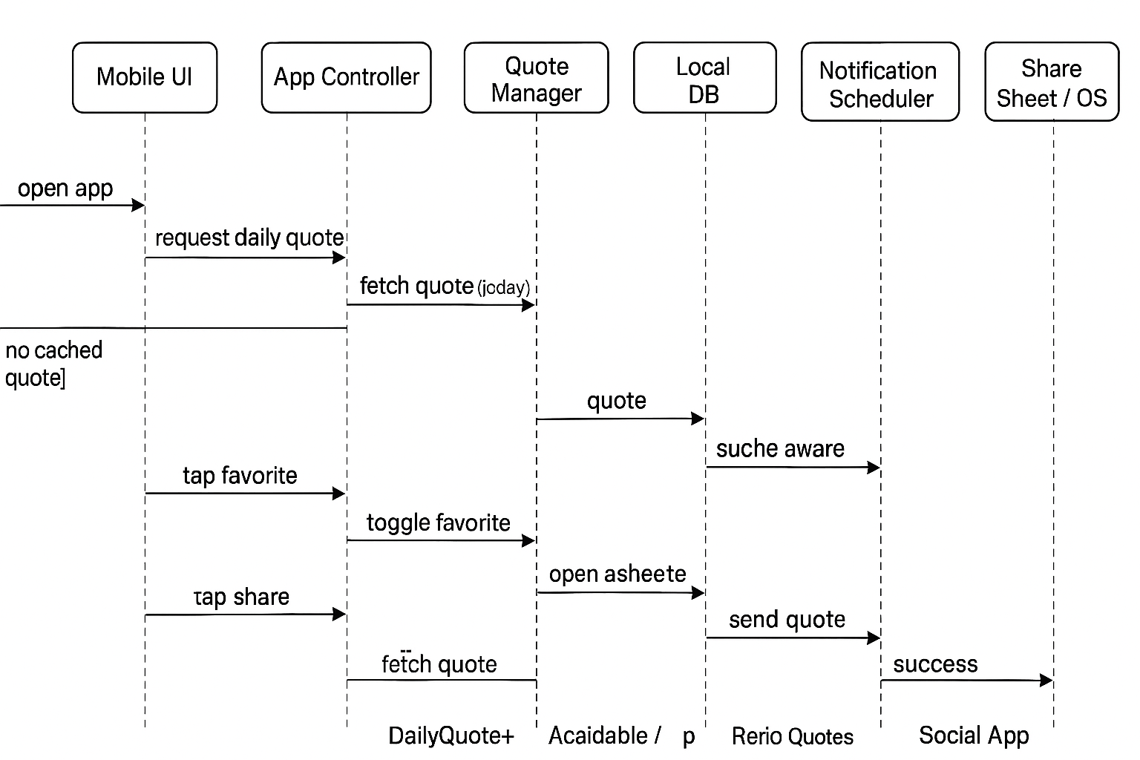
Figure 2: Sequence Diagram

- Sprint Plans:
Add your own treebo or github link

- Sprint:1

During Sprint-1, the core emphasis was placed on setting up the essential app architecture, identifying key features, and designing the minimal UI screens. Initial components such as the Daily Quote Screen, Favorites Screen, and Share Functionality were conceptualized and built using Jetpack Compose.
Core User Stories:
• As a user, I want to see a new quote every day so that I stay motivated.
• As a user, I want to mark quotes as favorites so that I can revisit them anytime.
• As a user, I want to share quotes with others so that I can inspire my friends.
• As a user, I want offline access so I can read my saved quotes even without internet.

UI / UX User Stories
• As a user, I want a clean and minimal UI so that I can focus on the quote without distractions.
• As a user, I want smooth interactions so that reading and saving quotes feels seamless.

System / Developer User Stories
• As a developer, I want to integrate a Quotes API so that the app can fetch fresh quotes daily.
• As a developer, I want to store data locally so users can access favorites offline.

