- Introduction:
Project Name: WaterMinder – Smart Hydration Tracking & Wellness Application

- Objectives:
The WaterMinder Mobile Application aims to help users stay hydrated throughout the day by providing personalized water-intake goals, smart reminders, hydration tips, and detailed logging features. The application focuses on improving user wellness by monitoring daily water consumption, sending timely vibration/notification reminders, offering actionable hydration advice via a Tips API, and storing user data efficiently using Room Database.
- Target Users:

- Fitness Enthusiasts
  - Office Workers / Desk Job Employees
  - Elderly Individuals
  - General Health-Conscious Users
  - Athletes & Sportspersons
  - People living in hot climates
  - Users wanting daily habit tracking
  - Individuals facing dehydration or fatigue issues

- System Diagram

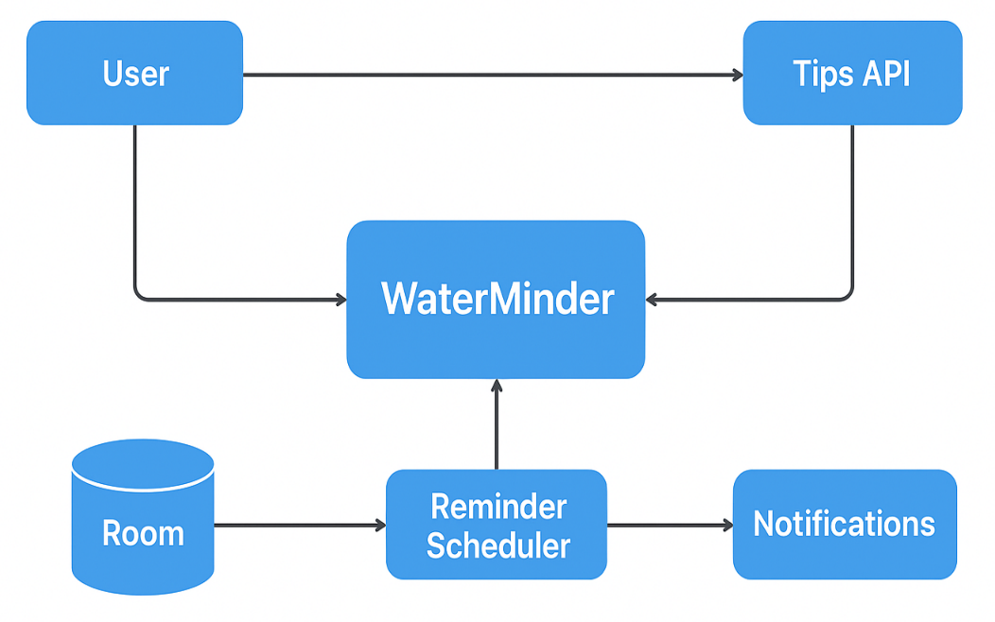
Figure 1: System Design

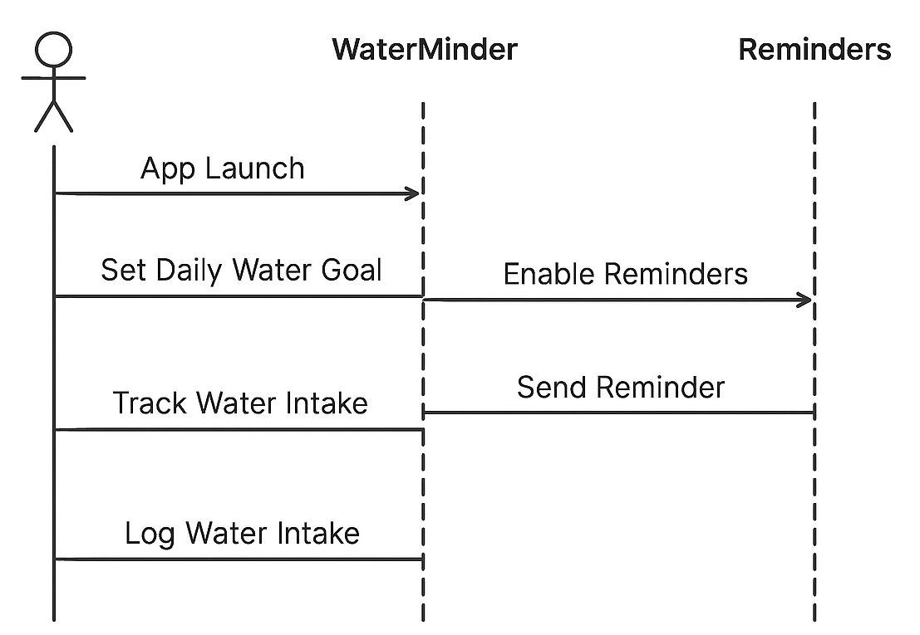
Figure 2: Sequence Diagram

- Sprint Plans:
Add your own github or treebo link

- Sprint:1
During Sprint-1, the primary focus was to define the core features of WaterMinder, gather system requirements, and design the fundamental UI flow for hydration tracking. Initial Jetpack Compose screens such as Splash Screen, Onboarding, Water Goal Setup, and Daily Tracking UI were designed and implemented. Core modules like local data storage using Room and notification channels for reminders were also initialized.
User stories:
• As a user, I want to set my daily water-intake goal so that the app can track and remind me accordingly.
• As a health-conscious individual, I want timely vibration/notification reminders so that I remember to drink water during the day.
• As a user, I want simple and clean UI screens so that I can log my water intake quickly and efficiently.
• As a wellness learner, I want hydration tips so that I can improve my daily hydration habits.
• As an app user, I want my water logs to be saved locally using Room so that I can view my past hydration history.

- Sprint: 2

During Sprint-2, the focus was on enabling secure user onboarding and creating the initial navigation flow of the StudyMate app. This sprint introduced user authentication, access control, and the first interactive screens that appear after login. A functional end-to-end flow—from app launch to reaching the home screen—was completed using Jetpack Compose and Firebase Authentication.
The basic structure for future features (like study plans and progress tracking) was also prepared during this sprint.

Core Features Implemented:
- Splash Screen with branding and smooth transition
- User Authentication Setup (Username/Password)
- Login & Signup Screens built with Jetpack Compose
- Form validation for email passwords
- Navigation flow from Splash → Login → Signup → Home
- Basic Home Screen (placeholder) prepared for future modules
- State handling for login/signup responses and errors

User Stories:
- As a user, I want to sign up with my email so I can create an account in the app.
- As a user, I want to log in quickly so I can access my study dashboard.
- As a user, I want the app to remember my session so I do not need to log in again each time.
- As a user, I want a simple Home Screen after login so I know I have successfully entered the app.

UI / UX User Stories:
- As a user, I want a clean login and signup layout so that the process feels simple and approachable.
- As a user, I want visual feedback during loading so I know the app is processing my login/signup.
- As a user, I want a friendly splash screen so the app feels polished and welcoming.

System / Developer User Stories
- As a developer, I want to integrate authentication so users can securely log in and create accounts.
- As a developer, I want to manage authentication states so users stay signed in after closing the app.
- As a developer, I want a basic home screen ready for future features like study schedule and progress tracking.
- As a developer, I want reusable UI components so future screens stay consistent.

