- Introduction:
Project Name: Study Mate – Mobile Learning & Productivity Application

- Objectives:
The Study Mate Mobile Application aims to support students in managing their study schedules, improving learning productivity, and staying organized throughout their academic journey. The application focuses on personalized study planning, reminders, collaborative features, learning resources, and performance tracking to help students achieve better academic outcomes.

- Target Users:
- School Students
- College & University Students
- Competitive Exam Aspirants
- Working Professionals pursuing part-time courses
- Self-Learners
- Students preparing for certification exams
- Group Study / Peer Learning Communities
- Tutors & Mentors

- System Diagram
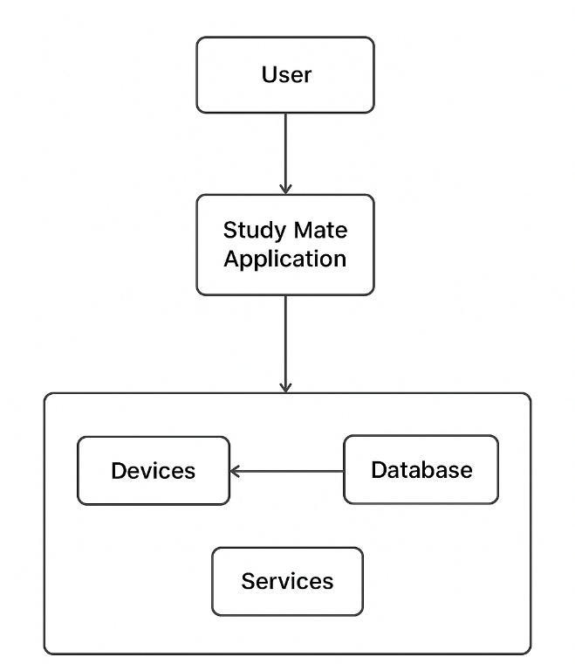

Figure 1: System Design

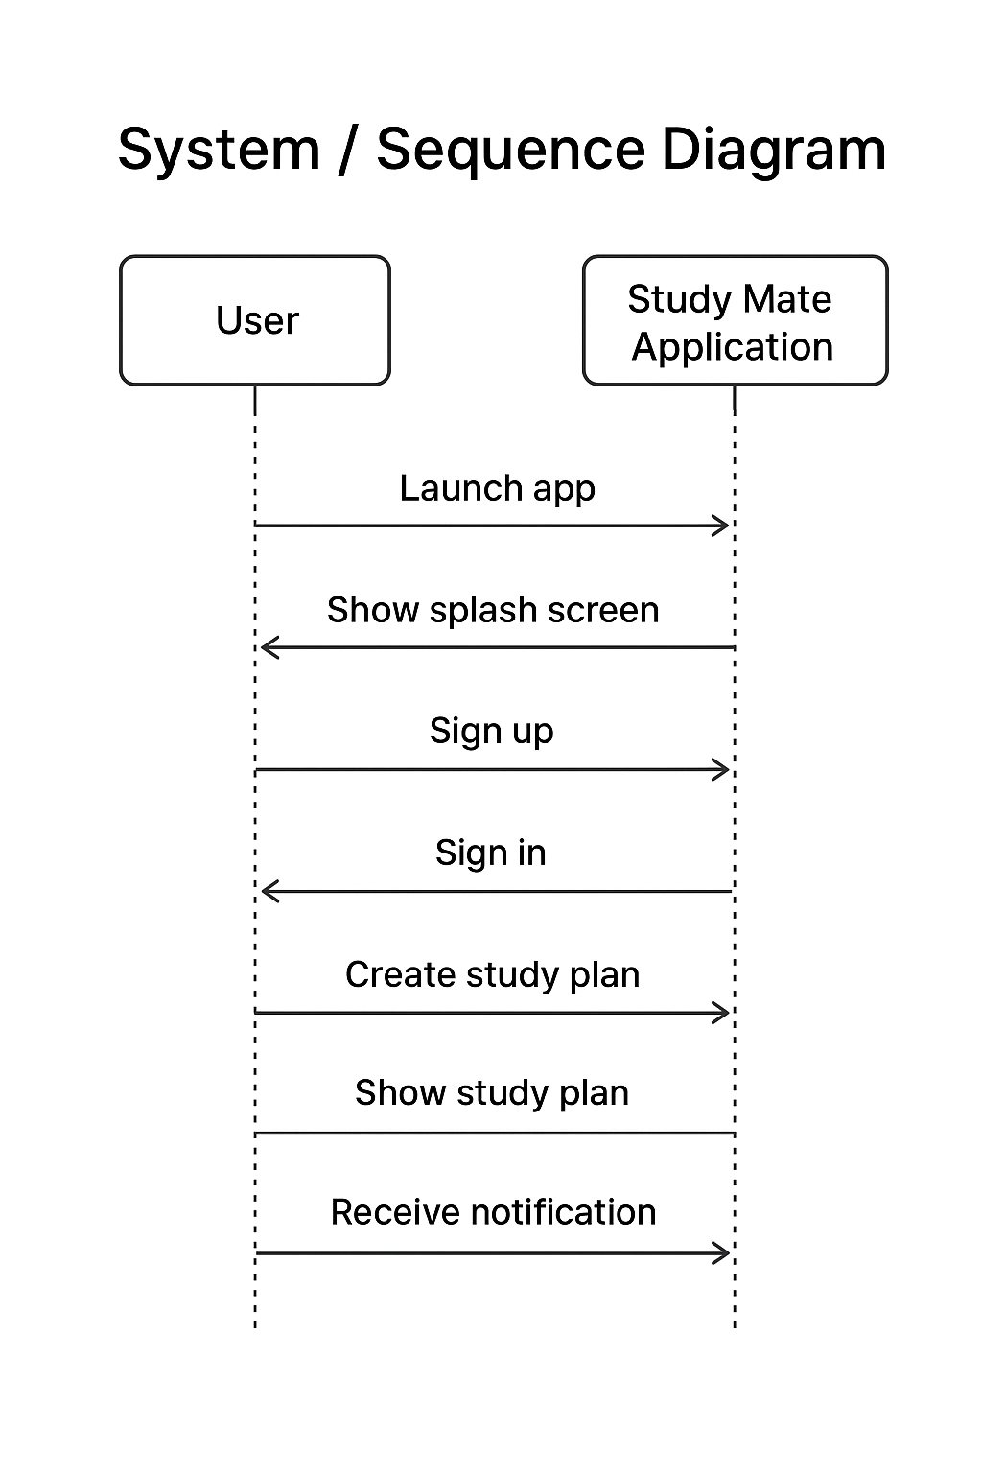
Figure 2: Sequence Diagram

- Sprint Plans:
Add your own treebo or github link

- Sprint:1
During Sprint-1, the primary focus was to define the core features of Study Mate, gather system requirements, and create the initial wireframes for the user interface. Essential UI screens such as the Splash Screen, Sign-Up, and Sign-In pages were designed and developed using Jetpack Compose.
User stories:
- As a student, I want to register and log into the Study Mate app so that I can create and access my personalized study plans.
- As a user, I want a clean and intuitive UI so that I can navigate through study features easily without confusion.
- As a planner, I want to identify the core system functionalities so that the app supports scheduling, reminders, and progress tracking effectively.

- Sprint: 2

During Sprint-2, the focus was on enabling secure user onboarding and creating the initial navigation flow of the WaterMinder app. This sprint introduced user authentication, access control, and the first interactive screens that appear after login. A functional end-to-end flow—from app launch to reaching the home screen—was completed using Jetpack Compose and Firebase Authentication.
The basic structure for future features (like study plans and progress tracking) was also prepared during this sprint.

Core Features Implemented:
- Splash Screen with branding and smooth transition
- User Authentication Setup (Username/Password)
- Login & Signup Screens built with Jetpack Compose
- Form validation for email passwords
- Navigation flow from Splash → Login → Signup → Home
- Basic Home Screen (placeholder) prepared for future modules
- State handling for login/signup responses and errors

User Stories:
- As a user, I want to sign up with my email so I can create an account in the app.
- As a user, I want to log in quickly so I can access my study dashboard.
- As a user, I want the app to remember my session so I do not need to log in again each time.
- As a user, I want a simple Home Screen after login so I know I have successfully entered the app.

UI / UX User Stories:
- As a user, I want a clean login and signup layout so that the process feels simple and approachable.
- As a user, I want visual feedback during loading so I know the app is processing my login/signup.
- As a user, I want a friendly splash screen so the app feels polished and welcoming.

System / Developer User Stories
- As a developer, I want to integrate Authentication so users can securely log in and create accounts.
- As a developer, I want to manage authentication states so users stay signed in after closing the app.
- As a developer, I want a basic home screen ready for future features like study schedule and progress tracking.
- As a developer, I want reusable UI components so future screens stay consistent.

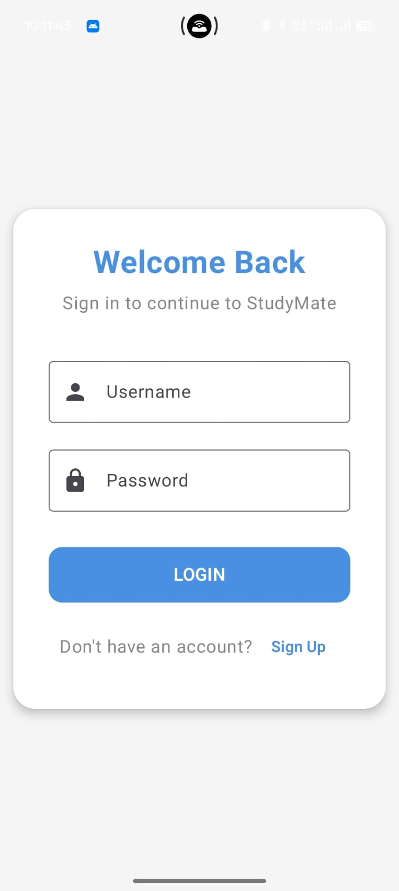


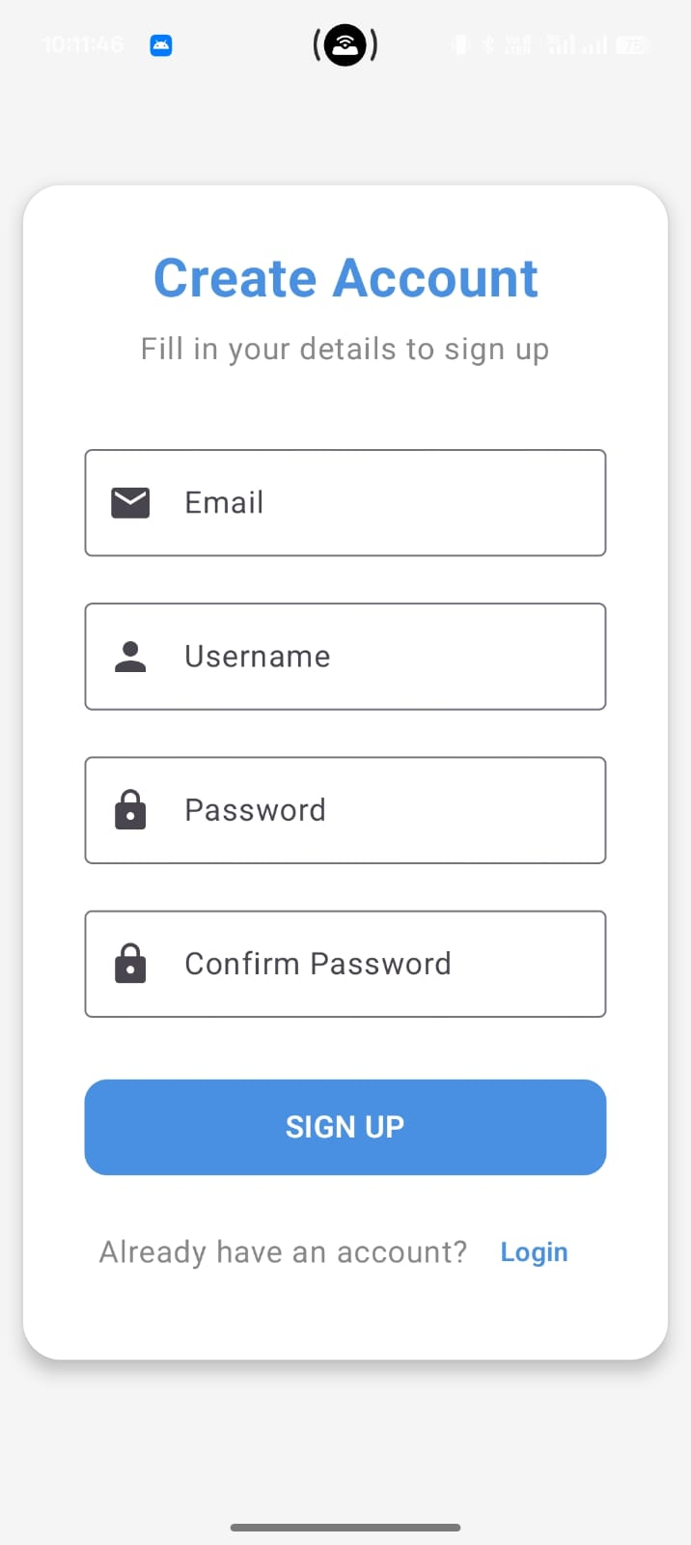

- Sprint: 3

During Sprint-3, the focus was on designing and implementing the Dashboard module, which acts as the central hub for all major features of the StudyMate application. This sprint aimed to make the user experience smoother by providing a clean, interactive, and easy-to-navigate home environment where students can quickly access their study tools.

A fully functional dashboard with interactive feature cards was created using Jetpack Compose. Each card now directs the user to a placeholder detail page, laying the foundation for future modules like Notes, To-Do Lists, Study Planner, and Resources. UI consistency and navigation flow were significantly improved, giving the app a more polished and structured appearance.

- Core Features Implemented (Sprint-3)

- Dashboard Screen with structured layout and premium-styled feature cards
- Tap actions added to all cards (Notes, Study Planner, To-Do, Resources, Profile)
- Smooth navigation from Login → Dashboard → Feature Screens
- Placeholder detail screens created for upcoming modules
- UI refinement using Jetpack Compose components
- Basic colors, typography, and spacing improved to create a clean and modern look
- Reusable composables created for consistent card behavior
- Error handling for navigation crashes and missing routes fixed

- User Stories Completed

Functional User Stories

- As a user, I want a dashboard that shows all study tools in one place so I can quickly access Notes, Tasks, and Study Plans without navigating multiple screens.

- As a user, I want to tap a card and open its corresponding screen so that navigation feels smooth and intuitive.

- As a user, I want placeholders for upcoming features so I know what modules will be available in future versions.

- As a user, I want a visually clean and structured dashboard so the app feels easy to use and welcoming after login.

- UI / UX User Stories

- As a user, I want visually appealing dashboard cards so the interface feels modern and organized.

- As a user, I want consistent spacing, colours, and icon visuals so the app experience feels premium.

- As a user, I want smooth page transitions so navigation feels effortless.

- System / Developer User Stories

- As a developer, I want reusable card components so future modules can be built faster and remain visually consistent.

- As a developer, I want navigation routes for all planned modules so future feature integration becomes straightforward.

- As a developer, I want structured UI architecture so the app remains scalable as more tools are added.

- Outcome of Sprint-3

Sprint-3 successfully delivered a polished, functional dashboard experience. Users can now navigate to multiple module screens, giving a sense of progress and readiness for the next development stages. The app now feels more like a complete product rather than just an authentication system.

This sprint laid the groundwork for implementing all core study tools in upcoming sprints, ensuring smooth integration and consistent design across the application

