- Introduction:
Project Name: Study Mate – Mobile Learning & Productivity Application

- Objectives:
The Study Mate Mobile Application aims to support students in managing their study schedules, improving learning productivity, and staying organized throughout their academic journey. The application focuses on personalized study planning, reminders, collaborative features, learning resources, and performance tracking to help students achieve better academic outcomes.

- Target Users:
- School Students
- College & University Students
- Competitive Exam Aspirants
- Working Professionals pursuing part-time courses
- Self-Learners
- Students preparing for certification exams
- Group Study / Peer Learning Communities
- Tutors & Mentors

- System Diagram
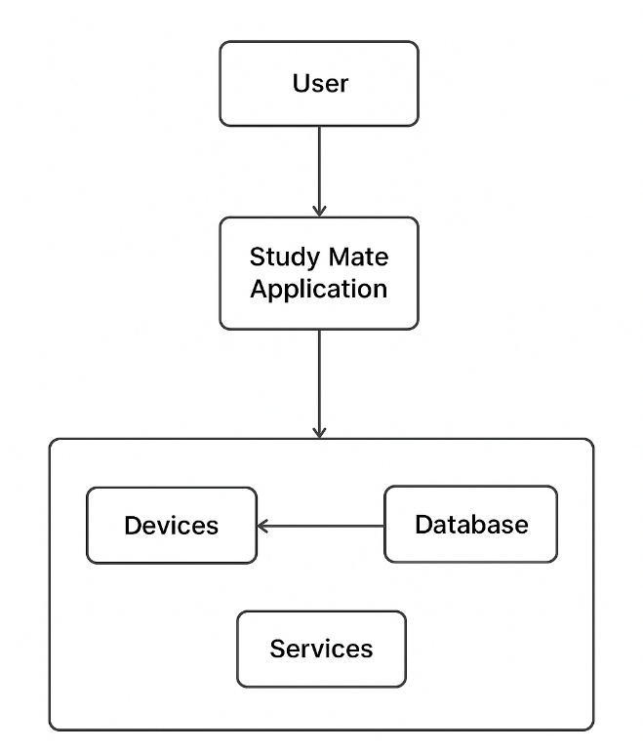

Figure 1: System Design

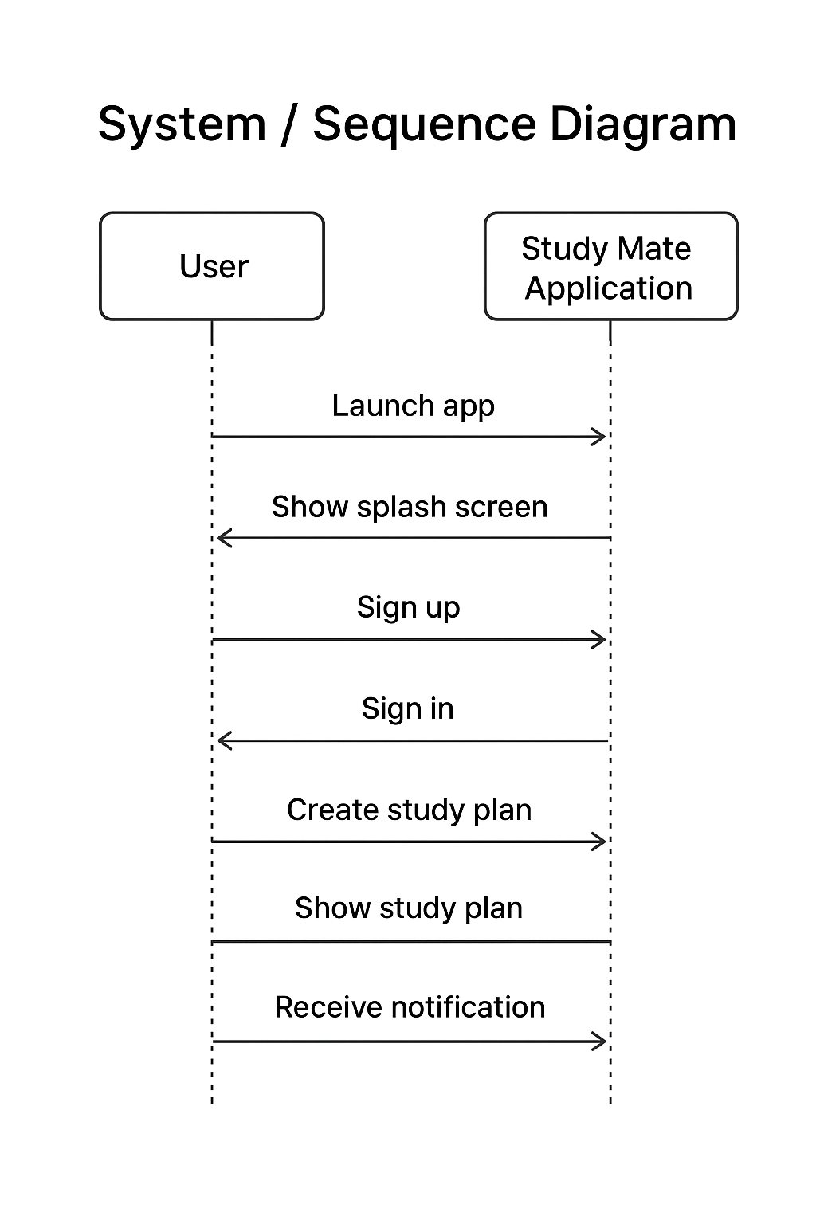
Figure 2: Sequence Diagram

- Sprint Plans:
Add your own treebo or github link

- Sprint:1
During Sprint-1, the primary focus was to define the core features of Study Mate, gather system requirements, and create the initial wireframes for the user interface. Essential UI screens such as the Splash Screen, Sign-Up, and Sign-In pages were designed and developed using Jetpack Compose.
User stories:
- As a student, I want to register and log into the Study Mate app so that I can create and access my personalized study plans.
- As a user, I want a clean and intuitive UI so that I can navigate through study features easily without confusion.
- As a planner, I want to identify the core system functionalities so that the app supports scheduling, reminders, and progress tracking effectively.

- Sprint: 2

During Sprint-2, the focus was on enabling secure user onboarding and creating the initial navigation flow of the WaterMinder app. This sprint introduced user authentication, access control, and the first interactive screens that appear after login. A functional end-to-end flow—from app launch to reaching the home screen—was completed using Jetpack Compose and Firebase Authentication.
The basic structure for future features (like study plans and progress tracking) was also prepared during this sprint.

Core Features Implemented:
- Splash Screen with branding and smooth transition
- User Authentication Setup (Username/Password)
- Login & Signup Screens built with Jetpack Compose
- Form validation for email passwords
- Navigation flow from Splash → Login → Signup → Home
- Basic Home Screen (placeholder) prepared for future modules
- State handling for login/signup responses and errors

User Stories:
- As a user, I want to sign up with my email so I can create an account in the app.
- As a user, I want to log in quickly so I can access my study dashboard.
- As a user, I want the app to remember my session so I do not need to log in again each time.
- As a user, I want a simple Home Screen after login so I know I have successfully entered the app.

UI / UX User Stories:
- As a user, I want a clean login and signup layout so that the process feels simple and approachable.
- As a user, I want visual feedback during loading so I know the app is processing my login/signup.
- As a user, I want a friendly splash screen so the app feels polished and welcoming.

System / Developer User Stories
- As a developer, I want to integrate Authentication so users can securely log in and create accounts.
- As a developer, I want to manage authentication states so users stay signed in after closing the app.
- As a developer, I want a basic home screen ready for future features like study schedule and progress tracking.
- As a developer, I want reusable UI components so future screens stay consistent.

