- Introduction:
Project Name: WaterMinder – Smart Hydration Tracking & Wellness Application

- Objectives:
The WaterMinder Mobile Application aims to help users stay hydrated throughout the day by providing personalized water-intake goals, smart reminders, hydration tips, and detailed logging features. The application focuses on improving user wellness by monitoring daily water consumption, sending timely vibration/notification reminders, offering actionable hydration advice via a Tips API, and storing user data efficiently using Room Database.
- Target Users:

- Fitness Enthusiasts
  - Office Workers / Desk Job Employees
  - Elderly Individuals
  - General Health-Conscious Users
  - Athletes & Sportspersons
  - People living in hot climates
  - Users wanting daily habit tracking
  - Individuals facing dehydration or fatigue issues

- System Diagram

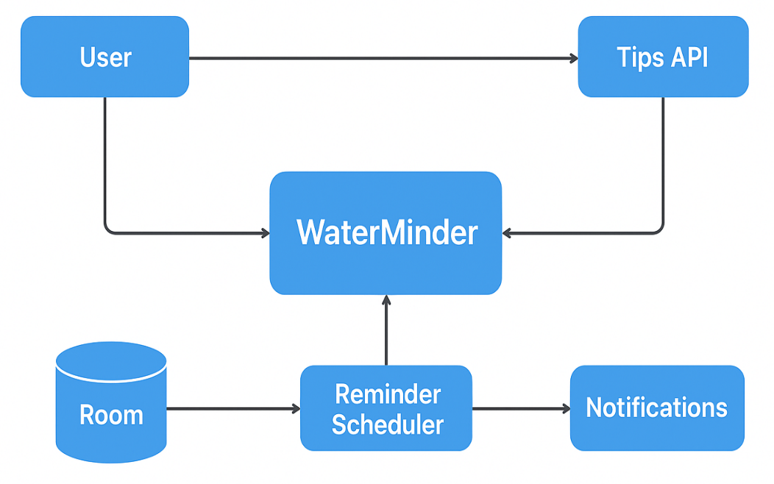
Figure 1: System Design

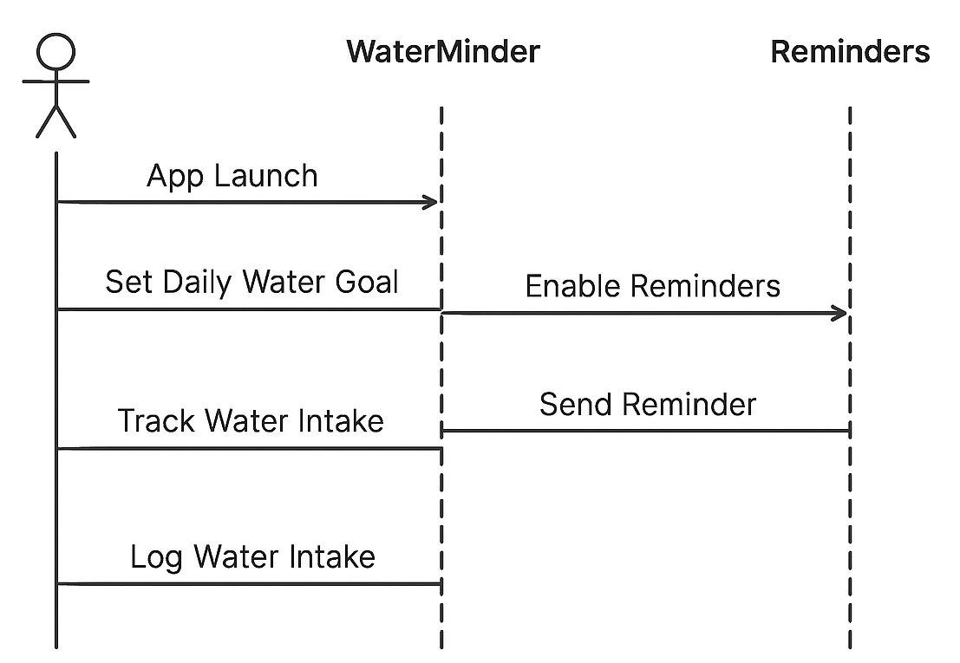
Figure 2: Sequence Diagram

- Sprint Plans:
Add your own github or treebo link

- Sprint:1
During Sprint-1, the primary focus was to define the core features of WaterMinder, gather system requirements, and design the fundamental UI flow for hydration tracking. Initial Jetpack Compose screens such as Splash Screen, Onboarding, Water Goal Setup, and Daily Tracking UI were designed and implemented. Core modules like local data storage using Room and notification channels for reminders were also initialized.
User stories:
• As a user, I want to set my daily water-intake goal so that the app can track and remind me accordingly.
• As a health-conscious individual, I want timely vibration/notification reminders so that I remember to drink water during the day.
• As a user, I want simple and clean UI screens so that I can log my water intake quickly and efficiently.
• As a wellness learner, I want hydration tips so that I can improve my daily hydration habits.
• As an app user, I want my water logs to be saved locally using Room so that I can view my past hydration history.

- Sprint: 2

During Sprint-2, the focus was on enabling secure user onboarding and creating the initial navigation flow of the StudyMate app. This sprint introduced user authentication, access control, and the first interactive screens that appear after login. A functional end-to-end flow—from app launch to reaching the home screen—was completed using Jetpack Compose and Firebase Authentication.
The basic structure for future features (like study plans and progress tracking) was also prepared during this sprint.

Core Features Implemented:
- Splash Screen with branding and smooth transition
- User Authentication Setup (Username/Password)
- Login & Signup Screens built with Jetpack Compose
- Form validation for email passwords
- Navigation flow from Splash → Login → Signup → Home
- Basic Home Screen (placeholder) prepared for future modules
- State handling for login/signup responses and errors

User Stories:
- As a user, I want to sign up with my email so I can create an account in the app.
- As a user, I want to log in quickly so I can access my study dashboard.
- As a user, I want the app to remember my session so I do not need to log in again each time.
- As a user, I want a simple Home Screen after login so I know I have successfully entered the app.

UI / UX User Stories:
- As a user, I want a clean login and signup layout so that the process feels simple and approachable.
- As a user, I want visual feedback during loading so I know the app is processing my login/signup.
- As a user, I want a friendly splash screen so the app feels polished and welcoming.

System / Developer User Stories
- As a developer, I want to integrate authentication so users can securely log in and create accounts.
- As a developer, I want to manage authentication states so users stay signed in after closing the app.
- As a developer, I want a basic home screen ready for future features like study schedule and progress tracking.
- As a developer, I want reusable UI components so future screens stay consistent.

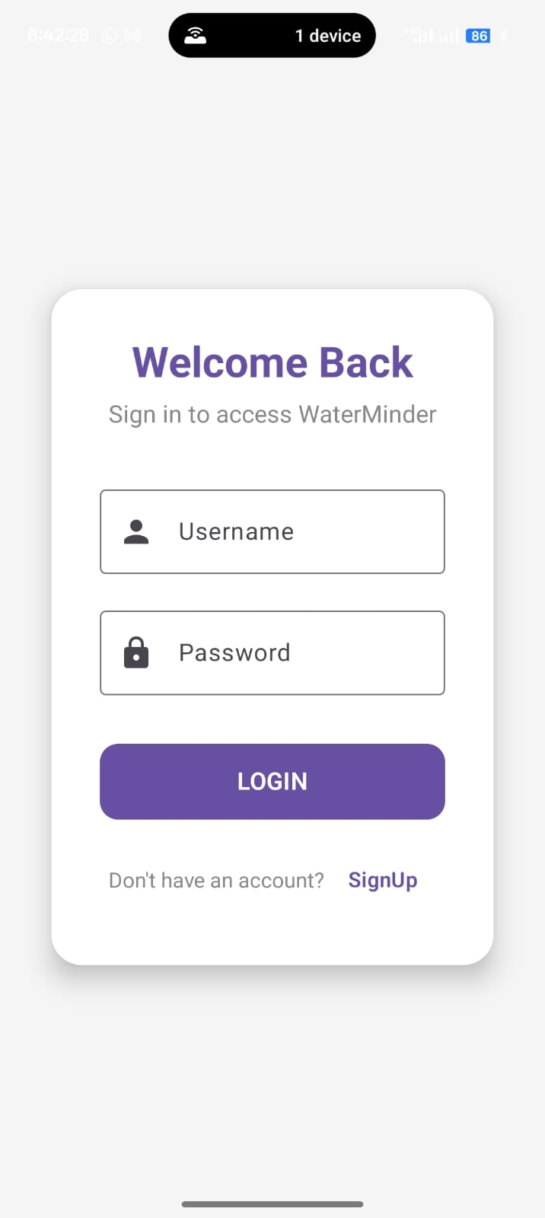


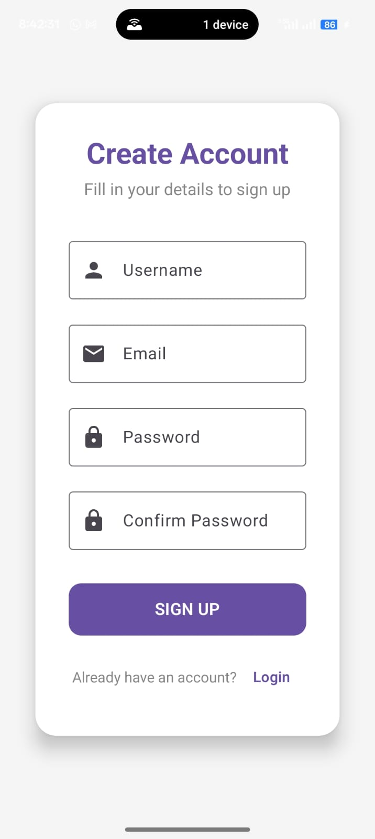

- Sprint 3

During Sprint-3, the focus was on building the Dashboard / Home module of the WaterMinder application, which acts as the central screen for users to view their hydration status, quick-add water intake, reminders, and daily progress. The goal of this sprint was to create a smooth, visually clean, and interactive experience that motivates users to stay hydrated throughout the day.
A fully interactive Hydration Dashboard was developed using Jetpack Compose, showcasing essential water-tracking tools in a structured layout. Each feature tile (Daily Goal, Water Intake Logs, Reminders, Hydration Tips, and Profile) now navigates users to placeholder detail screens, setting a strong foundation for upcoming modules. UI consistency, colour palette, and overall layout were improved to match the premium wellness theme of the application.

- Core Features Implemented (Sprint-3)

- Hydration Dashboard Screen with premium-styled health cards.
- Tap actions added to all dashboard options.
(Daily Goal, Quick Add, Logs, Reminders, Tips, Profile)
- Navigation setup from Login → Dashboard → Feature Screens.
- Placeholder UI pages created for future hydration modules.
- Improved UI refinement using Compose typography, spacing, and water-theme colours.
- Reusable card composable for consistent styling across the app.
- Crash fixes related to missing navigation routes.

- User Stories Completed
Functional User Stories

- As a user, I want a dashboard showing my hydration status so I can instantly see my progress for the day.
- As a user, I want to tap hydration options (Logs, Reminders, Goal) to quickly open the corresponding screen.
- As a user, I want placeholder screens for upcoming hydration features so I know what tools are coming next.
- As a user, I want a quick-add option to log water without multiple steps.

- UI / UX User Stories

- As a user, I want visually attractive hydration cards so the app feels modern and motivating.
- As a user, I want consistent water-theme colours (blue, aqua) with smooth spacing so the dashboard feels premium.
- As a user, I want a clean and welcoming home screen every time I open the app.
- System / Developer User Stories
- As a developer, I want reusable dashboard components to maintain design consistency and reduce rework.
- As a developer, I want predefined navigation routes to integrate future hydration modules easily.
- As a developer, I want a scalable UI architecture to support upcoming features like analytics and auto reminders.

- Outcome of Sprint-3

Sprint-3 successfully delivered a functional and visually polished Hydration Dashboard for the WaterMinder app. Users can now navigate to essential hydration tools, giving the app a complete and structured feel beyond basic authentication.
The sprint also lays the foundation for upcoming advanced modules such as smart reminders, daily intake analytics, and hydration tips API integration. With a strong visual and architectural base, the next sprints can focus on deeper logic, storage, and personalization.

