- Introduction:
Project Name: Study Mate – Mobile Learning & Productivity Application

- Objectives:
The Study Mate Mobile Application aims to support students in managing their study schedules, improving learning productivity, and staying organized throughout their academic journey. The application focuses on personalized study planning, reminders, collaborative features, learning resources, and performance tracking to help students achieve better academic outcomes.

- Target Users:
- School Students
- College & University Students
- Competitive Exam Aspirants
- Working Professionals pursuing part-time courses
- Self-Learners
- Students preparing for certification exams
- Group Study / Peer Learning Communities
- Tutors & Mentors

- System Diagram
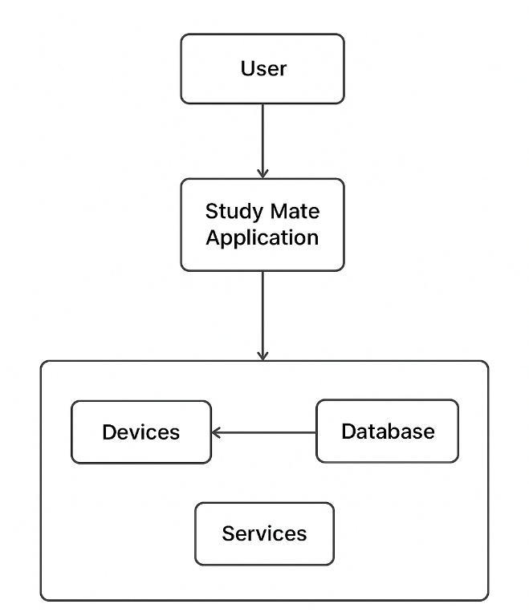

Figure 1: System Design

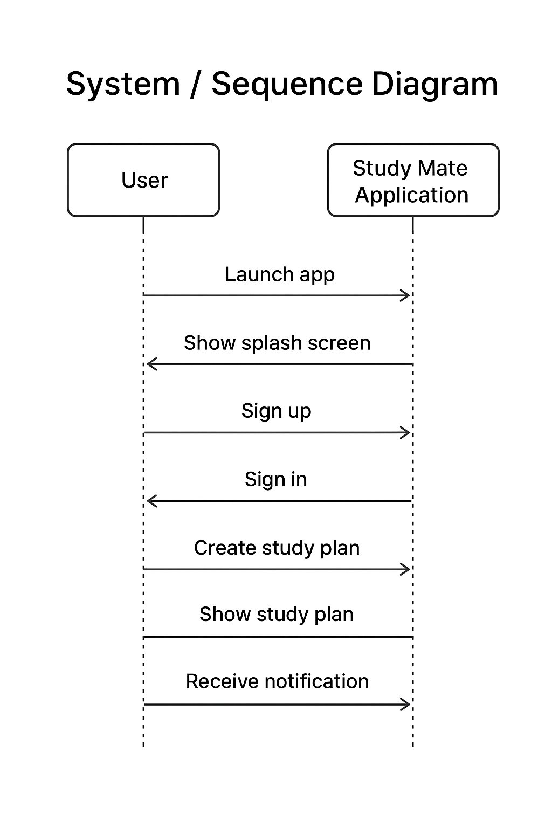
Figure 2: Sequence Diagram

- Sprint Plans:
Add your own treebo or github link

- Sprint:1
During Sprint-1, the primary focus was to define the core features of Study Mate, gather system requirements, and create the initial wireframes for the user interface. Essential UI screens such as the Splash Screen, Sign-Up, and Sign-In pages were designed and developed using Jetpack Compose.
User stories:
- As a student, I want to register and log into the Study Mate app so that I can create and access my personalized study plans.
- As a user, I want a clean and intuitive UI so that I can navigate through study features easily without confusion.
- As a planner, I want to identify the core system functionalities so that the app supports scheduling, reminders, and progress tracking effectively.

