Maven central repository

Maven: Central management tool

3 steps to install:

1. Download Mavin Zip file from website
2. Extract and put in the C drive
3. Set environment variable  
   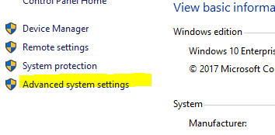

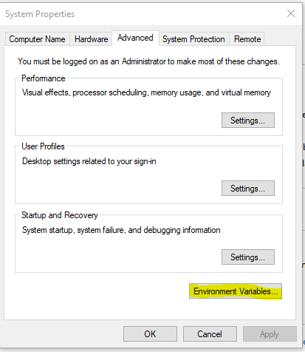  
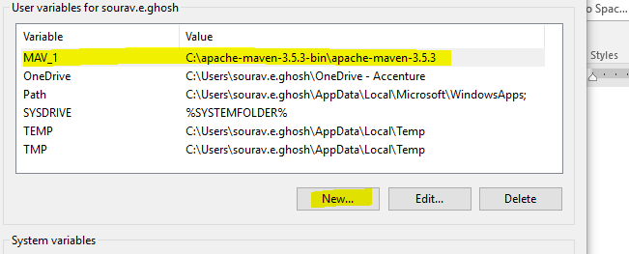

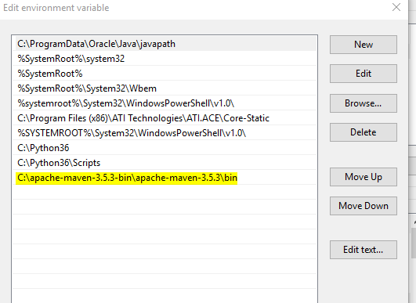

To check if Mavin is installed properly

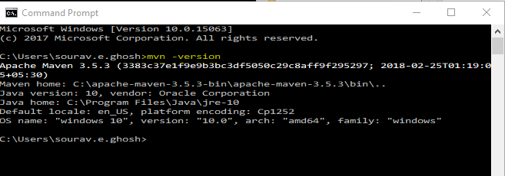

Creating Mavin Project:

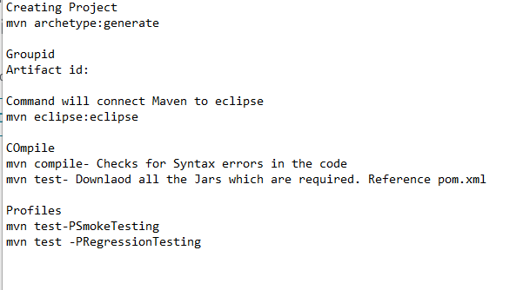

1. Start CMD>> Enter cd path name: cd C:\Users\sourav.e.ghosh\MAVIN_PROJECTS
2. Type mvn archetype:generate. It will take few minute  
   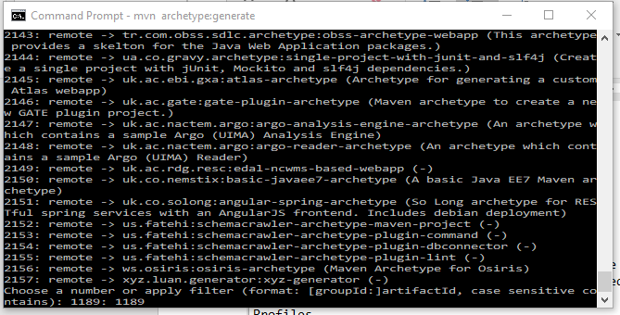  
   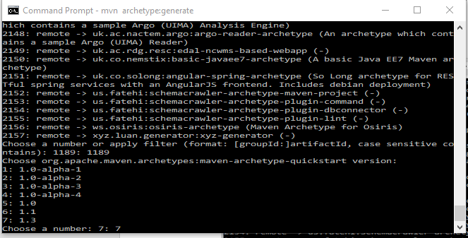  
   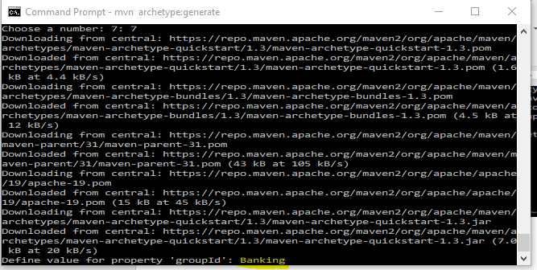  
   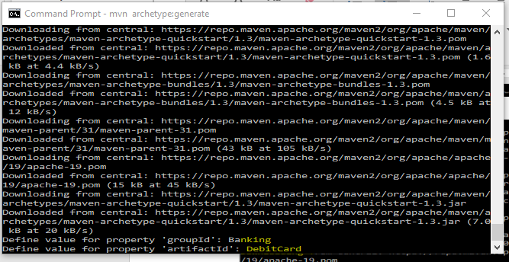

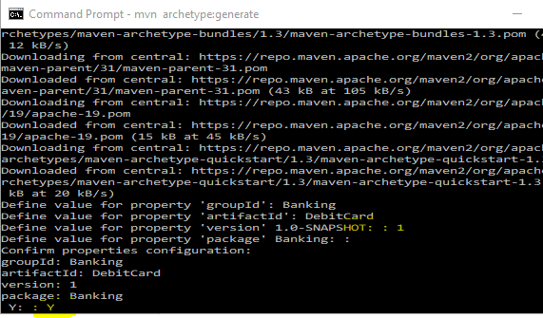

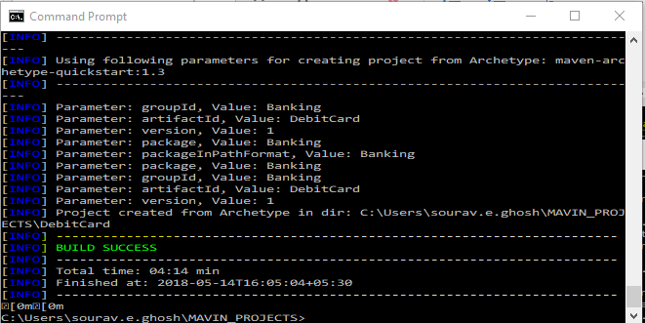

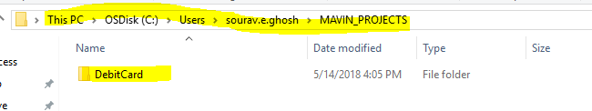

1. Double click on debit card
2. At the location on POM file. Load the location in CMD

cd C:\Users\sourav.e.ghosh\MAVIN_PROJECTS\DebitCard

1. Give command: mvn eclipse:eclipse (this creates the class.java)

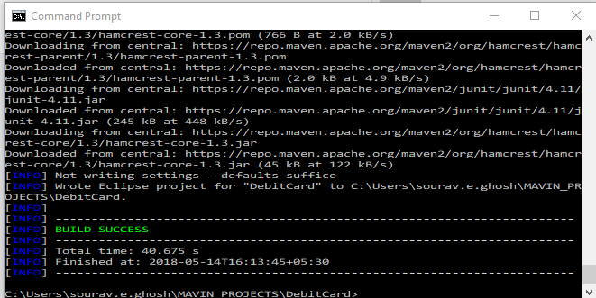

**Create Directly from eclipse.. Will be easy compared to this**

Don’t delete Junit. It’s a compiler on which mavin runs

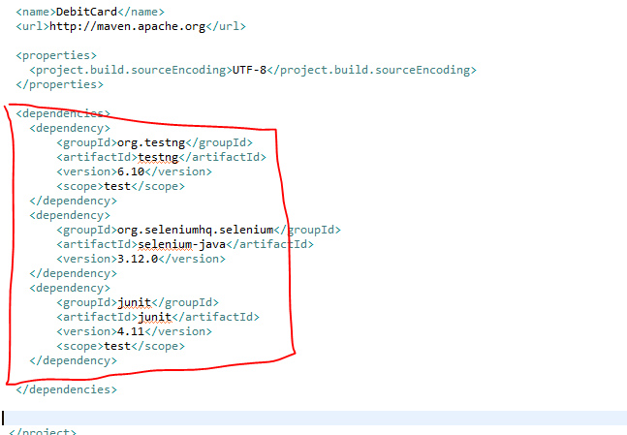

Add the dependencies

mvn compile: Checks if all is fine and download java dependendencies accordingly

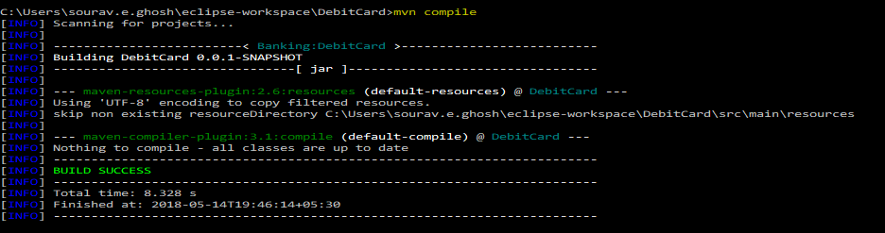

mvn test: downloads the files directly

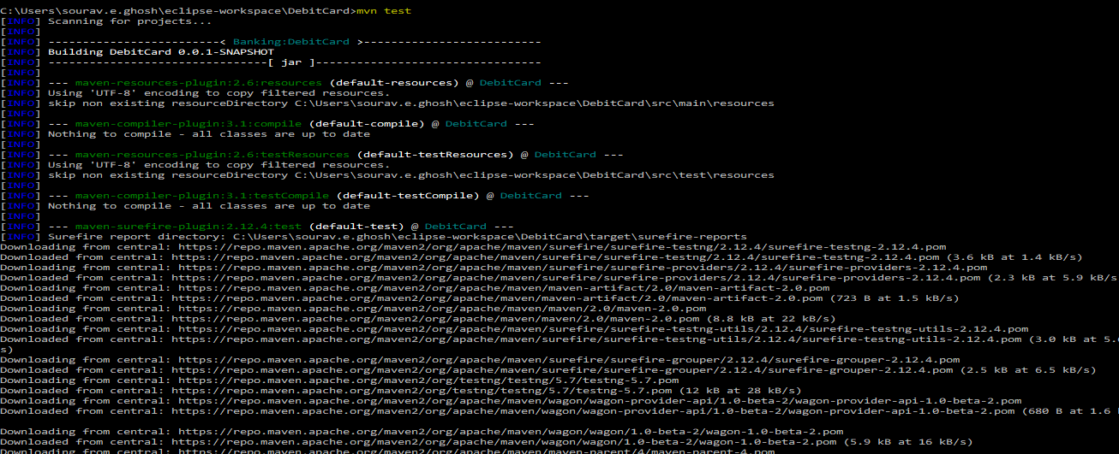

How to use POM.xml

<project xmlns=*"http://maven.apache.org/POM/4.0.0"* xmlns:xsi=*"http://www.w3.org/2001/XMLSchema-instance"*

xsi:schemaLocation=*"http://maven.apache.org/POM/4.0.0 http://maven.apache.org/xsd/maven-4.0.0.xsd"*>

<modelVersion>4.0.0</modelVersion>

<groupId>Banking</groupId>

<artifactId>DebitCard</artifactId>

<version>0.0.1-SNAPSHOT</version>

<packaging>jar</packaging>

<name>DebitCard</name>

<url>http://maven.apache.org</url>

<properties>

<project.build.sourceEncoding>UTF-8</project.build.sourceEncoding>

</properties>

<!-- ===========================================================================

============================Profile Start here=============================

=========================================================================== -->

<profiles>

<!-- #1 -->

<profile>

<id>Regression</id> <!-- Regression call -->

<build>

<plugins>

<plugin>

<groupId>org.apache.maven.plugins</groupId>

<artifactId>maven-surefire-plugin</artifactId>

<version>2.21.0</version>

<configuration>

<suiteXmlFiles>

<suiteXmlFile>regression.xml</suiteXmlFile>

</suiteXmlFiles>

</configuration>

</plugin>

</plugins>

</build>

</profile>

<!-- #2 -->

<profile>

<id>Build</id> <!-- Build call -->

<build>

<plugins>

<plugin>

<groupId>org.apache.maven.plugins</groupId>

<artifactId>maven-surefire-plugin</artifactId>

<version>2.21.0</version>

<configuration>

<suiteXmlFiles>

<suiteXmlFile>Build.xml</suiteXmlFile>

</suiteXmlFiles>

</configuration>

</plugin>

</plugins>

</build>

</profile>

</profiles>

<!-- ===========================================================================

============================Profile END here===============================

=========================================================================== -->

<!-- ===========================================================================

============================Dependency Start here==========================

=========================================================================== -->

<dependencies>

<!-- #1 -->

<dependency>

<groupId>org.testng</groupId>

<artifactId>testng</artifactId>

<version>6.10</version>

<scope>test</scope>

</dependency>

<!-- #2 -->

<dependency>

<groupId>org.seleniumhq.selenium</groupId>

<artifactId>selenium-java</artifactId>

<version>3.12.0</version>

</dependency>

<!-- #3 -->

<dependency>

<groupId>junit</groupId>

<artifactId>junit</artifactId>

<version>4.11</version>

<scope>test</scope>

</dependency>

</dependencies>

<!-- ===========================================================================

============================Dependency END here===============================

=========================================================================== -->

</project>

To be run using CMD

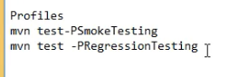

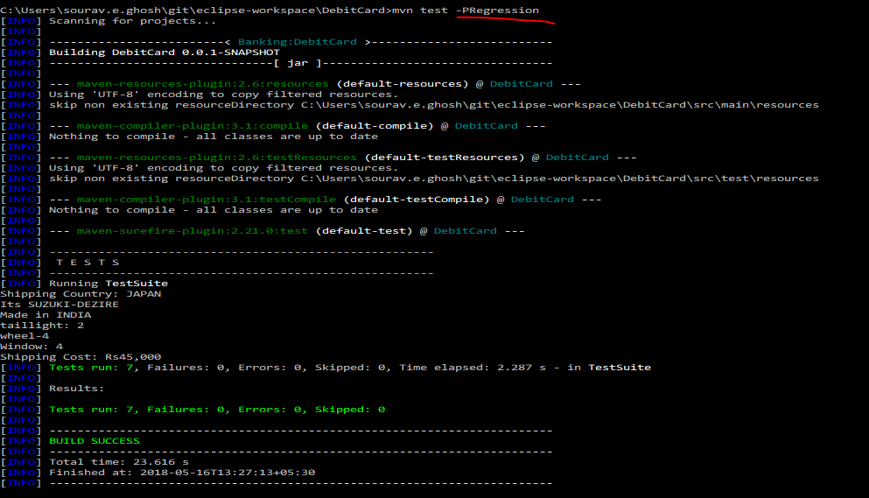

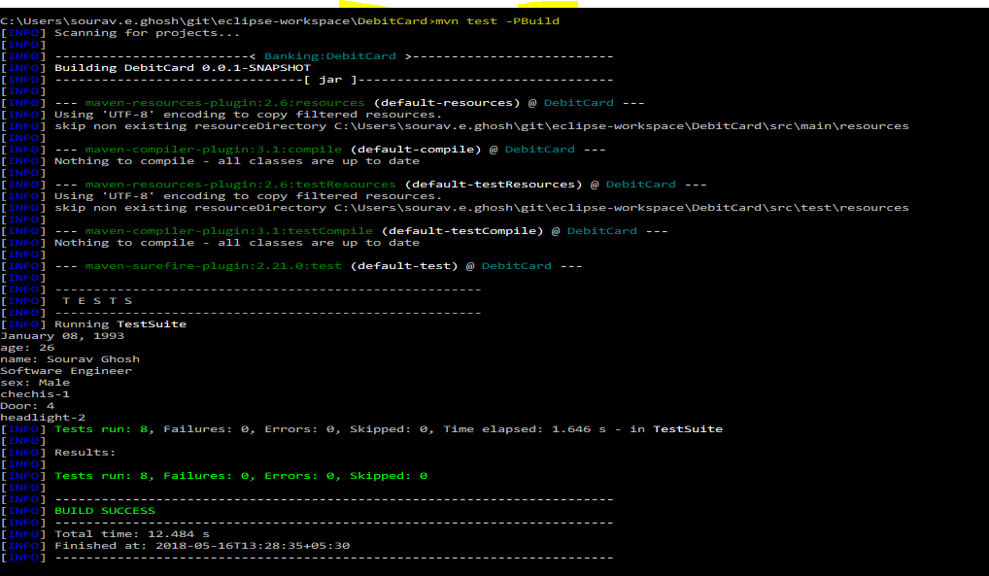

TestNG: <https://github.com/cbeust/testng/issues/1324>

Reports:

