Page Object Class/Module is used to create Object Repository in Selenium

Test cases are created over src/test/java

POM are created in src/main/java

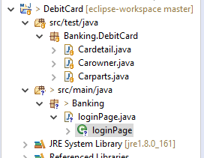

We will focus on the loginPage class

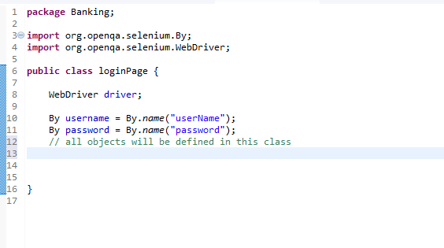

Here only name and password are taken

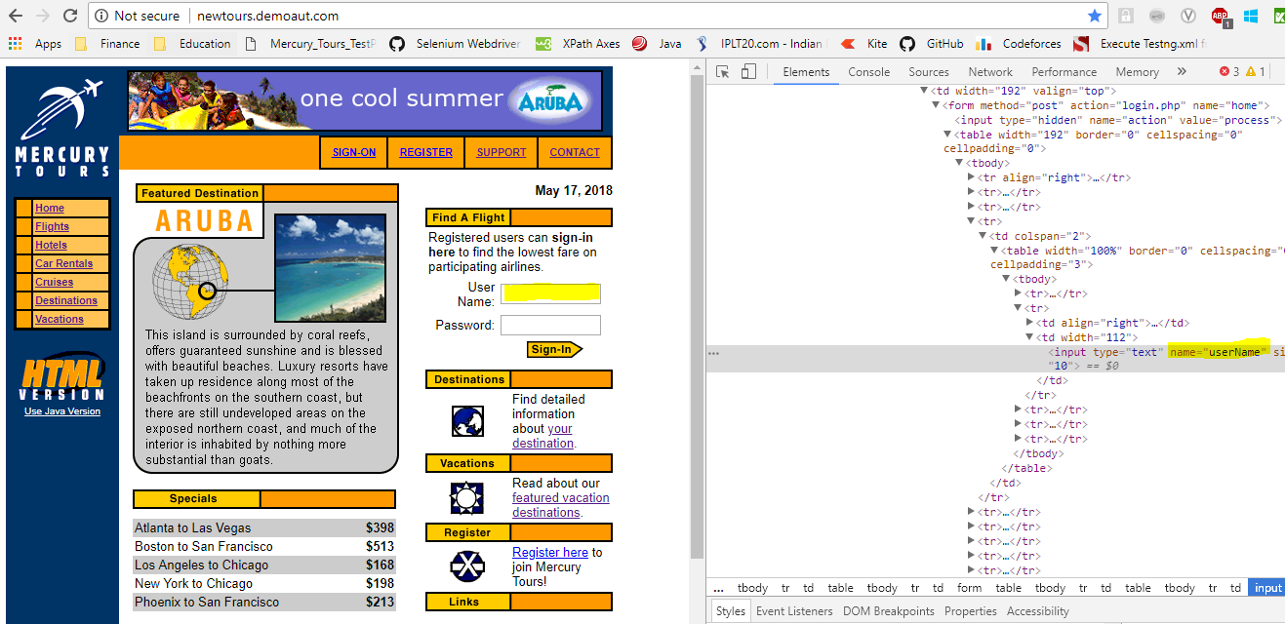

Create a constructor. It will be used when we assign Browser for testing. The browser will enter this class and execute the things

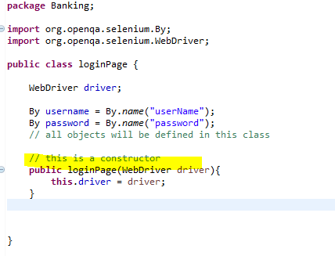

Create functions.

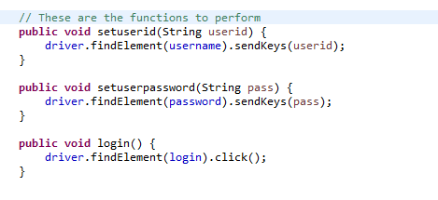

Now define a test just to check how its working.

