**Introduction**

Recommendation systems are built to predict what users might like, especially when there are lots of choices available. They can explicitly offer those recommendations to users (e.g., Amazon or Netflix, the classic examples), or they might work behind the scenes to choose which content to surface without giving the user a choice.

Either way, the “why” is clear: they’re critical for certain types of businesses because they can expose a user to content they may not have otherwise found or keep a user engaged for longer than they otherwise would have been. While building a simple recommendation system can be quite straightforward, the real challenge is to actually build one that works and where the business sees real uplift and value from its output.

Recommendation systems can be built using a variety of techniques, from simple (e.g., based only on other rated items from the same user) to extremely complex. Complex recommendation systems leverage a variety of different data sources (one challenge is using unstructured data, especially images, as the input) and machine learning (including deep learning) techniques. Thus, they are well suited for the world of artificial intelligence and more specifically unsupervised learning; as users continue to consume content and provide more data, these systems can be built to provide better and better recommendations.

In this post and those to follow, I will be walking through the creation and training of recommendation systems, as I am currently working on this topic for Master Thesis. Part 1 provides a high-level overview of recommendation systems, how they are built, and how they can be used to improve businesses across industries.

# ****The 2 Types of Recommendation System****

There are two primary types of recommendation systems, each with different sub-types. Depending on goals, audience, the platform, and what you’re recommending, these different approaches can be employed individually, though generally, the best results come from using them in combination:

## **1 — Collaborative Filtering**

It primarily makes recommendations based on inputs or actions from other people (rather than only the user for whom a recommendation is being made).

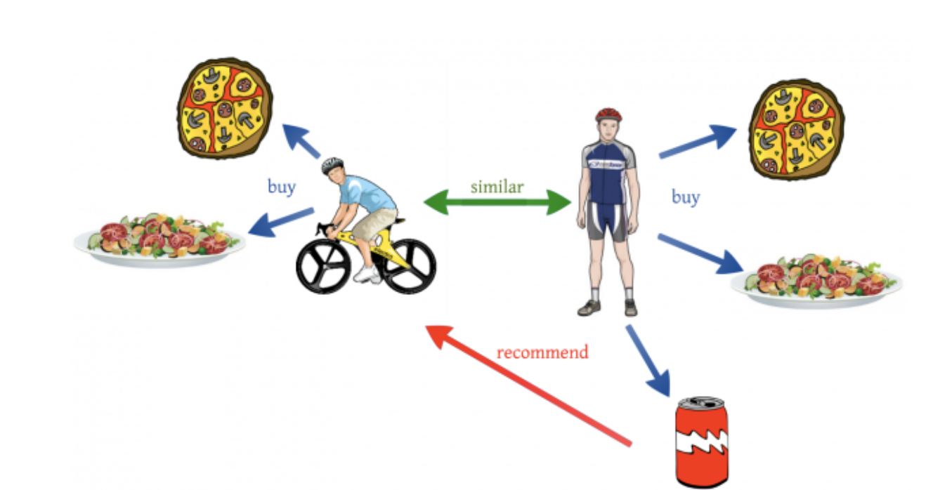

Variations on this type of recommendation system include:

**By User Similarity**

This strategy involves creating user groups by comparing users’ activities and providing recommendations that are popular among other members of the group. It is useful on sites with a strong but versatile audience quickly provide recommendations for a user on which little information is available.

**By Association:** Thisis a specific type of the one mentioned above, otherwise known as “Users who looked at X also looked at Y.” Implementing this type of recommendation system is a matter of looking at purchasing sequences or purchasing groups, and showing similar content. This strategy is useful for capturing recommendations related to naturally complementary content as well as at a certain point in the life of the user.

## **2 — Content-Based**

Content-based systems make recommendations based on the user’s purchase or consumption history and generally become more accurate the more actions (inputs) the user takes.

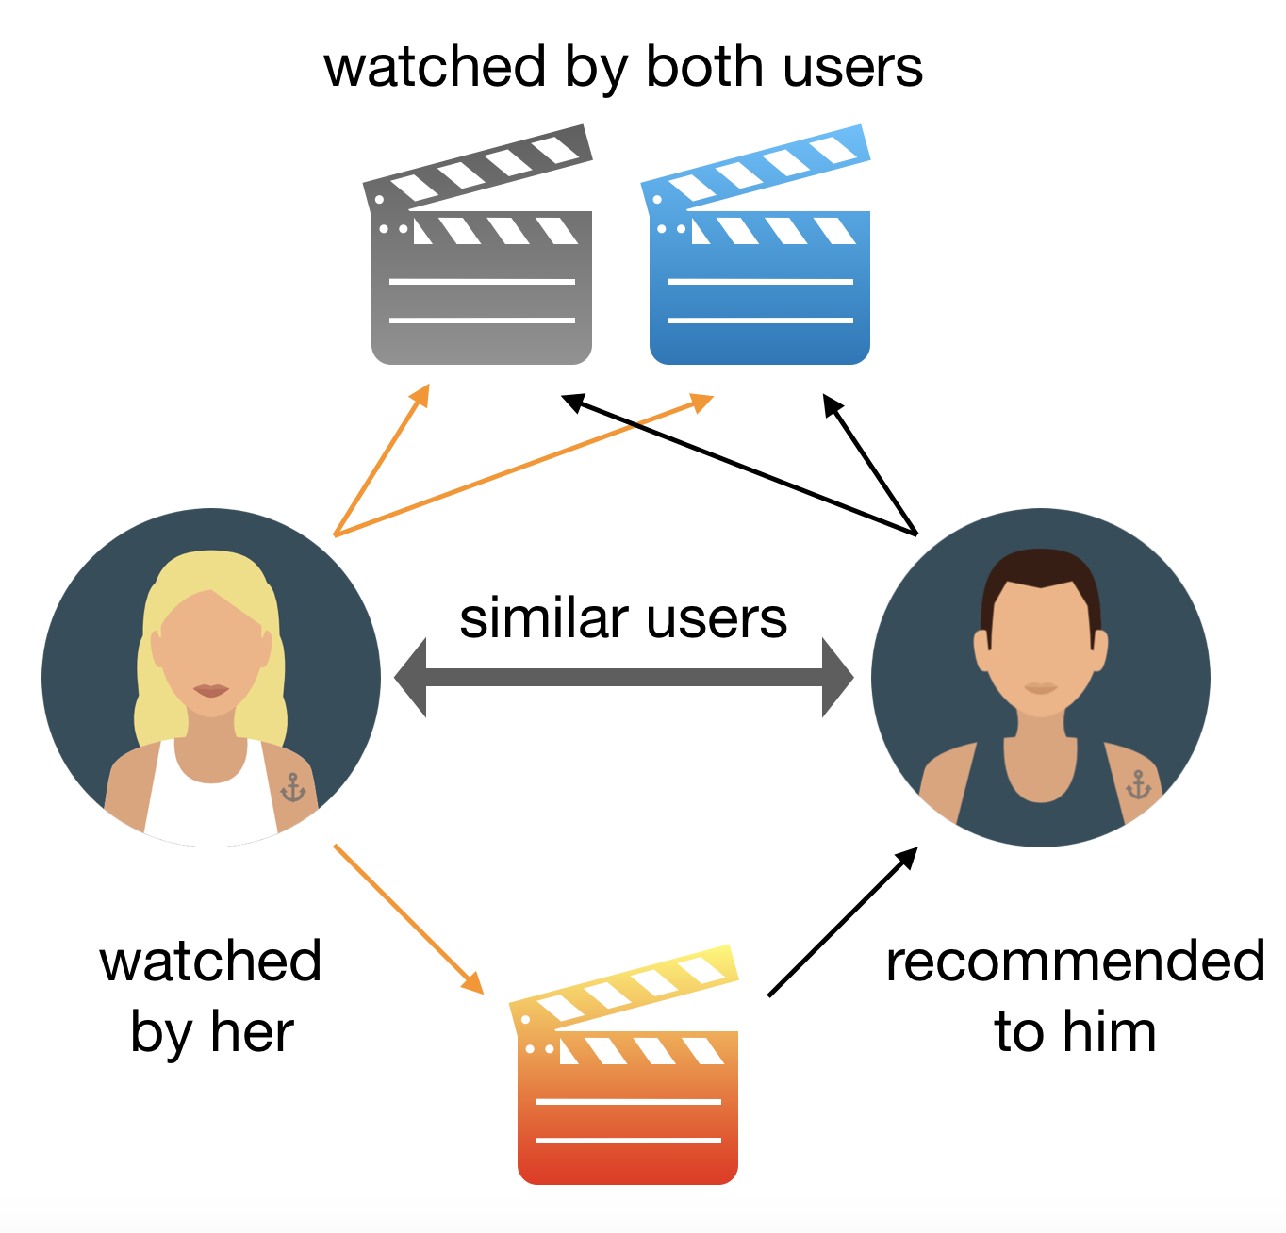

More specific types of content-based recommendation systems include:

**By Content Similarity:** As the most basic type of content-based recommendation system, this strategy involves recommending content that is close based on its metadata. This approach makes sense for catalogs with a lot of rich metadata and where traffic is low compared to the number of products in the catalog.

**By Latent Factor Modeling:**Going one step further than the content similarity approach, the crux of this strategy is inferring individuals’ inherent interests by assuming that previous choices are indicative of certain tastes or hobbies. Where the previous strategy is based on explicit, manually filled catalog metadata, this strategy hinges on discovering implicit relationships. This is done by using the history of users’ larger interactions (e.g., movie watched, item purchased, etc.) to learn these tastes.

**By Topic Modeling:**This is a variant of the Latent Factor Modeling strategy, whereby instead of considering users’ larger actions, one would infer interests by analyzing unstructured text to detect particular topics of interest. It is particularly interesting for use cases with rich but unstructured textual information (such as news articles).

**By Popular Content Promotion:**This involves highlighting product recommendations based on the product’s intrinsic features that may make it interesting to a wide audience: price, feature, popularity, etc. This strategy can also take into account the freshness or age of the content and thus enable using the most trendy content for recommendations. This is often used in cases where new content is the majority.