**Train & Test Cross Validation:-**

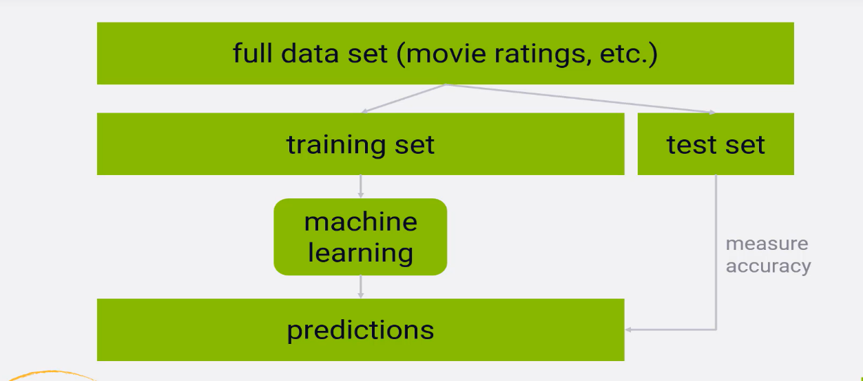

**Discussion:-**

A big part of why recommender systems are as much art as they are science,

is that it's difficult to measure how good they are .There's a certain aesthetic quality to the results they give you, and it's hard to say whether a person considers the recommendation to be good or not .Especially if you're developing your algorithms offline . People have come up with a lot of different ways to measure the quality of a recommender system and often, different measurements can be at odds with each other . But let's go through the more popular metrics for recommender systems,

as they all have their own uses. First, let's talk about the methodology for testing recommender systems offline . If you've done machine learning before , you're probably familiar with the concept of train/test splits . A recommender system is a machine learning system . You train it using prior user behaviour ,and then use it to make predictions about items new users might like . So on paper at least , you can evaluate a recommender system just like any other machine learning system.

**Here's how it works:-**

You measure your recommender system's ability to predict how people rated things in the past . But to keep it honest , you start by splitting up your ratings data into

a training set, and a testing set . Usually the training set is bigger , say 80 or 90 percent of all of your data, and you randomly assign ratings into one or the other.

So you train your recommender system using only the training data .This is where it learns the relationships it needs between items or between users . Once it's trained, you can ask it to make predictions about how a new user might rate some item

they've never seen before . So to measure how well it does , we take the data we reserved for testing .These are ratings that our recommender system has never seen before . So that keeps it from cheating . Let's say one rating in our test set says that the user actually rated the movie "Up" five stars .We just ask the recommender system how it thinks this user would rate "Up" without telling it the answer . And then we can measure how close it came to the real rating . If you do this over enough people, you can end up with a meaningful number that tells you how good your recommender system is at recommending things , or more specifically, recommending things people already watched and rated . That's really all you can do,

**K-fold Cross-Validation:-**

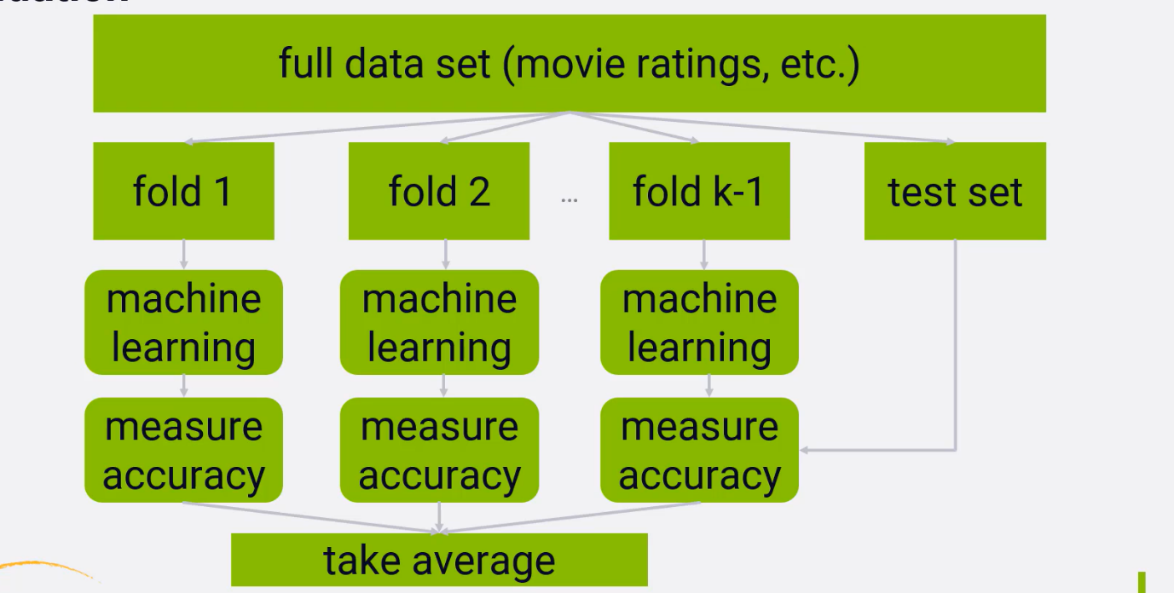

**Discussion:-**

it's possible to improve on a single train/test split by using a technique called k-fold cross validation. It's the same idea as train/test, but instead of a single training set,

we create many randomly assigned training sets . Each individual training set, or fold ,is used to train your recommender system independently , and then we measure the accuracy of the resulting systems against your test set . So we end up with a score of how accurately each fold ends up predicting user ratings , and we can average them together. This obviously takes a lot more computing power to do, but the advantage is that you don't end up over-fitting to a single training set.If your training data is small , you run the risk of optimizing for the ratings that are specifically in your training set instead of the test set . So k-fold cross-validation provides some insurance against that , and insures that you create a recommender system that works for any set of ratings , not just the ones in the training set that you happed to choose

**Measuring Accuracy of Both System:-**

To reiterate, train/test and k-fold cross-validation are ways to measure the accuracy of your

recommender system. That is, how accurately you can predict how users rated movies they have already seen and provided a rating for . But that's an important point . By using train/test, all we can do is test our ability to predict how people rated movies they already saw. That's not the point of a recommender system.

We want to recommend new things to people that they haven't seen, but find interesting.

However, that's fundamentally impossible to test offline. So researchers who can't just test out new algorithms on real people, on Netflix or Amazon, or whatever,

have to make do with approaches like this. We haven’t talked about how to actually come up with an accuracy metric when testing our recommender system , so let's cover a couple of different ways to do it.

**Mean Absolute Error (MAE):-**

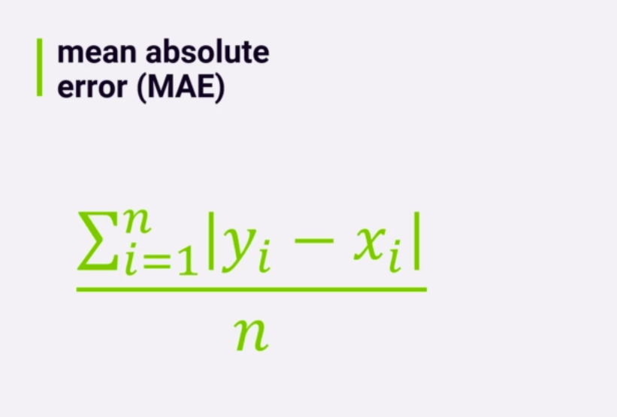

The most straightforward metric is mean absolute error or MAE. Here is the fancy, mathematical equation for how to compute it. It's not as complicated as it looks.

So, let's break it down. Let's say we have n ratings in our test set that we want to evaluate, for each rating we can call the rating or system predicts y, and the rating the user actually gave x. Just take the absolute value of the difference between the two, to measure the error for that rating prediction .It's literally just the difference

between the predicted rating and the actual rating. We sum those errors up across all n ratings in our test set, and divide by n to get the average, or mean. So mean absolute error is exactly that, the mean or average absolute values of each error in rating predictions. Remember error is bad, so you want

the lowest MAE score you can get, not the highest.