Superset Id:-6361766

**Exercise 1: Implementing the Singleton Pattern**

Code:-

File:- Main.java

public class Main {

    public static void main(String[] *args*) {

        Logger logger1 = Logger.getInstance();

        logger1.log("This is the first log message.");

        Logger logger2 = Logger.getInstance();

        logger2.log("This is the second log message.");

        if (logger1 == logger2) {

            System.out.println("Both logger1 and logger2 refer to the same instance.");

        } else {

            System.out.println("Different instances exist.");

        }

    }

}

File:-Logger.java

public class Logger {

    private static Logger instance;

    private Logger() {

        System.out.println("Logger Initialized");

    }

    public static Logger getInstance() {

        if (instance == null) {

            instance = new Logger();

        }

        return instance;

    }

    public void log(String *message*) {

        System.out.println("[LOG]: " + message);

    }

}

Ouput:-

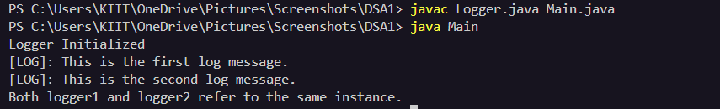

**Exercise 2: Implementing the Factory Method Pattern**

**// Document.java**

**public interface Document {**

**void open();**

**}**

**// WordDocument.java**

**public class WordDocument implements Document {**

**public void open() {**

**System.out.println("Opening Word Document");**

**}**

**}**

**// PdfDocument.java**

**public class PdfDocument implements Document {**

**public void open() {**

**System.out.println("Opening PDF Document");**

**}**

**}**

**// ExcelDocument.java**

**public class ExcelDocument implements Document {**

**public void open() {**

**System.out.println("Opening Excel Document");**

**}**

**}**

**// DocumentFactory.java**

**public abstract class DocumentFactory {**

**public abstract Document createDocument();**

**}**

**// WordDocumentFactory.java**

**public class WordDocumentFactory extends DocumentFactory {**

**public Document createDocument() {**

**return new WordDocument();**

**}**

**}**

**// PdfDocumentFactory.java**

**public class PdfDocumentFactory extends DocumentFactory {**

**public Document createDocument() {**

**return new PdfDocument();**

**}**

**}**

**// ExcelDocumentFactory.java**

**public class ExcelDocumentFactory extends DocumentFactory {**

**public Document createDocument() {**

**return new ExcelDocument();**

**}**

**}**

**// Mainn.java**

**public class Mainn {**

**public static void main(String[] args) {**

**DocumentFactory wordFactory = new WordDocumentFactory();**

**Document wordDoc = wordFactory.createDocument();**

**wordDoc.open();**

**DocumentFactory pdfFactory = new PdfDocumentFactory();**

**Document pdfDoc = pdfFactory.createDocument();**

**pdfDoc.open();**

**DocumentFactory excelFactory = new ExcelDocumentFactory();**

**Document excelDoc = excelFactory.createDocument();**

**excelDoc.open();**

**}**

**}**

**Output:-**

