Superset id:--6361766

**NUNIT HANDSON 1**

**TestFixture & Test**

**Code:- inside CalculatorTests.cs**

using CalcLibrary;

using NUnit.Framework;

using System;

using System.Collections.Generic;

using System.Linq;

using System.Text;

using System.Threading.Tasks;

namespace CalcLibraryTests

{

[TestFixture]

public class CalculatorTests

{

private SimpleCalculator _calculator;

[SetUp]

public void SetUp()

{

_calculator = new SimpleCalculator();

}

[TearDown]

public void TearDown()

{

_calculator = null;

}

[Test]

[TestCase(2, 3, 5)]

[TestCase(0, 0, 0)]

[TestCase(-1, 1, 0)]

[TestCase(100, 200, 300)]

public void Addition_WhenCalled_ReturnsExpectedResult(double a, double b, double expected)

{

var result = _calculator.Addition(a, b);

Assert.That(result, Is.EqualTo(expected));

}

}

}

**Ouput:-**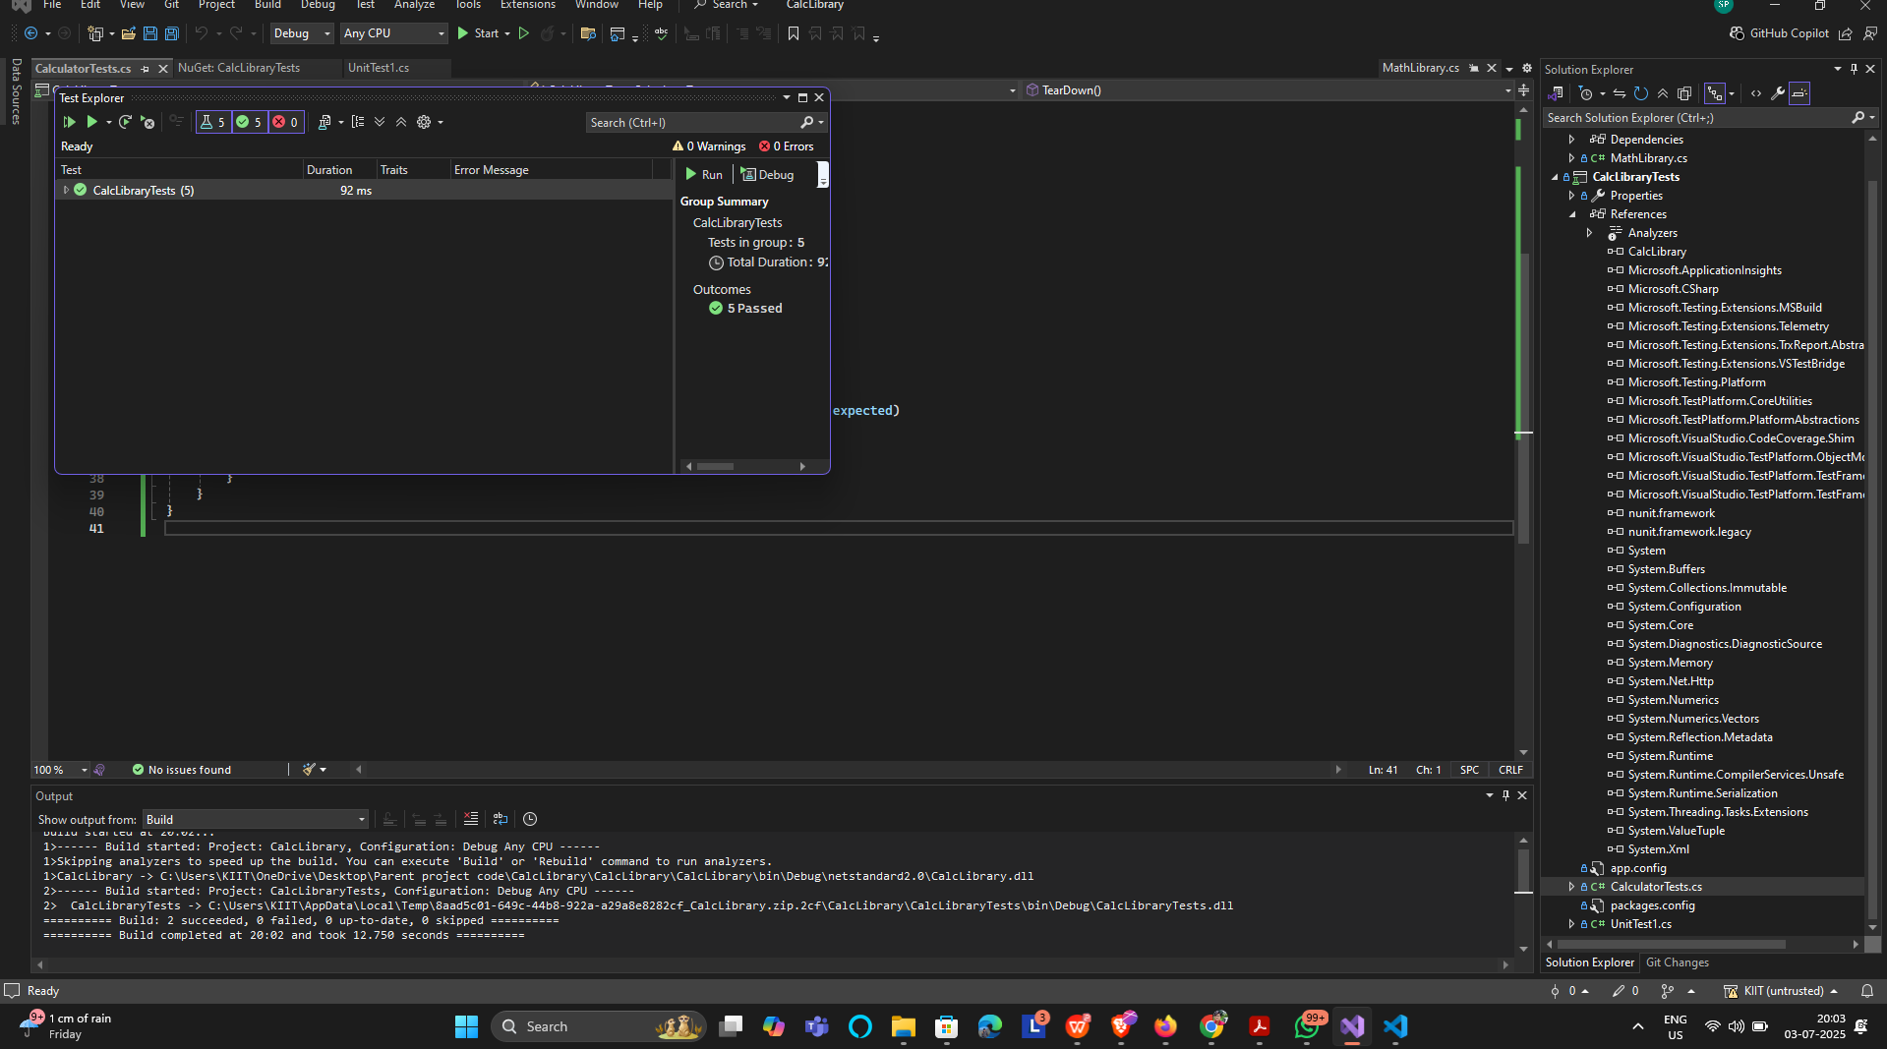

**1.2Testable code for MOQ**

using NUnit.Framework;

using Moq;

using MagicFilesLib;

using System.Collections.Generic;

namespace MagicFilesLib.Tests

{

[TestFixture]

public class DirectoryExplorerTests

{

[Test]

public void GetFiles_ReturnsMockedFileList()

{

// Arrange

var mockExplorer = new Mock<IDirectoryExplorer>();

var expectedFiles = new List<string> { "file1.txt", "file2.docx" };

mockExplorer

.Setup(de => de.GetFiles("C:\\MockPath"))

.Returns(expectedFiles);

// Act

var result = mockExplorer.Object.GetFiles("C:\\MockPath");

// Assert

Assert.That(result, Is.EqualTo(expectedFiles));

}

}

}

Ouput:-

