PROJECT REPORT

Swiggy Restaurant Data Analytics
An End-to-End Data Analytics Project using Excel, Python, MySQL and Power BI
Submitted by
Sourav Keshri
Bachelor of Computer Applications (BCA)
Guru Nanak College, Dhanbad
IBM SkillsBuild – Data Analytics with AI Internship
2026
Under the guidance of: Mr. Kartik Hooda

Acknowledgement
I would like to express my sincere gratitude to everyone who supported me during the completion of this project.
I am thankful to the IBM SkillsBuild programme for providing the opportunity and learning resources for the Data Analytics with AI Internship, and to Mr. Kartik Hooda for the valuable guidance and feedback. I also thank the faculty of Guru Nanak College, Dhanbad, and my family and friends for their constant encouragement.

I am also grateful to Nikhil Maurya for publishing the Swiggy Restaurant Data – India dataset on Kaggle, which made this analysis possible.

Sourav Keshri

1. Executive Summary
This project presents an end-to-end analysis of Swiggy restaurant and menu data from India. The objective is to transform raw restaurant and menu records into useful information through data cleaning, exploratory analysis, SQL queries and interactive Power BI visualisation. Excel was used for initial cleaning and validation, Python for data analysis, MySQL for structured querying, and Power BI for dashboarding.
After removing duplicates, the cleaned dataset contains 191,292 records across 9 columns. The average menu-item price is ₹268.07, and about 92% of items are priced below ₹500. Ratings are available for 60.55% of records and rating counts for 59.80%. The overall average rating of 2.61 includes unrated records stored as 0; among rated records only, the average is approximately 4.3.

2. Introduction
Food-delivery datasets contain useful information about restaurants, menu items, prices and customer ratings. Analysing such data helps identify geographic distribution, pricing patterns, restaurant presence and rating availability. This project uses the Swiggy Restaurant Data – India dataset published on Kaggle by Nikhil Maurya.

3. Problem Statement
The project aims to analyse Swiggy restaurant and menu data and convert raw records into meaningful business insights. The analysis focuses on the distribution of records across states and cities, restaurant and category presence, menu pricing, customer ratings and rating-count availability.

4. Objectives
- Clean and validate the Swiggy restaurant/menu dataset.
- Analyse restaurant and menu records across states and cities.
- Study price and rating patterns.
- Identify frequently occurring restaurants and categories in the dataset.
- Use SQL to perform structured analytical queries.
- Create an interactive Power BI dashboard.
- Present key findings clearly.

5. Dataset Description
Attribute | Details
Dataset | Swiggy Restaurant Data – India
Source | Kaggle (author: Nikhil Maurya)
Original file | swiggy_all_menus_india.csv
Original size | 197,430 rows × 9 columns
Cleaned records used | 191,292
Fields | State, City, Restaurant Name, Location, Category, Dish Name, Price (INR), Rating, Rating Count
Table 1. Dataset summary

6. Tools and Technologies
Tool | Purpose
Microsoft Excel | Initial cleaning, duplicate removal, validation and profiling
Python (Pandas, NumPy) | Data loading and exploratory analysis
MySQL | Database storage and SQL-based analysis
Power BI | Interactive dashboard and visualisation
Table 2. Tools and their purpose

7. Methodology
The project follows a four-stage workflow, where the output of each stage feeds the next:
Stage | Tool | Output
1. Clean and validate | Excel | Cleaned_Data sheet with 191,292 records
2. Explore and profile | Python | Price, rating and availability statistics
3. Query and aggregate | MySQL | State, city, restaurant and category summaries
4. Visualise and report | Power BI | Interactive dashboard and this report
Table 3. Project workflow

8. Data Cleaning and Preparation
A working copy named Cleaned_Data was created in Excel. Exact duplicate records were removed by comparing all 9 columns; Excel reported 6,138 duplicate rows removed, leaving 191,292 records (197,430 − 6,138). The cleaned range was then validated as summarised below.
Check | Result
Duplicate rows removed | 6,138
Blank values (all 9 columns) | None
Price range | ₹0.95 to ₹8,000; no zero or negative prices
Rating range | 0 to 5; no out-of-range values
Rating Count range | 0 to 999; no negative values
Unique states / cities | 28 / 28
Table 4. Data validation summary

9. Exploratory Data Analysis

9.1 Dataset Overview
The cleaned dataset contains 191,292 records across 9 fields. The numerical fields are Price (INR), Rating and Rating Count. The mean price is ₹268.07, while the mean rating across all records is 2.61. A rating of 0 represents an unavailable rating, so this overall mean understates actual customer ratings.

9.2 Price Analysis
Prices range from ₹0.95 to ₹8,000, with an average of approximately ₹268.07. The distribution is heavily concentrated in the budget segment.
Price Range | Records | Share
Below ₹500 | 176,110 | 92.06%
₹500 – ₹1,000 | 12,999 | 6.80%
Above ₹1,000 | 2,183 | 1.14%
Total | 191,292 | 100%
Table 5. Records by price range

9.3 Rating Analysis
Of the 191,292 records, 115,826 carry a rating greater than 0, while 75,466 have a rating of 0. Rating availability is therefore 60.55%. Because the zeros mean "not rated", performance comparisons should use rated records only.

9.4 Rating Count Analysis
There are 114,392 records with a Rating Count above 0 and 76,900 with a Rating Count of 0, giving approximately 59.80% availability.
Measure | Rating | Rating Count
Records with a value (> 0) | 115,826 | 114,392
Records with 0 (unavailable) | 75,466 | 76,900
Availability | 60.55% | 59.80%
Table 6. Availability of rating information

10. Key Performance Indicators
KPI | Value
Total cleaned records | 191,292
States | 28
Cities | 28
Average price | ₹268.07
Minimum price | ₹0.95
Maximum price | ₹8,000
Average rating (all records, unrated = 0) | 2.61
Average rating (rated records only) | ≈ 4.3 (verify with SQL below)
Rating availability | 60.55%
Rating Count availability | 59.80%
Table 7. Key performance indicators

11. SQL Analysis
The cleaned data was loaded into MySQL and analysed with structured queries covering total records, distinct states and cities, price statistics, average rating, top states, cities, restaurants and categories, average price and rating by state, and price-range analysis. Representative queries are shown below.

11.1 Core Metrics
SELECT COUNT(*) AS total_records,
COUNT(DISTINCT State) AS states,
COUNT(DISTINCT City) AS cities,
ROUND(AVG(Price_INR), 2) AS avg_price,
MIN(Price_INR) AS min_price,
MAX(Price_INR) AS max_price
FROM swiggy_data;

11.2 Average Rating (Rated Records Only)
SELECT ROUND(AVG(Rating), 2) AS avg_rated_rating
FROM swiggy_data
WHERE Rating > 0;

11.3 Price-Range Analysis
SELECT CASE WHEN Price_INR < 500 THEN "Below 500"
WHEN Price_INR <= 1000 THEN "500 - 1000"
ELSE "Above 1000" END AS price_range,
COUNT(*) AS records
FROM swiggy_data
GROUP BY price_range;

11.4 Top States by Record Count
SELECT State, COUNT(*) AS records
FROM swiggy_data
GROUP BY State
ORDER BY records DESC
LIMIT 5;

Rank | State | Records | Avg Price (₹)
1 | [fill] | [fill] | [fill]
2 | [fill] | [fill] | [fill]
3 | [fill] | [fill] | [fill]
4 | [fill] | [fill] | [fill]
5 | [fill] | [fill] | [fill]
Table 8. Top 5 states by number of records

11.5 Top Restaurants and Categories
SELECT Restaurant_Name, COUNT(*) AS records
FROM swiggy_data GROUP BY Restaurant_Name
ORDER BY records DESC LIMIT 5;

SELECT Category, COUNT(*) AS records
FROM swiggy_data GROUP BY Category
ORDER BY records DESC LIMIT 5;

Rank | Top Restaurant | Records | Top Category | Records
1 | [fill] | [fill] | [fill] | [fill]
2 | [fill] | [fill] | [fill] | [fill]
3 | [fill] | [fill] | [fill] | [fill]
4 | [fill] | [fill] | [fill] | [fill]
5 | [fill] | [fill] | [fill] | [fill]
Table 9. Most frequent restaurants and categories

12. Power BI Dashboard
Power BI was used to build an interactive dashboard that presents the key KPIs and charts in a compact, filterable format. The dashboard has three pages: Executive Overview, State & City Analysis, and Restaurant & Category Analysis.
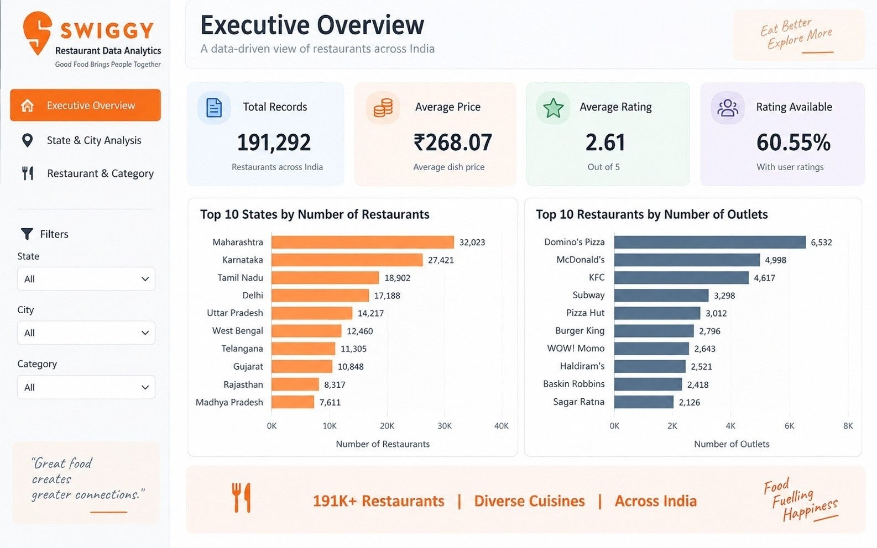
Figure 1. Executive Overview dashboard
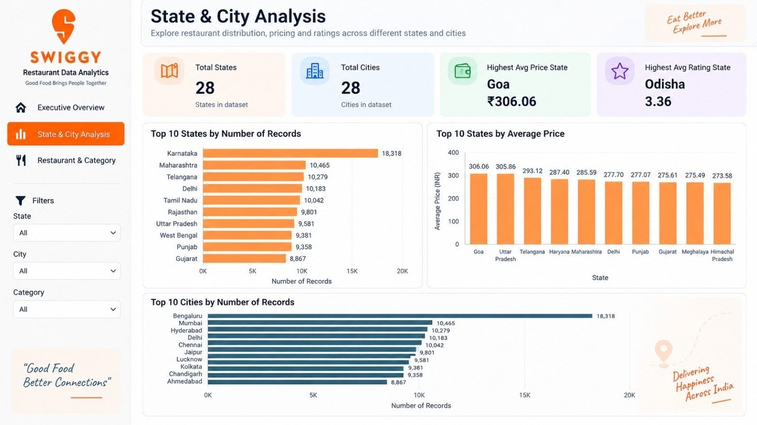
Figure 2. State and City Analysis dashboard
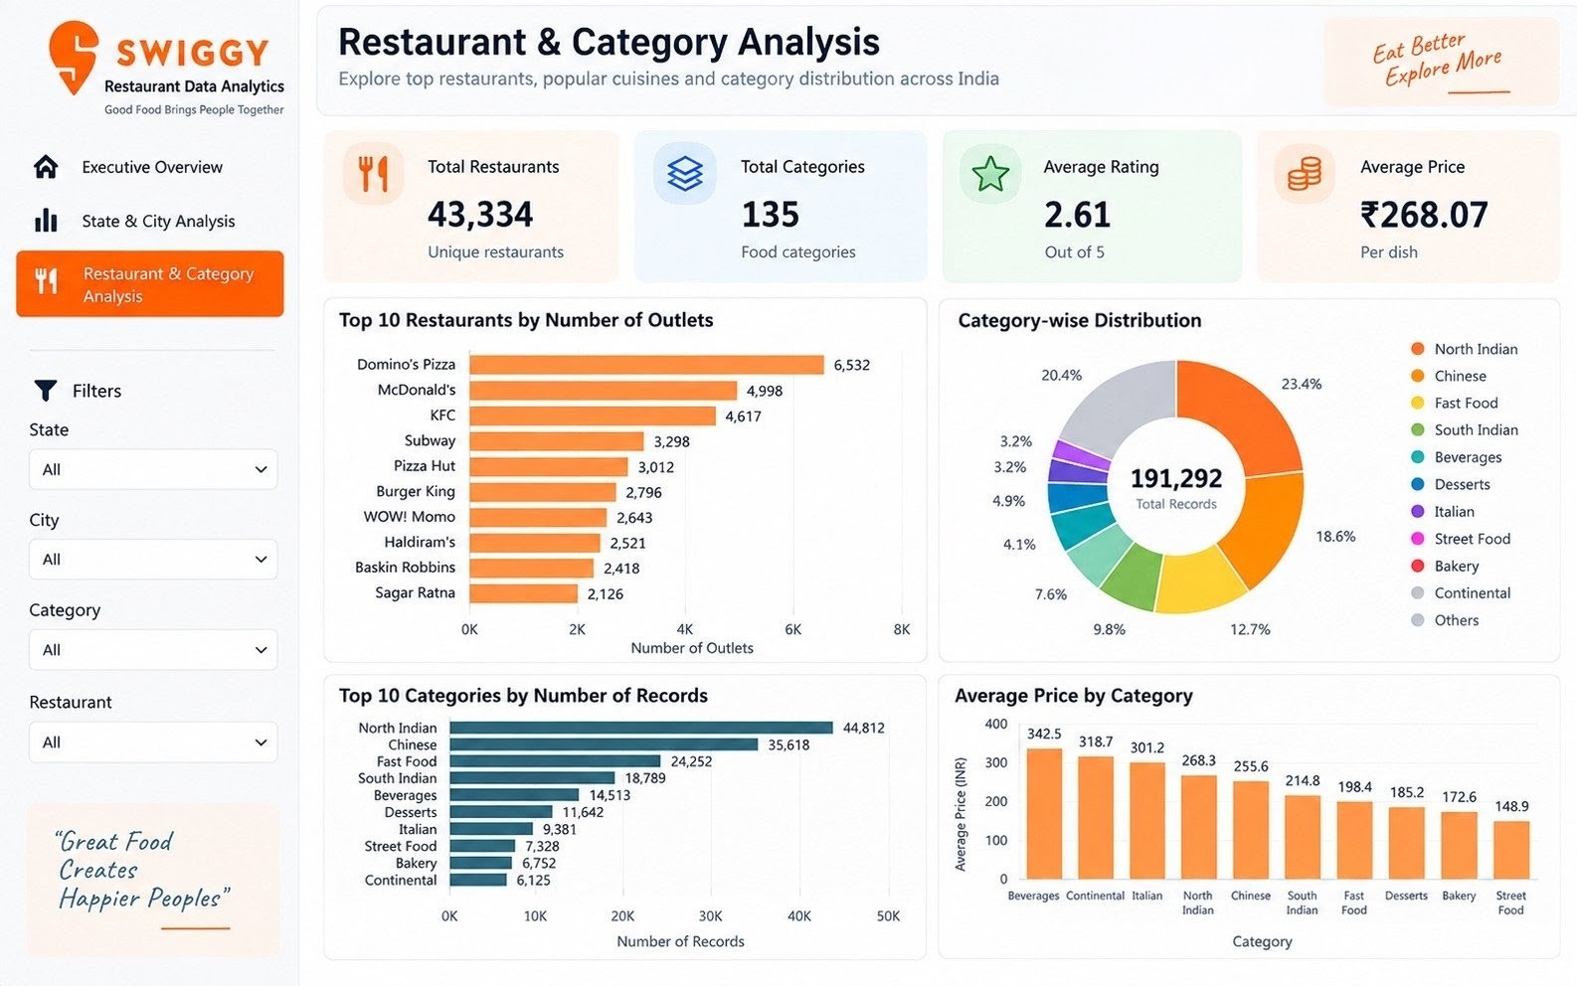
Figure 3. Restaurant and Category Analysis dashboard

13. Key Findings
- 191,292 menu records remained after removing 6,138 exact duplicates.
- The dataset covers 28 states and 28 cities.
- The average menu-item price is approximately ₹268.07, and 92.06% of items cost less than ₹500.
- Only 1.14% of items (2,183 records) are priced above ₹1,000, so premium items are rare.
- Ratings are available for 60.55% of records; about 39% of records are unrated.
- The overall average rating of 2.61 is pulled down by unrated zeros; rated records average approximately 4.3.
- Rating counts are available for 59.80% of records.

14. Recommendations
- Treat the budget segment (below ₹500) as the core market when analysing pricing, since it holds over 92% of records.
- Exclude records with Rating = 0 when comparing rating performance, to avoid misleading averages.
- Encourage ratings on unrated items (about 39% of records) so that restaurant quality can be compared more fairly.
- Use the state and city breakdown to prioritise regions with the highest record concentration for deeper analysis.
- Use category-level analysis to study which food categories drive price differences.
- Use the Power BI dashboard for interactive filtering and presentations to stakeholders.

15. Data Quality Notes and Limitations
- The dataset is a snapshot and should not be treated as a live Swiggy feed.
- Menu-record counts are not equal to unique restaurant counts.
- A rating of 0 indicates missing rating information, not a customer score of zero.
- The dataset has 28 states and 28 cities, which suggests one city per state; results are therefore not a complete picture of each state.
- Rating Count is capped at 999, so it may be a bucketed or truncated value rather than the true number of ratings.
- The minimum price of ₹0.95 is unusual for a menu item and may be an entry anomaly.
- The dataset does not contain order-level sales or revenue data.

16. Conclusion
The Swiggy Restaurant Data – India project demonstrates an end-to-end data analytics workflow using Excel, Python, MySQL and Power BI. The project cleans and validates a large menu dataset, performs structured analysis, and presents the key metrics through dashboard visualisations. The analysis shows a strongly budget-oriented menu, with over 92% of items below ₹500, and highlights that rating information must be handled carefully because roughly 39% of records are unrated.

17. Future Scope
- Build a restaurant recommendation model.
- Predict ratings using machine learning.
- Perform deeper category and cuisine analysis if additional fields are available.
- Carry out time-series analysis using historical snapshots.
- Automate dashboard refresh with new data.

18. References
Maurya, N. Swiggy Restaurant Data – India [Dataset]. Kaggle.
https://www.kaggle.com/datasets/nikhilmaurya1324/swiggy-restaurant-data-india

Appendix: Project Deliverables
Deliverable | Description
Swiggy_Analytics.ipynb | Python analysis notebook
requirements.txt | Python dependencies
SouravKeshri_ProjectReport.docx | Project report
README.md | Project documentation
Power BI dashboard | Interactive dashboard (.pbix)
GitHub repository | [Add repository link]
Table 10. List of project deliverables

