Lab Report : 02

* + - **Title** : Configuration and Implementation of Multiple LAN Network

1. **State of the problem:**

Make a network using switch and router.

**2. Hypothesis:**

Sending message using switch and router from one pc to another pc

**3. Materials:**

* 3 switch
* 4 PCs
* 2 Router

**4. Procedure:**

a. At first we implement the Cisco Packet Tracer software by opening a new file.

b. Then we connect 2 routers with one switch. Then we connect 2 routers with two different switch. Then we connect 4 pcs with 2 switch,2 pcs with each switch.

c. Now we will set the IP address to the pcs along with subnet mask and default gateway.

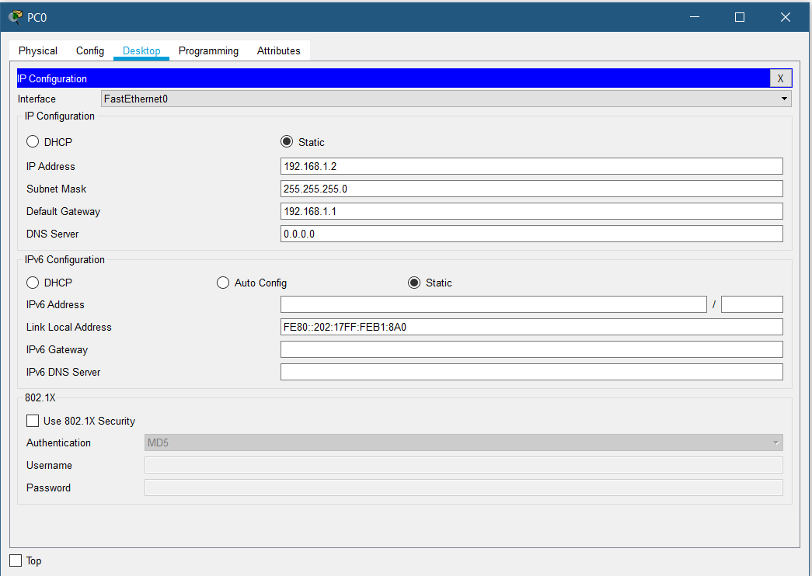

Figure : 1

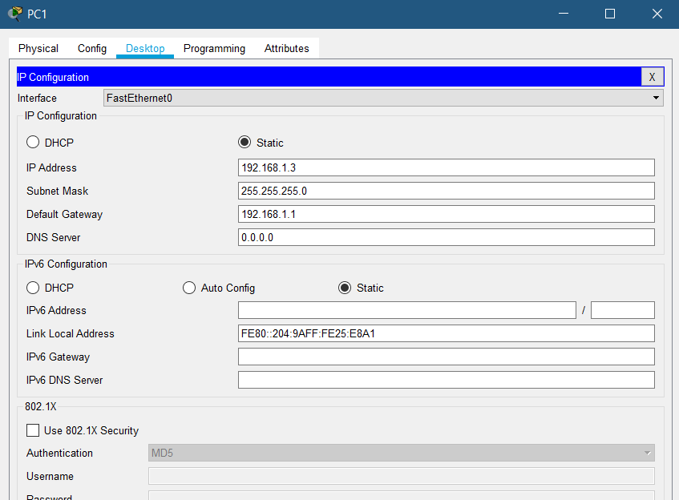

Figure : 2

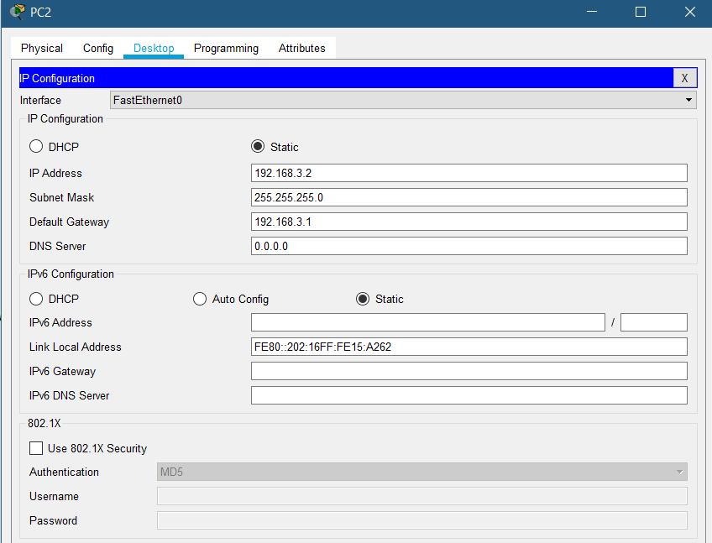

Figure : 3

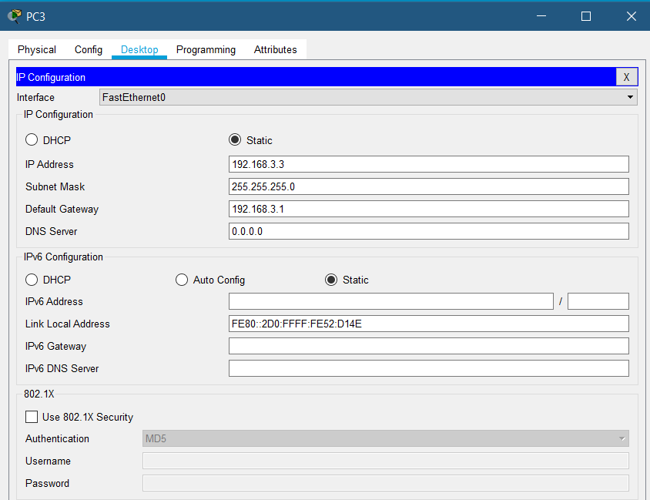

Figure : 4

PC0 IP address=192.168.1.2 , Default Gateway=192.168.1.1

PC1 IP address=192.168.1.3 , Default Gateway=192.168.1.1

PC2 IP address=192.168.3.2 , Default Gateway=192.168.3.1

PC3 IP address=192.168.3.3 , Default Gateway=192.168.3.1

d.Then we will set the IP addresses of the routers.

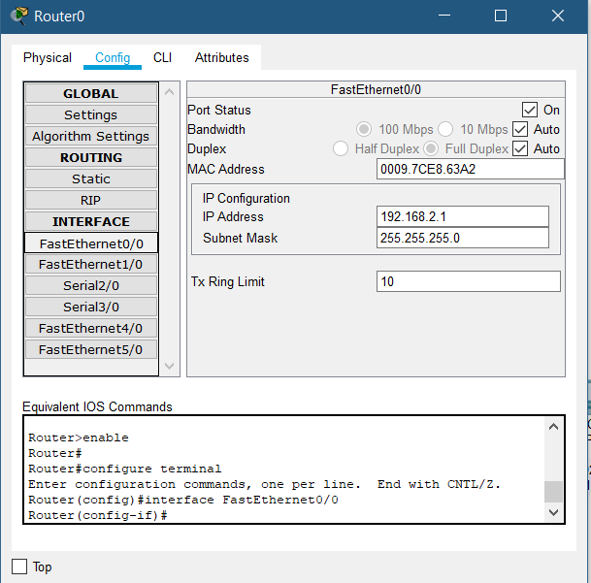

Figure : 5

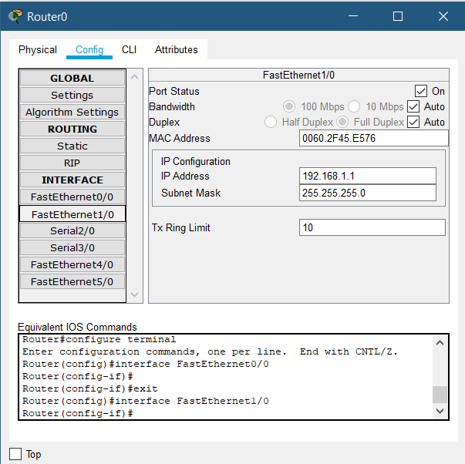

Figure :6

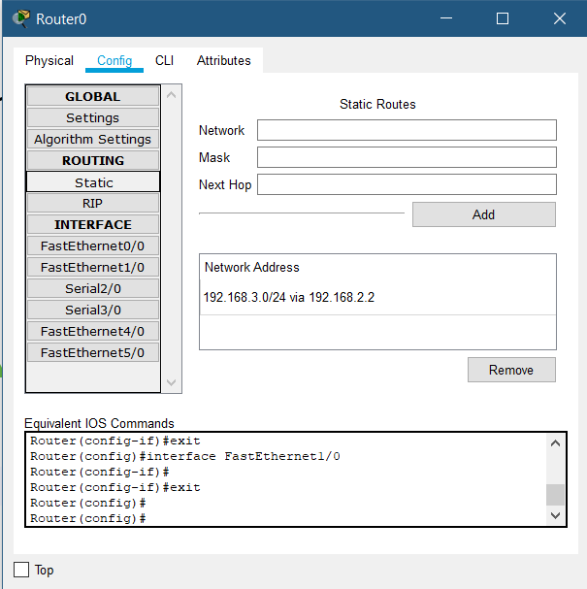

Figure :7

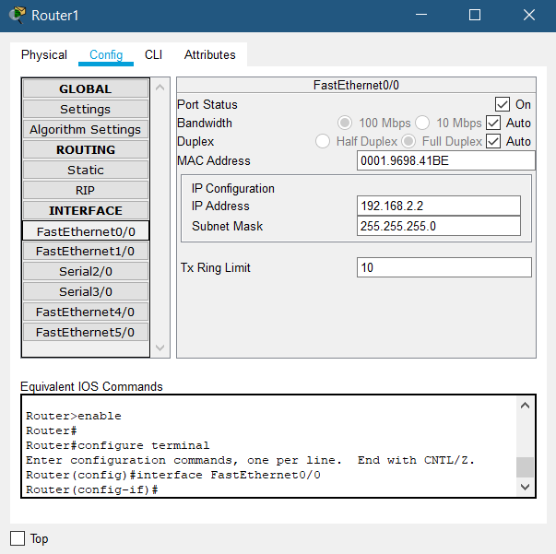

Figure : 8

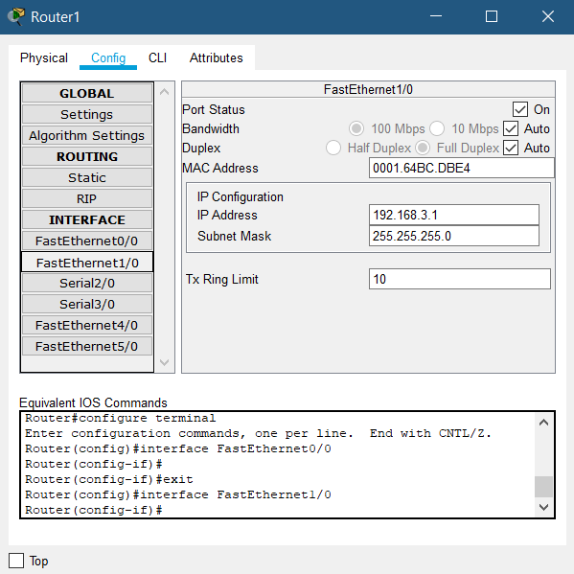

Figure :9

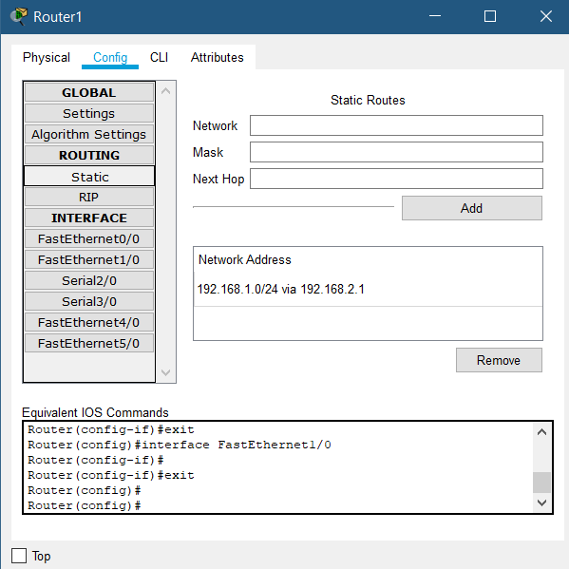

Figure :10

e . Just only a moment later I noticed that the indicating lights turned into green.

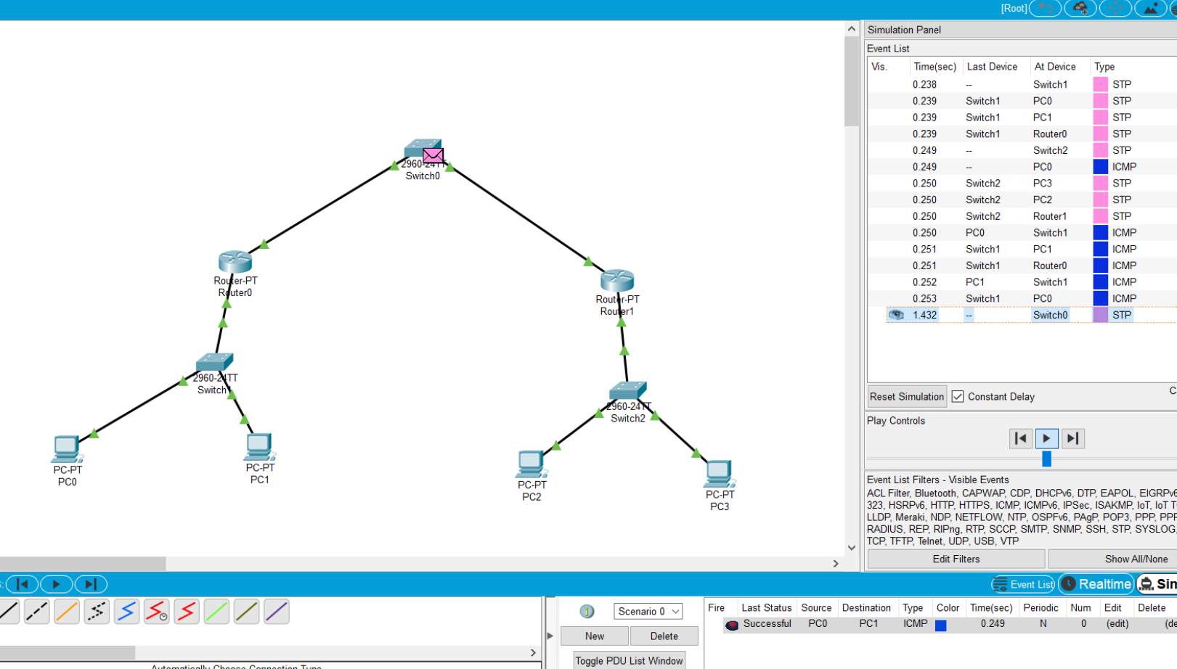

Figure : 11

f. Then we will switch from real time mode to simulation mode.

g . We take simple PDU to transfer from one Pc to another and click on auto capture / play button to see how the message transfers. We can also observe the simulation step by step by clicking on the button capture /forward.

5 . Result:



6. Discussions:

* We must check all the connections and IP address to ensure successful data transfer.
* If the number of computer increases, then the communication will become more complex.
* Switching speed is an important factor here.