**LAB REPORT: 4**

**Title:** Configuration router using CLI & Implementation of Multiple LAN Network.

**Problem Statement:** To learn how to configure multiple router for packet transmission in Cisco packet tracer simulation software using CLI

**Hypothesis:** At first we made a proper connection by setting up IP address of each PC and provide a proper router configuration for packet transmission between two or more LAN. Materials: Cisco Packet Tracer Software.

**Materials:**

* Cisco Packet Tracer Software

**Procedure:**

* Design the connection using Cisco Packet Tracer Software like figure 1.

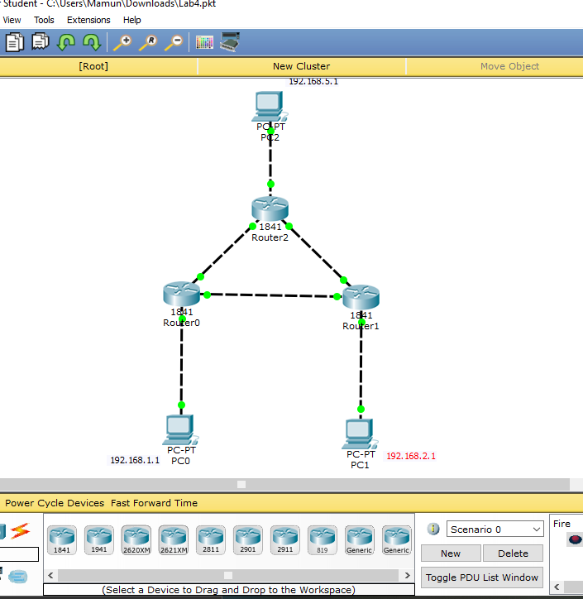

Figure:01

* Set IP address for each PC

PC0 IP address =192.168.1.1 , Default Gateway = 192.168.1.2

PC1 IP address =192.168.2.1 , Default Gateway = 192.168.2.2

PC2 IP address =192.168.5.1 , Default Gateway = 192.168.5.2

* Set Command
  + - Command for router 0:
      * no
      * en
      * conf t
      * int fa 0/0
      * ip add 192.168.1.2 255.255.255.0
      * no shut
      * exit
      * int fa 0/1
      * ip add 192.168.6.1 255.255.255.0
      * no shut
      * exit
      * int Eth 0/1/0
      * ip add 192.168.3.1 255.255.255.0
      * no shut
      * end
      * wr
    - Command for router 1:
      * no
      * en
      * conf t
      * int fa 0/0
      * ip add 192.168.6.2 255.255.255.0
      * no shut
      * exit
      * int fa 0/1
      * ip add 192.168.2.2 255.255.255.0
      * no shut
      * exit
      * int Eth 0/1/0
      * ip add 192.168.4.1 255.255.255.0
      * no shut
      * end
      * wr
    - Command for router 2:
      * no
      * en
      * conf t
      * int fa 0/0
      * ip add 192.168.3.2 255.255.255.0
      * no shut
      * exit
      * int fa 0/1
      * ip add 192.168.4.2 255.255.255.0
      * no shut
      * exit
      * int Eth 0/1/0
      * ip add 192.168.5.1 255.255.255.0
      * no shut
      * end
      * wr
* Now we with do the routing between router0, router1 and router2 using the following command:
  + - Router 0:
      * en
      * conf t
      * ip route 192.168.2.0 255.255.255.0 192.168.6.2
      * end
      * en
      * conf t
      * ip route 192.168.5.0 255.255.255.0 192.168.3.2
      * end
      * sh ip route
    - Router 1:
      * en
      * conf t
      * ip route 192.168.1.0 255.255.255.0 192.168.6.1
      * end
      * en
      * conf t
      * ip route 192.168.5.0 255.255.255.0 192.168.4.2
      * end
      * sh ip route
    - Router 3:
      * en
      * conf t
      * ip route 192.168.1.0 255.255.255.0 192.168.3.1
      * end
      * en
      * conf t
      * ip route 192.168.2.0 255.255.255.0 192.168.4.1
      * end
      * sh ip route

**Result:**

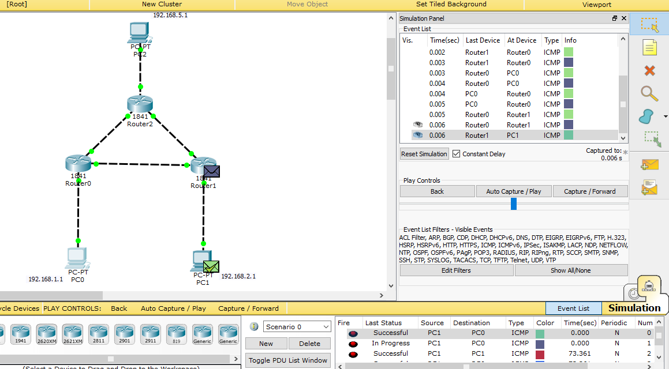  
 Figure:02

**Conclusion:**

* The hypothesis is accepted because we successfully sent and receive the packet**.**
* While configuring the PC we have to be very careful with the IP Address and commands.