

**DECLARATION**

“I declare that this report entitled “ROBOTIC ARM USING INVERSE KINEMATICS” is the result of my own research except as cited in the references.The report has not been accepted for any degree and is not concurrently submitted in candidature of any other degree.”

Signature :

Name : ANKAN POLLEY

EJAZ AHMED

SOURAV DAS

VISHAL SAMANTA

Date :

CERTIFICATE OF TRAINING

This is to certify that Industrial Training Report entitled

**“ROBOTIC ARM USING INVERSE KINEMATICS”**

Is a record of bona fide work done by

**ANKAN POLLEY**

**EJAZ AHMED**

**SOURAV DAS**

**VISHAL SAMANTA**

under my supervision and guidance .This project is submitted to from

**ARDENT COMPUTECH PVT.LTD**



in partial fulfillment of the requirement for the award of the Completion Certificate in “MAJOR PROJECT” during the year 2017-2018.

The matter embodies in thesis is original and has not been submitted for the award of any other course.

**ACKNOWLEDGEMENT**

The most sincere thanks and gratitude to the Al-Mighty who has eased the difficulty and cleared the ambiguity for me to fulfill this achievement.

First of all, I would like to say that it has been my honor to be a student of and also I would like to thank Mr. Kaustav Chatterjee, my final year project supervisor, who is for the guidance, support and encouragement he provided to me throughout the entire duration while I was doing and preparing my biggest project yet.

I also would like to take a moment thank all my academic supervisors

for the support and guidance they showed us through out my three years as an Bachelor of Computer Application student whenever I needed them.

Last but definitely not least, I would like to thank my Mother , Father, family member and friends for the constant encouragement and constant support they showed me throughout my entire period as a university student which helped me to keep going and never give up.

From the bottom of my heart THANK you all very much.

**Abstract**

This paper presents implementation of “ROBOTIC ARM USING INVERSE KINEMATICS”. This framework is intended to give help to satisfy the needs of the industries that makes garlands of plastic beads using manual labors. Additionally, the idea of using a robotic arm using image processing to make a garland of beads will eventually result in less manual labor and more production. The fundamental control system uses SG-90 Servo motors, 3D printed robotic arm and Image processing. The system design does not use any manual control but uses the image processing to do all the work. The robotic arm status is totally automatic using the program in the Arduino board connected to it as well as the image processing. This system is designed to reduce manual labor for weaving garlands of beads, increase daily production and less money consumption.

|  |  |  |
| --- | --- | --- |
| Chapter | | Page |
|  | DECLARATION |  |
|  | ACKNOWLEDGEMENT |  |
|  | ABSTRACT |  |
| 1.0 | INTRODUCTION |  |
|  | Project Requirement Specification |  |
|  | Design & Improvement of Requirement: |  |
|  | Arduino |  |
|  | SG-90 Servo motors |  |
|  | Electrical equipment |  |
|  | Circuits |  |
|  | Mechanical Design |  |
|  | Mechanical Assembly |  |
|  | Processing |  |
|  | Image processing |  |
|  |  |  |
|  |  |  |
|  |  |  |
|  |  |  |
|  |  |  |

**Chapter 1**

**INTRODUCTION**

**1.1 Research background**

A robotic gripper is a device, which enables the holding of an object to be manipulated. Just like a human hand, a gripper enables holding, tightening, handling and releasing of an object. With the use of intelligent mechanisms, an underactuated robot hand can be developed. Passive elements are used to kinematically constrain the finger and ensure the shape adaptation of the finger to the object grasped.

Robots are usually specified without grippers, the reason being that the grippers are peculiar to the task or application for which it is assigned. It is usually assumed that a gripper has no independent degrees of freedom since other robot elements like shoulder, wrist, or arm etc are expected to introduce degrees of freedom required for the sophisticated functioning. To overcome the problems related to the grippers such as improved force sensing capacity and improved flexibilities at the easy orientation for the perfect grasping, newer technologies are to be embedded. The shortcomings of working style of the existing commercial / industrial robots can be well improved by mimicking the dexterity of the human hand along with better sensing capabilities. Robot programme takes care for suitable closer-most position and not for comfortable and perfect grasping.

Gripper system working as per the feed back received from various relevant sensors, can offer improved grasping mode for robots. The grasping system suggested here can enable robot for independent and tele-operation mode of working. Vision system used or referred is of conventional type. Compactness and logical work style can enhance it's use towards making this system more versatile and efficient. Compactness and accuracy of the sensors are the major parameters for robot's operation.

**1.2 Problem statement**

A ROBOT GRIPPER is the end effector of a robotic mechanism. In this sense, it is akin to a human hand which allows one to pick and place any given object. Grippers are used in areas which involve hazardous tasks such as space exploration, high-temperature welding, handling radioactive materials, defusing bombs, mines and exploring shipwrecks, to name a few.

In India there are many companies that make garlands out of plastic beads, were a lot of people are hired as manual labors to weave the garlands on their own, which costs the company a lot of money to pay the labors and not increasing in profit at all.

Thus, our project specializes in creating a new technique used in major industries to replace manual labor into machines leading to more productions in one day and reducing the cost of several manual labors to just the maintenance of these garland weaving automated machines.

**1.3 Objective of the study**

• To construct a robot gripper arm and make it work using some SG90 9g Micro servo motors.

• To design and implement cost effective robot hand gripper yet an efficient one.

• To design a user friendly and a safe system to control the robotic arm especially aimed to aid in replacing of manual labors by these machine and cost effective.

**1.4 Scope of study**

In order to fulfill the stated objectives several steps must be taken. These steps involve both software programming and hardware implementation.

These steps are as follows:

• Fixing the servo motors into the 3D printed robot arm.

• Create a simple yet reliable home automation system using Arduino-NANO as a microcontroller that will be the medium between the android and the home appliances.

• To find a suitable app that will work efficiently with the Arduino-NANO board in order to control the home appliances.

• Program the Arduino-NANO board in a way that will let it interact with the android app.

**1.5 Significance of the study**

This study will be undertaken to create a home automation system at low cost and easy to create, this will benefit both the manufacturer and the client. It will help the manufacturer by making it easy and cheaper to apply it, and it will also benefit the clients by making it cost effective and the most important advantage is that it will make the house a much more convenient place for the clients especially for the elders and the handicapped.

**Chapter 2**

**LITERATURE REVIEW**

**2.1 Introduction**

This chapter will describe anything related to home automation, android and its operation system, android development tools, Bluetooth technology, Bluetooth module, Arduino and it will contain some examples to home automation projects.

**2.2 Home Automation System**

Home automation is computerization of the home, housework or household action. Home automation may incorporate a control unit for controlling of lighting, HVAC (warming, ventilation and aerating and cooling), machines, and different frameworks, to give enhanced accommodation, solace, better energy saving , productivity and security.

The idea of home Automation has been around for quite a while and items have been available for a considerable number of years, however nobody’s arrangement has gotten through to the standard yet. Home computerization for the elderly and debilitated can give expanded personal satisfaction to persons who may generally need parental figures or institutional consideration. It can likewise give a remote interface to home apparatuses or the automation system itself, through phone line,

remote transmission or the web, to give control and observe and monitor by means of an smart phones or a web explorer program.

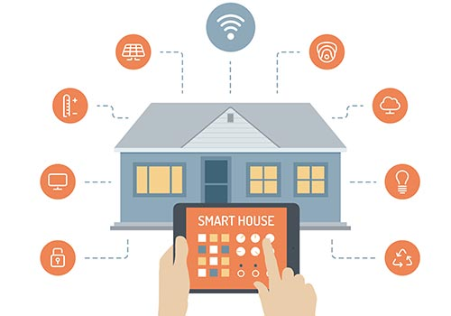

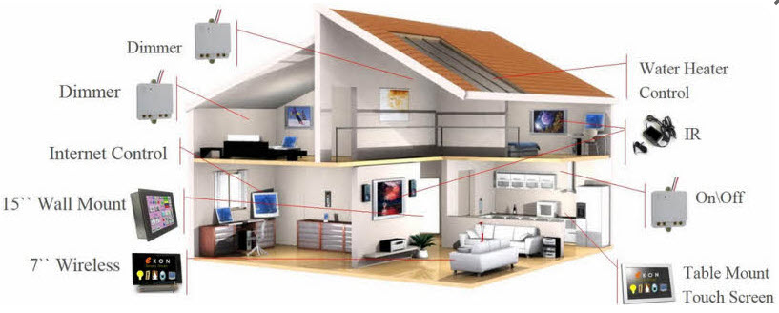

**2.3 Arduino**

Arduino is open source physical processing which is base on a microcontroller board and an incorporated development environment for the board to be programmed. Arduino gains a few inputs, for example, switches or sensors and control a few multiple outputs, for example, lights, engine and others.

Arduino program can run on Windows, Macintosh and Linux operating systems (OS) opposite to most microcontrollers’ frameworks which run only on Windows.

Arduino programming is easy to learn and apply to beginners and amateurs.

Arduino is an instrument used to build a better version of a computer which can control, interact and sense more than a normal desktop computer. It's an open-source physical processing stage focused around a straightforward microcontroller board, and an environment for composing programs for the board.

Arduino can be utilized to create interactive items, taking inputs from a diverse collection of switches or sensors, and controlling an assortment of lights, engines, and other physical outputs. Arduino activities can be remaining solitary, or they can be associated with programs running on your machine (e.g. Flash, Processing ) The board can be amassed by hand or bought preassembled; the open-source IDE can be downloaded free of charge.

Focused around the Processing media programming environment, the Arduino

Programming language is an execution of Wiring, a comparative physical computing platform

**2.3.1 Why choosing Arduino**

There are numerous different microcontrollers and microcontroller platforms accessible for physical computing. Parallax Basic Stamp, Netmedia's BX-24, Phidgets, MIT's Handyboard, and numerous others offer comparative usefulness.

These apparatuses take the chaotic subtle elements of microcontroller programming and wrap it up in a simple to-utilize bundle. Arduino additionally rearranges the methodology of working with microcontrollers; moreover it offers

some advantages for instructors, students, and intrigued individuals:

• Inexpensive - Arduino boards are moderately cheap compared with other microcontroller boards. The cheapest version of the Arduino module can be amassed by hand, and even the preassembled Arduino modules cost short of what Rs.350.00

• Cross-platform - The Arduino programming runs multiple operating systems Windows, Macintosh OSX, and Linux working frameworks. So we conclude that Arduino has an advantage as most microcontroller frameworks are constrained to Windows.

• Straightforward, clear programming method - The Arduino programming environment is easy to use for novices, yet sufficiently versatile for cutting edge customers to adventure as well. For educators, its favorably engaged around the Processing programming environment, so understudies finding ways to understand how to program in that environment will be familiar with the nature of Arduino.

• Open source and extensible programming. The Arduino program language is available as open source, available for development by experienced engineers. The lingo can be reached out through C++ libraries, and people expecting to understand the specific purposes of different interests can make the leap from Arduino to the AVR C programming language on which it is based. Basically, you can incorporate AVR-C code clearly into your Arduino programs if you have to.

• Open source and extensible hardware - The Arduino is concentrated around Atmel's Atmega8 and Atmega168 microcontrollers. The plans for the modules are circulated under a Creative Commons license, so experienced circuit designers can make their own particular interpretation of the module, extending it and improving it.

**Chapter 3**

**METHODOLOGY**

**3.1 Introduction**

This part will explain the path needed to undertake in order to achieve the goal of the project.

**3.2 Project Flow**

**3.3 Gathering the parts needed for the project**

|  |  |  |  |  |  |  |  |  |
| --- | --- | --- | --- | --- | --- | --- | --- | --- |
| SL.NO | | PRODUCT | | QTY. | | | PICTURE | |
| 1 | | ARDUINO –NANO | | 1 | | | ArduinoNanoFront_3_sm.jpg | |
| 2 | | HC-05  BLUETOOTH  MODULE | | 1 | | | Bluetooth_JY-MCU.png | |
| 3 | | 6V-10AMP  RELAY | | 3 | | | 6683105_orig.jpg | |
| 4 | | | RESISTOR  1K | 6 | | RES1K_MED.jpgRES1K_MED.jpg | | |
| SL.NO | | PRODUCT | | | | QTY | | | PICTURE |
| 5 | | DIODE  IN4007 | | | | 4 | | | https://www.digchip.com/datasheets/photos/176/1N4007-E373.jpghttps://www.digchip.com/datasheets/photos/176/1N4007-E373.jpg |
| 6 | | TRANSISTOR  2N2222 | | | | 4 | | | 415FssmdSFL._SY355_.jpgs-l300.jpgs-l300.jpgs-l300.jpg |
| 7 | | FEMALE  40 PIN HEADER | | | | mBR7CrX1n3YxqjvNkt2Wxxg.jpg2 | | |  |
| 8 | | VERO BOARD  (PCB DOTTED)  CONNECTING WIRES  BULBS  AND  HOLDERS | | | |  | | | Philips-Red-0-5-Watt-SDL458394425-1-04b48.jpg71BMjzyTYRL._SX425_.jpg |

**3.4 System Design**

Figure shows the system breakdown of this project. In this project two types of

Communication is used, first one is wireless (Via Bluetooth) and the second one is wired (appliances connected to the controller). HC-05 is a Bluetooth module that will enable the android phone to wirelessly connect with the controller.

**3.5 Hardware Implementation**

This part describes the implementation of the whole system, from arduino-nano board to the appliances.

This system is integrated using Arduino-nano board, a HC-05 Bluetooth module,

relays modules, an android device, an android app to control the arduino board, and other electronics components. Figure shows the important part in the design.

**3.5.1 Arduino- nano**

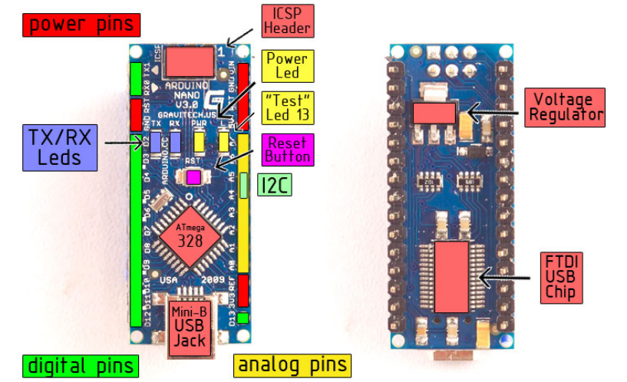Arduino Nano is a surface mount breadboard embedded version with integrated USB. It is a smallest, complete, and breadboard friendly The Nano is automatically sense and switch to the higher potential source of power, there is no need for the power select jumper.  
  
Nano’s got the breadboard-ability of the Boarduino and the Mini+USB with smaller footprint than either, so users have more breadboard space. It’s got a pin layout that works well with the Mini or the Basic Stamp (TX, RX, ATN, GND on one top, power and ground on the other). This new version 3.0 comes with ATMEGA328 which offer more programming and data memory space. It is two layers. That make it easier to hack and more affordable.

**POWER:**

The Arduino Nano can be powered via the Mini-B USB connection, 6-20V unregulated external power supply (pin 30), or 5V regulated external power supply (pin 27). The power source is automatically selected to the highest voltage source.

**MEMORY:**

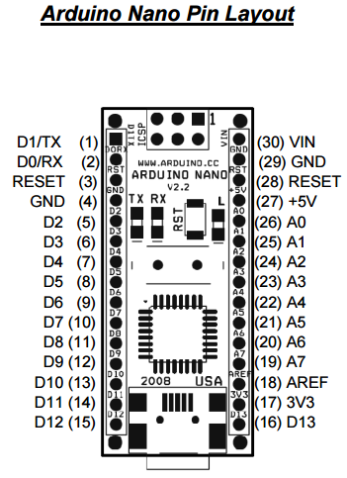The ATmega168 has 16 KB of flash memory for storing code (of which 2 KB is used for the bootloader); the ATmega328 has 32 KB, (also with 2 KB used for the bootloader). The ATmega168 has 1 KB of SRAM and 512 bytes of EEPROM (which can be read and written with the EEPROM library); the ATmega328 has 2 KB of SRAM and 1 KB of EEPROM.

**INPUT –OUTPUT PINS:**

Each of the 14 digital pins on the Nano can be used as an input or output, using pinMode(), digitalWrite(), and digitalRead() fun ctions. They operate at 5 volts. Each pin can provide or receive a maximum of 40 mA and has an internal pull-up resistor (disconnected by default) of 20-50 kOhms. In addition, some pins have specialized functions: Serial: 0 (RX) and 1 (TX). Used to receive (RX) and transmit (TX) TTL serial data.

These pins are

* Serial: 0 (RX) and 1 (TX). Used to receive (RX) and transmit (TX) TTL serial data. These pins are connected to the corresponding pins of the FTDI USB-to-TTL Serial chip.
* External Interrupts: 2 and 3. These pins can be configured to trigger an interrupt on a low value, a rising or falling edge, or a change in value. See the attachInterrupt() function for details.
* PWM: 3, 5, 6, 9, 10, and 11. Provide 8-bit PWM output with the analogWrite() function.
* SPI: 10 (SS), 11 (MOSI), 12 (MISO), 13 (SCK). These pins support SPI communication, which, although provided by the underlying hardware, is not currently included in the Arduino language.
* LED: 13. There is a built-in LED connected to digital pin 13. When the pin is HIGH value, the LED is on, when the pin is LOW, it's off.

**Table: Arduino-Nano specifications**

|  |  |
| --- | --- |
| Microcontroller | Atmel ATmega168 or ATmega328 |
| Operating Voltage (logic level) | 5 V |
| Input Voltage (recommended) | 7-12 V |
| Input Voltage (limits) | 6-20 V |
| Digital I/O Pins | 14 (of which 6 provide PWM output) |
| Analog Input Pins | 8 |
| DC Current per I/O Pin | 40 mA |
| Flash Memory | 16 KB (ATmega168) or 32 KB (ATmega328) of which 2 KB used by bootloader |
| SRAM | 1 KB (ATmega168) or 2 KB (ATmega328) |
| EEPROM | 512 bytes (ATmega168) or 1 KB (ATmega328) |
| Clock Speed | 16 MHz |
| Dimensions | 0.73" x 1.70" |
| Length | 45 mm |
| Width | 18 mm |
| Weight | 5 g |

**Table 1 – Arduino-NANO Specification**

**3.5.2 HC-05 Bluetooth Module**

HC‐05 module is an easy to use Bluetooth SPP (Serial Port Protocol) module, designed for transparent wireless serial connection setup. Serial port Bluetooth module is fully qualified Bluetooth V2.0+EDR (Enhanced Data Rate) 3Mbps Modulation with complete 2.4GHz radio transceiver and baseband. It uses CSR Bluecore 04‐External single chip Bluetooth system with CMOS technology and with AFH (Adaptive Frequency Hopping Feature).

**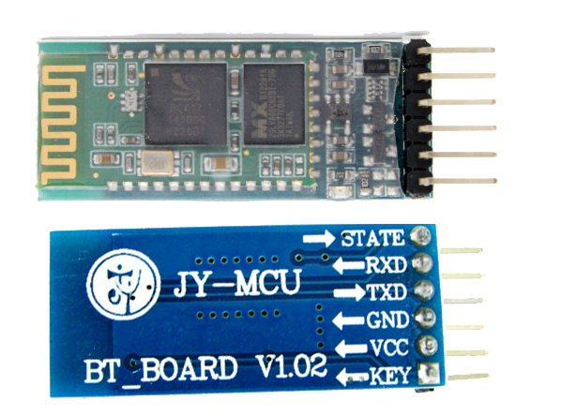**

**Table 3.5.2: HC-05 Bluetooth module specifications**

|  |  |
| --- | --- |
| Bluetooth protocol | Bluetooth Specification v2.0+EDR |
| Frequency | 2.4GHz ISM band |
| Modulation | GFSK(Gaussian Frequency Shift Keying) |
| Emission power | ≤4dBm, Class 2 |
| Sensitivity | ≤-84dBm at 0.1% BER |
| Speed | 2.1Mbps(Max) / 160 kbps, |
| Synchronous: | 1Mbps/1Mbps |
| Security Authentication and  encryption | Profiles Bluetooth serial port |
| Power supply | +3.3VDC 50mA |
| Working temperature | -20 ~ +75 Centigrade |
| Dimension | 26.9mm x 13mm x 2.2 mm |
| Mode | Slave and master |
| Baud rate (default) | 9600 baud rate |
| Pin code (default) | 1234 |

**Table 2 – HC-06 specifications**

**3.5.3 Relay Module**

A relay is a device that operates on electricity. It has a control and controlled systems. It is mostly used to control circuit automatically. Basically, it is an automatic switch to control using a low-current signal a high-current circuit.

By connection the power source to the In Port and the wanted appliance to the

normally open Pin (NO) if you want it to be active high otherwise connect it to the normally connected Pin (NC).

**3.5.3.1 Ordering information**

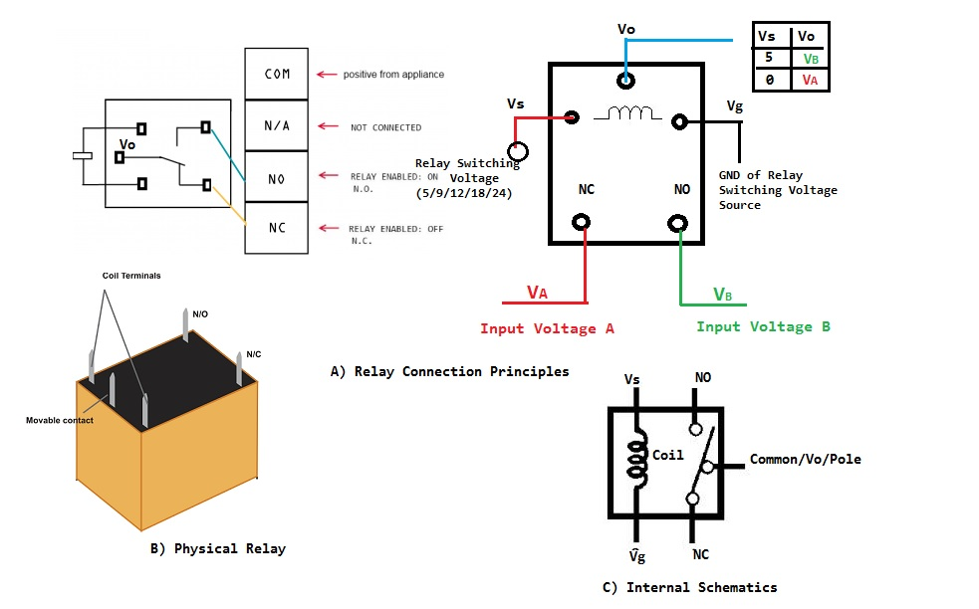

**3.6 Android Phone + Android App**

In this Project and android phone (Redmi 2 prime) is used as the remote control for the user alongside with an App created from “MIT App Inventor”

App Inventor Designer

Design the App's User Interface by arranging both on- and off-screen components.

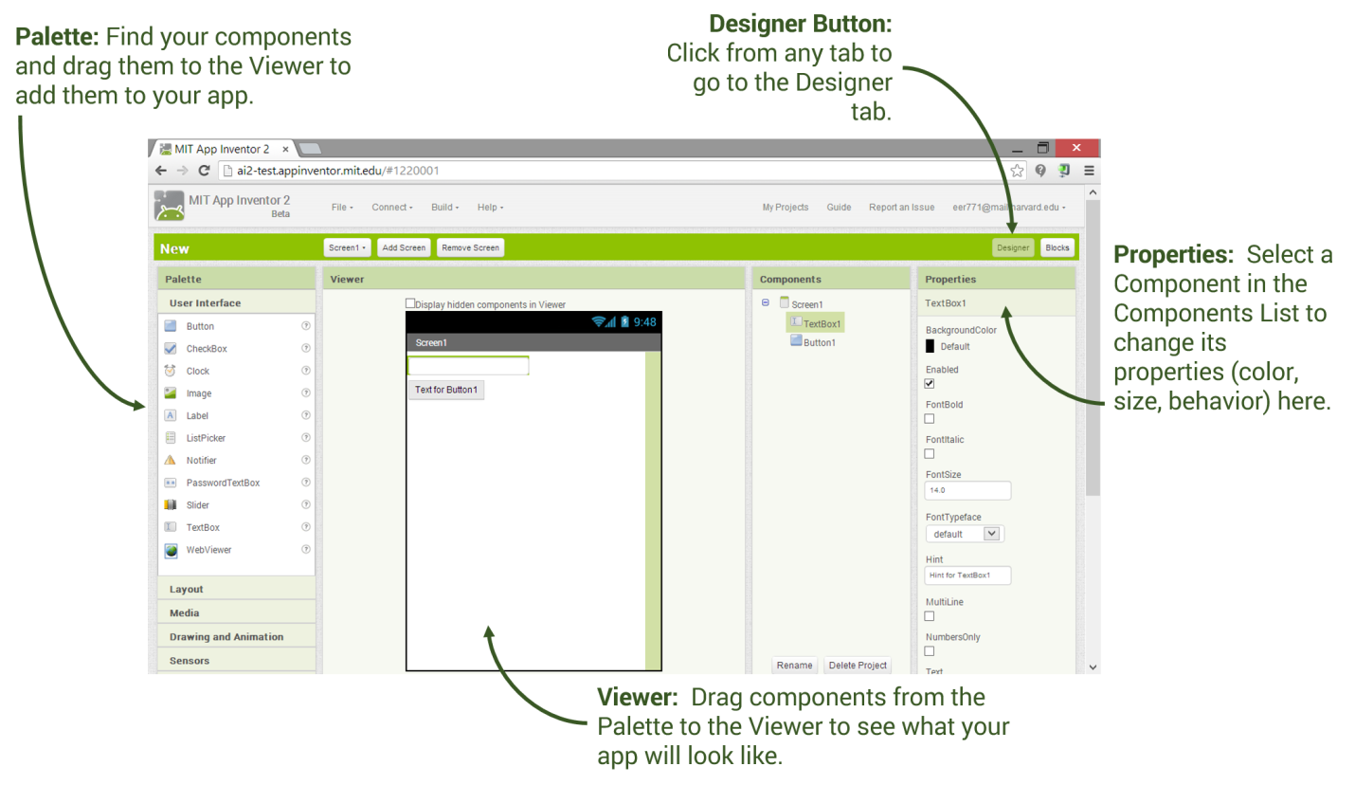

## App Inventor Blocks Editor

### BlocksTab.pngProgram the app's behavior by putting blocks together.

App inventor designer:

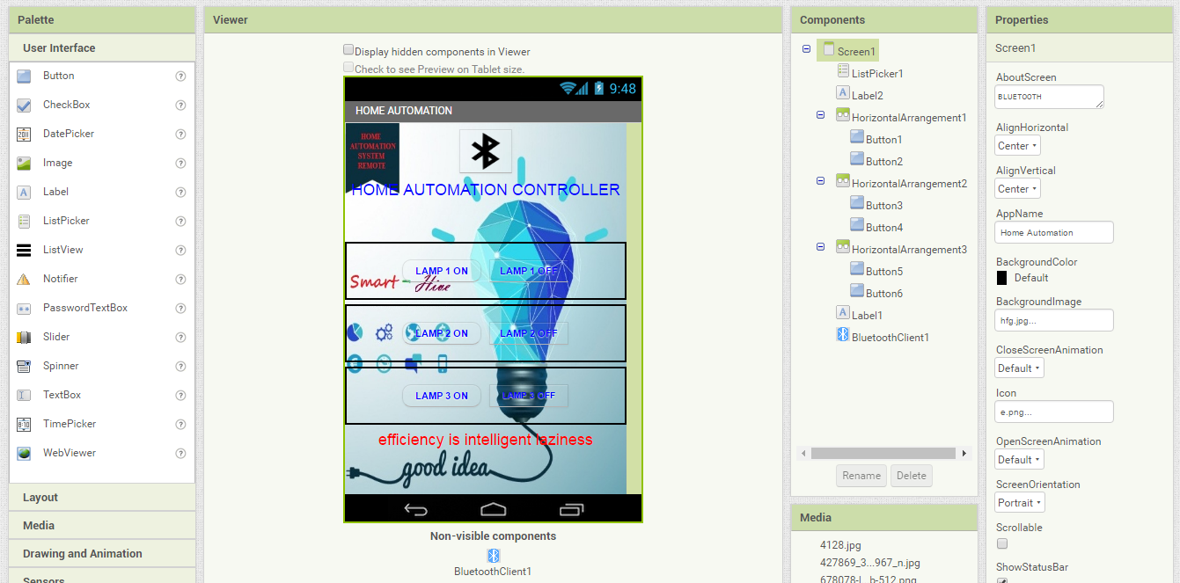

App inventor blocks editor:

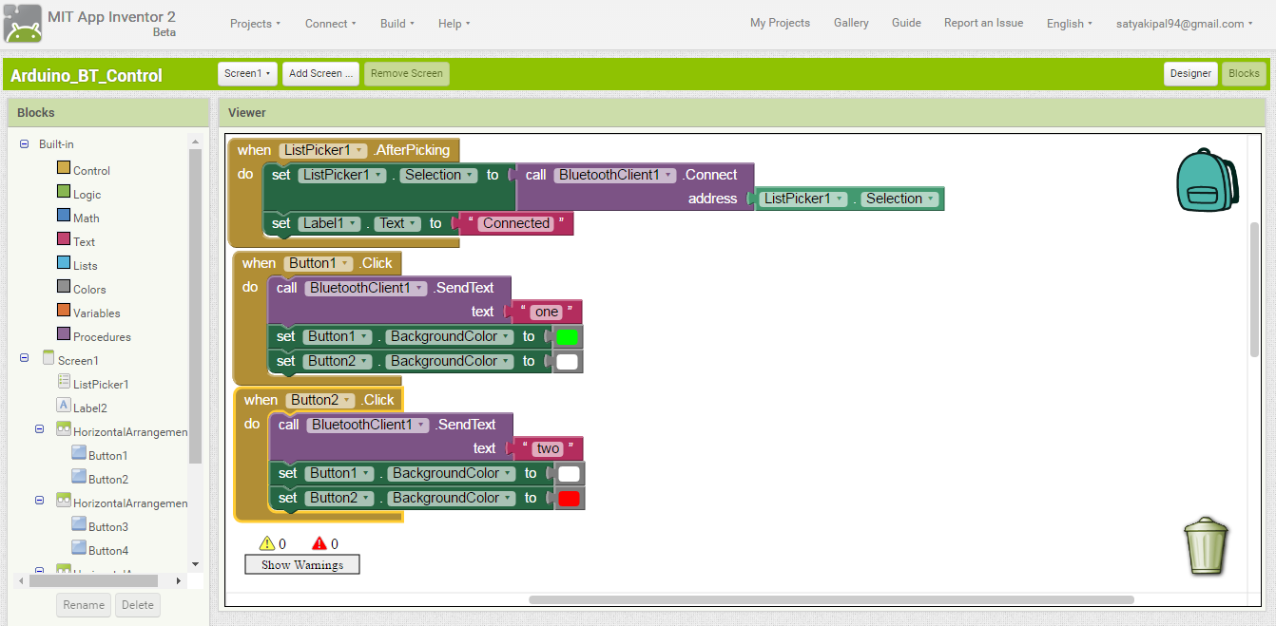

**3.7 Programming the Arduino-nano**

In order for the Arduino-nano board to be able to interact with the application used in this project certain program (code) needs to be uploaded to the Arduino-nano.

Arduino Company provides user friendly software which allows writing any code for any function wanted to be performed by the Arduino-nano and upload it to the board.

Refer to appendix A for the full source code of the Arduino-nano board.

**3.8 Connecting the Arduino-Nano board to the Bluetooth module**

A connection between the Arduino-nano and the Bluetooth module is required in order to enable the android to control the Arduino-nano.

First we need to connect the VCC pin of the Bluetooth module to the VCC port in the Arduino-nano board.

Second we need to connect the GND pin of the Bluetooth module to the GND port in the Arduino-nano board.

Lastly we need to connect the receiver of the Bluetooth module to the transmitter of the Arduino-nano board and the transmitter of the Bluetooth module to the receiver of the Arduino-nano board.

Table shows the process.

|  |  |
| --- | --- |
| Bluetooth Module (HC-06) Arduino-Nano Board | |
| VCC pin | VCC port |
| GND pin | GND port |
| TX pin | RX port |
| RX pin | TX port |

**Table – Bluetooth module/Arduino connection**

**3.9 Testing the connection**

After installing the app on the phone and connecting the Arduino-nano board with the Bluetooth module a test to make sure that the phone is interacting with arduino via the Bluetooth module is needed.

• Open the app in the android device

.

• Search for Bluetooth devices via the app

.

• Connect to the Bluetooth module.

• If the light in the Bluetooth module stopped blinking then everything is working fine otherwise the wiring need to be checked.

**3.10 Connecting the Appliances to the Arduino Board**

After everything is set and ready (android phone is connected to the Arduino) connecting the Arduino to the home appliances is needed.

Using wires and connector blocks connect the positive end of the home appliance (eg.Portable fan) to the normally open (in this project we want to make the output active high) port in the relay module and the negative end of the appliance to a power source.

Then connect the IN port of the same relay module to the wanted Arduino-nano port.

Apply the same for the other appliances only use different relays and different Arduino-nano Ports.

Connect the android phone with the Bluetooth module and now all the connected appliances can be controlled wirelessly using the android device.

**CHAPTER 4**

**RESULTS AND DISCUSSION**

This chapter discusses the results and any limitation and/or problems encountered

during the period of the project.

**4.1 Results**

Managed to successfully apply the HOME AUTOMATION SYSTEM USING

ARDUINO and it was user friendly and cost effective. User friendly as in anyone can use just a click of a button on an android screen and everything works. And it is cost effective as in it will cost exactly as the project requires (optimum price).

**Chapter 5**

**CONCLUSION AND FUTURE WORKS**

This chapter confers on the conclusion of Bluetooth Based Home Automation

System Using Android Phone and discusses some future recommendation.

**5.1 Conclusion**

It can be concluded that HOME AUTOMATION SYSTEM USING ARDUINO was a success. This system consists of an Arduino-nano board, a Bluetooth Module, an Android phone, power sockets, home appliances and an android Application . It is user friendly and it is cost effective.

Also it can be concluded that the objectives of this project has been successfully met and they are as follows:

• Constructed a wireless home automation system controlled by a smartphone specificallyan android device.

• Designed and implement cost effective home automation system yet an efficient one.

• Designed a user friendly and a safe system to control home appliances especially aimed to aid the elders and handicapped.

**5.2 Future Recommendations**

There are some recommendations for Future works. Some of them are:

1. Better to use relay modules and connect it directly than using normal relays

with breadboard.

2. Try to find a way to amplify the Bluetooth module signal to work in greater

distance.

3. Test each and every component before using them especially the relays for

safety purposes.

**REFERENCES**

[1] Deepali Javale, Mohd. Mohsin, Shreerang Nandanwar and Mayur Shingate. International Journal of Electronics Communication and Computer Technology (IJECCT) Volume 3 Issue 2 (March 2013).

[2] The official Arduino Website: <http://arduino.cc/en/Guide/Introduction>

[3] Inigo Puy, Bluetooth, 2008.

[4] The official Bluetooth Website: <http://www.bluetooth.com/Pages/Fast-Facts.aspx>

[5] Ming Yan and Hao Shi, SMART LIVING USING BLUETOOTHBASED ANDROID SMARTPHONE, 2013.

[6] HC-06 Bluetooth module instructional manual.

[7] LIU, J. Research on Development of Android Applications. Fourth International Conference on Intelligent Networks and Intelligent Systems. 2011

[8] HANSON, D. C. Android Application Development and Implementation 3 Dimensional Tic-Tac-Toe. 2010.

[9] LOXONE Miniserver based Smart Homes. 2015

**Appendix A**

**Source code for Arduino**

int ledpin1 = 3;

int ledpin2 = 5;

int ledpin3 = 7;

int ledpin4 = 9;

String readString;

void setup() {

Serial.begin(9600);

pinMode(ledpin1, OUTPUT);

pinMode(ledpin2,OUTPUT);

pinMode(ledpin3,OUTPUT);

pinMode(ledpin4,OUTPUT);

}

void loop() {

while (Serial.available()) {

delay(3);

char c = Serial.read();

readString += c;

}

if (readString.length() >0) {

Serial.println(readString);

if (readString == "one")

{

digitalWrite(ledpin1, HIGH);

}

if (readString == "two")

{

digitalWrite(ledpin1, LOW);

}

if (readString == "three")

{

digitalWrite(ledpin2,HIGH);

}

if (readString == "four")

{

digitalWrite(ledpin2,LOW);

}

if (readString == "five")

{

digitalWrite(ledpin3,HIGH);

}

if (readString == "six")

{

digitalWrite(ledpin3,LOW);

}

readString="";

}

}