**Laboratory Report**

Power System Protection Laboratory

Semester: Summer 2020-21

Experiment No.: 09

Experiment Title: Study of the performance of different protection schemes of a power transformer

Date of Experiment: 15-07-2021 Date of Report Submission: 14-08-2021

|  |  |  |  |  |
| --- | --- | --- | --- | --- |
| **Group No.** |  | **Group Members** | |  |
|  | Name |  | ID |
| 07 | 1. | Sourav Das | 18-37400-1 |  |
| 2. | Shahadot Hossain Shanto | 18-37397-1 |  |
| 3. | Ashik Ahamed | 18-37291-1 |  |
| 4. | Shompod Abdullah Noman | 18-37416-1 |  |
| 5. | Moon MD Umar Faruk | 18-37425-1 |  |
|

**Marking Rubrics for Laboratory Report (to be filled by Faculty)**

|  |  |  |  |  |
| --- | --- | --- | --- | --- |
| **Objectives** | **Unsatisfactory (1)** | **Good (2-3)** | **Excellent (4-5)** | **Marks** |
| **Theory** | The relevant theories are not being described properly. | Part of the relevant theories are described with proper mathematical expression and circuit diagrams (if any) | All the relevant theories are included with proper descriptions, mathematical expressions and circuit diagrams. (if any) |  |
| **Simulation circuits & Results** | Simulation circuits are not included in this report. | Partial simulation circuit results are included in this report. | All the simulation circuits are included in this report with appropriate results. |  |
| **Discussion,**  **Comparison between theoretical and simulation results** | Cannot reach meaningful conclusions from experimental data; Cannot summarize or compare findings to expected results | Can extract most of the accurate data. Answers to the report questions are partially correct; Summarize finding in an incomplete way | Can extract all relevant conclusion with appropriate answer to the report questions; Summarize  finding in a complete & specific way |  |
| **Organization of the report** | Report is not prepared as per the instruction. | Report is organized despite of few missing sections as per the recommended structure. | Report is very well organized. |  |
| **Comments** | Assessed by (Name, Sign, and Date) | | Total (out of 20): |  |

**Title:** Study of the performance of different protection schemes of a power transformer.

**Introduction:**

Power transformers are very important and central components of electric power systems. Protection of power transformers is a vital mission of protection engineers. Power transformers' protective relay should block the tripping during magnetizing inrush and rapidly operate the tripping during internal faults. This protection relay should be fast, economic and reliable. Consequently, high anticipations are imposed on power transformer protective Schemes. Expectations from these Schemes incorporate dependability, security, speed of operation (minimum clearing fault time) and stability. The objectives of this experiment are lo observe the performance of the following schemes of a power transform:

1. Buchholz alarm
2. 2 Buchholz trips
3. Temperature alarm
4. Temperature trip
5. Differential relay trip due lo phase lo phase and ground fault
6. Restricted EF relay trip

**Buchholz relay (Gas relay /Gas actuated relay:**

The Buchholz relay protects the transformer from internal faults. It is the gas actuated relay. The Buchholz relay is placed between the main tank and the conservator. Such type of relay is used in the transformer having the rating higher than 500KVA. It is not used in small transformer because of economic consideration.

**Working Principle:**

When the fault occurs inside the transformer, the temperature of the oil increases. The oil evaporates in the form of the gas. The generation of the gas depends on the magnitude of the fault occurs inside the transformer. The internal failure occurs in the transformer either because of the insulation breakdown between the winding or the winding have the weak initial contact.

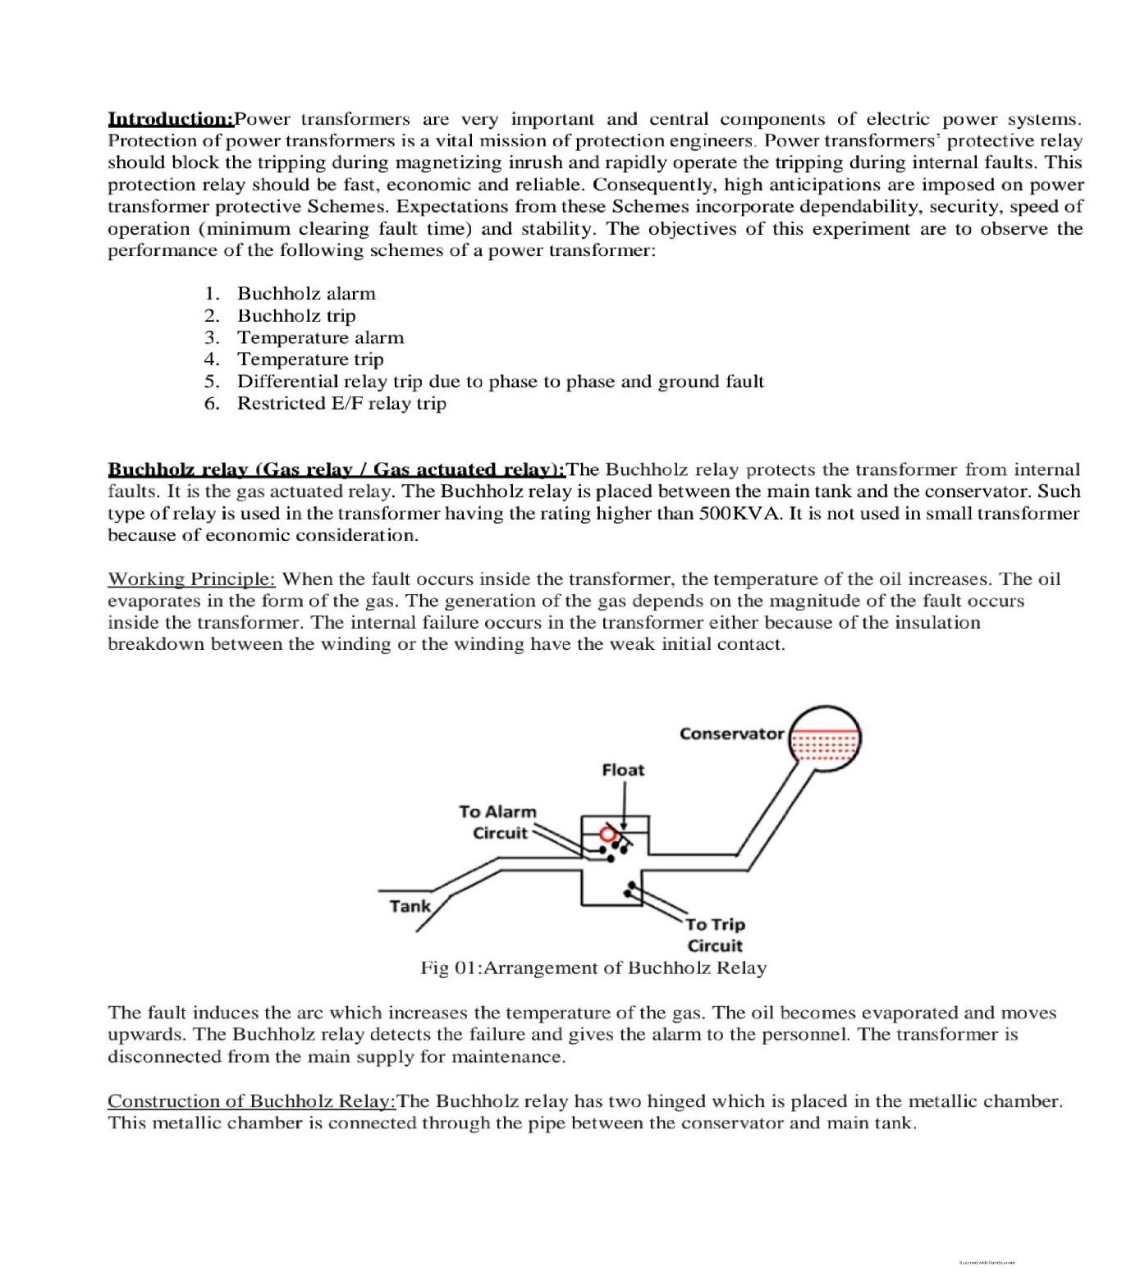

Fig 01: Arrangement of Buchholz Relay

The fault induces the arc which increase the temperature of the gas. The oil becomes evaporated and moves upwards. The Buchholz relay detects the failure and gives the alarm to the personnel. The transformer is disconnected from the main supply for maintenance.

**Construction of Buchholz Relay:**

The Buchholz relay has two hinged which is placed in the metallic chamber. This metallic chamber is connected through the pipe between the conservator and main tank. The one or the hinged S placed in the upper portion the metallic chamber along with the mercury Switch. This mercury switch ss used to activating the alarm. The other float is placed in the lower position of the metallic chamber along with the mercury switch. The mercury switch is used for actuating the tripping circuit.

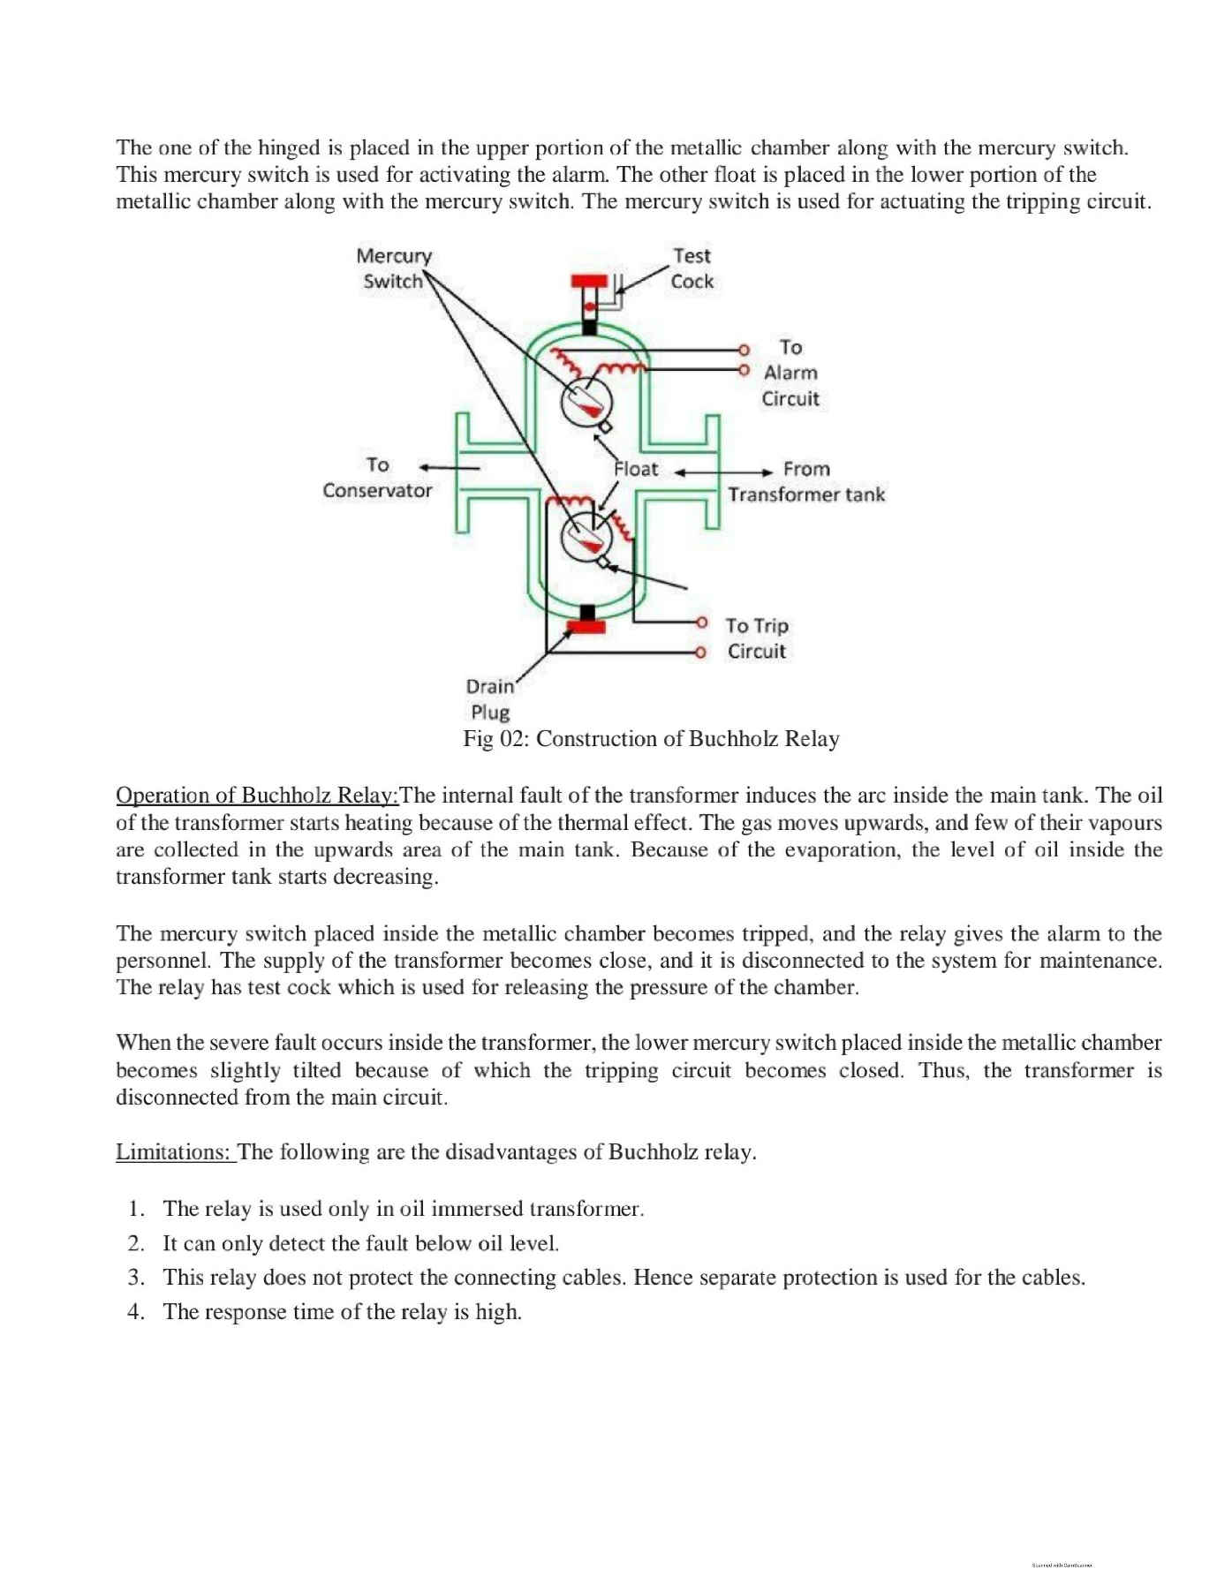

Fig 02: Construction of Buchholz Relay

**Operation of Buchholz Relay:**

The internal fault of the transformer induces the are inside the main tank. The oil of the transformer starts heating because of the thermal effect. The gas moves upwards, and few of their vapors are collected in the upwards area of the main tank. Because of the evaporation, the level of oil inside the transformer Lank starts decreasing.

The mercury switch placed inside the metallic chamber becomes tripped, and the relay gives the alarm ta the personnel. The supply of the transformer becomes close, and it is disconnected to the system for maintenance. The relay has test cock which is used for releasing the pressure of the chamber.

When the severe fault occurs inside the transformer, the lower mercury switch placed inside the metallic chamber becomes slightly titled because of which the tripping circuit becomes closed. Thus, the transformer is disconnected from the main circuit.

**Limitations:**

1. The following are the disadvantages of Buchholz relay.
2. The relay is used only in oil immersed transformer.
3. It can only detect the fault below oil level.
4. This relay does not protect the connecting cables. Hence separate protection is used for the cables.
5. The response time of the relay is high.

**Overheating Protection:**

The rating at the transformer is based on the temperature rise above an assumed maximum ambient temperature under this condition no sustained overload is usually permissible. At lower ambient temperature some degree of overload can be safely applied. Short time overloading is also permissible to an extent dependent on the previous loading Condit ions. No precise ruling applicable to all conditions can be given concerning the magnitude and direction of safe overload. Thermocouples or resistor temperature detectors are kept near each winding. These are connected to a bridge circuit. When temperature increases above safe value an alarm is given. If measures arc not taken, the circuit breaker is tripped after a certain temperature. Some typical settings for oil temperature are as follows-

At 60C, Switch on fans at 95°C. give an alarm

At 120C. give a trip signal to trip the CB.

A temperature of about 95°C is considered to be the normal maximum working value. Any further rise of 8°-10°C beyond this 95°C will make the life of the transformer half if this rise is sustained.

**Protections of transformer against internal fault by differential relay:**

In protection of a transformer. CTs are connected at both sides of the transformer. The CT secondaries are connected in star or delta and pilot wires are connected between the CTs of each end. The CT connections and CT ratios are such that current fed into the pilot wires front both the ends are equal during normal and for through fault conditions. During any kind of internal fault, like phase-to-phase faults or phase to ground faults, the balanced is disturbed. The out of balance current (l1 I2) flows through the relay operating coils. To avoid unwanted relay operation on through faults, restraining coils are provided in series with the pilot wires. The average current through the restraining coil is (1; t12)2. As a result, the restraining current increases with the increase of d-l) in the operating coil for a through fault condition.

**Procedure:**

3-phase, 28 MVA, 132/33KV, A- connected power Transformer feeds power lo a 33 KV bus from a 132KV bus as shown in the Figure bellow:

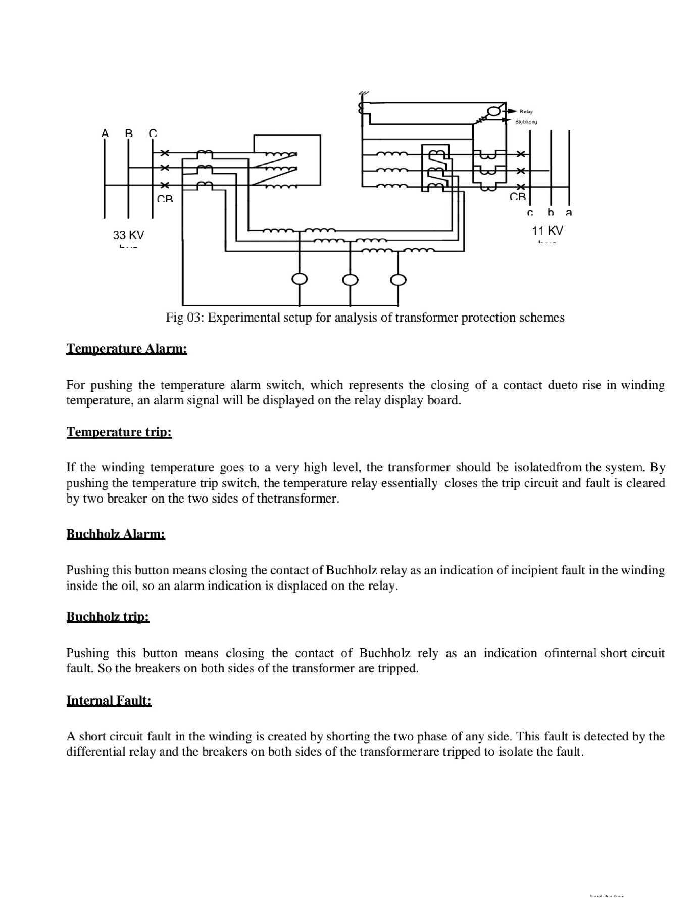

**Temperature Alarm:**

For pushing the temperature alarm switch, which represents the closing of a contact duct rise in winding temperature, an alarm signal will be displayed on the relay display board.

**Temperature trip:**

If the winding temperature goes to a very high level, the transformer should be isolated from the system. By pushing the temperature trip switch, the temperature relay essentially closes the trip circuit and fault is cleared by two breakers on the two sides of the transformer.

**Buchholz Alarm:**

Pushing this button means closing the contact to Buchholz relay as an indication of accipient fault in the winding inside the oil, so an alarm indication is displaced on the relay.

**Buchholz trip:**

Pushing this button means closing the contact of Buchholz rely as an indication internal short circuit

Fault. So, the breakers on both sides of the transformer are tripped.

**Internal fault**

A short circuit fault in the winding is created by shorting he two phases of any side. This fault is detected by the differential relay and the breakers on half sides al the Translaminar tripped.

**Restricted E/F Protection:**

An earth fault close to the neutral end to the winding or the transformer is created by Shorting the phase terminal and neutral terminal. This fault is detected by the concerned relay and the breakers on both sides of transformer arc tripped to iso late the fault.

**Simulation:**

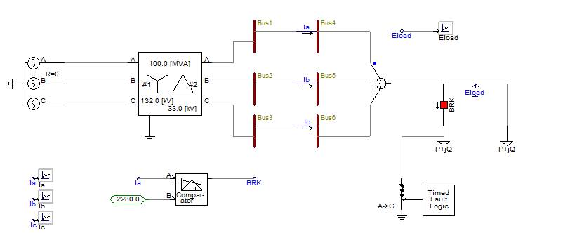

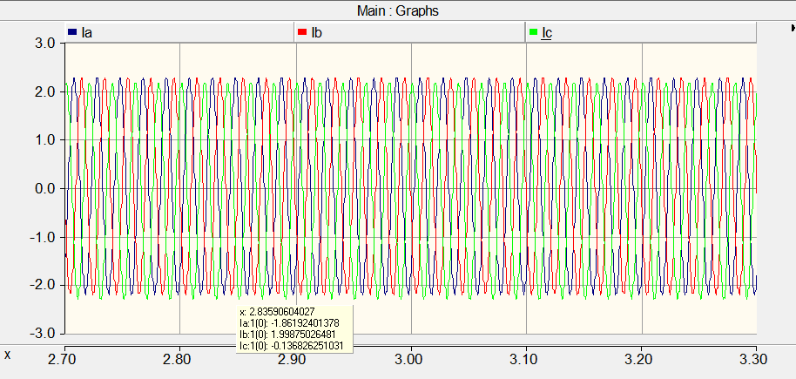

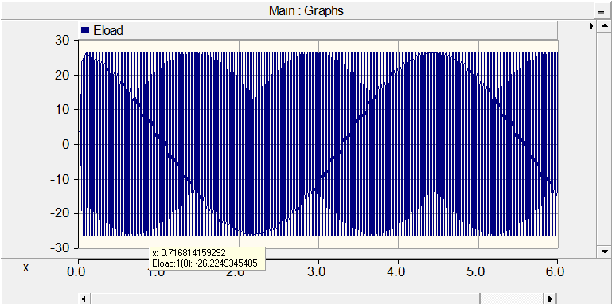

**Report question answer:**

**Question-1:** what do you mean by incipient faults in the transformer winding what are lie possibly causes this fault?

**Answer:** Incipient faults are internal faults which constitute no immediate hazard. But it these faults are over looked an taken care 1, they may lead to do faults, the faults group are mainly interlamination of oil flow paths. All these faults lead to overheating. So, transformer protection scheme is required for incipit transformer faults also. The earth fault, very nearer to neutral point of transformer star winding may also be Considered as an incipient toluene o

winding Connick o and earthing on early Taut current magnitude. Accurate exists Tor the current low into and out or the wining. Ampere-turns Dalene S mamateek Between the windings. The value of winding earth fault current depends upon position of the fault on the winding, method of winding connection and method of earthing.

**Question-2:** Is the earth fault close to neutral end of a wye connected winding very common? Why?

**Answer:** Probably not, because the potential (with respect to earth) of a point on the winding. close to its neutral end, will be relatively low. Accordingly, it is less likely that the insulation will fail the most common cause of electrical faults.

**Question-3:** Explain why percentage differential relay is not suitable for detecting the E'F near neutral end of a Y-connected winding who’s neutral is grounded through high resistance.

**Answer:** When earth fault occurs very near to the neutral point of wye winding. the voltage available for driving earth fault current is small. Hence fault current is low. Relay has to be too sensitive and then it can operate tor spurious signals like external faults, switching surges etc.

**Discussion:**

In this experiment we have learn about different protection system of a transformer. We learn details about the working principle of Buchholz relay and observe its working principle by video demonstration. Also, we design a protection system in PSCAD software and observe different parameter. Mainly make a manual fault in this simulation and observe its behavior in this PSCAD software. All those characteristics are matched with our theoretical concept.

**References:**

[1] AIUB Lab Manual

[2]https://circuitglobe.com/buchholzrelay.htmlt:text=Definition%3A%20The%20Buchholz%20relay%20protects, the%20rating% 20higher% 20than% 20500KVA.

[3] https://www.electrical4u.com/transformer protection and transformer fault/

[4] https://www.answers.com/QIs the earth fault close to neutral end of anywise connected winding common