**Individual Performance Test [Spring 2020-21], Mid Term**

**Renewable Energy Technology Lab [C]**

**Marks: 20**

|  |  |
| --- | --- |
| **Student Name:** | **MD MONJURUL ISLAM** |
| **Student ID:** | **18-37542-1** |
| **Group No:** |  |

**Instructions:**

**a. There are four questions based on the design statement.**

**b. If your question says ID+25 then use last two digits of your ID before the hyphen and then add 25. For example, If ID: 18-78253-2, then use 53 and add 25. In this case, ID+25 = 53+25 = 78.**

**c. Rename your file name as your student ID.**

**d. Rename the PV array used in the simulation as your student ID.**

**e. Each screenshot should be taken in a manner which shows the current time in your laptop/desktops.**

**f. Copied/identical submissions will be graded as 0.**

**g. After finishing, convert the word file into PDF format and submit it in Microsoft teams (assigned assignment Section)**

**Design Statement:** Design a PV Station with the following requirement.

* Maximum power (*Pmax*) = (**ID+25) MW (approximate the power as close as possible)**
* Open Circuit Voltage (*Voc*)=**1.5 kV (1500 V)**
* PV panel model: **SunPower SER-220P**
* PV Cell Irradiance: **1000 W/m2 and PV cell temperature: 25oC**

***Now based on the above criteria answer/fill out the below questions.***

**Q1.** How many **PV panels are required in series and parallel**? **Show necessary calculation**. You can paste your notebook picture or type the calculation.

Here,

My id is 18-375**42**-1

So, ID= 42

Given,

Maximum power (*Pmax*) = (ID+25) MW

= (42+25) MW

=67 MW

Open Circuit Voltage (*Voc*) =1.5 kV (1500 V)

So, Short Circuit current = Pmax/Voc = 67e6/1500= 44667 A

Now, PV panels are required in series = (1500/36.3) = 41

And, PV panels are required in parallel = (44667/8.3) = 5382

**Q2.** Paste the **snapshot of the layout of PV panel with capacitive load**. **[5]**

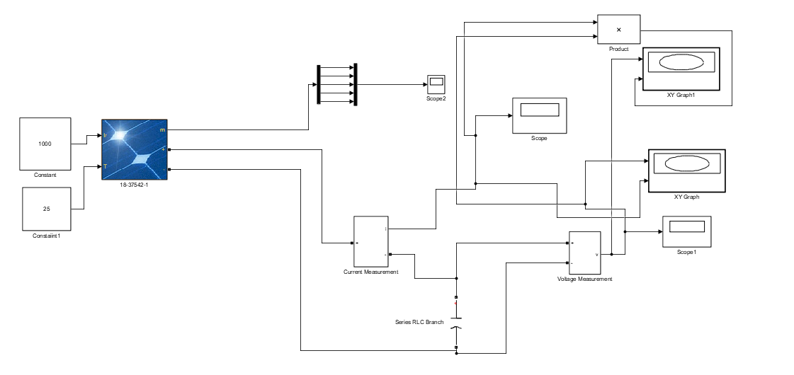

**Q3.** Paste the **block parameters snapshot** after double clicking on the PV module in Matlab Simulink for the designed PV station. **[5]**

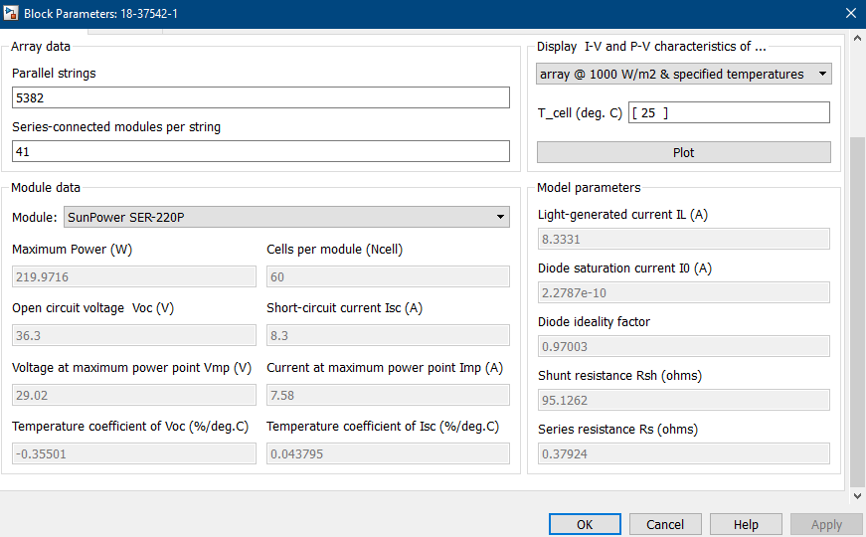

**Q4.** Paste the **I-V and P-V characteristics graph**s snapshots for the above criteria. **[5]**

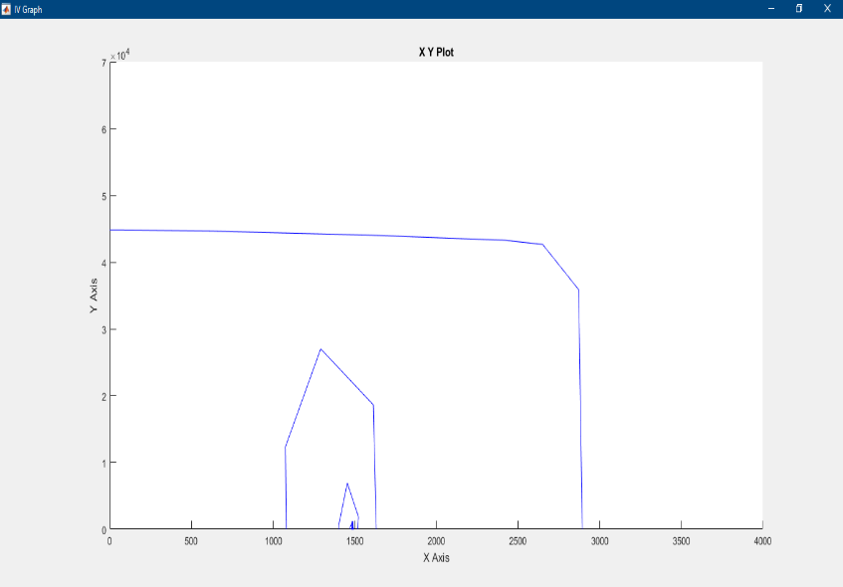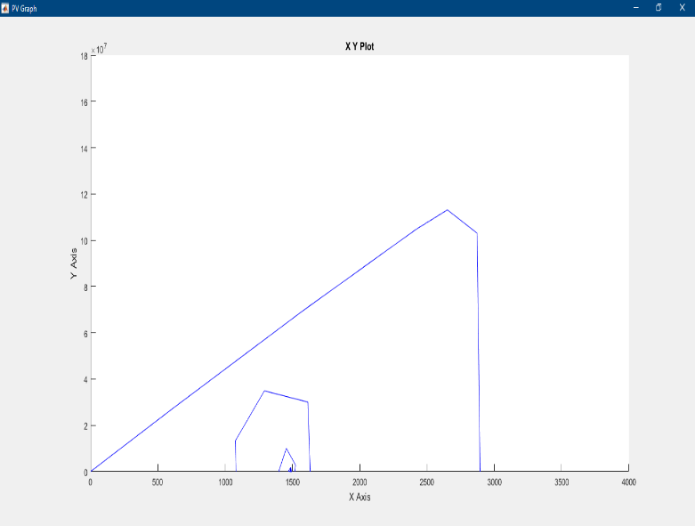 I-V Graph P-V Graph