## horizontal line



Plant Disease Detection

29/06/2020

LEARNLeaF

# Overview

The project is based on a computer vision binary classification problem where our primary goal is to detect if a plant is diseased or not by seeing the picture of its leaf.

Agricultural productivity is something on which the economy highly depends. This is one of the reasons that disease detection in plants plays an important role in the agriculture field, as having disease in plants is quite natural. If proper care is not taken in this area then it causes serious effects on plants and due to which respective product quality, quantity or productivity is affected. For instance a disease named little leaf disease is a hazardous disease found in pine trees in the United States. Detection of plant disease through some automatic technique is beneficial as it reduces a large work of monitoring in big farms of crops, and at a very early stage itself it detects the symptoms of diseases i.e. when they appear on plant leaves.

# DATASET

The dataset we used in this implementation is PLANT_VILLAGE DATASET and can be downloaded from [here](https://www.kaggle.com/emmarex/plantdisease).The dataset contained more than 20000 images but we have used 200 images from each folder which made our total images around 7980.

Displaying some of it with its label :-

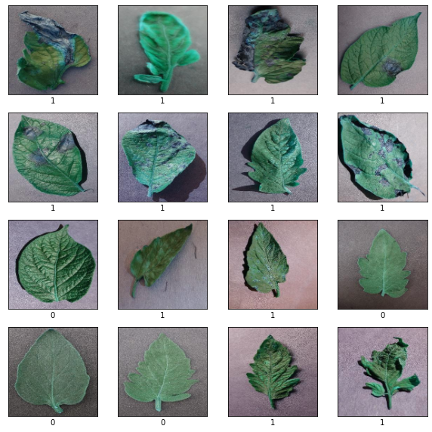

# Model Architecture

Still need to figure it out.

## 

# EXPERIMENTATION

We tried different model Architecture with the same training set and plotted graphs for accuracy vs epoch . There was a lot of information that could be extracted from it. We found that our XYZ model Performed well out of other models and it gave us satisfactory results with an accuracy of dash and a loss of dash . The plot for Xyz model shows that the valid accuracy is not much comparable with train accuracy which shows that the model isnt overfitting.

# EXPERIMENTATION PLOTS

1. SVM MODEL

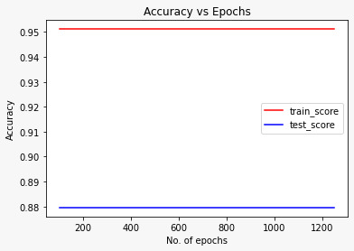

1. REGRESSION MODEL

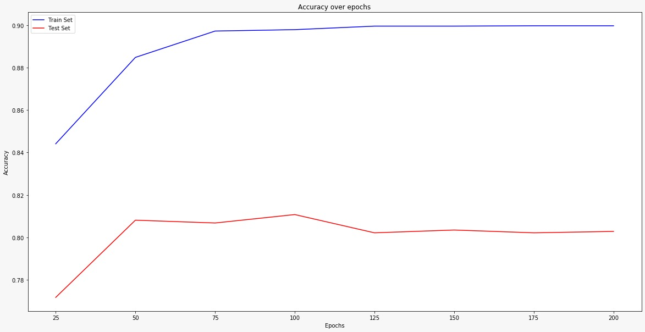

1. CNN MODEL

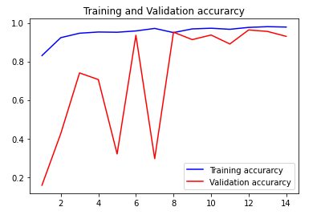

# CONCLUSION

We made different experimentation with different we different model architecture on the given PLANTVILLAGE dataset and forecasted a conclusion on the result that the model xyz performs much better than the other model and can be used to design a plant detection system.